313908000-KM-03, Sugar processing factory control calculations, NQF Level 5, Credits 12

LEARNER GUIDE

SAQA 97590
Occupational Certificate: Sugar Processing Controller

Document Version
Document Version | 1.0
Date Published
Publisher

Document Change History
Date | Version | Initials | Description
 | 1.0

Module #
NQF Level
Credit(s)
SAQA QUAL ID
Qualification Title

Contact information:
Name
Contact Address
Telephone (H)
Telephone (W)
Cellular

TABLE OF CONTENTS
Document Version 2
Document Change History 2
Contact information: 3
TABLE OF CONTENTS 4
QUALIFICATION RULES 7
ASSESSMENT REQUIREMENT 9
Both formative and summative assessments are used as part of this outcomes-based learning programme: 9
TOPIC ELEMENTS TO BE COVERED INCLUDE: 11
1. KM-03-KT01: Introduction to factory control concepts (40%) 12
1.1. KT0101 Averaging 12
1.1.1. Step 1: Understanding the Importance of Control Concepts 12
1.1.2. Step 2: Data Collection and Averaging Techniques 12
1.1.3. Step 3: Implementing Control Systems 13
1.1.4. Step 4: Benefits of Averaging in Sugar Processing 13
1.2. KT0102 Factory Figures 14
1.2.1. Overview of Sugar Processing Control 14
1.2.2. Key Factory Figures 14
1.2.3. Implementation of Control Systems 15
1.3. KT0103 Cane Payment 15
1.3.1. Understanding Cane Payment 15
1.3.2. Recent Challenges in South Africa’s Sugar Industry 15
1.4. KT0104 Calculations 16
1.4.1. Step 1: Understanding Key Processes 16
1.4.2. Step 2: Key Calculations 17
1.4.3. Step 3: Application in South African Context 18
1.4.4. Conclusion 18
2. KM-03-KT02: Materials Balance (25%) 19
2.1. KT0201 Data Source 19
2.1.1. Step 1: Understanding Material Balance 20
2.1.2. Step 2: Identifying Key Stages in Sugar Processing 20
2.1.3. Step 3: Sources of Data 20
2.1.4. Step 4: Application of Data 21
2.2. KT0202 Calculations 21
2.2.1. Step 1: Understanding the Components of Material Balance 21
2.2.2. Step 2: Data Collection 22
2.2.3. Step 3: Performing Material Balance Calculations 22
2.2.4. Step 4: Analyzing Results and Adjustments 23
2.2.5. Conclusion 23
3. KM-03-KT03: Stock Taking (10%) 25
3.1. KT0301 Purpose 25
3.1.1. Step 1: Accurate Inventory Management 25
3.1.2. Step 2: Enhancing Operational Efficiency 26
3.1.3. Step 3: Supporting Financial Sustainability 26
3.1.4. Step 4: Facilitating Compliance with Regulatory Requirements 26
3.2. KT0302 Data collection 27
3.2.1. Define Objectives and Scope 27
3.2.2. Develop a Data Collection Plan 27
3.2.3. Inventory Preparation 27
3.2.4. Conduct Physical Count 28
3.2.5. Data Verification 28
3.2.6. Data Analysis 28
3.2.7. Implement Adjustments 28
3.2.8. Continuous Monitoring 29
3.3. KT0303 Sampling 29
3.3.1. Understanding the Importance of Sampling 29
3.3.2. Defining Objectives 29
3.3.3. Developing a Sampling Plan 30
3.3.4. Methods of Sampling 30
3.3.5. Sample Collection Techniques 30
3.3.6. Analyzing Samples 31
3.3.7. Reporting Results 31
3.3.8. Continuous Improvement 31
4. KM-03-KT04: Calculations (25%) 33
4.1. KT0401 Factory Performance Calculations 33
4.1.1. Key Performance Indicators (KPIs) 34
4.1.2. Process Control Techniques 34
4.2. KT0402 Products in Process 35
4.2.1. Step 1: Understanding Raw Materials 35
4.2.2. Step 2: Processing Costs 36
4.2.3. Step 3: Yield Calculations 36
4.2.4. Step 4: Profit Margin Calculation 36
4.2.5. Step 5: Automation and Control Systems 37
4.3. KT0403 Calculations 37
4.3.1. 1. Cost of Sugar Production 37
4.3.2. 2. Key Metrics for Calculating Sugar Yield 38
4.3.3. 3. Profit Margin Calculation 39
REFERENCE 40

QUALIFICATION RULES
This qualification is made up of the following compulsory Knowledge and Practical Skill Modules: Knowledge Modules:
- 313908000-KM-01, Introduction to sugar processing laboratory work, NQF Level 4, Credits 8
- 313908000-KM-02, The sugar manufacturing process, NQF Level 5, Credits 12
- 313908000-KM-03, Sugar processing factory control calculations, NQF Level 5, Credits 12
- 313908000-KM-04, Sugar juice extraction, NQF Level 4, Credits 4
- 313908000-KM-05, Sugar juice handling and clarification, NQF Level 4, Credits 4
- 313908000-KM-06, Evaporation, NQF Level 4, Credits 8
- 313908000-KM-07, Pan Boiling theory and technology, NQF Level 5, Credits 8
- 313908000-KM-08, Crystallisation, Centrifuging and Drying, NQF Level 4, Credits 4
- 313908000-KM-09, Water and effluent treatment, NQF Level 4, Credits 4
- 313908000-KM-10, Sugar refining, NQF Level 5, Credits 4
- 313908000-KM-11, Operations management, NQF Level 5, Credits 12
- 313908000-KM-12, Safety, Health, Environment, Risk and Quality Control, (SHERQ), NQF Level 5, Credits 8
- 313908000-KM-13, Mechanical maintenance, NQF Level 5, Credits 4
Total number of credits for Knowledge Modules: 92
Practical Skill Modules:
- 313908000-PM-01, Monitor and control sugar processing equipment, NQF Level 5, Credits 16
- 313908000-PM-02, Control sugar milling operations and resources, NQF Level 5, Credits 8
- 313908000-PM-03, Monitor and direct subordinate performance and conduct, NQF Level 5, Credits 8
- 313908000-PM-04, Enforce compliance to Safety, Health, Environmental protection and Quality standards, NQF Level 5, Credits 6
- 313908000-PM-05, Conduct and respond to in-line quality tests and reports, NQF Level 5, Credits 8
- 313908000-PM-06, Inspect and coordinate maintenance of equipment, NQF Level 5, Credits 8
- 313908000-PM-07, Compile and present production reports, NQF Level 4, Credits 4
Total number of credits for Practical Skill Modules: 58
Work Experience Modules:
- 313908000-WM-01, Sugar processing equipment control procedures, NQF Level 5, Credits 28
- 313908000-WM-02, Sugar processing resource control procedures, NQF Level 5, Credits 16
- 313908000-WM-03, Safety, health, environmental protection and quality compliance procedures, NQF Level 5, Credits 16
- 313908000-WM-04, Mechanical equipment functionality and availability processes, NQF Level 4, Credits 16
Total number of credits for Work Experience Modules: 76

ASSESSMENT REQUIREMENT
- Learner Guide: The Learner Guide is designed to serve as a guide for the duration of your learning programme and as the main source document for transfer of learning. It contains information (knowledge and skills required) and application aids that will assist you in developing the knowledge and skills stipulated in the specific outcomes and assessment criteria. The learner guide also indicates the formative assessment class activities that you need to complete towards your Portfolio of Evidence.
- Learner Workbook: The learner Workbook contains all the class activities that you will be completing to show formative learning. These will be assessed as part of your portfolio of evidence as formative assessment. You will be handing in the Learner Workbook as part of your Portfolio of Evidence.
- Learner Portfolio of Evidence Guide: The Learner Portfolio of Evidence Guide provides details about the assessment, such as the assessment preparation, plan and specific summative assessment activities that you need to complete in the workplace.

Both formative and summative assessments are used as part of this outcomes-based learning programme:
- Formative Assessment: The Class Activities throughout your Learner Workbook are designed not only to help you learn new skills, but also to prove that you have mastered competence.
- Summative Assessment: This means that you will also be required to do independent research and assignments, such as Knowledge Questions Practical Activity (completed in the workplace), Witness Testimony and Logbook. The assessment process is discussed in detail in the Learner Portfolio of Evidence Guide. When you are ready, you will advise your mentor that you are ready for assessment. He or she will then sign off the required sections in the Learner Portfolio of Evidence Guide and you will be able to submit your Portfolio of Evidence for assessment. The summative assessment activities placed in the Learner Portfolio of Evidence Guide for your convenience. If any of your assessment is conducted using observation, role plays or verbal assessment, place a signed copy of the checklists, once completed by your mentor or line manager in your Learner Portfolio of Evidence Guide, as indicated.
The Training Provider will assess your portfolio. If successful, you will receive the credit value of this learning programme. The entire assessment process is explained in the Learner Portfolio of Evidence Guide and you are urged to read this guide as soon as possible as it explains the assessment process in detail and clarifies your rights and responsibilities to ensure that the assessment is fair, valid and reliable. If you are not successful, you will receive all the guidance needed to resubmit your Portfolio of Evidence within a specific time period, as per the Training Provider requirements.

TOPIC ELEMENTS TO BE COVERED INCLUDE:
The main focus of the learning in this knowledge module is to build an understanding of for the learner to gain fundamental understanding of analytical procedures and calculations to control a sugar processing factory.
The learning will enable learners to demonstrate an understanding of:
- KM-03-KT01: Introduction to factory control concepts (40%)
- KM-03-KT02: Materials Balance (25%)
- KM-03-KT03: Stock Taking (10%)
- KM-03-KT04: Calculations (25%)

KM-03-KT01: Introduction to factory control concepts (40%)
Topic elements to be covered include:
- KT0101 Averaging
- KT0102 Factory Figures
- KT0103 Cane Payment
- KT0104 Calculations

KT0101 Averaging
Averaging in factory control concepts is a critical aspect of sugar processing, particularly in South Africa’s sugar industry. This process involves the systematic collection and analysis of data to optimize operations, enhance efficiency, and ensure product quality throughout various stages of sugar production.

Step 1: Understanding the Importance of Control Concepts
- In the context of sugar processing, control concepts are essential for managing the complex operations involved in converting raw sugarcane into refined sugar. These concepts help maintain consistency in production, minimize waste, and ensure that the final product meets quality standards. In South Africa, where sugarcane is a significant agricultural commodity, effective control systems are vital for both economic viability and competitiveness in the global market.

Step 2: Data Collection and Averaging Techniques
- Averaging techniques play a crucial role in factory control by allowing operators to analyze performance data over time. This can include metrics such as:
- Cane Quality: Measuring parameters like sucrose content and fiber percentage.
- Juice Extraction Rates: Evaluating how efficiently juice is extracted from cane during processing.
- Evaporation Rates: Monitoring the concentration of juice during evaporation processes.
- By averaging these data points over specific time intervals (e.g., hourly or daily), operators can identify trends, detect anomalies, and make informed decisions about adjustments needed in real-time operations.

Step 3: Implementing Control Systems
- In South African sugar factories, various control systems are employed to facilitate averaging and data analysis:
- Distributed Control Systems (DCS): These systems enable centralized monitoring and control of various processes within the factory. They collect data from multiple sensors placed throughout the production line.
- Supervisory Control and Data Acquisition (SCADA): SCADA systems provide operators with real-time data visualization tools that help track performance metrics. Averaging functions can be integrated into SCADA systems to simplify data interpretation.
- Statistical Process Control (SPC): SPC techniques utilize statistical methods to monitor and control processes. By applying averaging methods within SPC frameworks, factories can maintain consistent quality levels while minimizing variability.

Step 4: Benefits of Averaging in Sugar Processing
- The implementation of averaging techniques within factory control concepts offers several benefits:
- Enhanced Decision-Making: Operators can make better-informed decisions based on averaged historical data rather than relying on isolated measurements.
- Quality Assurance: Consistent averaging helps ensure that product quality remains within specified limits by identifying deviations early on.
- Operational Efficiency: By analyzing average performance metrics, factories can pinpoint inefficiencies or bottlenecks in their processes, leading to improved throughput.

KT0102 Factory Figures
In the context of sugar processing, factory control concepts are essential for optimizing production efficiency, ensuring product quality, and managing resources effectively. This is particularly relevant in South Africa, where the sugar industry plays a significant role in the economy.

Overview of Sugar Processing Control
- Sugar processing involves several stages, including harvesting, cane preparation, juice extraction, evaporation, crystallization, and refining. Each stage requires precise control to ensure that the final product meets quality standards while maximizing yield and minimizing waste.

Key Factory Figures
- Cane Processing Capacity: The capacity of sugar factories can vary significantly. For instance, projects like the Nakambala Sugar Factory have increased their capacity from 425 tons of cane per hour to 640 tons per hour¹. This increase reflects advancements in technology and engineering practices aimed at improving efficiency.
- Yield Rates: Yield rates are critical figures in sugar processing. They represent the amount of sugar produced relative to the amount of cane processed. In South Africa, average yield rates can be influenced by factors such as agricultural practices, cane variety, and environmental conditions.
- Energy Consumption: Energy management is a vital aspect of factory control. Factories must monitor energy consumption closely to reduce costs and improve sustainability. Efficient energy use can lead to lower operational costs and a reduced carbon footprint.
- Water Usage: Water is another critical resource in sugar processing. Factories need to implement water management strategies to minimize usage while ensuring adequate supply for processing needs.
- Quality Control Metrics: Quality control metrics include parameters such as purity levels of juice and final sugar products. These metrics help ensure that the product meets market standards and consumer expectations.

Implementation of Control Systems
- To manage these figures effectively, sugar factories utilize various control systems:
- Automated Process Control Systems: These systems monitor real-time data from different stages of production to optimize processes automatically.
- Data Analytics: Advanced analytics tools are employed to analyze historical data for better decision-making regarding production schedules and resource allocation.
- Quality Assurance Protocols: Implementing strict quality assurance protocols ensures that all products meet regulatory requirements and customer satisfaction.

KT0103 Cane Payment
In the context of sugar processing in South Africa, the concept of cane payment is crucial for maintaining relationships between sugar mills and cane growers. This relationship is vital for the sustainability of the sugar industry, which has faced numerous challenges in recent years, including financial distress among major processors.

Understanding Cane Payment
- Cane payment refers to the compensation that sugar mills provide to cane growers for the sugarcane they deliver. This payment is typically based on several factors, including the quantity and quality of cane delivered, market prices for sugar, and contractual agreements between growers and mills. The timely and accurate payment for delivered cane is essential for ensuring that growers can continue to cultivate and supply sugarcane.

Recent Challenges in South Africa’s Sugar Industry
- The financial troubles faced by Tongaat Hulett, South Africa’s largest sugar processor, highlight significant issues within the industry. In October 2022, Tongaat Hulett announced its decision to enter voluntary business rescue due to severe financial distress. This situation culminated in missed payments totaling R401 million (approximately $22.9 million) owed to 4,300 growers for cane delivered in September 2022¹. While the company managed to pay around 4,000 small-scale growers, outstanding payments remained for commercial growers¹.
- These financial difficulties have broader implications for factory control concepts within sugar processing:
- Impact on Cane Supply: The inability of a major processor like Tongaat Hulett to meet its payment obligations can lead to a decline in cane supply as growers may become reluctant to deliver their product without assurance of timely payment.
- Production Forecasts: As a result of these challenges, raw sugar production was projected to fall by 2 percent to 2 million metric tons (MT) during the 2022/23 market year¹. This reduction was attributed not only to financial issues but also due to limited crushing capacity from the closure of two sugar mills and declining mill efficiencies.
- Quality Control: With financial instability affecting operations, there may be less investment in maintaining or improving mill efficiencies and processing capabilities. This could further impact both the quality of processed sugar and the overall profitability of operations.

KT0104 Calculations
In the sugar processing industry, factory control concepts are essential for ensuring efficiency, quality, and profitability. The control systems used in sugar factories manage various processes, including cane preparation, juice extraction, evaporation, crystallization, and refining. Understanding the calculations involved in these processes is crucial for optimizing production and maintaining product quality.

Step 1: Understanding Key Processes
- Cane Preparation: This involves cleaning and shredding the sugarcane before it enters the milling process.
- Juice Extraction: Juice is extracted from the prepared cane using mills or diffusers.
- Evaporation: The extracted juice is concentrated by removing water through evaporation.
- Crystallization: The concentrated syrup is cooled to form sugar crystals.
- Refining: Raw sugar is further purified to produce white sugar.

Step 2: Key Calculations
A. Cane Yield Calculation
- The yield of sugarcane can be calculated using the formula:
- Cane Yield (t/ha)=Total Cane Harvested (tonnes)Area Harvested (hectares)
- For example, if a farmer harvested 100 tonnes of cane from an area of 2 hectares:
- Cane Yield=100t2ha=50t/ha
B. Juice Extraction Efficiency
- The efficiency of juice extraction can be calculated as follows:
- Extraction Efficiency (%)=(Volume of Juice Extracted (litres)Volume of Cane Processed (litres))×100
- If 800 litres of juice were extracted from 1000 litres of processed cane:
- Extraction Efficiency=(8001000)×100=80%
C. Evaporation Rate Calculation
- The evaporation rate can be determined by measuring the amount of water removed during the concentration process:
- Evaporation Rate (kg/h)=Water Removed (kg)Time (hours)
- If a plant removes 500 kg of water over a period of 5 hours:
- Evaporation Rate=5005=100kg/h
D. Crystallization Yield Calculation
- The yield from crystallization can be calculated based on the amount of syrup processed:
- Crystallization Yield (%)=(Weight of Crystals Produced (kg)Weight of Syrup Processed (kg))×100
- If a factory produces 200 kg of crystals from 1200 kg of syrup:
- Crystallization Yield=(2001200)×100=16.67%

Step 3: Application in South African Context
- In South Africa, where sugarcane is a significant agricultural product, these calculations help optimize production processes across various regions such as KwaZulu-Natal and Mpumalanga. By applying these control concepts effectively, sugar factories can enhance their operational efficiency and ensure high-quality output.

Conclusion
- Understanding calculations related to factory control concepts in sugar processing is vital for improving productivity and quality within South African sugar mills. These calculations provide insights into various stages of production and help identify areas for improvement.

Internal Assessment Criteria and Weight
- IAC0101 Understanding the meaning of factory performance indicators can be demonstrated
(Weight 40%)

KM-03-KT02: Materials Balance (25%)
Topic elements to be covered include:
- KT0201 Data Source
- KT0202 Calculations

KT0201 Data Source
The data sources for material balance in sugar processing control in South Africa primarily include a combination of empirical studies, industry reports, and academic research that focus on the sugar production process. These sources provide critical insights into the various stages of sugar processing, including extraction, purification, and crystallization.
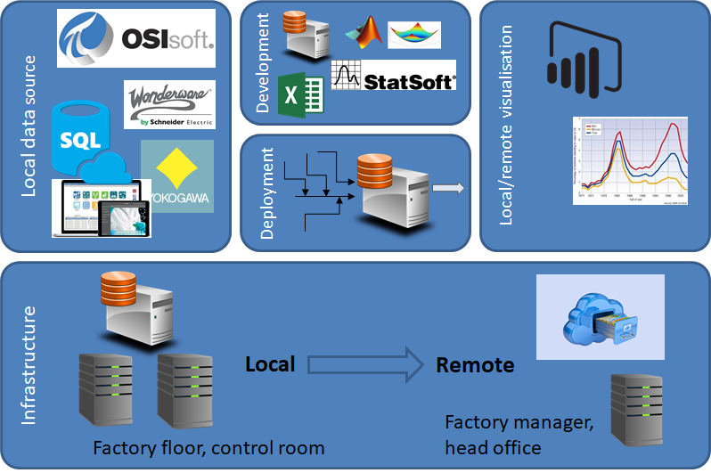

Step 1: Understanding Material Balance
Material balance is a fundamental concept in chemical engineering and process control that involves accounting for all materials entering and leaving a system. In the context of sugar processing, this includes raw materials such as sugar cane or sugar beet, water, chemicals used during processing, and the final product—sugar.

Step 2: Identifying Key Stages in Sugar Processing
The main stages of sugar processing include:
- Extraction: The initial stage where juice is extracted from sugar cane or beet.
- Purification: The removal of impurities from the extracted juice.
- Crystallization: The process where sugar crystals are formed from the purified syrup.
- Separation: The separation of sugar crystals from molasses.
Each stage requires precise measurement and monitoring to ensure an accurate material balance.

Step 3: Sources of Data

Empirical Studies
- Empirical studies conducted within South African sugar mills provide valuable data on material balances. These studies often involve direct measurements taken during various stages of processing to quantify inputs and outputs accurately.

Industry Reports
- Reports published by organizations such as the South African Sugar Association (SASA) contain aggregated data on production statistics, efficiency metrics, and operational benchmarks across different mills in South Africa. These reports are crucial for understanding industry-wide trends and performance.

Academic Research
- Research articles published in journals focusing on chemical engineering and food technology often explore specific aspects of material balance in sugar processing. For example, studies may investigate optimization techniques for improving yield or reducing waste during crystallization processes.

Software Tools
- Modern software tools like ProSimPlus® have been utilized to simulate processes within sugar factories. These tools can model material balances based on input parameters and operational conditions, providing insights into potential improvements in efficiency.

Step 4: Application of Data
- The collected data can be applied to:
- Optimize operational efficiency by identifying bottlenecks.
- Improve yield by adjusting process parameters based on real-time data.
- Ensure compliance with environmental regulations by minimizing waste generation.

KT0202 Calculations
Material balance is a fundamental principle used in the sugar processing industry to ensure that all inputs, outputs, and accumulations of materials are accounted for throughout the production process. In South Africa, where sugarcane is a primary raw material, effective material balance calculations are crucial for optimizing production efficiency and ensuring sustainability.

Step 1: Understanding the Components of Material Balance
- In sugar processing, the main components involved in material balance include:
- Inputs: These are the raw materials entering the system, primarily sugarcane.
- Outputs: These consist of products such as raw sugar, molasses, and bagasse (the fibrous residue after juice extraction).
- Accumulation: This refers to any change in quantity within the system over time.
- The basic equation for material balance can be expressed as:
- Input−Output+Accumulation=0
- This equation can be rearranged to solve for any unknown variable.

Step 2: Data Collection
- To perform accurate material balance calculations, data must be collected on various parameters:
- Sugarcane Input: The amount of sugarcane processed (in tons).
- Juice Extraction Rate: The percentage of sucrose extracted from the cane.
- By-products: Quantities of molasses and bagasse produced.
- Water Usage: Amount of water used during processing.
- For example, if a mill processes 100 tons of sugarcane with an extraction rate of 12% sucrose, we can calculate the amount of sucrose extracted as follows:
- Sucrose Extracted=Sugarcane Input×Extraction Rate=100tons×0.12=12tons

Step 3: Performing Material Balance Calculations
- Using hypothetical data for a sugar mill in South Africa:
- Input:
  - Sugarcane = 100 tons
  - Water = 50 tons (used for imbibition)
- Outputs:
  - Raw Sugar = 12 tons
  - Molasses = 5 tons
  - Bagasse = 30 tons (remaining fiber)
- Now we can apply these values into our material balance equation:
Inputs Calculation
- Total Inputs:Total Inputs=Sugarcane+Water=100+50=150tons
Outputs Calculation
- Total Outputs:Total Outputs=Raw Sugar+Molasses+Bagasse=12+5+30=47tons
Accumulation Calculation
- Assuming there is no accumulation over this period (steady-state operation), we set Accumulation to zero.
Final Material Balance Equation
- Substituting into the material balance equation gives us:150−47+0=?This results in:103tons (unaccounted)

Step 4: Analyzing Results and Adjustments
- The unaccounted mass indicates potential losses or inefficiencies within the system. Possible reasons could include:
- Evaporation losses during juice boiling.
- Incomplete extraction leading to residual sucrose in bagasse.
- Measurement inaccuracies.
- To improve efficiency, adjustments may involve optimizing imbibition rates or enhancing extraction techniques through better equipment maintenance or technology upgrades.

Conclusion
- Effective material balance calculations are essential for optimizing operations within South African sugar mills. By systematically analyzing inputs and outputs while considering accumulation factors, mills can identify inefficiencies and enhance overall productivity.
- In summary, maintaining accurate material balances allows sugar processors to maximize yield while minimizing waste and ensuring sustainable practices within the industry.

Internal Assessment Criteria and Weight
- IAC0201 Source of material to be balancedcan be explained
- IAC0202 Calculations are correctly performed
(Weight 25%)

KM-03-KT03: Stock Taking (10%)
Topic elements to be covered include:
- KT0301 Purpose
- KT0302 Data collection
- KT0303 Sampling

KT0301 Purpose
The purpose of stocktaking in sugar processing control in South Africa is to ensure accurate inventory management, enhance operational efficiency, support financial sustainability, and facilitate compliance with regulatory requirements.
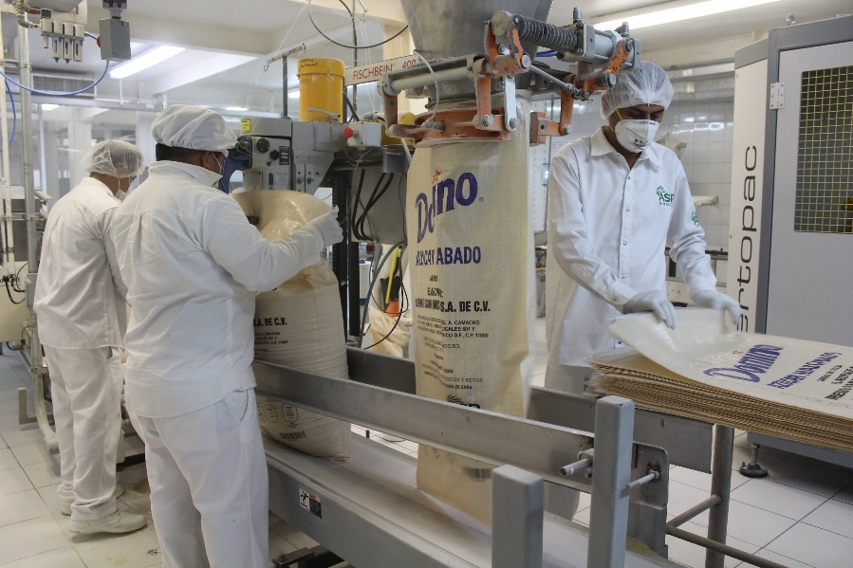

Step 1: Accurate Inventory Management
- One of the primary purposes of stocktaking is to maintain accurate records of the quantities and conditions of sugar stocks. This is crucial for several reasons:
- Preventing Stockouts: By knowing exactly how much sugar is available at any given time, processors can avoid stockouts that could disrupt production schedules.
- Reducing Overstocking: Accurate stock levels help prevent overordering, which can lead to excess inventory that may spoil or incur additional storage costs.

Step 2: Enhancing Operational Efficiency
- Stocktaking contributes significantly to operational efficiency within the sugar processing industry:
- Streamlining Production Processes: Regular stocktakes allow for better planning and scheduling of production runs based on actual inventory levels. This leads to smoother operations and reduced downtime.
- Identifying Discrepancies: Through regular checks, discrepancies between recorded and actual stock can be identified early. This helps address issues such as theft, damage, or misplacement before they escalate.

Step 3: Supporting Financial Sustainability
- Financial sustainability is critical for the survival of sugar processing businesses in South Africa:
- Cost Control: By maintaining accurate inventory records through stocktaking, companies can better manage their costs related to raw materials and finished goods. This is particularly important given the rising costs associated with sugar production.
- Profit Margin Analysis: Understanding the quantity and value of sugar stocks allows businesses to analyze profit margins effectively by comparing production costs against sales revenue.

Step 4: Facilitating Compliance with Regulatory Requirements
- The sugar industry in South Africa operates under various regulations that require accurate reporting and compliance:
- Regulatory Compliance: Stocktaking ensures that companies adhere to legal requirements regarding inventory management. Accurate records are essential for audits and inspections by regulatory bodies.
- Sustainability Reporting: As part of broader agricultural policies aimed at promoting sustainability, accurate stocktaking supports reporting on resource use and environmental impact.

KT0302 Data collection
Data collection in stock taking for sugar processing control in South Africa involves several systematic steps to ensure accuracy and efficiency. This process is crucial for managing inventory, optimizing production, and maintaining quality control within the sugar industry. Below are the key steps involved:

Define Objectives and Scope
- The first step in data collection is to clearly define the objectives of the stock-taking exercise. This includes understanding what specific data needs to be collected, such as quantities of raw materials (sugarcane), finished products (sugar), and by-products (molasses). The scope should also include which facilities or locations will be covered during the stock-taking process.

Develop a Data Collection Plan
- A comprehensive plan should be developed that outlines:
- Methodologies: Decide on methods for data collection, such as manual counting, automated systems, or a combination of both.
- Tools Required: Identify tools needed for data collection, including software applications for inventory management, barcode scanners, or RFID technology.
- Personnel Involved: Assign roles and responsibilities to staff members who will conduct the stock-taking.

Inventory Preparation
- Before actual data collection begins, it is essential to prepare the inventory:
- Labeling: Ensure all items are properly labeled with unique identifiers.
- Organization: Organize storage areas to facilitate easy access and counting of items.
- Training: Train personnel on how to use any tools or systems that will be employed during the stock-taking process.

Conduct Physical Count
- The physical count involves systematically counting all items in stock:
- Counting Procedures: Follow established procedures for counting each category of inventory. This may involve counting raw materials like sugarcane in fields or finished products stored in warehouses.
- Recording Data: Use standardized forms or digital systems to record counts accurately. Each entry should include item descriptions, quantities counted, and location details.

Data Verification
- After collecting initial data, verification is necessary to ensure accuracy:
- Cross-checking Counts: Compare recorded counts against previous inventory records or expected quantities based on production schedules.
- Recounts if Necessary: If discrepancies are found, recount those specific items to confirm accurate figures.

Data Analysis
- Once verified data is collected:
- Analysis Tools: Utilize software tools for analyzing inventory levels, turnover rates, and discrepancies.
- Reporting Findings: Generate reports that summarize findings from the stock-taking exercise, highlighting any issues such as overstocking or shortages.

Implement Adjustments
- Based on analysis results:
- Inventory Adjustments: Make necessary adjustments in inventory records to reflect accurate counts.
- Process Improvements: Identify areas where processes can be improved based on findings from the stock-taking exercise.

Continuous Monitoring
- Establish a system for ongoing monitoring of inventory levels:
- Regular Stock Takes: Schedule regular intervals for future stock takes (e.g., monthly or quarterly).
- Real-time Tracking Systems: Implement real-time tracking systems that provide continuous updates on inventory levels as they change due to production and sales activities.
- By following these steps systematically, sugar processing facilities in South Africa can effectively manage their inventories through accurate data collection during stock taking processes. This not only helps maintain operational efficiency but also supports compliance with industry regulations regarding food safety and quality control.

KT0303 Sampling
Sampling in stock taking within the sugar processing industry in South Africa is a critical component of quality control and inventory management. It involves systematic methods to ensure that the quantities and qualities of sugar produced meet regulatory standards and market demands. The process can be broken down into several key steps:

Understanding the Importance of Sampling
- Sampling is essential for accurately assessing the quality and quantity of sugar during various stages of production, from raw material intake to final product distribution. In South Africa, where sugar is a significant agricultural product, effective sampling helps maintain compliance with both local and international standards.

Defining Objectives
- The first step in effective sampling is to define clear objectives. This includes determining what aspects of the sugar (e.g., purity, moisture content, color) need to be measured and how these factors impact overall quality. For instance, the South African Bureau of Standards (SABS) sets specific guidelines for sugar quality that processors must adhere to.

Developing a Sampling Plan
- A well-structured sampling plan outlines how samples will be collected throughout the production process. This plan should include:
- Sample Size: Determining an appropriate sample size is crucial for statistical validity. Larger samples may provide more accurate representations but can also increase costs.
- Sampling Frequency: Regular intervals for sampling should be established based on production volume and variability.
- Locations: Identifying specific locations within the processing facility where samples will be taken ensures consistency.

Methods of Sampling
- There are various methods used for sampling in sugar processing:
- Random Sampling: Samples are taken at random intervals to avoid bias.
- Systematic Sampling: Samples are collected at regular intervals or predetermined points along the production line.
- Stratified Sampling: The population is divided into subgroups (strata), and samples are taken from each stratum to ensure representation across different batches or types of sugar.
- Each method has its advantages depending on the specific goals of the stock-taking exercise.

Sample Collection Techniques
- Proper techniques must be employed during sample collection to avoid contamination or degradation:
- Use Clean Equipment: All tools used for collecting samples should be sanitized before use.
- Avoid Contamination: Care should be taken not to introduce foreign substances during collection.
- Documenting Conditions: Recording environmental conditions (temperature, humidity) at the time of sampling can provide context for analysis later.

Analyzing Samples
- Once samples are collected, they must undergo rigorous testing:
- Laboratory Analysis: Samples are sent to accredited laboratories where they undergo tests for various parameters such as sucrose content, impurities, and microbial presence.
- Statistical Analysis: Results from multiple samples can be analyzed statistically to determine trends or issues within production processes.

Reporting Results
- After analysis, results should be compiled into reports that highlight findings related to quality control:
- Compliance Reports: These documents demonstrate adherence to SABS standards and other regulatory requirements.
- Internal Reports: Used by management for decision-making regarding production adjustments or improvements.

Continuous Improvement
- The final step involves using data gathered from sampling activities to inform continuous improvement initiatives within the processing plant:
- Feedback Loops: Establishing feedback mechanisms allows operators to adjust processes based on sample results.
- Training Programs: Staff training on proper sampling techniques can enhance accuracy over time.
- In conclusion, effective sampling in stock taking within South Africa’s sugar processing industry is vital for ensuring product quality and compliance with regulations. By following a structured approach that includes defining objectives, developing a comprehensive sampling plan, employing proper collection techniques, analyzing results rigorously, and fostering continuous improvement practices, sugar processors can maintain high standards in their operations.

Internal Assessment Criteria and Weight
- IAC0301 Knowledge of accurate stocking as a component of materials balance can be demonstrated
(Weight 10%)

KM-03-KT04: Calculations (25%)
Topic elements to be covered include:
- KT0401 Factory Performance Calculations
- KT0402 Products in Process
- KT0403 Calculations

KT0401 Factory Performance Calculations
In South Africa, the sugar processing industry plays a significant role in the economy, particularly in regions like KwaZulu-Natal and Mpumalanga. The performance of sugar factories is critical for ensuring efficiency, profitability, and sustainability. This involves various calculations and control measures that help optimize production processes.
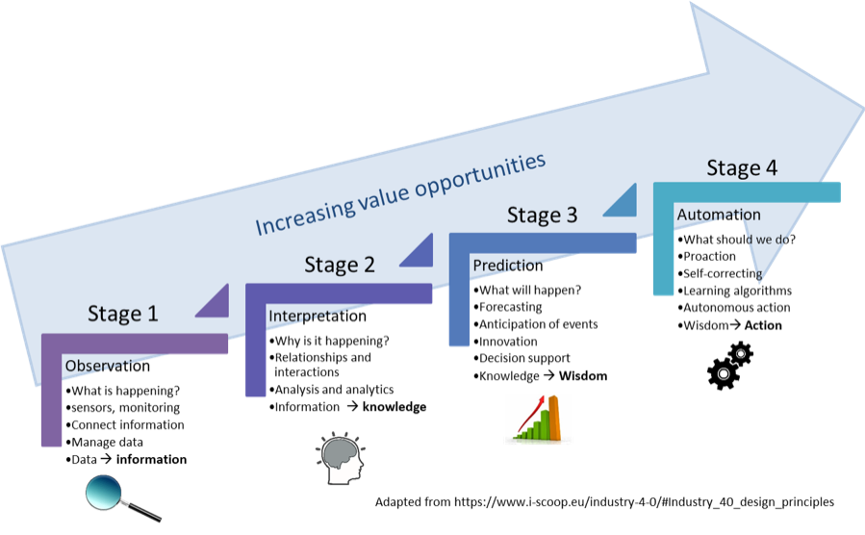

Key Performance Indicators (KPIs)
- To assess factory performance in sugar processing, several key performance indicators (KPIs) are utilized:
- Extraction Efficiency: This measures the percentage of sucrose extracted from the cane during processing. It is calculated as:Extraction Efficiency=(Sugar ProducedTotal Sugar Content in Cane)×100
- Purity Analysis: Purity refers to the ratio of sugar content to total dissolved solids (TDS). It is essential for determining the quality of sugar produced. The apparent purity can be calculated using:Apparent Purity=(PolBrix)×100where Pol is the sugar content measured in degrees Pol (°Z), and Brix is the measurement of dry substances.
- Throughput Rate: This indicates how much cane can be processed over a specific period, typically expressed in tons per hour (TPH). It can be calculated by measuring the total amount of cane processed divided by the time taken.
- Energy Consumption: Monitoring energy usage is crucial for cost management. Energy consumption per ton of sugar produced can be calculated as:Energy Consumption=Total Energy Used (kWh)Total Sugar Produced (tons)
- Water Usage: Water efficiency is important for sustainability. The water-to-sugar ratio can be assessed to ensure optimal use:Water Usage Ratio=Water Used (liters)Sugar Produced (kg)

Process Control Techniques
- To enhance factory performance, several process control techniques are implemented:
- Real-Time Monitoring Systems: Utilizing advanced measurement systems such as those provided by Anton Paar allows for efficient purity analysis and compliance with ICUMSA standards¹. These systems enable continuous monitoring of parameters like sugar content and dry substances, facilitating immediate adjustments to optimize production.
- Data Analytics: Employing data analytics tools helps identify trends and inefficiencies within the production process. By analyzing historical data on extraction rates, energy consumption, and other KPIs, factories can make informed decisions to improve operations.
- Automation: Automation technologies streamline workflows and reduce human error in measurements and calculations. Automated systems can manage tasks such as sample distribution and analysis, significantly increasing throughput rates while maintaining accuracy².
- Training Programs: Continuous training for staff on best practices in sugar processing technology ensures that operators are well-equipped to handle equipment efficiently and respond to any issues that arise during production.

KT0402 Products in Process
In the sugar processing industry, particularly in South Africa, the control of products in process is essential for optimizing production efficiency and ensuring product quality. This involves a series of calculations that help manage various aspects of sugar manufacturing, from raw material input to final product output. Below is a detailed step-by-step explanation of how these calculations are performed and their significance.

Step 1: Understanding Raw Materials
- The primary raw materials used in sugar processing are sugarcane and sugar beets. The first step involves calculating the total quantity of raw materials required for production. This includes:
- Quantity of Sugarcane/Sugar Beets: The amount needed is determined based on the expected yield and recovery rates.
- Cost Calculation: The cost per tonne of these raw materials must be calculated to understand the financial implications.
- For example, if a mill requires 1,000 tonnes of sugarcane at a price of R50 per tonne, the total cost would be R50,000.

Step 2: Processing Costs
- Once the raw materials are acquired, processing costs must be calculated. These include:
- Labor Costs: Wages paid to workers involved in the processing.
- Energy Costs: Electricity and fuel costs associated with running machinery.
- Maintenance Costs: Regular maintenance expenses for equipment used during processing.
- These costs need to be summed up to determine the total processing expenditure.

Step 3: Yield Calculations
- Yield calculations are critical for assessing how much sugar can be extracted from the processed raw materials. Key metrics include:
- Sugar Recovery Rate: This is calculated by dividing the weight of sugar obtained by the weight of raw material processed. For instance, if 100 tonnes of sugar is produced from 1,000 tonnes of cane, the recovery rate would be (100/1000) * 100 = 10%.
- Tonnes of Sugar per Hectare (TSH): This metric helps evaluate productivity. If a farm produces 80 tonnes of cane per hectare with a recovery rate of 10%, then TSH would be calculated as follows:
- ���=TCH×Recovery Rate=80×0.10=8tonnes

Step 4: Profit Margin Calculation
- To assess profitability within South African sugar processing operations, profit margins must be calculated:
- Cost Price: This includes all costs incurred (raw materials + processing).
- Selling Price: The market price at which sugar is sold.
- The profit margin can then be computed using:
- Profit Margin=(Selling Price−Cost PriceSelling Price)×100
- For example, if the selling price is R700 per tonne and cost price is R600 per tonne:
- Profit Margin=(700−600700)×100=14.29%

Step 5: Automation and Control Systems
- In modern South African sugar factories, automation plays a crucial role in managing these calculations effectively. Automation systems can monitor real-time data regarding:
- Production Rates: Ensuring that machinery operates at optimal levels.
- Quality Control: Monitoring parameters such as brix levels during juice extraction to maintain product quality.
- Automation systems allow for centralized control over various processes within the factory, leading to improved efficiency and reduced labor costs.

KT0403 Calculations
In sugar processing control in South Africa, several key calculations are essential for optimizing production efficiency, ensuring quality, and managing costs. These calculations include determining the cost of sugar production, calculating sugar yield metrics, and assessing profit margins. Each of these areas involves specific steps that can significantly impact the overall performance of sugar manufacturing operations.

1. Cost of Sugar Production
- Calculating the cost of sugar production is crucial for understanding profitability and making informed business decisions. The following steps outline how to calculate this cost:

Step 1: Raw Material Costs
- Identify the price per tonne of sugarcane or sugar beets.
- Multiply the price by the total amount of raw material needed for production.

Step 2: Processing Costs
- Include all expenses related to processing, such as:
  - Energy costs (electricity, steam)
  - Labor costs (wages for workers involved in processing)
  - Maintenance costs (repairs and upkeep of machinery)

Step 3: Transportation Costs
- Factor in the costs associated with transporting raw materials to the processing facility and distributing finished products to market.

Step 4: Overhead Expenses
- Include indirect costs such as administrative expenses, taxes, and any other overheads that contribute to overall production costs.

Step 5: Total Production Cost Calculation
- Add all these expenses together and divide by the total output of sugar produced to determine the cost per unit (e.g., per kilogram).
- For example, if producing 10,000 kilograms of sugar incurs a total cost of R50,000, then:Cost per kilogram=Total CostTotal Output=50,00010,000=R5per kg

2. Key Metrics for Calculating Sugar Yield
- Sugar yield is a critical metric that indicates how efficiently raw materials are converted into finished product. The following metrics are commonly used:

Sugar Recovery Rate
- This is calculated as:Sugar Recovery Rate=(Weight of Sugar ObtainedWeight of Raw Material Processed)×100
- Tonnes of Cane per Hectare (TCH)
- This measures productivity in terms of cane yield:TCH=Total Tonnes HarvestedHectares Cultivated
- Tonnes of Sugar per Hectare (TSH)
- This combines TCH with recovery rate:TSH=TCH×(Sugar Recovery Rate100)
- For instance, if a farmer harvests 80 tonnes of cane per hectare with a recovery rate of 10%, then:TSH=80×(10100)=8tonnes

3. Profit Margin Calculation
- Understanding profit margins is vital for evaluating financial performance in sugar trading:

Step 1: Determine Cost Price
- Calculate total acquisition costs including purchase price and transportation.

Step 2: Calculate Selling Price
- Assess revenue generated from selling sugar at market prices.

Step 3: Profit Margin Calculation
- Use the formula:Profit Margin (%)=(Selling Price−Cost PriceSelling Price)×100For example, if selling price is R700 per tonne and cost price is R600 per tonne:Profit Margin=(700−600700)×100=14.29%

Conclusion
- In summary, effective calculations in sugar processing control involve detailed assessments across various aspects such as production costs, yield metrics, and profit margins. By systematically applying these calculations—considering factors unique to South Africa’s agricultural context—producers can enhance operational efficiency and profitability within the competitive landscape of the sugar industry.

Internal Assessment Criteria and Weight
- IAC0401 Knowledge of formulas and accurate application can be demonstrated
(Weight 25%)

REFERENCE

