613101-000-00-KM-01
Crops and Livestock Management, NQF Level 5, Credits 10

LEARNER GUIDE

Module # | 613101-000-00-KM-01
NQF Level | 5
Credits | 10
Occupational Code | 613101-000-00-00
SAQA QUAL ID | 125077
Qualification Title | Higher Occupational Certificate: Mixed Crop and Livestock Farmer

Name
Contact Address
Telephone (H)
Telephone (W)
Facsimile
Cellular
E-mail

Note to the learner
This Learner Guide provides a comprehensive overview of the module. It is designed to improve the skills and knowledge of learners, and thus enabling them to effectively and efficiently complete specific tasks.

Purpose
The main focus of learning of this knowledge module is to ensure understanding of livestock and crop management. The learning contact time, which is the time that reflects the required duration of enrolment for this module, is at least 12 days.
Upon completion of the learning learners will be able to demonstrate understanding of the following knowledge topics
List of Knowledge Topics:
- KM-01-KT01 Crop Production management. 40
- KM-01-KT02 Livestock Production management. 40
- KM-01-KT03 Sustainable grazing practices. 20

Exemptions
None

Entry Requirements
NQF Level 4 Qualification with Agriculture Science/Applied Agriculture/Agricultural Technology or related.

Provider Accreditation Requirements for the Knowledge Module

Physical Requirements
- Classroom with chairs, tables, sufficient lighting and ventilation
- Whiteboards, data projector and screen Computer, internet access, applicable software. Ablutions facilities.
- Curriculum Aligned Learning Material
- Quality Management System
- Learner Management Information System

Human Resource Requirements:
- Facilitator must hold a minimum of NQF Level 6 qualification in Agriculture with 3 years working experience in Crop and Livestock production environment.

FACILITATOR/LEARNER RATIO 1:30

Legal Requirements
- CIPC registered entity
- Valid Tax Compliance pin
- Infrastructure compliant with OHS Act
- Display of Labour Laws within the premises
- Compliant to POPI Act
- Valid Lease Agreement / Title deed

Venue, Date and Time:
Consult your facilitator should there be any changes to the venue, date and/or time.
Refer to your timetable

Assessments

The only way to establish whether you are competent and have accomplished the learning outcomes is through continuous assessments. This assessment process involves interpreting evidence about your ability to perform certain tasks. You will be required to perform certain procedures and tasks during the training programmer and will be assessed on them to certify your competence.
This module includes assessments in the form of self-evaluations/activities and exercises. The exercises, activities and self-assessments will be done in pairs, groups or on your own. These exercises/activities or self-assessments (Learner workbook) must be handed to the facilitator. It will be added to your portfolio of evidence, which will be proof signed by your facilitator that you have successfully performed these tasks.

Listen carefully to the instructions of the facilitator and do the given activities in the time given to you.

KM-01-KT01 Crop production management. 40 %
Topic elements to be covered include:
- KT0101 Crop selection and production planning
- KT0102 Soil testing
- KT0103 Soil preparation
- KT0104 Fertilizer application
- KT0105 Crop water management / Irrigation
- KT0106 Crop planting
- KT0107 Crop pests and diseases management
- KT0108 Crop harvesting
- KT0109 Crop rotation

KM-01-KT01 Crop Production Management
Crop production management refers to the planning, organising, implementing, and controlling of all activities required to produce crops efficiently, profitably, and sustainably. For a mixed crop and livestock farmer, crop production management is not limited to planting and harvesting only. It includes selecting suitable crops, preparing the land, managing soil fertility, planting at the correct time, controlling weeds, pests and diseases, monitoring crop growth, harvesting correctly, and handling produce after harvest. In South Africa, crop production management must also take into account local climate conditions, rainfall patterns, soil potential, water availability, labour, input costs, and market demand. Good crop production management ensures that the farmer produces crops of the right quality and quantity while also protecting the natural resources on which future production depends.
A key part of crop production management is planning. Before production starts, the farmer must decide what crop to plant, where to plant it, how much land to use, and what resources are needed. This decision depends on soil type, rainfall, irrigation access, temperature, expected market prices, and the role of the crop in the whole farming system. For example, maize may be planted for grain and livestock feed, while lucerne may be planted mainly for fodder. Crop rotation planning is also important because planting the same crop repeatedly on the same land can reduce soil fertility and increase pest and disease pressure. The farmer must therefore create a production plan that fits the farm calendar and allows efficient use of land, water, machinery, labour, and finances.
Soil preparation and soil fertility management are central to successful crop production. The farmer must understand the condition of the soil before planting. This involves observing soil texture, structure, drainage, compaction, and moisture-holding capacity, and it is best supported by soil testing. Soil tests help determine pH and nutrient levels so that lime and fertilisers can be applied correctly. If the soil is too acidic, crop growth may be poor even when fertiliser is added. Proper land preparation may include ploughing, disking, ripping, harrowing, or conservation tillage methods, depending on the production system. The main aim is to create a suitable seedbed, improve root penetration, control early weeds, and conserve moisture. Good soil fertility management also includes the use of manure, compost, crop residues, and fertilisers to maintain long-term productivity.
Seed and planting management are also important in crop production management. The farmer must choose seed varieties that are suitable for the local environment and production purpose. In South Africa, farmers often choose varieties that are drought tolerant, disease resistant, or early maturing, especially in areas where rainfall is uncertain. Certified seed is usually preferred because it offers better germination, purity, and yield potential. Planting must be done at the correct time to match the rainfall season or irrigation schedule. Incorrect planting time can expose the crop to drought, frost, pests, or poor germination. The farmer must also ensure correct planting depth, spacing, and plant population because overcrowding or underpopulation can reduce yields. Planting methods may be manual or mechanical, but in either case precision and uniformity are essential.
Water management is another major component of crop production management. In South Africa, water is a scarce and valuable resource, so it must be used carefully and efficiently. In dryland farming, the farmer depends on rainfall and must use soil and water conservation practices to retain as much moisture as possible. These practices may include mulching, minimum tillage, contour farming, and maintaining soil organic matter. In irrigated systems, the farmer must schedule irrigation according to crop needs, soil type, weather conditions, and growth stage. Too little water causes moisture stress and poor yields, while too much water can cause root diseases, nutrient leaching, and wastage. Effective water management is therefore essential for both productivity and sustainability.
Weed, pest, and disease control form an important part of protecting crop yield and quality. Weeds compete with crops for sunlight, nutrients, water, and space, especially in the early growth stages. If weeds are not controlled on time, they can reduce production significantly. Weed control may involve manual weeding, mechanical cultivation, mulching, crop rotation, or herbicides. Pest and disease management requires regular scouting and early identification of problems. Farmers must inspect crops for signs of insect damage, fungal infection, nutrient deficiency, or viral symptoms. Integrated pest management is the best approach because it combines prevention, monitoring, cultural methods, biological control, and chemical treatments only when necessary. This reduces costs, protects beneficial organisms, and lowers the risk of resistance and environmental harm.
Nutrient management is closely linked to crop growth and yield. Crops require macronutrients such as nitrogen, phosphorus, and potassium, as well as secondary nutrients and trace elements. The farmer must apply the right type and amount of fertiliser at the correct time and in the correct method. For example, basal fertiliser may be applied at planting, while top dressing may be applied during active crop growth. Excessive fertiliser use wastes money and may damage crops or pollute water sources, while too little fertiliser results in poor growth and low yields. In a mixed farming system, manure from livestock can be used to enrich the soil and reduce the need for purchased fertiliser. This shows the importance of integrating crop and livestock enterprises in a sustainable way.
Crop monitoring and field supervision are necessary throughout the production cycle. The farmer must regularly inspect fields to check emergence, plant stand, growth rate, colour, flowering, weed pressure, pest damage, and soil moisture. This allows problems to be detected early and corrected before serious losses occur. Field records should be kept for planting dates, fertiliser applications, rainfall, chemical use, irrigation, labour activities, and crop performance. These records are useful for evaluating results at the end of the season and improving future decisions. Effective supervision also includes ensuring that workers carry out tasks properly, safely, and on time.
Harvesting management is the stage where the farmer secures the results of the season’s work. Crops must be harvested at the correct stage of maturity to achieve the best quality and reduce losses. If crops are harvested too early, yield and quality may be poor; if too late, there may be losses due to shattering, rotting, lodging, or bird damage. The harvesting method used must suit the crop and available equipment. After harvest, proper handling, drying, grading, storage, and transport are essential. Poor post-harvest management can lead to spoilage, contamination, pest infestation, and reduced market value. For a mixed farmer, some harvested crops may be sold, while others may be stored for animal feed or seed for the next season.
Crop production management also includes economic and business considerations. The farmer must budget for seed, fertiliser, chemicals, fuel, labour, irrigation, and machinery costs. Decisions must be based not only on what can be produced, but also on whether the production will be profitable. The farmer should compare expected income with production costs and market risks. Market-oriented production planning helps ensure that crops are produced in the right quantities, at the right time, and to the required quality standards. Good management also requires compliance with health, safety, and environmental requirements, especially when handling chemicals, operating machinery, and protecting soil and water resources.
Crop production management is the complete process of managing all factors involved in successful crop production. It includes planning, soil preparation, fertility management, seed selection, planting, water management, weed and pest control, crop monitoring, harvesting, storage, and financial control. For a mixed crop and livestock farmer in South Africa, good crop production management supports both crop sales and livestock feeding, improves farm productivity, protects natural resources, and strengthens the long-term sustainability of the farming enterprise.

KT0101 Crop Selection and Production Planning
Crop selection and production planning is the process of deciding which crops to grow, why they should be grown, where they should be planted, and how they will be managed from planting to harvest. For a mixed crop and livestock farmer in South Africa, this is one of the most important management functions because it influences food production, livestock feed availability, farm income, labour use, input costs, and the long-term productivity of the land. Good crop selection and planning help the farmer use available resources wisely and reduce the risks associated with climate variability, pests, diseases, and changing market conditions. It is not enough to choose a crop simply because it is popular or because it has been grown before. The farmer must make informed decisions based on the natural environment, available resources, production purpose, and expected returns.
The first factor in crop selection is the suitability of the crop to the local natural conditions. South Africa has a wide range of climatic regions, from summer rainfall areas to winter rainfall areas, and from dry semi-arid zones to more humid regions. A farmer must therefore choose crops that can perform well under the specific rainfall pattern, temperature range, altitude, and soil conditions of the farm. For example, maize is commonly grown in summer rainfall regions, while wheat is often grown in winter rainfall areas or under irrigation. Sorghum and millet may be more suitable in drier areas because they are more tolerant of low rainfall. Vegetables, fodder crops, legumes, and pasture species must also be matched to the climate and the season. If a crop is selected without considering environmental suitability, the farmer may experience low yields, poor quality, and financial losses.
Soil characteristics are another major consideration in crop selection. Different crops perform better in different soil types, depths, drainage conditions, and fertility levels. Some crops require deep, well-drained soils, while others can tolerate lighter or less fertile soils. Before deciding what to plant, the farmer should assess the soil through observation and soil analysis. Soil tests help determine pH, nutrient status, and any limitations such as salinity or acidity. This information guides the selection of crops as well as fertilisation and soil amendment needs. For example, legumes may be a good choice where the farmer wants to improve soil nitrogen levels, while root crops may need loose, well-prepared soils for good development. Matching crops to soil potential is essential for efficient and sustainable production.
Production purpose also plays a central role in crop selection. In a mixed farming system, crops may be grown for different reasons. Some crops are planted for direct sale as cash crops, others for household food security, and others mainly for livestock feed. A farmer may grow maize both for grain sales and for feeding cattle or poultry. Lucerne, oats, or forage sorghum may be selected to provide hay, silage, or grazing. Legume crops such as beans or cowpeas may be chosen because they provide food, income, and soil fertility benefits. The production plan must therefore reflect the overall goals of the farm. A farmer who needs winter feed for livestock may plan to plant fodder crops in addition to commercial grain crops. This makes crop selection more strategic because it supports both the crop and livestock enterprises.
Market demand and profitability must also be considered when selecting crops. A crop may grow well in an area, but if there is little market demand or the price is too low, it may not be profitable. The farmer must understand who will buy the crop, what quality is required, when the market needs the produce, and what price is likely to be received. Transport distance, storage requirements, processing opportunities, and competition from other producers also influence the decision. Production planning should include a budget that estimates the costs of seed, fertiliser, chemicals, labour, water, fuel, and harvesting against the expected income. This helps the farmer compare different crop options and choose those that are economically viable. Good production planning reduces the risk of planting crops that cannot be sold easily or that cost too much to produce.
Availability of resources is another important aspect of crop selection and production planning. The farmer must consider how much land is available, how much labour is on hand, what machinery and equipment can be used, whether irrigation water is available, and whether enough capital exists to buy inputs. Some crops are labour intensive and require frequent weeding, irrigation, pruning, or harvesting, while others are more mechanised and require less manual labour. Some crops require expensive inputs or specialised knowledge. A production plan must therefore match the selected crops to the actual capacity of the farm. It is poor planning to select crops that the farm cannot support properly. Realistic planning ensures that the farmer can carry out all production activities on time and to the required standard.
Crop rotation and diversification are also important principles in crop selection and planning. Growing the same crop on the same land season after season can lead to declining soil fertility, increased pest and disease build-up, and reduced yields. Crop rotation helps break pest and disease cycles, improves soil structure, and makes better use of nutrients. For example, rotating cereals with legumes can help improve soil nitrogen levels and reduce dependence on fertilisers. Diversification also spreads risk. If one crop fails due to drought, pest damage, or market problems, the farmer may still earn income or secure feed from other crops. In South Africa, where weather conditions can be unpredictable, diversification is an important strategy for resilience. A mixed farmer may therefore plant a combination of grain crops, legumes, vegetables, and fodder crops to balance risk and improve overall farm performance.
Production planning involves developing a clear schedule of operations for the selected crops. Once the farmer has decided what to plant, the next step is to plan how and when each activity will be carried out. This includes land preparation, soil testing, fertiliser application, seed procurement, planting dates, irrigation scheduling, weed control, pest and disease monitoring, harvesting, and storage. Each activity must be timed according to the crop’s growth requirements and the local season. Delays in planting, weeding, irrigation, or harvesting can reduce yield and quality. A good production plan also allocates labour, machinery, and finances to each stage so that resources are available when needed. This planning helps the farmer avoid confusion, reduce waste, and improve coordination across the farming enterprise.
Risk management must be included in crop selection and production planning. Farming in South Africa is exposed to risks such as drought, floods, frost, hail, pests, diseases, and market instability. The farmer should therefore choose crops and varieties that reduce vulnerability to these risks. Drought-tolerant, disease-resistant, or early-maturing varieties may be more suitable in uncertain environments. The farmer may also stagger planting dates, plant more than one crop type, conserve water, and keep reserve feed to reduce the effect of seasonal shocks. Production planning should not only focus on ideal conditions but also prepare for difficult conditions. This forward planning improves the resilience and sustainability of the farm.
Record-keeping is an essential support to crop selection and production planning. The farmer should keep records of previous crops planted, yields obtained, rainfall received, inputs used, pest and disease problems, labour used, and profits made. These records provide valuable information for deciding which crops performed well and which did not. They also help identify trends and improve future planning. A farmer who keeps accurate records is better able to budget, monitor performance, and make evidence-based decisions rather than relying only on memory or tradition.
Crop selection and production planning are the foundation of successful crop production management. They involve choosing the right crops for the local climate, soil, farm objectives, market opportunities, and available resources, and then planning all production activities carefully from beginning to end. For a mixed crop and livestock farmer in South Africa, good crop selection and planning support food production, livestock feeding, soil health, profitability, and risk reduction. When done properly, they help the farmer use land and resources efficiently, respond to environmental and market challenges, and build a productive and sustainable farming system.

KT0102 Soil Testing
Soil testing is the scientific process of analysing soil to determine its physical and chemical condition so that informed decisions can be made about crop production. For a mixed crop and livestock farmer in South Africa, soil testing is an essential management practice because soil is the foundation of all crop growth and it also affects the quality of grazing and fodder production for livestock. A farmer cannot manage soil effectively by guesswork alone. Even when soil looks fertile on the surface, it may still be lacking important nutrients, may be too acidic or too alkaline, or may have other limitations that reduce crop performance. Soil testing therefore provides reliable information that helps the farmer choose suitable crops, apply the correct fertiliser and lime, and improve long-term productivity in a cost-effective and sustainable way.
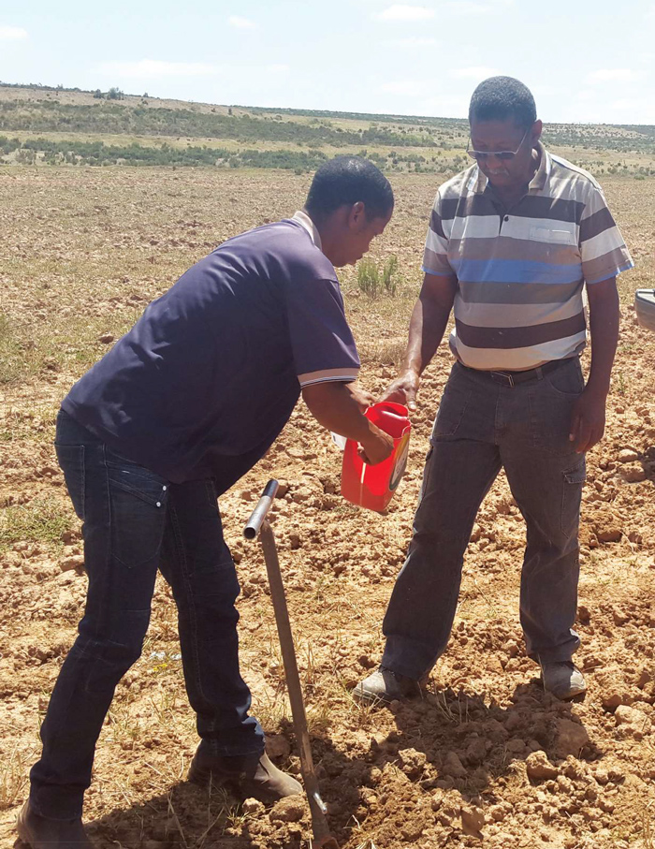
The main purpose of soil testing is to determine the nutrient status and chemical balance of the soil. Crops require nutrients such as nitrogen, phosphorus, potassium, calcium, magnesium, and sulphur, as well as smaller quantities of micronutrients like zinc, boron, copper, manganese, and iron. If one or more of these nutrients are deficient, crop growth may be poor even when the field is well prepared and rainfall is adequate. Soil testing also measures soil pH, which is very important because soil acidity or alkalinity affects the availability of nutrients to plants. In many parts of South Africa, soil acidity is a common problem, especially in high rainfall areas. When soil is too acidic, certain nutrients become less available, while toxic elements such as aluminium may become more available and damage plant roots. By testing the soil, the farmer can determine whether lime is needed to correct the pH and improve crop performance.
Soil testing is important because it supports better planning and decision-making before planting. A farmer who tests the soil can match crop choice to soil potential and can apply the right fertiliser at the right rate. Without a soil test, the farmer may apply too much fertiliser, which wastes money and may harm the environment, or too little fertiliser, which results in poor yields. Soil testing also helps prevent imbalances where one nutrient is applied in excess while another limiting nutrient is ignored. For a mixed farmer, this is particularly useful because manure from livestock may be applied to fields. Although manure improves soil fertility, it does not always provide nutrients in balanced amounts. Soil testing helps the farmer understand what nutrients the manure is contributing and what additional amendments may still be needed.
The soil testing process begins with proper soil sampling, because the accuracy of the results depends on the quality of the sample sent to the laboratory. A soil sample must represent the actual condition of the field or camp being tested. The farmer should divide the land into sampling units according to differences in soil type, slope, previous crop history, fertiliser use, or production potential. Each area that is clearly different should be sampled separately. Using a soil auger, spade, or probe, the farmer collects small soil portions from several spots within the same area and combines them into one composite sample. This method gives a more representative sample than taking soil from only one point. The sampling depth is important and usually depends on the crop and the purpose of the test. For most field crops, topsoil samples are taken from the root zone where nutrient uptake begins. The sample must be placed in a clean container and labelled correctly before being sent to a recognised soil testing laboratory.
Good sampling practice requires care and consistency. The farmer should avoid taking samples from unusual spots such as near gates, kraals, compost heaps, water troughs, eroded patches, or fertiliser bands, unless those areas are specifically being investigated. These spots may not represent the general condition of the field and can lead to misleading results. Soil should preferably be sampled before planting and before fertiliser application, because recent fertiliser placement can affect the reading. It is also useful to sample at the same time of year when comparing results over different seasons. In this way, the farmer can monitor changes in soil fertility over time and evaluate whether soil management practices are improving or degrading the land.
Once the soil sample reaches the laboratory, it is analysed for selected properties depending on the type of crops to be grown and the information needed. Common soil test results include pH, phosphorus level, potassium level, calcium, magnesium, sodium, organic matter, and sometimes micronutrients. The laboratory usually provides the results together with interpretation or recommendations. However, the farmer must understand that these results do not stand alone. They must be read in relation to the soil type, crop requirements, expected yield, and local farming conditions. A certain nutrient level may be sufficient for one crop but too low for another. This is why soil test interpretation should ideally be supported by agricultural advisors, extension officers, or crop production specialists.
One of the most important outcomes of soil testing is fertiliser recommendation. Based on the results, the farmer can decide what type of fertiliser to use, how much to apply, and when to apply it. If phosphorus is low, the farmer may apply a fertiliser rich in phosphorus at planting. If nitrogen is needed, it may be applied in split applications according to crop growth stage. If potassium is deficient, the fertiliser plan can be adjusted accordingly. This targeted approach improves fertiliser efficiency and reduces unnecessary expenditure. It also supports environmental protection by reducing the risk of nutrient leaching, runoff, and pollution of water resources. In a country like South Africa, where farming inputs are costly, using fertiliser according to actual soil need is a very important management principle.
Soil testing also plays an important role in lime application and soil acidity correction. When pH is too low, the soil may need agricultural lime to neutralise acidity and create better conditions for root development and nutrient uptake. The soil test helps determine whether lime is needed and at what rate it should be applied. Applying lime without testing may lead to under-application, where acidity remains a problem, or over-application, which may create other nutrient imbalances. In mixed farming systems, where the farmer may rely on both natural grazing and cultivated fodder, maintaining the correct soil pH helps improve pasture productivity as well as crop yields.
Another value of soil testing is that it supports sustainable land management. A farmer who tests the soil regularly can identify problems early before they become severe. For example, declining fertility, salinity build-up, or nutrient mining can be detected and addressed in time. Soil testing also helps the farmer evaluate the effect of farming practices such as crop rotation, manure application, conservation agriculture, and residue management. Over time, the results show whether the soil is improving, remaining stable, or becoming less productive. This long-term view is very important in sustainable farming because healthy soil is one of the farm’s most valuable resources.
For a mixed crop and livestock farmer, soil testing has added importance because crop fields, planted pastures, and grazing areas all depend on soil fertility. Better soil produces stronger crops and better-quality fodder, which in turn supports livestock nutrition and productivity. At the same time, livestock manure can be recycled into the soil, but soil testing is needed to manage this properly and avoid overloading the soil with certain nutrients. This shows how soil testing supports the integration of crop and livestock enterprises on the farm.
Soil testing is a vital practice in crop production management because it provides scientific information about soil fertility, nutrient levels, and pH. It enables the farmer to make accurate decisions about crop choice, fertiliser use, lime application, and long-term soil improvement. For a mixed crop and livestock farmer in South Africa, soil testing improves productivity, reduces input waste, supports sustainable farming, and strengthens the overall efficiency of the farming system. It is therefore not just a technical activity, but a key management tool for profitable and responsible agriculture.

KT0103 Soil Preparation
Soil preparation is the process of getting the land into a suitable condition for planting crops and supporting healthy crop growth. For a mixed crop and livestock farmer in South Africa, soil preparation is a very important part of crop production management because it affects seed germination, root development, water infiltration, weed control, and the overall productivity of the land. Proper soil preparation creates a good seedbed, improves contact between seed and soil, allows roots to grow deeply, and helps the crop use water and nutrients effectively. It also contributes to better crop establishment, which is one of the first requirements for achieving good yields. If soil is poorly prepared, even high-quality seed and fertiliser may not produce good results because the crop will struggle from the beginning.
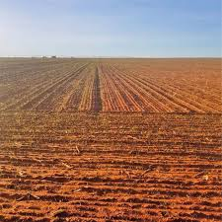
The main aim of soil preparation is to create a soil environment that is favourable for planting and early plant growth. This means the soil should be loose enough for roots to penetrate, fine enough for good seed placement, and firm enough to maintain moisture around the seed. Soil preparation also helps remove or reduce weeds, break up hard layers, incorporate crop residues or organic matter, and improve aeration and drainage where necessary. In mixed farming systems, soil preparation may also include incorporating livestock manure into the soil to improve fertility and soil structure. Because South African farming conditions vary widely, the method of soil preparation must be suited to the local rainfall pattern, soil type, slope, and cropping system.
Before soil preparation begins, the farmer must assess the condition of the land. This includes checking the previous crop residues, weed growth, soil moisture, compaction, erosion risk, and the general physical condition of the soil. A farmer should not prepare the soil blindly or use the same method every season without evaluating the field. For example, if the soil has become compacted due to machinery traffic or livestock trampling, deeper tillage such as ripping may be necessary to break the hard layer and improve root penetration. If the land is on a slope, the farmer must prepare it in a way that reduces runoff and soil erosion. Soil preparation should therefore be based on observation, experience, and where possible, soil testing and land capability assessment.
Primary tillage is usually the first stage of soil preparation. This is the initial breaking or loosening of the soil and may involve ploughing or ripping. Ploughing turns over the soil and buries weeds, residues, and some pests, while ripping breaks up compacted layers without fully turning the soil over. The purpose of primary tillage is to loosen the soil deeply enough for root growth, improve water infiltration, and prepare the land for further operations. However, the farmer must choose the method carefully. Excessive ploughing can destroy soil structure, reduce organic matter, and increase the risk of erosion, especially in dry and windy conditions. In some South African farming systems, minimum tillage or conservation tillage is preferred because it protects the soil surface and conserves moisture.
Secondary tillage follows primary tillage and is used to refine the soil into a suitable seedbed. This may include harrowing, disking, levelling, or rolling, depending on the crop and planting method. Secondary tillage breaks large clods into smaller particles, smooths the surface, and helps prepare the correct planting depth and spacing conditions. The goal is not to make the soil powdery, but to create a well-structured seedbed that supports uniform germination. If the soil is worked too much, it may become too fine and prone to crusting, which can reduce seedling emergence after rain. The farmer must therefore strike a balance between adequate preparation and protecting the soil’s natural structure.
Weed control is one of the important benefits of soil preparation. Before planting, weeds already growing in the field compete for moisture and nutrients, and they can interfere with crop establishment. By ploughing, cultivating, or using other suitable methods, the farmer reduces the weed burden before the crop is planted. This gives the crop a stronger start and lowers the pressure on later weed control measures. However, the farmer must remember that tillage alone does not eliminate all weed problems. It must be combined with good timing, crop rotation, mulching, and where appropriate, herbicide use. Proper soil preparation should therefore form part of a wider weed management strategy.
Soil moisture management is closely linked to soil preparation, especially in South Africa where rainfall is often limited and unevenly distributed. The farmer must prepare the soil in a way that conserves as much water as possible. Preparing very dry soil can create large clods and poor seedbeds, while preparing soil that is too wet can damage structure and lead to compaction. The ideal time for soil preparation is when the soil has enough moisture to be worked effectively without smearing or hardening. In dryland farming, tillage methods that leave some residue on the surface can help reduce evaporation and improve moisture retention. In conservation agriculture, the farmer may disturb the soil as little as possible in order to protect moisture, maintain soil cover, and support long-term soil health.
In mixed crop and livestock farming, organic matter management is another important aspect of soil preparation. Crop residues, compost, and animal manure can be incorporated into the soil to improve fertility, increase microbial activity, and strengthen soil structure. Organic matter improves the soil’s ability to hold water and nutrients and makes it easier for roots to grow. However, manure and residues must be handled properly. Fresh manure should be applied in appropriate amounts and incorporated at the right time to avoid nutrient losses or crop damage. The farmer must also decide whether some crop residues should remain on the surface for mulching and erosion control, or whether they should be incorporated into the soil. This decision depends on the production system, livestock feed needs, and conservation goals.
Soil preparation must also consider erosion control and sustainable land use. Poor preparation methods can leave soil bare and exposed to wind and water erosion. This is a serious risk in many South African farming areas, especially on sloping land or in regions with intense rainfall or strong winds. To reduce erosion, the farmer may use contour ploughing, strip cropping, minimum tillage, cover crops, and residue retention. Preparing the soil across the slope rather than down the slope helps slow water movement and reduce soil loss. Sustainable soil preparation protects the productive topsoil and ensures that the land remains useful for future farming seasons.
The choice of equipment for soil preparation depends on the scale of farming, available resources, and the type of crop being grown. Small-scale farmers may use hand tools, animal-drawn implements, or simple mechanical tools, while larger commercial farmers may use tractors with ploughs, rippers, harrows, or planters. Whatever the scale, the equipment must be used correctly and safely. Poorly adjusted implements can prepare the soil unevenly, waste fuel, or create compaction. Machinery must be maintained properly to ensure effective performance and to reduce breakdowns during critical planting periods. Labour involved in soil preparation must also be supervised so that the work is completed accurately and on time.
Timing is a critical factor in soil preparation. If preparation is done too early, weeds may return before planting, or moisture may be lost before seed is planted. If preparation is done too late, the farmer may miss the optimum planting window, reducing the chance of a good harvest. The timing of each operation must therefore fit the seasonal calendar, rainfall expectations, and the specific crop requirements. In mixed farming systems, the farmer may also need to coordinate soil preparation with livestock activities, such as grazing management or manure collection, to avoid delays and make best use of farm resources.
Soil preparation is a key activity in crop production management because it creates the physical conditions needed for good crop establishment and growth. It involves assessing the field, loosening the soil, preparing a proper seedbed, managing weeds, conserving moisture, incorporating organic matter, and preventing erosion. For a mixed crop and livestock farmer in South Africa, proper soil preparation improves crop performance, supports better use of water and nutrients, and contributes to the long-term health and sustainability of the farming system. It is therefore not just a mechanical operation, but a carefully planned management practice that directly influences the success of crop production.

KT0104 Fertilizer Application
Fertilizer application is the planned and correct addition of plant nutrients to the soil or directly to the crop in order to support healthy growth, good yields, and quality production. For a mixed crop and livestock farmer in South Africa, fertilizer application is a critical part of crop production management because crops remove nutrients from the soil during growth, and these nutrients must be replaced to maintain soil fertility and productivity. Fertilizers help provide essential nutrients such as nitrogen, phosphorus, and potassium, as well as secondary nutrients and trace elements where needed. However, fertilizer application is not simply a matter of spreading nutrients on the land. It requires careful planning, correct timing, proper methods, and knowledge of crop needs, soil condition, and environmental factors.
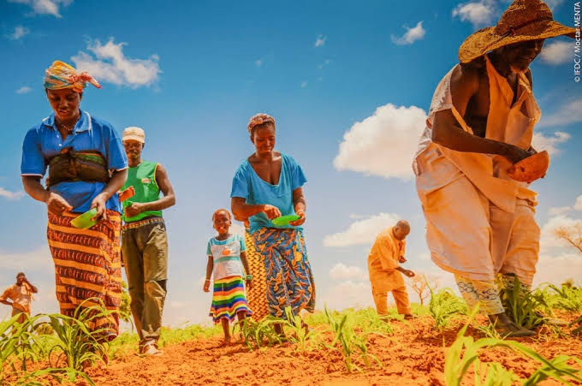
The purpose of fertilizer application is to ensure that crops receive the nutrients required for each stage of growth. Crops need nutrients for germination, root development, leaf formation, flowering, grain filling, and overall plant health. When nutrients are lacking, crops may show poor growth, yellowing leaves, weak root systems, low yields, and poor resistance to drought, pests, and disease. In South Africa, many soils are naturally low in certain nutrients or become depleted after continuous cultivation, especially where crops are removed year after year without adequate nutrient replacement. Fertilizer application therefore helps correct nutrient deficiencies and restore the productive capacity of the soil. In a mixed farming system, fertilizer use may be combined with organic sources such as animal manure and compost, which support long-term soil health and improve nutrient availability.
Before fertilizer is applied, the farmer should know the nutrient status of the soil and the nutrient requirements of the crop. This is why soil testing is very important. A soil test shows whether the soil is deficient in nitrogen, phosphorus, potassium, lime, or other nutrients, and it helps determine the correct type and quantity of fertilizer to apply. Without soil testing, fertilizer may be applied incorrectly. Too little fertilizer can result in poor crop performance, while too much fertilizer wastes money, damages crops, and may pollute water sources through leaching or runoff. A mixed crop and livestock farmer must therefore base fertilizer application on actual soil needs, expected yield targets, and the type of crop being planted. This approach improves efficiency and reduces unnecessary costs.
The type of fertilizer used depends on the nutrients that the crop needs and the form in which those nutrients must be supplied. Fertilizers may be organic or inorganic. Organic fertilizers include manure, compost, and plant residues, while inorganic fertilizers are manufactured products such as LAN, urea, superphosphate, and NPK mixtures. Each fertilizer has a specific nutrient composition. Nitrogen fertilizers mainly promote leaf and vegetative growth, phosphorus encourages strong roots and early development, and potassium supports general plant health, water regulation, and disease resistance. Some crops may also need micronutrients such as zinc or boron. The farmer must understand the role of each nutrient so that the correct fertilizer is selected for the crop and stage of growth.
Timing is one of the most important principles of fertilizer application. Nutrients must be supplied when the crop can use them most effectively. Basal fertilizer is usually applied before or at planting to support early root growth and establishment. This often includes phosphorus and part of the nitrogen requirement. Top dressing is applied later during active crop growth, especially when nitrogen is needed for leaf development and yield formation. If fertilizer is applied too early, nutrients may be lost before the crop can use them. If it is applied too late, the crop may already have suffered nutrient stress that reduces final yield. In South African farming conditions, timing must also take rainfall and soil moisture into account because moisture affects nutrient movement and uptake. Fertilizer should not be applied when heavy rain is expected if there is a high risk of runoff or leaching.
There are different methods of fertilizer application, and the choice depends on the crop, the fertilizer type, and the farming system. Broadcasting involves spreading fertilizer over the soil surface, either by hand or with equipment, and is commonly used before planting or on established pastures. Band placement places fertilizer in rows or bands close to the seed or root zone, which improves nutrient availability and reduces waste. Side dressing involves applying fertilizer next to the growing crop during the season, while foliar feeding involves spraying nutrients onto the leaves. Each method has its advantages and limitations. For example, phosphorus is often more effective when placed near the root zone because it does not move easily in the soil. Nitrogen top dressing may be broadcast or side dressed, depending on the crop and equipment available. The farmer must apply fertilizer carefully to avoid burning the seed or roots and to ensure even distribution.
In mixed crop and livestock farming, organic manure is an important source of nutrients and can play a major role in fertilizer application. Manure from cattle, sheep, goats, pigs, or poultry adds nutrients and organic matter to the soil. It improves soil structure, water-holding capacity, and microbial activity, and it can reduce dependence on expensive commercial fertilizers. However, manure must be applied properly. Its nutrient content varies depending on the animal source, storage method, and decomposition stage. Fresh manure may lose nutrients quickly or damage crops if used incorrectly. It should therefore be handled carefully, composted where possible, and applied at suitable rates. Soil testing helps the farmer understand how much manure contributes to soil fertility and whether additional fertilizer is still needed.
Correct fertilizer application also requires attention to equipment and labour. When using spreaders, planters, or sprayers, the equipment must be calibrated properly so that the correct rate is applied per hectare. Uneven application can lead to patches of over-fertilized and under-fertilized crop, which reduces uniformity and yield. Where fertilizer is applied by hand, workers must be trained to measure and distribute it consistently and safely. Fertilizer bags should be stored in a dry, secure place to prevent moisture damage and nutrient loss. Safety is also important because some fertilizers can irritate the skin, eyes, or respiratory system. Workers should follow safe handling procedures and use protective clothing where necessary.
Environmental responsibility is a very important part of fertilizer application. Fertilizer should be applied in a way that supports production without harming soil, water, or surrounding ecosystems. Excess fertilizer can leach into groundwater, flow into rivers and dams, or accumulate in the soil, causing long-term problems. In South Africa, where water is scarce and environmental protection is important, careful nutrient management is essential. Farmers should avoid applying fertilizer near watercourses without proper safeguards, and they should use conservation practices such as mulching, contour farming, and proper irrigation management to reduce losses. Efficient fertilizer use benefits both the farm and the environment.
Record-keeping is another important part of fertilizer management. The farmer should keep records of the type of fertilizer used, application dates, rates applied, fields treated, weather conditions, and crop response. These records help evaluate whether the fertilizer programme was effective and support better decision-making in future seasons. They also help with budgeting, stock control, and traceability. In a mixed farming enterprise, records can show how commercial fertilizers and livestock manure are being combined to support crop production efficiently.
Fertilizer application is a key aspect of crop production management because it ensures that crops receive the nutrients they need for healthy growth, strong yields, and good quality. It involves selecting the right fertilizer, applying it at the correct rate, using the correct method, and timing the application properly according to crop needs and soil conditions. For a mixed crop and livestock farmer in South Africa, fertilizer application is most effective when based on soil testing, combined with organic nutrient sources such as manure, and managed in a way that supports both profitability and environmental sustainability. Proper fertilizer application not only improves crop production but also strengthens the overall efficiency and resilience of the farming system.

KT0105 Crop Water Management / Irrigation
Crop water management, also referred to as irrigation management where water is applied artificially, is the process of supplying, controlling, conserving, and monitoring water so that crops receive the correct amount of moisture for healthy growth and optimum yield. For a mixed crop and livestock farmer in South Africa, crop water management is one of the most important parts of crop production because water availability directly affects seed germination, root development, nutrient uptake, plant growth, flowering, and final yield. South Africa is a water-scarce country with uneven rainfall distribution, frequent dry spells, and recurring drought conditions in many farming areas. This means that farmers must use available water carefully, efficiently, and responsibly. Good crop water management helps reduce crop stress, improve productivity, conserve water resources, and support both crop and livestock enterprises on the farm.
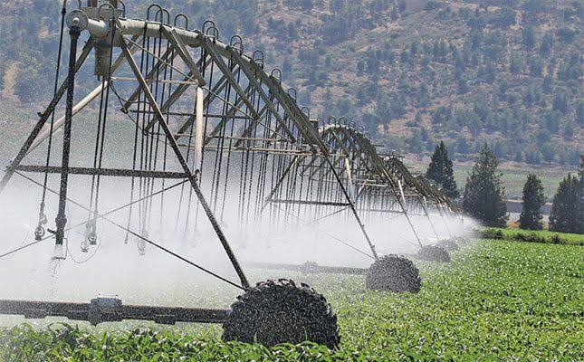
The main purpose of crop water management is to ensure that the crop has enough water at each stage of growth without overwatering or wasting water. Crops need moisture for all biological processes, including photosynthesis, nutrient transport, cell expansion, and temperature regulation. When crops do not receive enough water, they suffer moisture stress, which can lead to poor germination, wilting, stunted growth, reduced flowering, poor fruit or grain development, and low yields. On the other hand, too much water can also be harmful because it reduces oxygen in the root zone, encourages root diseases, causes nutrient leaching, and may weaken the crop. Effective water management therefore means applying the right amount of water at the right time and in the right way according to the crop, soil, and weather conditions.
The first principle of crop water management is understanding crop water requirements. Different crops need different amounts of water depending on their species, growth stage, rooting depth, and production purpose. For example, maize, vegetables, lucerne, and pasture crops each have different moisture needs. Crops are usually most sensitive to water shortage during critical stages such as germination, flowering, and grain or fruit filling. A farmer must know which stages are most important so that water can be prioritised when supply is limited. In a mixed crop and livestock farming system, water planning is even more important because some crops may be grown specifically for livestock feed, such as fodder maize, oats, or lucerne, and their quality depends heavily on proper moisture supply.
Soil plays a major role in crop water management because different soils hold and release water differently. Sandy soils drain quickly and hold less water, so crops on sandy land may need more frequent irrigation in smaller amounts. Clay soils can hold more water, but they may drain slowly and become waterlogged if too much water is applied. Loam soils are generally more balanced and favourable for many crops. The farmer must understand the soil type, depth, and structure of each field in order to manage irrigation correctly. Soils with good organic matter content usually hold water better and support stronger root growth. This is why practices such as adding compost or manure, retaining crop residues, and reducing unnecessary tillage can improve water management by increasing the soil’s ability to store moisture.
Rainfall management is an important part of water management in dryland farming areas. In South Africa, many mixed farmers rely mainly on rainfall, so they must use practices that conserve as much rainwater as possible in the soil. This includes timely land preparation, contour farming, mulching, minimum tillage, residue retention, and weed control. Weeds use large amounts of water and can reduce the amount available to the crop, so early weed management is essential. Conservation agriculture practices help reduce evaporation, improve infiltration, and reduce runoff. By managing rainfall efficiently, the farmer can improve crop survival and productivity even where irrigation is limited or unavailable.
Where irrigation is available, the farmer must select and manage the irrigation system carefully. Common irrigation methods include surface irrigation, sprinkler irrigation, drip irrigation, and centre pivot systems. Surface irrigation may be used where water flows over the field by gravity, but it requires proper levelling and can lead to losses if poorly managed. Sprinkler irrigation distributes water above the crop and can be used for a wide range of crops, but wind and evaporation may reduce efficiency. Drip irrigation applies water directly to the root zone in small amounts and is one of the most water-efficient systems, especially for vegetables, orchards, and high-value crops. Centre pivot irrigation is commonly used on larger commercial farms for field crops and pastures. The choice of system depends on available water, farm size, crop type, soil condition, capital cost, and maintenance capacity.
Irrigation scheduling is the process of deciding when to irrigate and how much water to apply. This is one of the most important management decisions in irrigated crop production. Irrigation should not be done simply by routine or guesswork. The farmer should consider crop growth stage, soil moisture status, recent rainfall, evaporation rate, and weather forecasts. Water should be applied before the crop suffers serious stress, but not so often that the soil becomes saturated and water is wasted. Scheduling may be based on observation of plant condition, soil feel, soil moisture measurement tools, or farm irrigation plans. In South Africa, where water costs and scarcity are major concerns, proper scheduling is essential for efficient production. It helps save water, reduce pumping costs, and improve crop performance.
Water quality is another important factor in crop water management. Irrigation water must be suitable for crop use and should not contain harmful levels of salts, chemicals, or pollutants. Poor-quality water can damage soil structure, increase salinity, reduce plant growth, and affect long-term land productivity. Farmers should monitor the quality of water from rivers, dams, boreholes, or storage tanks, especially where irrigation is practised intensively. Water sources must also be protected from contamination by fertilizers, pesticides, manure, or animal waste. On a mixed farm, where livestock and crops are managed together, care must be taken to prevent runoff from animal areas from polluting irrigation water sources.
Efficient crop water management also depends on maintaining irrigation infrastructure properly. Pumps, pipes, canals, sprinklers, valves, filters, and drip lines must all be checked regularly to ensure that the system is working correctly. Leaks, blocked emitters, broken nozzles, poor pressure, and uneven water distribution can lead to water losses and poor crop growth. A farmer must therefore inspect the system routinely, repair faults quickly, and keep equipment clean and functional. Good maintenance reduces wastage, lowers operating costs, and improves the reliability of irrigation during critical crop growth periods.
In a mixed crop and livestock system, water management must be integrated across the whole farm. Water is needed not only for crops, but also for livestock drinking, cleaning, fodder production, and sometimes pasture irrigation. The farmer must therefore allocate water carefully so that both enterprises can function well. During drought or restricted water supply, decisions may have to be made about which crops to prioritise, how to adjust planting plans, and how to secure feed for animals. This requires strong planning and flexibility. For example, a farmer may decide to plant drought-tolerant fodder crops, reduce irrigated area, or conserve more forage in good seasons for future dry periods.
Environmental sustainability is a central principle of crop water management. Overuse of water reduces the availability of this resource for future farming and for other users, while poor irrigation practices can contribute to soil erosion, salinisation, and pollution. The farmer should therefore use water-saving methods, protect wetlands and watercourses, and follow local water-use regulations. Efficient irrigation, soil cover, erosion control, and good drainage all support sustainable production. In South Africa, responsible water use is especially important because agriculture depends heavily on limited water supplies and climate variability is increasing the pressure on water resources.
Record-keeping and monitoring support good irrigation management. The farmer should keep records of rainfall, irrigation dates, quantities applied, crop response, water source levels, and system maintenance. These records help identify patterns, improve scheduling, and evaluate whether water is being used effectively. They also support better planning for future seasons and help the farmer respond more effectively to drought or changing conditions. On a mixed farm, such records are useful for coordinating crop production with livestock feeding requirements and overall resource management.
Crop water management or irrigation is the careful control and use of water to ensure that crops receive sufficient moisture for healthy growth and good yields. It involves understanding crop water needs, soil water-holding capacity, rainfall patterns, irrigation methods, scheduling, water quality, infrastructure maintenance, and environmental protection. For a mixed crop and livestock farmer in South Africa, effective water management is essential because water is limited, valuable, and closely linked to both crop productivity and livestock support. Good crop water management improves yields, saves water, reduces production risk, and strengthens the sustainability and resilience of the farming enterprise.

KT0106 Crop Planting
Crop planting is the process of placing seed or planting material into the soil in the correct manner, at the correct time, and under suitable conditions so that the crop can germinate, establish, and grow successfully. For a mixed crop and livestock farmer in South Africa, crop planting is one of the most important practical stages of crop production management because it directly affects plant population, crop establishment, growth uniformity, yield potential, and the availability of produce for sale, household use, or livestock feed. Even if land preparation, soil testing, and fertilizer planning have been done properly, poor planting practices can still lead to weak emergence, gaps in the field, uneven crop growth, and low yields. Crop planting must therefore be done carefully and according to sound agricultural principles.
The first important aspect of crop planting is correct timing. Planting must take place during the most suitable season for the chosen crop, taking into account rainfall, temperature, soil moisture, frost risk, and the length of the growing period. In South Africa, many field crops such as maize, sorghum, and beans are planted during the summer rainfall season, while crops such as wheat are often planted in winter rainfall areas or under irrigation. If planting is done too early, seed may rot in cold or dry soil, while late planting can shorten the growing season and expose the crop to drought, pests, or frost at critical growth stages. For a mixed crop and livestock farmer, planting time is also important because some crops may be intended as fodder, silage, hay, or grazing, and must fit into the farm’s livestock feeding programme.
Soil moisture is a key condition for successful planting. The soil must contain enough moisture to support seed germination and early root growth, but it should not be so wet that it causes compaction or poor soil structure. Planting into dry soil may delay germination or lead to patchy emergence, while planting into waterlogged soil can result in seed rot and poor oxygen supply to the young roots. The farmer must therefore assess soil moisture before planting and decide whether the field is ready. In dryland systems, planting is often timed to follow effective rainfall. In irrigated systems, pre-irrigation or irrigation soon after planting may be used to ensure proper establishment. Good moisture management at planting is especially important in South Africa because rainfall can be unreliable and early crop stress can reduce final yield significantly.
Seed quality is another critical factor in crop planting. The farmer must use seed that is healthy, viable, clean, and suited to the production environment. Certified seed is generally preferred because it has known germination ability, varietal purity, and disease-free status. Poor-quality seed may have low germination rates, weak seedlings, or contamination with weed seeds and diseases. The choice of seed variety should match the climate, soil conditions, rainfall expectations, and intended use of the crop. A mixed crop and livestock farmer may choose varieties for grain production, fodder production, drought tolerance, early maturity, disease resistance, or dual-purpose use. Good planting begins with good seed, because the success of the crop depends heavily on the genetic and physical quality of the planting material.
Plant population and spacing are essential parts of correct crop planting. Each crop has a recommended plant population and spacing that allow the crop to use sunlight, nutrients, water, and space efficiently. If seed is planted too close together, the plants may compete too strongly with one another, leading to weak growth and lower yields. If planted too far apart, there may be gaps in the field and the land will not be used efficiently. Row spacing and intra-row spacing must therefore be planned carefully according to the crop, soil fertility, moisture availability, and production system. For example, crops planted under irrigation or in fertile soils may support higher plant populations than crops in dryland or poorer soils. Uniform spacing also makes later operations such as weeding, fertilizing, spraying, and harvesting easier and more effective.
Planting depth is also very important. Seed must be placed deep enough to reach moisture and be protected from birds or excessive heat, but not so deep that the seedling cannot emerge easily. The correct planting depth depends on the size of the seed, the type of soil, and the moisture level in the field. Large seeds such as maize and beans are generally planted deeper than very small seeds. Sandy soils may require slightly deeper planting than clay soils because they dry out more quickly. If the seed is planted too shallow, it may dry out or be damaged. If planted too deep, emergence may be delayed, uneven, or unsuccessful. Proper planting depth contributes to uniform germination and a strong, even crop stand.
The method of planting depends on the scale of the farm, available equipment, and the type of crop being produced. Planting may be done by hand, with simple tools, with animal-drawn equipment, or with tractor-operated planters. Small-scale and subsistence farmers may plant by hand using hoes or dibble sticks, while larger commercial farmers often use precision planters that place seed and fertilizer accurately at the required depth and spacing. Whatever method is used, care must be taken to ensure uniform placement, proper seed coverage, and minimal damage to the seed. Equipment used for planting must be calibrated and adjusted correctly so that the correct seeding rate is applied and so that the depth and spacing are consistent across the field. Good planting equipment and correct operator skill help improve crop establishment and reduce seed wastage.
Crop planting also involves the application of basal fertilizer where required. In many crops, fertilizer is placed at planting time to support early root development and seedling growth. This fertilizer is usually applied close to the seed, but not so close that it burns or damages the young plant. The farmer must understand the recommended fertilizer type, rate, and placement method for the specific crop and soil condition. On a mixed crop and livestock farm, organic manure may also be incorporated into the soil before planting to improve fertility and soil structure. The integration of organic and inorganic nutrient sources can support better crop establishment and longer-term soil health, but planting must still be done carefully so that the seed is not harmed by poorly decomposed manure or excessive salts.
Weed management begins at planting. A field that is planted into clean, well-prepared land gives the crop a better chance to establish without immediate competition from weeds. In some systems, herbicides may be applied before or after planting, depending on the crop and management approach. Mulching and crop residue retention may also help suppress weeds and conserve moisture. The planting pattern and row arrangement should make later weed control easier, whether by hand, hoe, cultivator, or chemical control. Planting is therefore not an isolated action, but part of the broader crop management process.
In a mixed crop and livestock farming system, crop planting must be linked to the overall farm production plan. Some crops are planted mainly for sale, while others are planted for feed, silage, hay, or grazing. This means that the farmer must coordinate planting with livestock needs, seasonal labour demands, and feed shortages expected later in the year. For example, fodder crops may need to be planted early enough to supply feed during the dry season, while grain crops may need to fit into a crop rotation that also supports soil fertility and residue use. Good planting decisions help ensure that the farm produces enough food and feed while also supporting sustainability and profitability.
Environmental care and sustainability are important in crop planting. Planting should be done in a way that protects soil structure, reduces erosion, and conserves moisture. On sloping land, planting along the contour can reduce water runoff and soil loss. Conservation agriculture systems may use minimum tillage and direct planting to reduce soil disturbance and maintain residue cover. These methods can improve water retention, reduce erosion, and build healthier soils over time. In South Africa, where many farming areas face drought, erosion, and land degradation risks, sustainable planting practices are especially important.
Record-keeping is also part of good crop planting management. The farmer should record planting dates, crop varieties, seed rates, fertilizer applied, weather conditions, field locations, and any challenges experienced during planting. These records are useful for evaluating crop performance later and improving future planting decisions. They also help with labour planning, input control, and enterprise budgeting. For a mixed farmer, such records support better integration between crop production and livestock feeding systems.
Crop planting is a key operation in crop production management because it sets the foundation for crop establishment, growth, and final yield. It involves correct timing, suitable soil moisture, good seed quality, proper spacing, correct planting depth, suitable planting methods, and integration with fertilizer and weed management. For a mixed crop and livestock farmer in South Africa, effective crop planting supports both food and feed production, improves resource use, and contributes to the long-term success of the farming enterprise. Proper planting is therefore not just the act of putting seed into the ground, but a carefully managed process that determines the future performance of the crop.

KT0107 Crop Pests and Diseases Management
Crop pests and diseases management is the planned process of preventing, monitoring, identifying, controlling, and reducing the harmful effects of insects, weeds, fungi, bacteria, viruses, nematodes, and other damaging organisms that affect crops. For a mixed crop and livestock farmer in South Africa, this is a vital part of crop production management because pests and diseases can reduce germination, damage leaves and roots, lower yields, reduce crop quality, and in severe cases destroy the entire crop. Effective management is not only about killing pests after they appear. It involves understanding the causes of infestations and disease outbreaks, taking preventive measures, monitoring fields regularly, and using suitable control methods in a safe, economical, and environmentally responsible way.
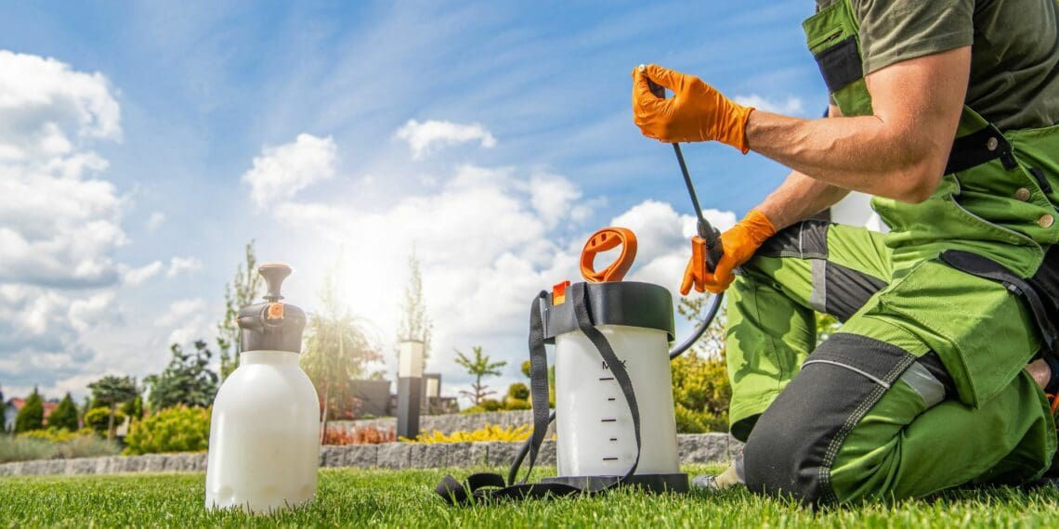
The main purpose of crop pests and diseases management is to protect the crop throughout its growth cycle so that it can reach its full production potential. Healthy crops are better able to use sunlight, water, and nutrients efficiently, while damaged crops often become weak, stunted, or unproductive. In South Africa, pest and disease pressure varies according to climate, crop type, season, and farming practices. Warm temperatures, irregular rainfall, humidity, and continuous cropping can all encourage the spread of harmful organisms. A mixed crop and livestock farmer must therefore be alert throughout the season and understand that pest and disease management is an ongoing activity rather than a once-off action.
The first principle of crop pests and diseases management is prevention. It is always better to prevent a problem than to deal with a serious outbreak later. Preventive management begins with good crop planning. The farmer must choose crop varieties that are suited to the local environment and, where possible, resistant or tolerant to common pests and diseases. Healthy certified seed should be used because poor-quality or infected seed can introduce disease into the field from the start. Crop rotation is another important preventive measure because planting the same crop repeatedly in the same field often allows pests and diseases to build up in the soil or residue. Rotating cereals with legumes or fodder crops can break these cycles and improve overall field health. Good land preparation, balanced fertilization, proper irrigation, and sanitation also strengthen the crop and reduce vulnerability to attack.
Correct identification of pests and diseases is one of the most important management skills. A farmer must be able to recognise when a crop problem is caused by insects, pathogens, nutrient deficiency, chemical damage, or environmental stress. Not every yellow leaf or wilted plant is caused by disease. Some symptoms may result from poor drainage, drought, nutrient imbalance, or root damage. Effective control depends on knowing exactly what the problem is. Insect pests may damage crops by chewing leaves, sucking sap, boring into stems, or feeding on roots, while diseases may show symptoms such as leaf spots, rotting, wilting, discoloration, mould growth, or deformed fruit and grain. The farmer should inspect crops regularly and, where necessary, consult agricultural advisers, extension officers, or plant health specialists for correct diagnosis before applying control measures.
Field scouting and crop monitoring are essential in pest and disease management. The farmer should inspect fields frequently from planting until harvest to observe crop condition and detect early signs of problems. Monitoring involves checking leaves, stems, roots, flowers, fruits, and the surrounding soil for any unusual symptoms or pest presence. Early detection is important because problems are easier and cheaper to control before they spread widely. Monitoring also helps the farmer decide whether action is needed immediately or whether the problem can be tolerated without major loss. In this way, the farmer avoids unnecessary chemical applications and focuses only on real threats. Record-keeping during monitoring is valuable because it helps identify recurring problems, seasonal patterns, and the effectiveness of previous control methods.
An important approach to crop pests and diseases management is integrated pest management, commonly known as IPM. This is a balanced and sustainable approach that combines different methods of control rather than relying only on chemicals. Integrated pest management begins with prevention and monitoring, then uses cultural, mechanical, biological, and chemical methods where appropriate. Cultural control includes practices such as crop rotation, planting at the correct time, using resistant varieties, destroying infected crop residues, controlling weeds, and maintaining field hygiene. Mechanical control may include hand-picking pests, removing infected plants, trapping insects, or using barriers. Biological control involves using natural enemies such as beneficial insects, fungi, or bacteria to suppress pest populations. Chemical control is used only when necessary and in a targeted manner. This integrated approach is important because it reduces costs, slows the development of resistance, protects beneficial organisms, and supports environmental sustainability.
Weed management is also closely linked to crop pest and disease management. Weeds compete with crops for nutrients, water, light, and space, but they can also act as hosts for pests and diseases. A field with poor weed control often has greater pest pressure because insects and pathogens can survive and multiply on the weeds. Effective weed management therefore helps protect the crop indirectly as well as directly. Weed control can be achieved through hand weeding, hoeing, mulching, cultivation, cover crops, crop rotation, and herbicide application where suitable. The farmer should aim to control weeds early, especially during the early growth stages of the crop when competition is most harmful.
Chemical control remains an important tool in managing serious pest and disease outbreaks, but it must be used carefully and responsibly. Pesticides, fungicides, herbicides, and other crop protection chemicals can be effective when used correctly, but they can also be dangerous to people, livestock, crops, beneficial organisms, and the environment if used incorrectly. The farmer must choose the correct product for the target pest or disease, follow label instructions, apply the correct dosage, and use the proper equipment. Timing of application is also important because some chemicals are most effective at specific stages of pest development or disease infection. Protective clothing and safe handling procedures are essential to protect workers. On a mixed crop and livestock farm, the farmer must also ensure that chemicals do not contaminate animal feed, water sources, grazing areas, or livestock housing.
Resistance management is an important part of modern pest and disease control. When the same chemical is used repeatedly, pests or pathogens may develop resistance, making the product less effective over time. To reduce this risk, the farmer should rotate chemicals with different modes of action, use non-chemical methods where possible, and avoid unnecessary spraying. Good resistance management protects the usefulness of crop protection products and supports long-term farm productivity. This is especially important in South Africa, where farmers often face recurring pest challenges under variable climatic conditions.
Environmental and climatic conditions have a major influence on pest and disease development. Warm, humid weather often encourages fungal diseases, while hot, dry conditions may favour certain insect pests. Poor drainage and over-irrigation can also create conditions for root diseases and mould. The farmer must therefore manage water, air circulation, plant spacing, and field sanitation in ways that reduce favourable conditions for outbreaks. Understanding seasonal patterns helps the farmer prepare in advance for likely pest or disease risks. For example, a farmer may expect greater disease pressure in wet seasons or increased insect activity during certain temperature periods.
In mixed crop and livestock farming systems, pest and disease management must be coordinated with the broader farm system. Some crop residues may need to be removed or destroyed if they carry disease, while others may be used for livestock feed if safe. The farmer must be careful when using treated crops or crop residues as feed, because chemical residues may affect animal health. Likewise, manure used in crop fields should be properly managed to avoid introducing weed seeds or pathogens. This shows that crop health management must be integrated with livestock management and overall farm hygiene.
Record-keeping is a valuable part of pest and disease management. The farmer should keep records of pest and disease occurrences, affected fields, weather conditions, products used, application dates, and crop response. These records help identify trends, improve future planning, and evaluate whether the chosen control measures were effective. They also support compliance, budgeting, and traceability. By learning from past seasons, the farmer can improve prevention and response strategies over time.
Crop pests and diseases management is the systematic protection of crops against harmful organisms that reduce growth, yield, and quality. It involves prevention, correct identification, regular monitoring, weed control, integrated pest management, responsible chemical use, resistance management, and careful record-keeping. For a mixed crop and livestock farmer in South Africa, effective pest and disease management is essential for protecting crop production, ensuring livestock feed quality, reducing losses, and supporting sustainable farming. It is therefore a key management function that requires knowledge, observation, planning, and responsible action throughout the production season.

KT0108 Crop Harvesting
Crop harvesting is the process of removing mature crops from the field at the correct time, in the correct manner, and with the correct handling procedures in order to preserve yield, quality, and value. For a mixed crop and livestock farmer in South Africa, harvesting is one of the most important stages of crop production management because it is the point at which the farmer secures the results of all the work done during land preparation, planting, fertilizing, irrigation, and crop protection. If harvesting is poorly timed or badly managed, a large portion of the crop can be lost even after a good growing season. Crop harvesting must therefore be planned carefully and carried out efficiently so that the produce can be used for sale, household consumption, seed, or livestock feed.
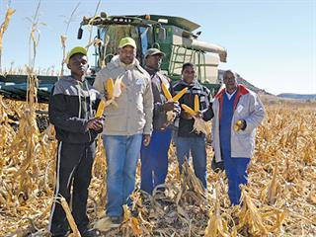
The main purpose of crop harvesting is to collect the crop when it has reached the right level of maturity for its intended use. Different crops have different maturity indicators and harvesting requirements. Grain crops such as maize, sorghum, and wheat are usually harvested when the grain has dried sufficiently and reached physiological maturity. Vegetables and fruits may be harvested when they reach the size, colour, tenderness, or flavour required by the market. Fodder crops such as lucerne, oats, or maize for silage must be harvested at the stage where feed quality and quantity are best balanced. If a crop is harvested too early, the yield may be low and the produce may be immature or of poor quality. If it is harvested too late, losses can occur due to shattering, lodging, spoilage, pest damage, over-drying, or reduced nutritional value. Correct harvesting time is therefore a key decision that affects both production and profit.
The farmer must understand the signs of crop maturity in order to determine the best time for harvesting. These signs vary according to the crop. In grain crops, maturity may be indicated by the drying of leaves and stalks, hardening of grain, colour change, and reduced moisture content. In vegetables, maturity may depend on market preference, tenderness, size, shape, and colour. For fodder crops, the farmer must consider not only plant size but also feed quality. For example, if a fodder crop is harvested too late, the yield may be high but the fibre content may increase and the nutritional value may decrease. In a mixed crop and livestock system, this is especially important because harvested fodder must meet the feeding needs of the livestock enterprise.
Harvesting methods depend on the type of crop, the scale of production, and the resources available on the farm. Crops may be harvested by hand or by machine. Small-scale farmers often use hand tools such as sickles, knives, or hoes, while larger farms may use combine harvesters, forage harvesters, or specialised harvesting equipment. Manual harvesting allows careful handling and may be suitable for delicate produce or smaller areas, but it is labour intensive and can be slow. Mechanical harvesting is faster and more efficient on larger areas, but the equipment must be correctly adjusted and operated to reduce losses and damage. The choice of harvesting method must therefore consider labour availability, cost, field conditions, crop type, and the purpose of the harvested produce.
Proper planning is essential before harvesting begins. The farmer must ensure that labour, machinery, tools, bags, transport, and storage facilities are ready in advance. If harvesting is delayed because of poor planning, the crop may deteriorate in the field. Weather conditions must also be considered because rain during harvesting can damage mature crops, delay operations, and increase spoilage risk. In South Africa, where weather conditions can change quickly during harvest periods, the farmer must monitor forecasts and act promptly when the crop is ready. Harvest planning should also include the route of transport from field to storage or processing point, especially where produce is perishable or where large volumes must be moved quickly.
Crop losses during harvesting are a major concern and must be minimised through good management. Losses can occur when grain falls to the ground, when fruits and vegetables are bruised or cut, when crops are left too long in the field, or when machinery is not adjusted correctly. Poor handling by workers can also damage produce and reduce market quality. The farmer must supervise harvesting activities carefully and train workers in correct methods. In grain crops, attention must be paid to reducing breakage, spillage, and contamination. In fresh produce, careful picking, sorting, and packing are necessary to preserve appearance and shelf life. In fodder harvesting, losses of leaves or nutrients must be minimised because these directly affect feed quality.
Moisture content is an important factor in harvesting, especially for grain and fodder crops. Grain harvested at too high a moisture level may spoil in storage due to mould, heating, or fungal growth. Grain harvested when too dry may suffer cracking or shattering losses during handling. The farmer must therefore judge moisture carefully and, where necessary, dry the harvested crop before storage. In fodder production, moisture content is also important for hay and silage. Hay must be dried enough to prevent moulding, but not so dry that valuable leaves are lost during baling and transport. Silage crops must be harvested at the right moisture level so that fermentation occurs properly and good-quality feed is produced. For a mixed crop and livestock farmer, this is particularly important because poor-quality conserved fodder can reduce livestock performance and increase feed shortages.
Post-harvest handling forms an important part of harvesting management. Harvesting does not end when the crop is cut or removed from the field. The produce must be cleaned, sorted, dried, graded, packed, stored, or transported according to its intended use. Poor post-harvest handling can lead to losses even after a successful harvest. Grain must be protected from moisture, rodents, and insects. Vegetables and fruits must be handled gently to avoid bruising and contamination. Fodder must be stored in a dry and protected place to preserve nutritional value. The farmer must therefore ensure that storage structures, sheds, silos, bags, crates, and transport vehicles are clean, suitable, and ready for use.
In a mixed crop and livestock farming system, crop harvesting is closely linked to livestock management. Some crops are harvested directly for feed, while crop residues such as maize stover, straw, and haulms may also be collected or grazed by animals after harvest. The farmer must decide how much of the crop will be sold, how much will be stored, and how much will be used for feed. This requires planning because residues that are valuable as livestock feed may also be important for soil cover and organic matter. The farmer must balance these needs carefully. For example, removing all residues for feed may reduce soil protection, while leaving all residues in the field may waste a valuable feed resource during dry periods. Good harvesting management in mixed farming therefore includes decisions about residue use, fodder conservation, and integration with animal feeding programmes.
Harvesting also has an economic dimension. The farmer must harvest efficiently to reduce labour and machinery costs while maintaining quality. A delay in harvesting can reduce market price if the crop quality declines or if the produce misses a market window. In commercial farming, market requirements such as grade, moisture level, cleanliness, and appearance often determine how and when the crop is harvested. The farmer must therefore understand buyer requirements and harvest accordingly. Good harvesting management improves returns, reduces waste, and contributes directly to farm profitability.
Safety is another important consideration during harvesting. Workers must use tools and machinery correctly to avoid injuries. Mechanical harvesters, tractors, trailers, and cutting equipment can be dangerous if not operated properly. Harvesting often takes place during busy periods when fatigue can lead to mistakes. The farmer must therefore ensure safe working procedures, proper supervision, protective clothing where necessary, and good equipment maintenance. On a mixed farm, safety is also important where livestock are present near harvested feed, machinery, or transport routes.
Record-keeping should be part of harvesting management. The farmer should record harvest dates, field yields, quality observations, labour used, machinery performance, storage quantities, and any losses or problems experienced. These records help in evaluating production performance, planning future seasons, budgeting, and monitoring how much crop is available for sale or livestock feeding. Accurate records are especially useful in mixed farming because crop harvest results affect feed planning, stocking decisions, and enterprise profitability.
Crop harvesting is the careful and timely removal of mature crops from the field in a way that protects yield, quality, and value. It involves identifying the correct stage of maturity, choosing the appropriate harvesting method, planning labour and equipment, managing moisture content, reducing losses, handling produce properly after harvest, and linking crop use to the needs of the overall farm. For a mixed crop and livestock farmer in South Africa, effective harvesting is essential because it secures both income and feed resources, supports efficient farm management, and contributes to the sustainability and profitability of the farming enterprise.

KT0109: Crop Rotation
Crop rotation is the planned practice of growing different crops on the same piece of land in a specific sequence over a number of seasons or years. Instead of planting the same crop in the same field every season, the farmer changes the crop type to improve soil health, reduce pest and disease problems, manage weeds, and increase overall productivity. For a mixed crop and livestock farmer in South Africa, crop rotation is a very important management practice because it supports sustainable production, improves efficient use of land, and strengthens resilience against climate and market challenges.
The main idea behind crop rotation is that different crops have different nutrient needs, rooting depths, growth habits, and effects on the soil. For example, maize removes large amounts of nutrients such as nitrogen from the soil, while legumes such as beans, cowpeas, or lucerne can help improve soil fertility by fixing nitrogen through their root nodules. When these crops are grown in rotation, the soil is not continuously depleted by one type of crop. This helps maintain soil productivity and reduces the need for excessive fertilizer use. In South Africa, where many farming areas experience variable rainfall, soil degradation, and declining fertility, crop rotation is an effective way to protect and restore the productive capacity of farmland.
Crop rotation also plays a major role in breaking pest, disease, and weed cycles. Many pests and diseases are crop-specific, meaning they survive and multiply when the same crop is planted repeatedly in the same field. For example, continuous planting of one crop can allow soil-borne diseases, insect pests, or parasitic weeds to build up over time. By rotating with an unrelated crop, the life cycle of these pests and diseases is interrupted, reducing their numbers and limiting damage. Weed control is also improved because different crops allow different tillage methods, planting dates, canopy structures, and herbicide programs. This makes it harder for one weed species to dominate the field year after year.
Another important benefit of crop rotation is the improvement of soil structure and water use efficiency. Different crops have different rooting systems. Deep-rooted crops can break compacted soil layers and improve water infiltration, while shallow-rooted crops make use of nutrients and moisture near the surface. Rotating crops with varying root structures helps keep the soil loose, balanced, and biologically active. It also improves organic matter levels when crop residues are returned to the soil. Better soil structure means the soil can hold water more effectively, drain properly, and resist erosion. This is especially important in South African farming areas affected by drought, heavy rainfall, or wind erosion.
For mixed crop and livestock farmers, crop rotation has additional advantages because crop and animal enterprises can support one another. Some rotational crops, such as lucerne, oats, sorghum, or cowpeas, can be used as livestock feed, grazing, hay, or silage. At the same time, livestock manure can be returned to crop fields to improve soil fertility and organic matter. This integration reduces waste, lowers input costs, and improves overall farm efficiency. A farmer may rotate maize with a legume and then follow with a fodder crop that supports livestock production, creating a balanced and productive farming system.
A good crop rotation plan should be based on several factors, including climate, soil type, water availability, market demand, and the purpose of the crop. Farmers should avoid rotating crops that belong to the same family if they share similar pests and diseases. They should also include legumes where possible, use cover crops to protect the soil, and consider the nutrient demands of each crop in the sequence. In dry regions, drought-tolerant crops may be included to reduce risk. In irrigated systems, higher-value crops may be rotated to balance income and soil management. Proper planning is necessary to ensure that each crop in the rotation contributes to the productivity and sustainability of the entire farm system.
crop rotation is a key agricultural practice that helps farmers manage soil fertility, improve soil structure, conserve water, reduce pests and diseases, control weeds, and support sustainable production. For South African mixed crop and livestock farmers, it is a practical and cost-effective strategy for improving both crop yields and livestock support systems. By carefully planning the sequence of crops grown on the farm, farmers can protect their land, reduce production risks, and achieve long-term productivity and profitability.

Internal Assessment Criteria (IAC) and Weight

IAC0101 – Crop Selection and Production Planning
Crop selection and production planning involve choosing crops that are best suited to the climate, soil type, water availability, and market demand of the farm. In South Africa, environmental conditions vary widely between provinces, so selecting the correct crop is critical to ensure success. For example, maize and sunflower thrive in areas with moderate rainfall, while drought-tolerant sorghum or millet may be better in semi-arid regions. Production planning involves creating a seasonal calendar, determining planting dates, estimating labour and input requirements, and planning the rotation of crops to optimize land use. This ensures that both the crop and livestock enterprises in a mixed system complement each other, such as using crop residues for livestock feed.

IAC0102 – Soil Characteristics for Crop Suitability and Soil Testing
Understanding soil characteristics is fundamental for determining crop suitability. Soil texture, structure, pH, organic matter, and nutrient content influence crop growth and yield. Sandy soils drain quickly but retain fewer nutrients, while clay soils hold water and nutrients but can become compacted. Physical soil testing involves examining soil texture, structure, compaction, and drainage, while chemical testing measures pH, nitrogen, phosphorus, potassium, and micronutrient levels. In South Africa, soil testing is essential due to regional differences in fertility. Results guide lime application, fertilizer use, and crop selection, helping to improve yield and avoid nutrient deficiencies or toxicity.

IAC0103 – Soil Preparation for Sustainable Crop Production
Soil preparation involves practices that make soil suitable for planting, ensuring optimal conditions for root growth, water infiltration, and nutrient availability. This includes ploughing or tilling to loosen compacted soil, removing weeds, incorporating organic matter, and levelling fields. Conservation practices such as minimum tillage, mulching, or contour farming can reduce soil erosion and maintain soil health. In South African farming, sustainable soil preparation ensures long-term productivity and supports mixed farming, as healthy soils produce higher crop yields and better-quality residues for livestock feed.

IAC0104 – Fertilizer Application for Crop Production for Optimum Yield
Fertilizer application is the process of supplying essential nutrients to crops to maximize growth and yield. Fertilizers can be organic (compost, manure) or inorganic (chemical NPK formulations). The application rate depends on soil test results, crop type, growth stage, and environmental conditions. Over-fertilization can harm the soil and the environment, while under-fertilization reduces yield. South African farmers often use targeted application methods such as broadcasting, side-dressing, or fertigation to improve nutrient uptake efficiency, reduce waste, and promote sustainable production.

IAC0105 – Soil-Crop-Water Management / Irrigation for Optimum Yield
Water management is essential in crop production, particularly in South Africa, where rainfall can be irregular. Irrigation ensures that crops receive sufficient water for growth, while efficient water management prevents wastage and soil degradation. Methods include drip irrigation, sprinkler systems, furrow irrigation, or supplemental irrigation. Soil-crop-water management also involves monitoring soil moisture, using mulches to retain water, and planning crop planting dates according to rainfall patterns. Efficient water use ensures higher crop yields and improves the quality of crop residues used for livestock.

IAC0106 – Planting / Sowing Process of Various Crops
The planting or sowing process determines the initial establishment of crops and has a direct impact on yield. It includes selecting quality seed, treating seeds if necessary (e.g., fungicide coating), determining the correct spacing and depth, and using manual or mechanical methods for sowing. For example, maize is typically planted in rows with proper spacing to optimize sunlight exposure and nutrient uptake. Planting at the correct time, in alignment with rainfall or irrigation schedules, ensures maximum germination, healthy growth, and efficient use of resources.

IAC0107 – Control of Crop Pests and Diseases Management
Crop pests and diseases reduce yield and quality, and their management is essential for sustainable production. This involves identifying pests and diseases early, using chemical, biological, or cultural control methods, and implementing integrated pest management (IPM) strategies. Cultural methods include crop rotation, intercropping, and removing infected plant material. Biological control uses natural predators or parasites to reduce pest populations. Chemical control, such as insecticides or fungicides, must be used responsibly to avoid resistance, environmental contamination, and harm to livestock. Effective pest and disease management is vital in South African mixed farms to protect both crops and animals.

IAC0108 – Maturity and Harvesting Process of Various Crops
Harvesting at the correct maturity stage ensures maximum yield and quality. Crop maturity is assessed by visual indicators, moisture content, or developmental stage. For example, maize is harvested when kernels have reached physiological maturity and moisture content is low enough for storage. Harvesting methods may be manual, using hand tools, or mechanical, using harvesters. Proper timing reduces losses, preserves nutrients, and ensures that crop residues remain valuable for livestock feed or soil incorporation. In mixed farming, efficient harvesting supports both crop profitability and livestock feed supply.

IAC0109 – Crop Rotation and Its Importance in Sustainable Production
Crop rotation is the practice of growing different crops on the same field in successive seasons. It reduces pest and disease build-up, improves soil fertility, prevents erosion, and enhances nutrient cycling. For instance, legumes like beans or soybeans fix nitrogen in the soil, benefiting subsequent cereal crops like maize. In South Africa, crop rotation is particularly important in areas with nutrient-poor soils or high pest pressure. It supports sustainable production by reducing dependency on chemical fertilizers, maintaining soil structure, and ensuring consistent yields over the long term.

KM-01-KT02 Livestock production management. 40%
Topic element
- KT0201 Livestock production systems.
- KT0202 Livestock production planning.
- KT0203 Livestock Breeds, Breeding and Genetics
- KT0204 Calving/Lambing/Kidding/Furrowing/ Laying season
- KT0205 Animal identification
- KT0206 Animal processing

KM-01-KT02 Livestock Production Management
Livestock production management is the systematic process of planning, organising, supervising, and monitoring all activities related to raising, feeding, breeding, caring for, and marketing animals on a farm. For a mixed crop and livestock farmer in South Africa, livestock production management is a critical part of overall farm productivity because livestock contribute to food production, income generation, manure for soil fertility, and the farm’s sustainability. Proper management ensures that animals grow healthily, reproduce efficiently, produce quality meat, milk, eggs, or wool, and remain free from disease and stress. Mismanagement, on the other hand, can lead to low growth rates, poor reproduction, high mortality, low product quality, and financial losses.
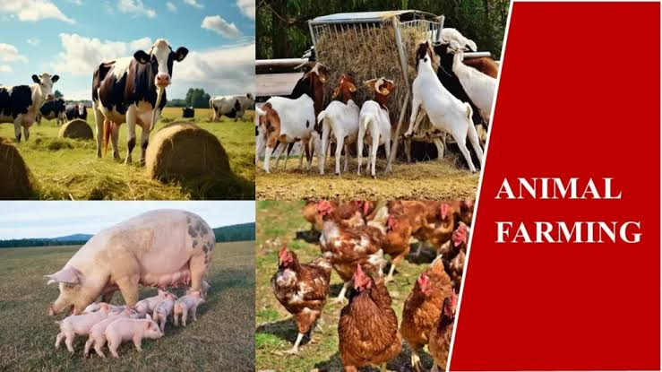
The main objective of livestock production management is to optimise animal performance while maintaining farm resources and environmental sustainability. This involves selecting the right species and breeds that are well adapted to the local climate, feed availability, and production goals. For example, in South Africa, beef cattle may need to be hardy and drought-tolerant in semi-arid areas, whereas dairy cattle may require high-quality pasture and reliable water supply. Sheep, goats, pigs, and poultry may be raised for meat, milk, eggs, or wool, depending on the farm’s objectives. By choosing the appropriate livestock type and breed, the farmer can improve productivity, reduce disease risk, and increase the efficiency of feed conversion and reproduction.
Feeding and nutrition management is central to livestock production. Proper nutrition supports growth, reproduction, lactation, and general health. Livestock require a balanced diet containing energy, protein, vitamins, and minerals. Mixed farmers often use a combination of natural grazing, crop residues, forage crops, silage, hay, and commercial feed supplements. Feed must be provided in adequate quantities and at the right times, taking into account the age, breed, and physiological stage of the animals. For example, lactating cows require higher protein and energy than dry cows, while growing animals need sufficient nutrition to reach their target weight efficiently. In South Africa, seasonal variations in feed availability often require careful planning, including conserving fodder during good seasons for use during dry periods.
Water management is equally important in livestock production. All animals require clean, fresh water for drinking, digestion, thermoregulation, and overall health. Water sources must be reliable and protected from contamination by chemicals, faeces, or other pollutants. In dry regions of South Africa, farmers often need to manage water storage, pumping, and distribution to ensure livestock have sufficient water, especially during drought periods. Water shortages can stress animals, reduce feed intake, lower reproduction rates, and compromise product quality.
Health management is a critical aspect of livestock production. Preventing and controlling diseases and parasites is essential for maintaining animal performance and farm profitability. Farmers must develop a health programme that includes vaccination, deworming, parasite control, and regular health monitoring. Early detection of illness allows prompt treatment, reducing mortality and production losses. Biosecurity measures, such as controlling access to the farm, disinfecting equipment, and quarantining new or sick animals, are also essential to prevent the spread of contagious diseases. In South Africa, farmers face challenges such as tick-borne diseases in cattle, foot-and-mouth disease, and Newcastle disease in poultry, which require careful monitoring and management.
Reproduction and breeding management are essential to ensure livestock sustainability and genetic improvement. Farmers must plan mating, artificial insemination, or controlled breeding programs to produce healthy offspring and maintain or improve desirable traits. Proper timing, nutrition, and health support during gestation are critical for high survival rates and the production of strong, productive young animals. In mixed farming systems, reproduction management ensures a continuous supply of replacement animals and supports long-term herd or flock growth.
Housing and shelter management is another important area in livestock production. Animals need protection from extreme temperatures, wind, rain, and predators. Proper housing reduces stress, improves feed efficiency, reduces disease risk, and enhances overall welfare. Housing must provide adequate space, ventilation, bedding, and access to water and feed. In South African conditions, shelters may range from simple shade structures to fully enclosed barns, depending on the species, climate, and farm resources.
Record-keeping and monitoring are fundamental components of livestock production management. Farmers should maintain detailed records of animal identification, breeding, growth rates, health treatments, feed intake, production outputs, and mortality. These records allow the farmer to monitor performance, identify problems, plan improvements, and make informed decisions. They also support farm planning, budgeting, and compliance with regulatory requirements, including meat and milk quality standards in South Africa.
Integration with crop production is an advantage of mixed farming systems. Crop residues, silage, and forage crops produced on the farm can feed livestock, while manure from livestock can improve soil fertility for crop production. This cycle enhances sustainability, reduces input costs, and improves the resilience of the farm system. Proper planning ensures that both crop and livestock components complement each other without overexploiting resources.
Economic and marketing considerations are also part of livestock production management. Farmers must plan when to sell animals or products to optimise income, manage costs of feed, veterinary care, and labour, and respond to market demand. Decisions on whether to sell live animals, meat, milk, eggs, or wool affect the farm’s cash flow and overall profitability. Marketing strategies, including quality assurance and meeting consumer standards, are increasingly important in South Africa’s competitive agricultural markets.
Livestock production management involves coordinating all activities related to feeding, health, breeding, housing, monitoring, and marketing of farm animals to achieve high productivity, quality products, and sustainable farm operations. For a mixed crop and livestock farmer in South Africa, effective livestock management ensures the efficient use of resources, supports crop production through integrated systems, secures income, and contributes to the overall resilience and sustainability of the farming enterprise. Good livestock management is therefore a combination of technical knowledge, careful observation, planning, and practical decision-making.

KT0201 Livestock Production Systems
Livestock production systems refer to the organized methods by which animals are raised and managed to produce meat, milk, eggs, wool, or other animal products. These systems describe how farmers integrate animals, land, feed, water, labour, and technology to achieve specific production goals. For a mixed crop and livestock farmer in South Africa, understanding livestock production systems is essential because it influences animal performance, resource efficiency, environmental sustainability, and profitability. Different production systems are suitable for different species, farm sizes, climates, and market objectives, and choosing the right system can make the difference between a productive, profitable farm and one that struggles to maintain animals.
The main livestock production systems can be broadly classified into extensive, semi-intensive, and intensive systems, each with its characteristics, advantages, and limitations.
1. Extensive Livestock Production:
In extensive systems, animals are raised primarily on natural pastures or rangelands with minimal human intervention. This system is common in many parts of South Africa, especially in arid or semi-arid regions where rainfall is low and feed resources are limited. Animals graze freely over large areas, and supplementary feeding or housing is minimal. Extensive systems are suitable for hardy breeds that can tolerate heat, drought, and poor forage quality. Advantages of this system include low input costs, low labour requirements, and suitability for large areas with natural grazing. However, productivity per animal is often lower compared to intensive systems, and there is greater exposure to predators, disease, and environmental risks. For mixed farmers, extensive systems are often combined with crop residue grazing to maximise feed use.
2. Semi-Intensive Livestock Production:
Semi-intensive systems are a combination of grazing and supplementary feeding. Animals graze on pastures but receive additional feed such as hay, silage, concentrates, or crop residues to improve growth, reproduction, or milk production. Housing or shelter may be provided for protection from extreme weather or predators. This system is common for dairy, sheep, and goat farms in South Africa where pasture alone may not meet nutritional requirements throughout the year. Semi-intensive systems allow farmers to increase productivity while still using natural resources efficiently. Labour and input costs are higher than in extensive systems but lower than in fully intensive systems.
3. Intensive Livestock Production:
Intensive systems involve raising animals in controlled environments where feed, water, housing, and health management are strictly regulated. This includes feedlots for beef cattle, dairy barns for cows, poultry houses, pigsties, and feedlot sheep systems. Intensive systems maximise growth, reproduction, and output per unit area of land because animals are provided with high-quality feed and constant care. This system requires higher investment in infrastructure, feed, and labour, but yields faster production cycles and higher overall productivity. In South Africa, intensive systems are widely used for dairy, broiler and layer poultry, and pig farming. Intensive systems allow farmers to produce year-round, maintain higher product quality, and access markets with consistent supply.
4. Pastoral and Ranching Systems:
Pastoral or ranching systems are extensive forms of livestock production where large herds graze communal or private rangelands. This system is traditional in parts of South Africa, particularly in communal areas and semi-arid regions. Livestock are often indigenous breeds adapted to local conditions. Pastoral systems focus on maintaining herd size, resilience, and sustainability of rangeland resources. Challenges include seasonal feed shortages, water scarcity, and the need to prevent overgrazing and land degradation.
5. Mixed Farming Systems:
Mixed farming systems integrate crop production with livestock rearing. Animals are used for draft power, manure production, and feed recycling from crop residues. Crops provide feed for livestock, while livestock improve soil fertility and contribute to farm income. This system is common in South Africa, especially for small- to medium-scale farmers, because it allows better resource use, diversification of income, and improved resilience against climate variability. For example, maize stover may feed cattle, while manure supports soil fertility for crop growth.
6. Specialized and Commercial Systems:
Some farmers focus on specialized production, such as dairy, broiler or layer poultry, pig production, or wool production. These systems may be intensive or semi-intensive, and they often require advanced management skills, high-quality feed, veterinary support, and compliance with market and regulatory standards. Commercial systems are market-driven and aim for high productivity, product quality, and profitability. For a mixed crop and livestock farmer, integrating specialized systems with other farm operations can enhance income and improve resource use.
Each livestock production system requires careful planning of feed, water, housing, health, reproduction, and labour management. For example, extensive systems depend heavily on seasonal rainfall and pasture quality, semi-intensive systems require supplementary feed planning, and intensive systems depend on feed formulation, controlled environments, and frequent monitoring. Farmers must also consider environmental sustainability, including soil conservation, water management, and waste handling, to prevent negative impacts on surrounding ecosystems.
Choosing the right livestock production system also involves considering economic factors. Input costs, labour availability, market demand, infrastructure, and capital investment all influence which system is most suitable. In South Africa, factors such as drought risk, access to markets, government support, and availability of grazing land or irrigation also play a significant role in system selection. Mixed crop and livestock farmers can benefit from a combination of systems, tailoring production methods to the species, farm size, and local conditions.
Livestock production systems define how animals are raised, fed, housed, and managed to achieve specific production goals. For a mixed crop and livestock farmer in South Africa, understanding these systems allows for informed decisions about species selection, production intensity, resource allocation, and farm integration. Effective livestock production management requires adapting the system to local conditions, balancing productivity with sustainability, and integrating crop and livestock operations to optimise output, income, and resource use across the farm. Properly managed livestock systems increase efficiency, reduce risk, and support the long-term success of a mixed farming enterprise.

KT0202 Livestock Production Planning
Livestock production planning is the process of systematically organising all resources, activities, and schedules related to raising and managing farm animals to achieve specific production, financial, and sustainability goals. For a mixed crop and livestock farmer in South Africa, livestock production planning is essential because it ensures that animals receive the right care, nutrition, and management at the right time, while optimising the use of farm resources such as land, water, labour, feed, and capital. Effective planning reduces risks, increases productivity, supports profitability, and integrates the livestock enterprise with crop production and overall farm objectives.
The first step in livestock production planning is defining production objectives. Farmers must decide whether their livestock enterprise is focused on meat, milk, eggs, wool, draft power, or a combination of products. The objectives may also include producing replacement stock, generating income for household use, or supporting crop production through manure and draft power. For a mixed crop and livestock farmer, clearly defined objectives help determine the species, breeds, production system, and scale of operation that best suit the farm’s resources and market opportunities.
Resource assessment is a crucial part of production planning. The farmer must evaluate the availability and quality of land, water, feed, housing, labour, capital, and equipment. For example, pasture availability, crop residues, and water sources will influence how many animals can be supported and which feeding strategies to use. Housing, handling facilities, and fencing must also be assessed to ensure animal welfare, security, and operational efficiency. A thorough assessment of resources helps the farmer avoid overstocking, reduces feed shortages, and prevents stress or disease outbreaks.
Feed and nutrition planning is central to livestock production. Animals must receive adequate feed and water to maintain growth, reproduction, lactation, and overall health. The farmer must plan the type, quantity, and timing of feed provision, considering seasonal availability of pasture, forage crops, crop residues, and supplements. Feed budgets should be developed for each class of livestock, including young stock, breeding animals, lactating cows, and finishing animals. For example, during the dry season in South Africa, feed shortages may require strategic harvesting of fodder crops or purchase of supplemental feed to maintain animal performance. Proper feed planning reduces costs, prevents malnutrition, and supports optimal productivity.
Breeding and reproduction planning ensures a consistent supply of healthy and productive animals. The farmer must plan mating schedules, choose appropriate sires or dams, consider artificial insemination or controlled breeding programs, and manage gestation and birthing periods. Reproductive planning must align with feed availability, labour capacity, and market demand for livestock products. For instance, a farmer may schedule calving or lambing during periods when pasture is abundant, reducing reliance on supplementary feed. Planning also includes record-keeping of breeding history, offspring performance, and culling decisions to improve herd or flock genetics over time.
Health and disease management planning is essential to protect livestock from illness and prevent financial losses. Farmers must schedule vaccination programs, deworming, parasite control, and routine health checks. Planning should also include quarantine procedures for new or sick animals, biosecurity measures to prevent disease introduction, and contingency measures for outbreaks. In South Africa, livestock are at risk of diseases such as foot-and-mouth disease, tick-borne illnesses, and Newcastle disease, making proactive planning critical. Regular veterinary consultations and early detection strategies form part of a comprehensive health plan.
Housing, shelter, and infrastructure planning are also key components of livestock production planning. Adequate housing protects animals from extreme weather, predators, and disease. The farmer must plan for sufficient space, ventilation, bedding, and feeding areas to ensure animal welfare and productivity. Maintenance schedules for buildings, fences, water troughs, and feeding equipment must also be included to prevent operational interruptions and reduce long-term costs. Well-planned infrastructure contributes to efficiency and safety on the farm.
Labour and time management are integrated into livestock production planning. Farmers must determine the labour requirements for feeding, cleaning, health monitoring, breeding, and record-keeping. Labour schedules must be aligned with critical tasks, such as milking, lambing, or vaccination days, to ensure timely and effective execution. Efficient labour planning reduces stress on both animals and workers and supports smooth farm operations.
Financial and marketing planning is another essential element. Farmers must estimate costs related to feed, health care, infrastructure, labour, and equipment. They must also plan expected revenue from sales of animals or animal products, factoring in market demand, seasonal fluctuations, and quality standards. Financial planning helps the farmer make informed decisions about scaling production, investing in infrastructure, or purchasing inputs. Marketing plans ensure that livestock products are sold at the right time, in the right quantity, and at optimal prices to maximise farm profitability.
Integration with crop production is an important consideration for mixed farmers. Crop residues, silage, and fodder from the farm can provide feed for livestock, while manure can be used to improve soil fertility for crops. Effective planning ensures that crop and livestock enterprises support each other, maximising resource efficiency and farm sustainability. For example, maize grown for grain can be used as feed for cattle, while crop rotations help maintain soil health for both crop and fodder production.
Monitoring and record-keeping complete the production planning process. Farmers must record feed consumption, growth rates, reproductive events, health treatments, production output, and financial transactions. Monitoring performance allows the farmer to adjust plans, detect problems early, and make evidence-based decisions for future seasons. Good records also support compliance with regulatory requirements, such as livestock identification and disease control programs in South Africa.
Livestock production planning is the structured approach to managing animals in a way that balances productivity, profitability, resource use, and sustainability. For a mixed crop and livestock farmer in South Africa, planning ensures that animals are fed, housed, bred, and cared for appropriately, while integrating with crop production, managing costs, and meeting market demands. Proper livestock production planning increases efficiency, reduces risks, improves product quality, and contributes to the long-term success and resilience of the farm.

KT0203 Livestock Breeds, Breeding, and Genetics
Livestock breeds, breeding, and genetics form a foundational aspect of livestock production management, as they determine the productivity, adaptability, and overall performance of farm animals. For a mixed crop and livestock farmer in South Africa, understanding breeds, breeding methods, and genetic principles is essential to select animals that are best suited to the local environment, production goals, and market demands. Proper management of breeding and genetics can improve growth rates, milk yield, reproductive efficiency, disease resistance, and feed conversion, directly impacting profitability and farm sustainability.
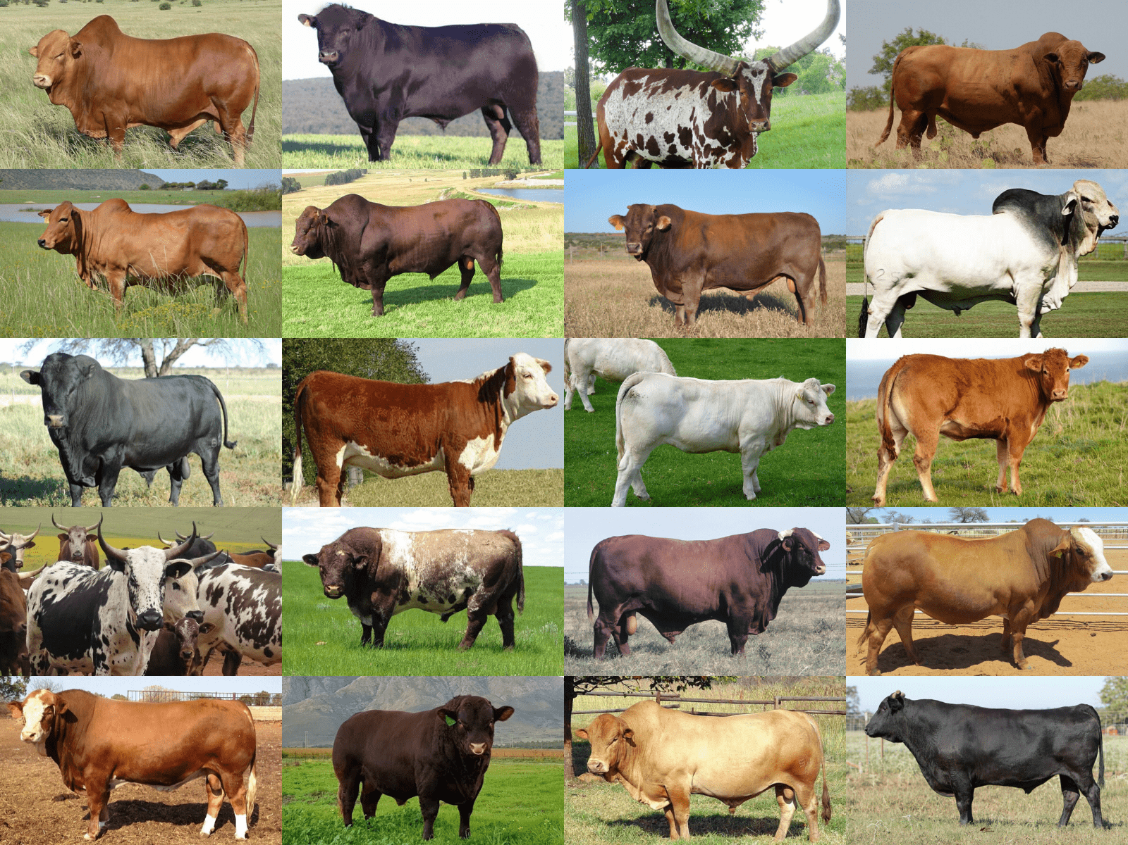
Livestock Breeds
A livestock breed is a group of animals with specific characteristics that are inherited from their ancestors. These characteristics may include size, growth rate, fertility, milk production, meat quality, wool or hide quality, and adaptation to local climate and diseases. In South Africa, farmers must select breeds based on their intended purpose, the environmental conditions, and resource availability. For example, indigenous cattle breeds such as Nguni are well adapted to heat, drought, and tick-borne diseases, making them suitable for extensive farming systems, while exotic breeds like Holstein-Friesian dairy cows offer high milk production but require more intensive care and feeding. Similarly, Boer goats are preferred for meat production, while South African Angora goats are raised for mohair. Choosing the correct breed ensures animals perform optimally under the farm’s production system and environmental conditions.
Breeding Principles
Breeding involves the controlled mating of animals to improve desirable traits and maintain herd or flock performance. Effective breeding management requires knowledge of genetics, reproductive physiology, and production objectives. Key principles include selecting superior males and females, maintaining genetic diversity, avoiding inbreeding, and matching breeding methods to production goals. For a mixed crop and livestock farm, breeding plans must align with seasonal feed availability, market demands, and livestock production cycles.
Breeding Methods
There are several breeding methods used by farmers in South Africa:
- Natural Mating: Animals mate naturally under controlled conditions. This method is simple and cost-effective, especially in extensive or semi-intensive systems. However, it provides less control over genetic improvement and can limit selective breeding if superior sires are unavailable.
- Artificial Insemination (AI): AI involves manually inseminating females using semen from genetically superior males. This method allows farmers to access high-quality genetics without purchasing a bull, increases reproductive efficiency, and reduces the risk of transmitting disease. AI is widely used in dairy cattle and poultry but requires skilled labour, proper infrastructure, and careful timing.
- Controlled Mating / Selection Mating: Farmers select which males and females will mate to achieve specific production traits. This can be done through pen mating, hand mating, or rotational mating systems. Controlled mating helps improve traits such as growth rate, milk yield, fertility, or resistance to local diseases.
- Crossbreeding: Crossbreeding involves mating animals from different breeds to produce offspring with desirable traits from both parents. For example, crossbreeding indigenous Nguni cattle with exotic breeds can produce animals with improved growth and milk production while retaining adaptability to local conditions. Crossbreeding can enhance hybrid vigour (heterosis), leading to faster growth, higher fertility, and better disease resistance.
Genetics in Livestock Production
Genetics is the study of how traits are inherited from parents to offspring. Understanding basic genetic principles enables the farmer to improve herd or flock performance over time. Traits such as milk yield, growth rate, fertility, disease resistance, and meat quality are influenced by genetics. Farmers can use selection to enhance these traits by choosing superior animals as breeding stock. Genetic improvement programs often combine performance recording, pedigree analysis, and breeding strategies to achieve long-term gains.
Selection of Breeding Stock
Selecting animals for breeding requires evaluating physical characteristics, health status, production records, reproductive performance, and temperament. Healthy, well-adapted, and productive animals should be prioritized for breeding. For example, dairy cows with high milk yield, good udder structure, and fertility should be selected, while beef cattle should show good growth rates, strong skeletal structure, and disease resistance. Proper selection ensures that desirable traits are passed on to future generations, improving overall herd or flock performance.
Record-Keeping in Breeding and Genetics
Maintaining accurate records is critical in livestock breeding. Farmers should record parentage, birth dates, weights, milk production, reproductive events, health treatments, and performance of offspring. This information allows farmers to track genetic progress, identify superior animals, plan matings, and prevent inbreeding. Records also support farm planning, decision-making, and compliance with regulatory requirements or breed societies in South Africa.
Integration with Farm Systems
For a mixed crop and livestock farm, breeding decisions must align with other farm activities. Feed availability, labour capacity, housing, and market requirements influence when and how animals are bred. Crop residues and fodder can support pregnant and lactating animals, while offspring may be raised for sale, meat, or replacement stock. Integrating genetics and breeding management with the broader farm system ensures optimal resource use and farm sustainability.
Understanding livestock breeds, breeding methods, and genetics allows a mixed crop and livestock farmer in South Africa to improve animal performance, productivity, and farm profitability. By selecting suitable breeds, applying controlled and strategic breeding methods, and managing genetic improvement through careful selection and record-keeping, the farmer can produce healthy, productive animals adapted to local conditions. Effective breeding and genetic management are therefore fundamental to sustainable and profitable livestock production, supporting both market and farm needs while maintaining long-term herd or flock quality.

KT0204 Calving, Lambing, Kidding, Furrowing, and Laying Season
The calving, lambing, kidding, furrowing, and laying season refers to the period when animals reproduce and give birth or produce eggs, marking a critical stage in livestock production management. For a mixed crop and livestock farmer in South Africa, managing these reproductive events is vital to ensure herd or flock productivity, animal health, feed efficiency, and farm profitability. This period requires careful planning, monitoring, and support to optimize survival rates of offspring, milk production, and future productivity of the herd or flock. Understanding the timing, preparation, and management of reproductive seasons is essential for aligning breeding programs, feed availability, and labour resources with the farm’s production goals.
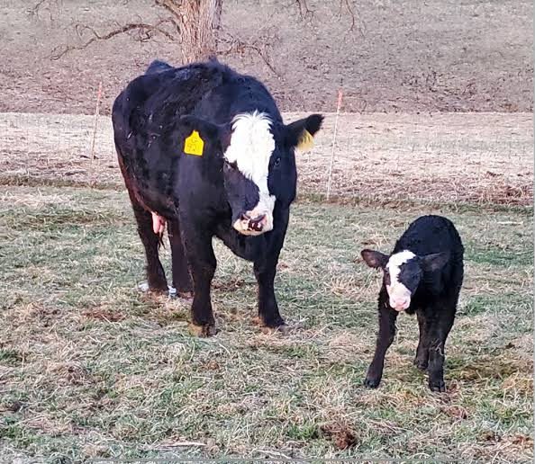
1. Calving (Cattle):
Calving is the process of a cow giving birth to a calf. For mixed farmers, proper calving management ensures the survival of both the cow and the calf and sets the stage for high future productivity. Timing of calving is crucial and should coincide with periods of abundant feed availability, usually following the rainy season when pastures are green and nutritious. Farmers must provide a clean, safe, and sheltered calving environment to reduce stress, prevent disease, and minimize calf mortality. Calving management includes monitoring cows for signs of labour, assisting with difficult births, ensuring colostrum intake by the newborn, and providing veterinary care if necessary. Accurate record-keeping of calving dates, calf sex, birth weight, and cow health supports future breeding and herd management decisions.
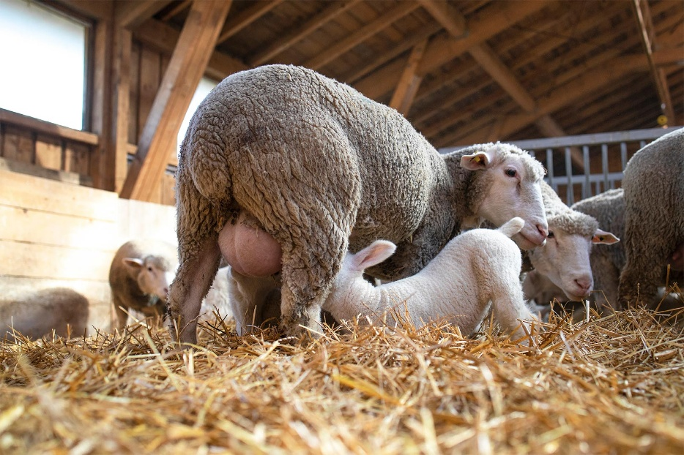
2. Lambing (Sheep):
Lambing is the birth of lambs, usually occurring after a gestation period of approximately five months. Successful lambing depends on proper nutrition of ewes before and during pregnancy, good shelter, and close supervision during birth. Farmers should prepare lambing pens to provide warmth and protection from predators and harsh weather. Assistance may be required during difficult births, and lambs must receive colostrum promptly to ensure immunity and survival. Synchronizing lambing with periods of high pasture availability reduces feed stress and supports rapid growth. Proper management during lambing also reduces ewe mortality and enhances future reproductive efficiency.
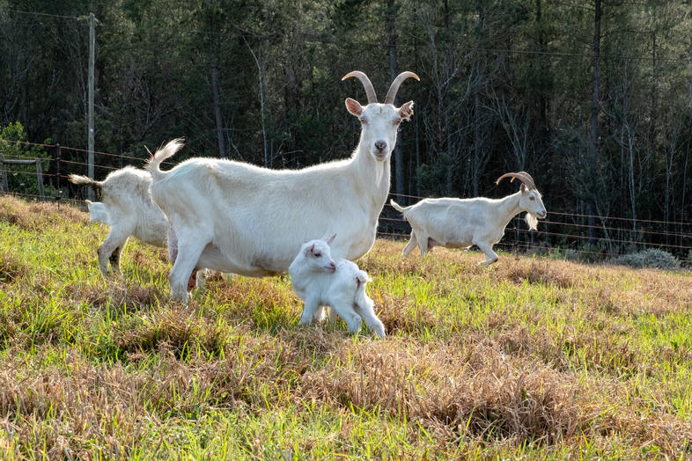
3. Kidding (Goats):
Kidding is the birth of kids in goats. Similar to lambing, successful kidding requires proper planning, adequate nutrition, and shelter. Goats often have multiple births, so special attention is needed to ensure all kids survive and receive enough colostrum. Farmers must also monitor for complications such as dystocia (difficult birth), and maintain hygiene to prevent infections in both does and kids. Aligning kidding with periods of high-quality forage ensures lactating does can produce sufficient milk for their offspring. Proper kidding management contributes to herd growth, income, and long-term productivity.
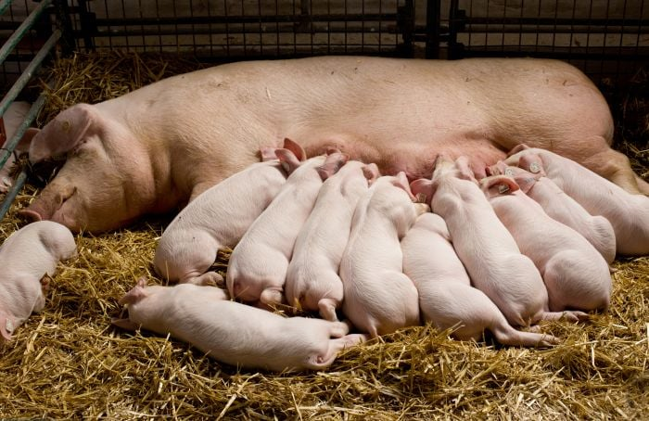
4. Furrowing (Pigs):
Furrowing is the process of sows giving birth to piglets. Piglets are highly vulnerable at birth, and sows require clean, dry, and warm farrowing pens to prevent chilling and mortality. Management includes supervising sows during farrowing, assisting with difficult births, ensuring piglets receive colostrum, and reducing the risk of crushing by the sow. Feed intake of pregnant sows must be optimized during gestation and lactation to support both the sow’s health and piglet growth. Planning the farrowing season to coincide with available feed resources and manageable farm labour ensures better survival rates and growth performance.
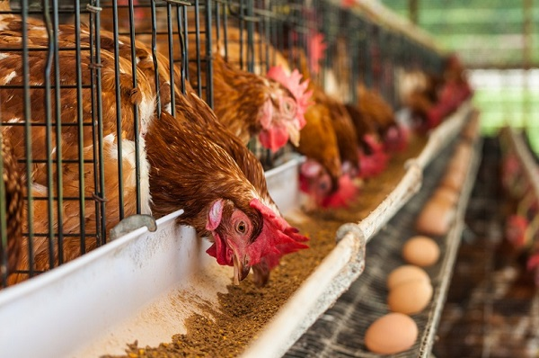
5. Laying Season (Poultry):
The laying season refers to the period when hens produce eggs. Egg production is influenced by breed, age, nutrition, lighting, temperature, and general health. Managing the laying season involves providing balanced feed rich in protein, calcium, and essential vitamins to support consistent egg production. Proper lighting schedules encourage regular laying, while clean housing and nesting areas reduce disease risk and improve egg quality. Monitoring egg production trends allows farmers to adjust feed, lighting, and flock management practices to maintain efficiency and productivity.
Key Management Considerations for Reproductive Seasons:
- Nutrition: Animals require higher-quality feed before, during, and after giving birth or during peak egg production. Adequate energy, protein, vitamins, and minerals are essential for reproductive performance, lactation, and offspring growth.
- Health Care: Vaccinations, deworming, and disease prevention strategies must be implemented prior to the reproductive season. Health monitoring during and after birth reduces mortality and ensures rapid recovery.
- Shelter and Environment: Clean, dry, and safe shelters reduce stress and protect both mothers and offspring from weather, predators, and disease. Proper ventilation, bedding, and hygiene are critical.
- Timing: Synchronizing reproductive events with feed availability, favourable climatic conditions, and labour availability improves survival rates, animal welfare, and productivity. For instance, calving or lambing at the beginning of the rainy season provides optimal grazing conditions.
- Monitoring and Assistance: Farmers should observe animals closely for signs of labour, complications, or distress. Assistance during difficult births or provision of supplemental feed and water is often necessary.
- Record-Keeping: Documenting reproductive events, birth outcomes, offspring survival, and maternal performance is essential for future breeding decisions, herd or flock improvement, and farm planning.
Integration with Mixed Farming Systems:
In a mixed crop and livestock system, reproductive seasons should be integrated with crop production. Crop residues can provide feed for pregnant or lactating animals, while offspring may utilize conserved fodder. Efficient coordination ensures that feed, labour, and shelter resources are available at critical times, supporting both animal and crop production.
The calving, lambing, kidding, furrowing, and laying season represents a critical window in livestock production, requiring careful planning, supervision, and support. Proper management ensures high survival rates, good growth, optimal milk or egg production, and overall herd or flock productivity. For a mixed crop and livestock farmer in South Africa, aligning reproductive events with feed availability, climatic conditions, and labour resources enhances farm efficiency, profitability, and sustainability. Effective reproductive season management is therefore central to achieving long-term success in livestock farming.
KT0205 Animal Identification
Animal identification is the process of assigning a unique mark, tag, or code to individual animals within a herd or flock to distinguish them from one another. For a mixed crop and livestock farmer in South Africa, proper animal identification is critical for effective livestock management, traceability, breeding, health monitoring, and compliance with legal and market requirements. Identification allows the farmer to track an animal’s growth, health history, reproduction, production performance, and lineage, which improves decision-making, resource allocation, and overall farm productivity.
The main purpose of animal identification is to create a reliable system that links each animal to its records. This is essential for breeding programs, as it enables the farmer to select animals with superior traits, monitor genetic performance, prevent inbreeding, and evaluate the results of crossbreeding. Identification also supports health management by keeping track of vaccinations, deworming schedules, treatments, and disease outbreaks. For mixed farming operations, proper animal identification ensures that animals are managed efficiently across different production systems, such as separating lactating cows from dry cows, or broiler chickens from layers.
Methods of Animal Identification:
- Ear Tags: These are the most common and widely used identification method. Tags are attached to the ear of the animal and can be plastic or metal. Each tag carries a unique number, code, or barcode, allowing for easy visual identification. Ear tags are commonly used in cattle, goats, sheep, and pigs.
- Branding: This method involves marking the animal’s skin with a hot or freeze brand to create a permanent identification mark. Branding is often used in extensive cattle systems, particularly in South Africa, where large herds graze over communal or private rangelands. Branding ensures permanent identification even if tags are lost.
- Tattoos: Tattooing is a method of injecting ink into the skin, usually on the ear or inner lip of an animal. It provides permanent identification and is commonly used in pigs, goats, and some cattle operations. Tattoos are especially useful for breeding stock or animals involved in pedigree programs.
- Collars and Neckbands: Collars or neckbands with engraved numbers, electronic tags, or RFID chips can be used for short-term identification or in situations where animals need frequent monitoring. This method is often applied to goats, sheep, or horses.
- Electronic Identification (EID): Modern systems include microchips, RFID tags, and electronic ear tags that store animal-specific information. These systems allow farmers to scan animals quickly, access digital records, and integrate with farm management software. EID is particularly useful for large herds or commercial operations requiring traceability and compliance with export regulations.
Benefits of Animal Identification:
- Health and Disease Management: Accurate identification ensures that vaccinations, deworming, and treatments are correctly administered and tracked. It also helps in controlling disease outbreaks by allowing affected animals to be isolated.
- Breeding and Genetic Improvement: Identification enables farmers to select the best animals for breeding based on performance records, lineage, and reproductive history. This improves herd genetics and long-term productivity.
- Production Monitoring: Farmers can track growth rates, milk yield, egg production, wool quality, or weight gain for individual animals, which allows for performance comparisons and better resource allocation.
- Record-Keeping and Compliance: Proper identification supports accurate record-keeping for farm management, regulatory compliance, livestock movement control, and participation in formal markets or export programs. In South Africa, cattle identification is linked to national traceability requirements to prevent and manage diseases like Foot-and-Mouth Disease (FMD).
- Management Efficiency: Identification simplifies herd or flock management, especially for feeding, separating different classes (e.g., lactating vs. dry cows), culling, and sale of animals. It reduces errors and labour during routine farm operations.
Implementation Considerations:
- Selection of Method: The identification method should suit the species, farm size, production system, and management objectives. For example, ear tags and RFID are ideal for dairy cattle, while branding may be better for extensive beef systems.
- Record Integration: Each identification mark must be linked to accurate records including birth date, breed, sex, health history, production data, and reproductive information.
- Animal Welfare: The chosen method must minimize stress, pain, and infection risk. Proper handling and hygiene during tagging, tattooing, or branding are essential.
- Maintenance and Monitoring: Tags, collars, or electronic devices should be checked regularly to ensure they remain legible and functional. Replacement procedures must be in place for lost or damaged identifiers.
Integration with Mixed Farming:
In a mixed crop and livestock farm, animal identification also supports the integration of crop residues and fodder use. For example, it allows the farmer to allocate feed based on the nutritional needs of individual animals, monitor feed efficiency, and prevent overuse of limited resources. It also aids in separating animals intended for sale from those kept for breeding or household use.
Animal identification is a cornerstone of effective livestock management. For a mixed crop and livestock farmer in South Africa, it enables proper monitoring of animal health, reproduction, growth, and productivity. By implementing suitable identification systems and linking them to detailed records, farmers can improve decision-making, support genetic improvement programs, ensure traceability and regulatory compliance, and enhance overall farm efficiency and profitability. Proper identification is therefore a fundamental tool for sustainable and productive livestock farming.

KT0206 Animal Processing
Animal processing refers to the methods and procedures used to convert livestock into consumable products such as meat, milk, eggs, wool, hides, and other by-products. For a mixed crop and livestock farmer in South Africa, understanding animal processing is essential because it adds value to livestock, extends shelf life, improves marketability, and supports farm profitability. Proper processing techniques ensure that products meet safety, quality, and regulatory standards while maximising economic returns and reducing waste.
1. Meat Processing:
Meat processing involves the slaughtering, dressing, cutting, packaging, and storage of livestock for human consumption. For small- to medium-scale farmers, this may occur on-farm under controlled conditions or at licensed abattoirs. Key steps include humane handling of animals before slaughter to reduce stress and improve meat quality, proper stunning or slaughter techniques, bleeding, skinning or plucking, evisceration, and chilling to prevent microbial growth. In South Africa, compliance with legislation such as the Meat Safety Act is mandatory to ensure that meat is safe for human consumption. Good meat processing practices also include hygiene, record-keeping, and proper storage at controlled temperatures.
2. Milk Processing:
Milk processing transforms raw milk into safe and consumable products such as pasteurized milk, yoghurt, cheese, butter, and other dairy products. For dairy farmers, proper milk handling begins on-farm with clean milking procedures, storage in sanitized containers, and rapid cooling to prevent bacterial growth. Pasteurization or other heat treatments are used to ensure safety and extend shelf life. Packaging, labelling, and storage conditions are also critical. Effective milk processing ensures high-quality dairy products, meets regulatory standards, and opens up opportunities for direct sales to consumers or processors.
3. Egg Processing:
Egg processing includes collection, cleaning, grading, packaging, and storage. Hens must be monitored during the laying season, and eggs collected regularly to prevent breakage or contamination. Eggs are washed, disinfected, and sorted according to size and quality before being packed in clean cartons. Proper storage at low temperatures reduces spoilage and maintains quality. For farmers selling eggs locally, maintaining hygiene and correct labelling is essential for customer safety and satisfaction.
4. Wool and Fibre Processing:
In sheep and goat farming, processing involves shearing, cleaning, grading, and storing wool or mohair. Wool processing starts with careful shearing to avoid injury to the animal, followed by removal of dirt, grease, and vegetable matter. Grading sorts fibres by length, texture, and quality. Proper processing improves the value of the fibre, allows access to commercial markets, and maximises returns.
5. Hides and Skins:
Processing of hides and skins involves cleaning, curing, drying, and sometimes tanning to produce leather or other products. Proper handling after slaughter prevents damage and contamination. In South Africa, hides and skins can be sold to tanneries, generating additional income for livestock farmers.
6. Animal By-Products:
Processing also includes handling by-products such as blood, bones, offal, and manure. These can be used as fertilizers, animal feed, or industrial products, reducing waste and improving farm sustainability. For example, manure from cattle, goats, or poultry can be composted and applied to crop fields to enhance soil fertility.
Key Considerations in Animal Processing:
- Hygiene and Sanitation: Proper cleaning of facilities, tools, and equipment prevents contamination and ensures food safety. Farmers must follow strict hygiene protocols during slaughter, milking, egg collection, and fibre handling.
- Animal Welfare: Humane handling and slaughter methods are essential to reduce stress and suffering, which also improves the quality of meat and other products.
- Quality Control: Monitoring temperature, storage, and processing techniques ensures that products meet quality standards and consumer expectations.
- Compliance with Regulations: Farmers must adhere to South African legislation such as the Meat Safety Act, Animal Health Act, and Department of Agriculture regulations to ensure products are legally marketable and safe for consumption.
- Value Addition: Processing increases the economic value of livestock products. For example, milk can be processed into cheese or yoghurt, and wool can be cleaned and sold as premium fibre.
- Integration with Farm Management: Processed products must be planned according to production cycles, market demand, and storage capacity. For mixed crop and livestock farmers, integrating crop production with feed resources ensures that livestock are healthy and productive for processing purposes.
Animal processing is a crucial component of livestock production management. For a mixed crop and livestock farmer in South Africa, it transforms raw animal products into safe, marketable, and high-value commodities while supporting farm profitability and sustainability. Effective processing requires proper handling, hygiene, compliance with regulations, and strategic planning. By mastering animal processing, farmers can maximise returns, reduce waste, and contribute to food security and economic development.

Internal Assessment Criteria (IAC) and Weight
IAC0201 – Different Types of Production Systems
Livestock production systems are the methods by which animals are raised to achieve specific production goals, and they vary according to climate, available resources, market demand, and farming objectives. In South Africa, common production systems include:
- Extensive systems – Animals graze on natural pastures over large areas with minimal human intervention. Common for beef cattle and sheep in arid or semi-arid regions. This system relies on natural forage, has lower input costs, but can be affected by drought and disease.
- Intensive systems – Animals are confined and managed closely, with controlled feeding, housing, and veterinary care. Typical in poultry, pigs, dairy, and feedlot operations. This system allows higher production per animal but requires more labour, capital, and biosecurity measures.
- Semi-intensive systems – A combination of grazing and supplemental feeding. Animals graze part-time and are provided additional feed or housing. This system balances low input costs with improved productivity.
Selecting the appropriate system depends on resources, climate, market demands, and the integration with crop production. Mixed crop and livestock farmers often use a combination to optimize land use and feed supply.

IAC0202 – Characteristics of Different Types of Animal Breeds
Animal breeds differ in appearance, productivity, adaptability, and suitability to local conditions. Characteristics include:
- Cattle: Beef breeds (e.g., Brahman, Angus) are selected for meat quality, growth rate, and adaptability, while dairy breeds (e.g., Holstein, Jersey) are chosen for milk yield and lactation length.
- Sheep: Wool breeds (e.g., Merino) are selected for fibre quality, while meat breeds (e.g., Dorper) are for rapid growth and carcass quality.
- Goats: Dairy (e.g., Saanen) vs. meat breeds (e.g., Boer) differ in milk or meat production traits.
- Poultry: Broilers for meat, layers for egg production, with hybrids optimized for feed efficiency and growth.
Understanding breed characteristics helps the farmer choose animals suited to the environment, resources, and market, ensuring efficient production and sustainable management.

IAC0203 – Production Calendar and Its Activities
A production calendar organizes all livestock activities throughout the year to ensure optimal productivity and animal health. It includes:
- Feeding schedules – Adjusted for seasonal pasture availability or supplemental feeding periods.
- Breeding cycles – Timing mating and calving/lambing to coincide with feed availability.
- Vaccination and health programs – Scheduled to prevent disease outbreaks.
- Weaning, shearing, or milking periods – Ensuring animal growth and productivity targets.
The calendar allows the farmer to anticipate labour, feed, and financial requirements, coordinate crop-livestock interactions (e.g., grazing residues, manure application), and maintain a sustainable production system.

IAC0204 – Gestation for Various Animals
Gestation is the period during which an animal carries developing offspring. The length varies by species:
- Cattle: ~280 days
- Sheep: ~147 days
- Goats: ~150 days
- Pigs: ~114 days
- Horses: ~340 days
- Poultry: N/A (egg-laying species have incubation instead)
Understanding gestation periods allows the farmer to plan breeding, nutrition, housing, and labour requirements so that offspring are born during favourable environmental conditions and adequate feed availability.

IAC0205 – Mating Seasons for Various Animals
Mating or breeding seasons are periods when animals are naturally or artificially bred to optimize fertility and offspring survival. Examples:
- Cattle: Can breed year-round, but in seasonal systems, mating is aligned with feed availability.
- Sheep: Often seasonal breeders, with mating in autumn to produce spring lambs.
- Goats: Typically breed seasonally (autumn or winter) in temperate climates.
- Pigs: Non-seasonal breeders; can breed throughout the year.
Aligning mating with seasons ensures that young are born when feed and environmental conditions are favourable, reducing mortality and improving growth rates.

IAC0206 – Breed Characteristics and Genetic Considerations in Breed Selection
Breed selection involves choosing animals with desirable traits for production, adaptability, and disease resistance. Genetic considerations include:
- Heredity: Selecting animals with superior genetic traits for milk, meat, or growth.
- Inbreeding avoidance: Maintaining genetic diversity to prevent weakness or disease susceptibility.
- Crossbreeding: Combining breeds to enhance hybrid vigour, such as improved fertility, growth, or hardiness.
For mixed farmers in South Africa, careful breed selection ensures livestock can thrive under local conditions while contributing to farm profitability and sustainable resource use.

IAC0207 – Importance and Methods of Dehorning
Dehorning is removing or preventing horn growth in livestock for safety and management purposes. Its importance includes:
- Reducing injuries to other animals, handlers, and infrastructure.
- Facilitating easier handling, feeding, and transport.
- Minimizing bruising of meat and damage to farm equipment.
Methods include:
- Physical removal – Using dehorning saws or shears.
- Chemical cauterization – Applying caustic paste on horn buds in young animals.
- Thermal cauterization – Using hot irons to destroy horn tissue.
Proper timing, usually when animals are young, and safe techniques are essential to reduce stress, pain, and infection risks.

IAC0208 – Importance of Animal Identification, Types, and Application
Animal identification is essential for record-keeping, breeding, health management, traceability, and legal compliance. Benefits include:
- Tracking parentage and genetics for breeding programs.
- Recording vaccinations, treatments, and disease management.
- Facilitating marketing and trade compliance.
Types of identification:
- Ear tags – Common for cattle, sheep, goats; easy to read and apply.
- Branding – Fire or freeze branding for permanent visual identification.
- Tattoos – Used in some breeds for legal registration.
- Electronic ID (RFID) – For automated data collection and herd management.
Proper application ensures efficient farm management, improved biosecurity, and compliance with South African livestock regulations.

KM-01-KT03 Sustainable grazing practices. 20%
Topic element
- KT0301 Importance of sustainable grazing practices
- KT0302 Location, climate, field and land types
- KT0303 Carrying capacity for livestock
- KT0304 Different grazing methods

KM-01-KT03 Sustainable Grazing Practices
Sustainable grazing practices are management strategies that ensure livestock have adequate feed while maintaining the long-term health, productivity, and biodiversity of grazing land. For a mixed crop and livestock farmer in South Africa, sustainable grazing is critical because it balances the nutritional needs of livestock with the conservation of natural resources, prevents land degradation, and ensures the farm remains productive for future generations. Proper grazing management improves pasture quality, soil fertility, water retention, and ecosystem resilience, which are especially important in South Africa’s diverse climates, ranging from arid regions to high-rainfall areas.
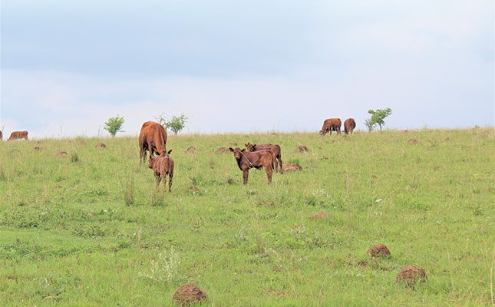
Principles of Sustainable Grazing
Sustainable grazing is based on several key principles that guide how livestock are allowed to use pastures:
- Carrying Capacity Assessment:
This involves determining the maximum number of livestock that can graze on a piece of land without causing overgrazing or soil degradation. Carrying capacity depends on pasture type, rainfall, soil fertility, and seasonal growth patterns. Farmers must regularly monitor pasture biomass and adjust stocking rates to match the land’s productive potential. Overstocking reduces plant cover, increases soil erosion, and depletes pasture resources, while understocking may lead to the growth of undesirable weeds and inefficient use of land.
- Rotational Grazing:
Rotational grazing involves dividing pasture into smaller paddocks and moving livestock between them on a scheduled basis. This allows grazed areas time to recover, promotes even pasture use, and stimulates regrowth of nutritious forage. Rotational grazing improves soil structure, encourages plant diversity, and reduces the risk of pasture degradation. For mixed farmers, integrating rotational grazing with crop residues or forage crops can extend feed availability during dry periods.
- Rest Periods for Pastures:
Allowing pastures to rest after grazing ensures plants can recover energy reserves, develop roots, and grow new leaves. Rest periods are determined by pasture growth rates, season, and species composition. Proper rest periods increase the resilience of grasslands, prevent soil erosion, and support sustainable forage production for livestock.
- Mixed Species Grazing:
Using different livestock species on the same pasture can improve sustainability. For example, cattle, sheep, and goats graze differently: cattle prefer grasses, sheep graze short grass and forbs, while goats browse shrubs. This complementary grazing reduces the dominance of any one plant species, promotes biodiversity, and utilises feed resources efficiently.
- Supplementary Feeding and Fodder Conservation:
During periods of low pasture availability, such as dry seasons, farmers should provide supplementary feed, including conserved fodder, silage, hay, or crop residues. This reduces overgrazing and supports livestock productivity. Proper planning of supplementary feeding ensures that pastures are not depleted during critical periods.
- Water Management:
Access to clean water is essential for livestock and pasture health. Strategic placement of water points encourages even grazing and prevents overuse of areas near water sources, which are prone to soil compaction and erosion. Rotating livestock away from water points and providing multiple water sources helps distribute grazing pressure evenly.
- Soil Fertility Management:
Livestock grazing contributes nutrients to the soil through manure and urine. Sustainable grazing includes returning organic matter to the soil, using rotational grazing to distribute manure evenly, and supplementing soil nutrients through compost or fertilizer as needed. Maintaining soil fertility supports healthy pasture growth and improves forage quality for livestock.
- Monitoring and Record-Keeping:
Farmers must regularly monitor pasture condition, forage growth, livestock performance, and environmental impacts. Keeping records of stocking rates, grazing patterns, rainfall, and pasture condition allows for informed decision-making, adaptive management, and long-term sustainability. Monitoring ensures that corrective actions, such as reducing stock or resting paddocks, are taken before damage occurs.

Benefits of Sustainable Grazing Practices:
- Improved Pasture Productivity: Healthy pastures produce more nutritious and abundant forage, increasing livestock growth, reproduction, and milk production.
- Soil Conservation: Sustainable grazing reduces soil erosion, maintains soil structure, and improves water retention.
- Biodiversity Preservation: Proper grazing management promotes diverse plant species and habitats for wildlife.
- Climate Resilience: Well-managed pastures are more resilient to drought and extreme weather events.
- Economic Efficiency: Sustainable grazing reduces the need for expensive feed inputs, improves livestock performance, and increases profitability over time.
Integration with Mixed Crop and Livestock Systems:
In a mixed farming system, sustainable grazing complements crop production. Crop residues can be grazed or conserved for feed, while livestock manure fertilizes crop fields. Planning grazing rotations around crop fields, fodder plots, and water availability ensures optimal resource use. This integration supports the long-term sustainability and profitability of the entire farm.
Sustainable grazing practices are essential for balancing livestock production with environmental stewardship. For a mixed crop and livestock farmer in South Africa, these practices ensure that pastures remain productive, soil fertility is maintained, and ecosystems are preserved. By implementing rotational grazing, monitoring stocking rates, managing feed and water resources, and integrating livestock with crop production, farmers can achieve high productivity while protecting their land for future generations. Sustainable grazing is therefore both an ecological and economic strategy that underpins long-term farm success.

KT0301 Importance of Sustainable Grazing Practices
Sustainable grazing practices are critical for ensuring that livestock production is both productive and environmentally responsible. For a mixed crop and livestock farmer in South Africa, implementing sustainable grazing practices is essential for maintaining pasture health, improving livestock performance, and securing long-term farm profitability. The importance of sustainable grazing extends beyond immediate farm outputs—it also contributes to soil conservation, biodiversity, climate resilience, and overall farm sustainability.
1. Maintaining Pasture Productivity and Quality:
Sustainable grazing practices, such as rotational grazing, controlled stocking rates, and rest periods, ensure that pastures remain productive and provide high-quality forage for livestock. Overgrazing can lead to the depletion of desirable grass species, reduced forage availability, and a decline in nutrient content, which negatively impacts livestock growth, reproduction, and milk production. By managing grazing intensity and timing, farmers preserve the health and productivity of their pastures, ensuring a steady and nutritious food source for their animals throughout the year.
2. Soil Conservation and Land Protection:
Proper grazing management prevents soil degradation caused by trampling, compaction, and erosion. Overgrazed land often suffers from bare patches, reduced soil fertility, and water runoff, which decreases the land’s carrying capacity. Sustainable grazing practices, such as rotational grazing and providing rest periods for pastures, allow soil to recover, maintain organic matter, and support the growth of deep-rooted grasses that stabilize the land. In the long term, this protects the farm’s most important resource—its soil—ensuring continued productivity and profitability.
3. Enhancing Biodiversity:
Sustainable grazing encourages a diversity of plant species, which supports a healthy ecosystem. Different grazing pressures, combined with mixed-species livestock grazing (e.g., cattle, sheep, and goats), prevent any single species from dominating the pasture, allowing shrubs, forbs, and grasses to thrive. Biodiverse pastures provide multiple benefits, including improved forage variety, habitats for wildlife, and increased resilience to pests and diseases. For South African farmers, biodiversity also helps maintain ecological balance in rangelands and protects indigenous plant species.
4. Supporting Climate Resilience:
Well-managed grazing systems improve the resilience of farmland to climate variability, such as droughts or extreme rainfall. Healthy pastures with deep-rooted grasses retain soil moisture, reduce surface runoff, and recover more quickly from adverse weather conditions. Sustainable grazing also enhances carbon sequestration in soils, contributing to climate change mitigation. By protecting pastures from overuse and degradation, farmers safeguard their livestock’s feed supply during periods of environmental stress.
5. Economic Benefits and Resource Efficiency:
Sustainable grazing practices increase the efficiency of resource use, reducing the need for purchased feed or fertilizers. By optimising pasture growth and livestock productivity, farmers can maintain healthy animals without overexploiting land or incurring unnecessary costs. Improved livestock performance—including growth rates, milk yield, and reproductive success—directly translates to higher income and profitability. Furthermore, sustainable grazing supports long-term farm viability by preventing costly land rehabilitation or loss of grazing potential.
6. Compliance and Market Access:
In South Africa, proper land and livestock management, including sustainable grazing, is increasingly linked to regulatory requirements and market standards. Farms that implement sustainable practices are better positioned to access premium markets, participate in eco-certification programs, or comply with government guidelines on land and livestock management. These advantages improve the farm’s reputation, marketability, and long-term competitiveness.
7. Integration with Mixed Farming Systems:
For mixed crop and livestock farmers, sustainable grazing is vital for integrating livestock with crop production. Crop residues can be grazed or stored for feed, while manure from livestock enhances soil fertility for crops. Proper grazing ensures that livestock do not overuse crop residues or rangelands, maintaining a balanced system where both crops and livestock benefit. This integration maximizes resource use efficiency, reduces waste, and enhances overall farm sustainability.
The importance of sustainable grazing practices cannot be overstated. For mixed crop and livestock farmers in South Africa, these practices preserve pasture productivity, protect soil, enhance biodiversity, improve climate resilience, and increase economic returns. Sustainable grazing is not only an ecological necessity but also a practical strategy for maintaining farm efficiency, profitability, and long-term viability. By adopting careful planning, monitoring, and adaptive management, farmers ensure that their grazing lands continue to support productive livestock and healthy ecosystems for generations to come.

KT0302 Location, Climate, Field, and Land Types
Understanding the location, climate, field, and land types is fundamental for effective crop and livestock production, especially for a mixed crop and livestock farmer in South Africa. These factors influence what species and breeds can be raised, which crops can be grown, and how farm resources are managed. Effective management requires integrating knowledge of environmental conditions with sustainable farming practices to optimise productivity, profitability, and long-term resilience.
1. Location:
The geographic location of a farm determines access to markets, availability of water, soil types, and natural resources. Location also influences the prevalence of pests, diseases, and the suitability of certain livestock breeds or crop varieties. For instance, farms in the Highveld have cooler temperatures and higher rainfall than those in the Karoo, which is semi-arid. Location affects farm logistics, including transportation of inputs and outputs, proximity to abattoirs or milk processors, and access to agricultural support services. For mixed farmers, choosing suitable livestock and crops that are adapted to the location ensures better survival, productivity, and efficiency.
2. Climate:
Climate includes temperature, rainfall, humidity, wind patterns, and seasonal variability. It plays a critical role in determining pasture growth, crop yields, water availability, and livestock health. South Africa has diverse climatic zones:
- Arid and semi-arid regions (e.g., parts of Northern Cape) require drought-tolerant livestock breeds and hardy crops.
- High rainfall regions (e.g., KwaZulu-Natal) support intensive crop production and high-yielding dairy or beef systems.
- Temperate regions (e.g., Western Cape) are ideal for vineyards, fruits, and mixed livestock production.
Farmers must plan grazing, planting, and breeding schedules according to climate patterns to optimise feed and forage availability and reduce risks from droughts, heat stress, or floods. Climate-smart practices, such as water harvesting, irrigation, and shade provision, help manage adverse conditions.
3. Field Types:
Field types refer to the configuration, size, and management potential of arable land or grazing areas on a farm. Fields can be classified based on slope, soil fertility, drainage, and exposure to sun and wind. For example, flat, fertile fields are ideal for crop cultivation, whereas sloped or less fertile areas may be better suited for grazing or fodder production. Proper understanding of field types allows farmers to match crops and livestock production to land capacity, reduce erosion risks, and optimise resource allocation. Rotational grazing, crop rotation, and field zoning are examples of strategies that maximise the productivity of each field type.
4. Land Types:
Land types refer to the broader categorisation of land based on soil, vegetation, and topography. In South Africa, land types include:
- Arable land: Suitable for crops and fodder production due to fertile soils and favourable drainage.
- Rangeland/pastureland: Grasslands used primarily for livestock grazing. These can be natural or improved pastures.
- Bushveld/veld: Semi-natural areas that may support mixed grazing or browse for goats.
- Mountainous or rocky land: Typically unsuitable for crops, may be used for extensive grazing.
Understanding land types enables farmers to plan land use sustainably, avoiding overgrazing, soil degradation, and erosion. It also helps in determining which areas can support irrigation, mechanised farming, or conservation efforts.
5. Integration with Farm Management:
Farmers must consider the interaction between location, climate, field, and land types when making management decisions. For example:
- Selecting livestock breeds adapted to local climate and land type.
- Rotating crops or grazing livestock based on field fertility and pasture recovery rates.
- Using drought-resistant crops in arid areas and shade or cooling measures for livestock in hot climates.
- Planning infrastructure such as water points, shelters, and storage facilities according to field accessibility and land type.
6. Environmental and Sustainability Considerations:
Understanding these factors also supports sustainable farming practices. Properly matching livestock and crops to the land and climate reduces resource overuse, prevents soil degradation, and preserves biodiversity. It also supports resilience against climate change impacts such as erratic rainfall, extreme temperatures, or invasive species.
Knowledge of location, climate, field, and land types is essential for effective decision-making on a mixed crop and livestock farm in South Africa. These factors determine which crops and livestock are suitable, influence production schedules, guide resource allocation, and affect farm profitability and sustainability. By integrating this understanding with adaptive and sustainable management practices, farmers can optimise productivity, protect the environment, and ensure long-term farm resilience.

KT0303 Carrying Capacity for Livestock
Carrying capacity is a key concept in livestock production and sustainable grazing management. It refers to the maximum number of animals that a particular piece of land can support over a specific period without causing long-term damage to the pasture, soil, or ecosystem. For a mixed crop and livestock farmer in South Africa, understanding and managing carrying capacity is essential to balance livestock productivity with environmental sustainability, prevent overgrazing, and maintain farm profitability over time.
1. Definition and Importance:
Carrying capacity is typically expressed as the number of livestock units (LU) per hectare that a pasture can support. A livestock unit standardizes different species based on their feed requirements—for example, one adult cow may equal one livestock unit, whereas one sheep may equal 0.1–0.2 LU. Understanding carrying capacity allows farmers to make informed decisions about stocking rates, pasture rotation, supplementary feeding, and land management. Exceeding the carrying capacity leads to overgrazing, soil erosion, pasture degradation, and reduced animal productivity, while understocking can result in underutilization of resources and inefficient farm operations.
2. Factors Affecting Carrying Capacity:
Several environmental, biological, and management factors influence the carrying capacity of a farm:
- Pasture Type and Quality: Different grasses and forage plants provide varying nutritional value and biomass. Improved pastures with high-yielding grasses support more livestock than natural rangelands.
- Soil Fertility: Fertile soils produce more forage, increasing carrying capacity. Poor soils with low nutrient content may require fertilization or reduced stocking rates.
- Climate and Rainfall: Seasonal and annual rainfall patterns affect pasture growth. During dry periods, carrying capacity decreases due to reduced forage availability.
- Grazing Management: Practices such as rotational grazing, rest periods, and mixed-species grazing influence pasture recovery and productivity. Well-managed pastures can support more livestock sustainably.
- Animal Type and Size: Different livestock species and breeds have varying feed requirements. Larger or high-producing animals require more forage than smaller or less productive animals.
3. Calculating Carrying Capacity:
Carrying capacity is calculated using forage availability, livestock nutritional requirements, and pasture utilization efficiency. A simple method involves:
- Estimating the total biomass of available forage on the land.
- Determining the daily feed requirement per livestock unit.
- Considering the proportion of forage that can be sustainably consumed without damaging the pasture (typically 40–60%).
For example, if a 10-hectare pasture produces 5,000 kg of dry matter per hectare per season, and each livestock unit requires 10 kg of dry matter per day, the farmer can calculate how many animals the pasture can support sustainably over the season.
4. Implications of Exceeding Carrying Capacity:
Exceeding the land’s carrying capacity has serious consequences:
- Overgrazing: Reduces grass cover and prevents regrowth, leading to degraded pastures.
- Soil Erosion: Bare soil is prone to wind and water erosion, reducing soil fertility and long-term productivity.
- Reduced Animal Productivity: Limited forage leads to poor growth, lower milk production, reduced fertility, and higher susceptibility to disease.
- Biodiversity Loss: Overgrazing can result in the disappearance of desirable plant species and the dominance of weeds or unpalatable vegetation.
5. Benefits of Maintaining Appropriate Carrying Capacity:
Maintaining stocking rates within the carrying capacity has several benefits:
- Ensures sustainable forage availability for livestock year-round.
- Promotes healthy pastures with high-quality nutrition, supporting growth and reproduction.
- Prevents land degradation and preserves soil fertility for future production.
- Reduces the need for expensive supplementary feeding or land rehabilitation.
- Supports biodiversity and environmental conservation.
6. Integration with Mixed Farming:
For a mixed crop and livestock farmer, understanding carrying capacity is essential for integrating crops and livestock. Crop residues can supplement feed during low forage periods, while manure from livestock improves soil fertility for crops. Adjusting livestock numbers according to pasture availability ensures that both crop and livestock enterprises are productive and sustainable. Carrying capacity calculations should be revisited each season to account for changes in pasture growth, rainfall, and livestock productivity.
Carrying capacity is a critical tool for sustainable livestock management. By understanding the maximum number of animals that land can support, a mixed crop and livestock farmer in South Africa can prevent overgrazing, maintain pasture and soil health, and optimise animal performance. Properly managing carrying capacity ensures that livestock production remains profitable while preserving natural resources, supporting long-term sustainability, and integrating effectively with crop production systems.

KT0304 Different Grazing Methods
Grazing methods are strategies used to manage how livestock feed on pastures, ensuring optimal forage utilization, animal performance, and land sustainability. For a mixed crop and livestock farmer in South Africa, understanding and applying the appropriate grazing methods is crucial for balancing livestock nutrition, pasture productivity, and environmental conservation. Different grazing methods influence pasture regrowth, soil health, livestock growth, and overall farm profitability.
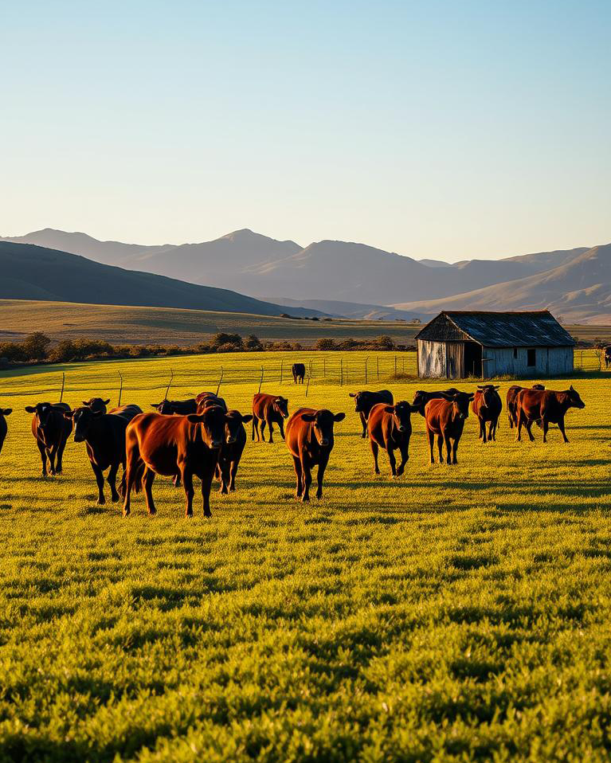
1. Continuous Grazing (Set Stocking):
Continuous grazing, also called set stocking, is a method where livestock are allowed to graze a specific pasture area continuously without rotation. Animals have unrestricted access to the entire paddock throughout the grazing season.
- Advantages:
  - Requires less management and labour.
  - Simple to implement, suitable for extensive systems with large rangelands.
- Disadvantages:
  - Overgrazing of preferred plants can occur, leading to pasture degradation.
  - Reduced pasture regrowth and uneven forage utilization.
  - Soil erosion may increase in heavily grazed areas.
- Use Case: Common in semi-arid or extensive grazing systems where labour is limited and land is abundant.
2. Rotational Grazing (Paddock Grazing):
Rotational grazing involves dividing pasture into smaller paddocks and moving livestock from one paddock to another on a planned schedule. Each paddock is grazed for a limited time and then allowed to rest, promoting pasture recovery.
- Advantages:
  - Improves pasture regrowth and sustainability.
  - Promotes uniform grazing and reduces selective feeding.
  - Enhances forage quality and availability.
  - Reduces soil erosion and maintains biodiversity.
- Disadvantages:
  - Requires more labour, fencing, and water points.
  - Careful planning is needed to match grazing periods with pasture growth.
- Use Case: Suitable for mixed crop and livestock systems where high-quality pasture is needed to support intensive or semi-intensive livestock production.
3. Strip Grazing:
Strip grazing is a form of intensive rotational grazing where livestock are given access to a narrow strip of pasture at a time, usually using temporary electric fencing. Livestock consume all the forage in the strip before moving to the next section.
- Advantages:
  - Maximizes pasture utilization and reduces waste.
  - Encourages even grazing and better manure distribution.
  - Pasture regrowth is faster due to controlled grazing intensity.
- Disadvantages:
  - Requires regular movement of livestock and fencing adjustments.
  - Labour-intensive and may need planning for feed allocation.
- Use Case: Ideal for high-value pastures or limited grazing areas, especially during dry seasons or in intensive livestock operations.
4. Deferred or Rest-Rotation Grazing:
Deferred grazing involves resting a pasture area for a predetermined period before grazing. Rest periods are timed to allow plants to reach optimal growth or recover from previous grazing.
- Advantages:
  - Promotes pasture regrowth and long-term productivity.
  - Reduces overgrazing and improves soil health.
  - Can be combined with rotational grazing to increase flexibility.
- Disadvantages:
  - Requires careful planning and monitoring of pasture growth.
  - Rest periods may temporarily reduce available forage for livestock.
- Use Case: Used in regions with seasonal pasture growth, such as South Africa’s Highveld or dry areas, to ensure feed availability during critical periods.
5. Mob Grazing or High-Density Short-Duration Grazing:
Mob grazing is an intensive method where a high density of livestock grazes a small area for a very short period before being moved. This method mimics natural grazing patterns of wild herbivores.
- Advantages:
  - Stimulates pasture growth by trampling and distributing manure evenly.
  - Increases soil fertility and improves organic matter.
  - Enhances pasture biodiversity and resilience.
- Disadvantages:
  - Requires high labour input and careful planning.
  - May need temporary fencing and water access adjustments.
- Use Case: Effective for regenerating degraded pastures and integrating livestock with crop residues.
6. Selective or Targeted Grazing:
This method involves directing livestock to specific areas or plant species, usually to manage weeds, invasive plants, or crop residues. Goats, for example, are often used for browsing shrubs or weeds that cattle avoid.
- Advantages:
  - Controls unwanted vegetation naturally.
  - Reduces reliance on chemical herbicides.
  - Optimizes forage use by combining species with different feeding habits.
- Disadvantages:
  - Not suitable for general pasture management.
  - Requires close supervision and understanding of animal preferences.
- Use Case: Useful in mixed farming systems for weed control, pasture improvement, or utilizing crop residues efficiently.
7. Integration with Mixed Farming:
For mixed crop and livestock farmers, grazing methods should complement crop production. Livestock can graze cover crops, crop residues, or fodder plots after harvest, reducing waste and providing organic fertilizer to fields. Choosing the appropriate grazing method depends on pasture availability, season, livestock type, field size, and farm labour capacity.
Different grazing methods provide farmers with tools to manage pasture effectively, enhance livestock performance, and maintain environmental sustainability. For a mixed crop and livestock farmer in South Africa, understanding and applying the right grazing method—whether rotational, strip, mob, or selective grazing—ensures optimal forage utilization, prevents land degradation, supports biodiversity, and integrates livestock with crop production. Implementing these methods strategically improves both farm productivity and long-term sustainability.

Internal Assessment Criteria (IAC) and Weight
IAC0301 – Sustainable Grazing Practices
Sustainable grazing practices are strategies used to manage livestock on natural or cultivated pastures in a way that maintains or improves the productivity and health of the land over the long term. In South Africa, where grazing land (veld) forms the primary feed source for many livestock, sustainable practices prevent overgrazing, soil erosion, and degradation of plant biodiversity. Key practices include:
- Rotational grazing – Moving livestock between paddocks to allow pastures to recover after grazing.
- Proper stocking rates – Adjusting the number of animals according to the carrying capacity of the land.
- Monitoring veld condition – Regular observation of pasture height, species composition, and signs of erosion.
- Fertilization and reseeding – Applying nutrients and planting suitable forage species to maintain pasture productivity.
- Controlling invasive species and weeds – Preventing non-native plants from reducing pasture quality.
These practices ensure that livestock production is economically viable while preserving soil fertility, water retention, and biodiversity, making grazing sustainable for future generations.

IAC0302 – Different Climates for Various Geographical Areas of Grazing
South Africa has diverse climatic zones that influence the type and productivity of grazing. Understanding these climates helps the farmer manage pastures effectively:
- Arid and semi-arid regions (Karoo, parts of North West, Northern Cape): Low rainfall (200–500 mm/year) limits pasture growth. Grazing is sparse, requiring low stocking rates and drought-resilient species.
- Temperate grasslands (Free State, Highveld): Moderate rainfall (500–800 mm/year) supports natural grasses and rotational grazing systems.
- Subtropical and summer rainfall areas (KwaZulu-Natal, Mpumalanga): High rainfall supports lush pastures but requires management to avoid overgrazing during wet seasons and feed shortages in winter.
- Mediterranean climate (Western Cape): Winter rainfall with dry summers requires supplementary feeding during dry months and careful pasture planning.
By understanding the climate, farmers can select appropriate forage species, determine grazing periods, plan supplemental feeding, and manage water resources efficiently.

IAC0303 – Carrying Capacity of Grazing and Its Use in Sustainable Veld Management
Carrying capacity is the maximum number of livestock that a grazing area can support without causing land degradation, loss of biodiversity, or decline in pasture productivity. It is determined by pasture productivity, rainfall, soil fertility, and animal type. In South Africa, carrying capacity varies widely due to regional differences in climate and veld condition.
Using carrying capacity in sustainable veld management ensures:
- Animals are not overstocked, which prevents overgrazing and soil erosion.
- Pasture recovery periods are respected, allowing grasses to regenerate.
- Long-term productivity of the land is maintained, supporting both livestock and crop residue availability in a mixed farming system.
Farmers can adjust stocking rates seasonally, reduce herd size during droughts, and implement rotational or cell grazing to optimize land use while preserving ecological balance.

IAC0304 – Different Grazing Methods for Livestock
Different grazing methods help farmers manage pasture use efficiently and sustain animal production. Common methods include:
- Continuous grazing: Livestock remain in one large pasture throughout the season. It is simple but can lead to overgrazing of preferred plants and underutilization of less palatable species.
- Rotational grazing: Pastures are divided into paddocks, and livestock are moved periodically. This allows grass to recover, reduces weed invasion, and increases pasture utilization efficiency.
- Strip grazing: Livestock are given access to a strip of pasture for a limited time. This ensures even grazing and prevents selective overgrazing.
- Zero grazing / Cut-and-carry: Animals are confined and fed harvested forage. Suitable for intensive systems or areas with limited pasture.
- Deferred grazing: Pastures are rested during critical growth periods to allow seed set and regrowth, enhancing long-term pasture quality.
Selecting the appropriate grazing method depends on land size, pasture type, animal species, climate, and production goals. In mixed crop-livestock farms, grazing methods can also be integrated with crop residue use and soil fertility management, creating a sustainable and productive system.

REFERENCE

- Tainton, N. M. Veld Management in South Africa. (Print: University of Natal Press)↩
- Acocks, J. P. H. Veld Types of South Africa. (Print: Botanical Research Institute)↩
- Killham, Ken. The Biology of Soil: A Community and Ecosystem Approach. (Print: Oxford University Press)↩
- Brady, Nyle C., and Ray R. Weil. The Nature and Properties of Soils. (Print: Pearson Education)↩
- Flint, Mary Louise. Pests of the Garden and Small Farm: A Grower's Guide to Using Less Pesticide. (Print: University of California Press)↩
- Srinivasan, Ancha. Handbook of Precision Agriculture: Principles and Applications. (Print: Food Products Press)↩
- Coetzer, J. A. W., and R. C. Tustin. Infectious Diseases of Livestock. (Print: Oxford University Press Southern Africa)↩
- Ensminger, M. E. The Stockman's Handbook. (Print: Interstate Publishers)↩
- Wilkins, R. J. Forages and Grazing in Horse Nutrition. (Academic Journal: Wageningen Academic Publishers)↩
- Scholtz, M. M. Beef Breeding in South Africa. (Print: Agricultural Research Council)↩

