613101-000-00-KM-02
Management of Agricultural resources, NQF Level 5, Credits 5

LEARNER GUIDE

Module # | 613101-000-00-KM-02
NQF Level | 5
Credits | 5
Occupational Code | 613101-000-00-00
SAQA QUAL ID | 125077
Qualification Title | Higher Occupational Certificate: Mixed Crop and Livestock Farmer

Name
Contact Address
Telephone (H)
Telephone (W)
Facsimile
Cellular
E-mail

Note to the learner
This Learner Guide provides a comprehensive overview of the module. It is designed to improve the skills and knowledge of learners, and thus enabling them to effectively and efficiently complete specific tasks.

Purpose
The main focus of the module is to ensure the understanding of utilization of resources. The learning contact time, which is the time that reflects the required duration of enrolment for this module, is at least 6 days (b) List of Knowledge Topics:
Topic title
- KM-02-KT01 Different types of soil 10
- KM-02-KT02 Sustainable land practices 20
- KM-02-KT03 Water conservation strategies 20
- KM-02-KT04 Use of fertilizers, pesticides and agrochemicals 20
- KM-02-KT05 Carbon footprint, biodiversity 10
- KM-02-KT06 Livestock housing 20
Exemptions
None

Entry Requirements
NQF Level 4 Qualification with Agriculture Science/Applied Agriculture/Agricultural Technology or related.

Provider Accreditation Requirements for the Knowledge Module

Physical Requirements
- Classroom with chairs, tables, sufficient lighting and ventilation
- Whiteboards, data projector and screen Computer, internet access, applicable software. Ablutions facilities.
- Curriculum Aligned Learning Material
- Quality Management System
- Learner Management Information System

Human Resource Requirements:
- Facilitator must hold a minimum of NQF Level 6 qualification in Agriculture with 3 years working experience in Crop and Livestock production environment.

FACILITATOR/LEARNER RATIO 1:30

Legal Requirements
- CIPC registered entity
- Valid Tax Compliance pin
- Infrastructure compliant with OHS Act
- Display of Labour Laws within the premises
- Compliant to POPI Act
- Valid Lease Agreement / Title deed

Venue, Date and Time:
Consult your facilitator should there be any changes to the venue, date and/or time.
Refer to your timetable

Assessments

The only way to establish whether you are competent and have accomplished the learning outcomes is through continuous assessments. This assessment process involves interpreting evidence about your ability to perform certain tasks. You will be required to perform certain procedures and tasks during the training programmer and will be assessed on them to certify your competence.
This module includes assessments in the form of self-evaluations/activities and exercises. The exercises, activities and self-assessments will be done in pairs, groups or on your own. These exercises/activities or self-assessments (Learner workbook) must be handed to the facilitator. It will be added to your portfolio of evidence, which will be proof signed by your facilitator that you have successfully performed these tasks.

Listen carefully to the instructions of the facilitator and do the given activities in the time given to you.

KM-02-KT01 Different Types of soil. 10%
Topic elements to be covered include:
- KT0101 Characteristics and benefits of soil types
- KT0102 Types of soil suitable for planting crops
- KT0103 Ways of conserving soil

KM-02-KT01 Different Types of soil
Different types of soil are one of the most important topics in agricultural resource management because soil is the medium in which crops grow, water is stored, nutrients are supplied, and plant roots develop. For a mixed crop and livestock farmer in South Africa, understanding soil types is essential because the type of soil on the farm affects what crops can be planted, how much water the soil can hold, how easily roots can penetrate, how much fertilizer is needed, and how vulnerable the land is to erosion. Soil also affects grazing productivity because healthy soil supports the growth of grasses and forage crops that livestock depend on. A farmer who understands different soil types can use land more wisely, improve productivity, and avoid costly mistakes such as planting unsuitable crops in poor soils or overworking land that should rather be protected.
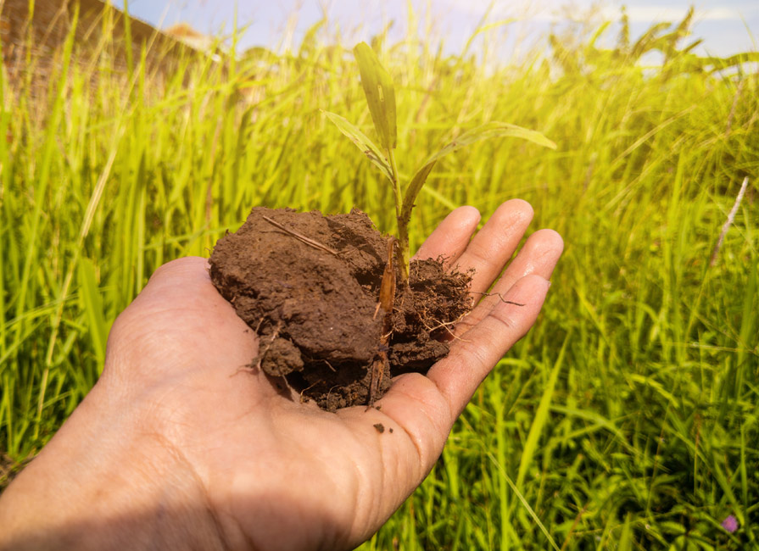
Soil is made up of different proportions of mineral particles, organic matter, water, and air. The mineral portion consists mainly of sand, silt, and clay particles, and the proportion of these particles determines the soil texture. Texture is one of the main ways of classifying soil types. In practical farming, soils are often grouped as sandy soils, clay soils, silty soils, loamy soils, and organic or humus-rich soils. Each type behaves differently under cultivation and grazing conditions. Some soils drain quickly, others hold water for longer. Some warm up quickly in spring, while others remain cool and wet. Some are fertile and easy to work, while others are difficult to cultivate or prone to compaction. For this reason, the farmer must identify the soil type before deciding on crop production methods, grazing use, irrigation practices, and fertilizer programmes.
Sandy soil contains a high proportion of large mineral particles and feels coarse or gritty when handled. This type of soil has large spaces between particles, so water drains through it quickly and air movement is generally good. Sandy soils are easy to cultivate and warm up quickly, which can be useful for early planting. However, they usually have poor water-holding capacity and low nutrient retention because water and dissolved nutrients move through them rapidly. In South Africa, sandy soils are common in some dryland and savanna regions, and farmers working these soils often face challenges with drought stress, leaching of fertilizers, and low organic matter content. To manage sandy soils effectively, the farmer must add organic matter, use mulching, apply fertilizers in smaller and more frequent amounts, and conserve moisture carefully. Grazing on sandy soils must also be controlled to prevent vegetation loss and wind erosion.
Clay soil contains a high proportion of very fine particles. It feels sticky when wet and hard when dry. Clay soils have very small spaces between particles, so they hold water and nutrients well. This can make them naturally fertile, but they also drain slowly and may become waterlogged if drainage is poor. When wet, clay soils can be difficult to cultivate because they stick to machinery and become compacted easily. When dry, they can become very hard and cracked. In farming, clay soils can support good crop growth if they are managed properly, especially where moisture retention is important. However, they require careful timing of cultivation, proper drainage, and good structure management. In a mixed farming system, heavy trampling by livestock on wet clay soils can damage the soil structure badly, leading to compaction and reduced root growth. The farmer must therefore avoid overstocking and unnecessary traffic on wet clay land.
Silty soil consists of particles that are finer than sand but coarser than clay. It feels smooth or floury when dry and slightly slippery when wet. Silty soils generally hold more water and nutrients than sandy soils and are often more fertile, but they can be easily compacted and are highly vulnerable to erosion if left bare. Under South African conditions, silty soils require careful conservation measures, especially on sloping land or in areas with intense rainfall. These soils can produce good crops, but they must be protected by maintaining ground cover, reducing excessive tillage, and preventing runoff. Because silt particles can be detached and carried away easily by water, silty fields benefit from contour farming, strip cropping, mulching, and cover crops. Good management preserves the productivity of silty soils and prevents the loss of topsoil.
Loamy soil is often regarded as the best agricultural soil because it contains a balanced mixture of sand, silt, and clay, together with organic matter. This balance gives loam good structure, moderate drainage, good water-holding capacity, and good nutrient retention. Loamy soils are usually easy to cultivate and are suitable for a wide range of crops. For a mixed crop and livestock farmer, loam is highly valuable because it supports both crop production and pasture growth effectively. It allows good root penetration, responds well to fertilizers and manure, and is generally less extreme in behaviour than pure sandy or clay soils. However, even loamy soils can lose their quality if they are mismanaged through erosion, compaction, nutrient depletion, or overgrazing. Therefore, even the best soils require conservation and proper management to remain productive.
Organic or humus-rich soils contain high levels of decomposed plant and animal material. These soils are usually dark in colour and are often very fertile because organic matter improves soil structure, nutrient supply, and water-holding capacity. Organic matter also supports microbial activity, which helps break down residues and release nutrients for plant use. In most farming soils, organic matter is not the main particle type like sand, silt, or clay, but its presence greatly improves the condition of the soil. For South African farmers, maintaining organic matter is essential, especially where soils are naturally poor or where cropping is intensive. Organic matter can be increased by incorporating manure, compost, crop residues, green manure crops, and cover crops. In mixed farming, livestock manure becomes a valuable resource because it can be returned to crop fields to build soil fertility and structure over time.
Another important way of understanding soil types is by looking at soil horizons or layers. A soil profile usually includes topsoil and subsoil. Topsoil is the upper layer where most roots, microorganisms, and organic matter are found. It is the most productive part of the soil for agriculture. Subsoil lies beneath the topsoil and usually has less organic matter but may contain accumulated clay, salts, or other minerals. Different soils have different depths and profiles, and this affects their agricultural potential. Shallow soils restrict root growth and store less water, making them less suitable for some crops. Deep soils provide more rooting space, better moisture storage, and often higher production potential. A mixed farmer must therefore understand not only the surface texture of soil but also its depth, layering, and drainage characteristics.
Soils can also be classified according to their colour, structure, drainage, and chemical properties. Dark soils often contain more organic matter, while red and yellow soils may indicate the presence of iron compounds and varying drainage conditions. Soil structure refers to the way soil particles are grouped into aggregates. Good structure allows air, water, and roots to move freely, while poor structure causes crusting, compaction, and poor drainage. Chemical properties such as pH, salinity, and nutrient status are also important in identifying and managing soil types. Some South African soils are acidic and require lime, while others may have salinity problems in irrigated areas. A farmer must therefore combine visual observation with soil testing to understand the true nature of the soil.
In South Africa, the diversity of climate and geology means that farmers encounter many soil forms and conditions across different provinces and farming regions. Some areas have deep, fertile soils suitable for intensive crop production, while others have shallow, stony, or sandy soils better suited to grazing or extensive farming. This is why soil type must always be considered together with rainfall, temperature, slope, and veld condition. A soil that performs well in one region may not be equally productive in another because environmental conditions differ. The mixed farmer must assess the local situation carefully and use each soil type according to its capability rather than forcing all land into the same use.
The importance of identifying soil types lies in the fact that each soil type requires different management practices. Sandy soils need moisture conservation and organic matter improvement. Clay soils need drainage and careful timing of cultivation. Silty soils need erosion control. Loamy soils need maintenance of fertility and structure. Organic soils need protection against excessive decomposition and degradation. Fertilizer application, irrigation scheduling, stocking density, grazing management, crop choice, tillage method, and erosion control all depend on soil type. When soil is managed according to its nature, productivity improves and degradation is reduced.
Different types of soil form the basis of successful agricultural production. For a mixed crop and livestock farmer in South Africa, the main soil types include sandy soil, clay soil, silty soil, loamy soil, and humus-rich soil, each with its own characteristics, strengths, and limitations. Soil type influences water movement, nutrient availability, root growth, ease of cultivation, grazing potential, and crop suitability. Understanding these differences allows the farmer to use land correctly, apply the right management practices, and protect the soil for future use. Good farming begins with good soil knowledge, because the farmer who understands soil is better able to manage crops, livestock, and the entire agricultural system effectively.

KT0101 Characteristics and benefits of soil types
The characteristics and benefits of soil types are very important in agriculture because soil is the basic natural resource that supports plant growth, water storage, nutrient supply, and biological activity. For a mixed crop and livestock farmer in South Africa, knowing the characteristics of each soil type helps in deciding which land is suitable for crop production, pasture establishment, grazing, irrigation, or conservation. Different soil types do not behave in the same way. Some soils drain quickly, some hold water for long periods, some are rich in nutrients, and some are more vulnerable to erosion or compaction. The benefits of a particular soil type can only be fully realized when the farmer understands its nature and manages it correctly.
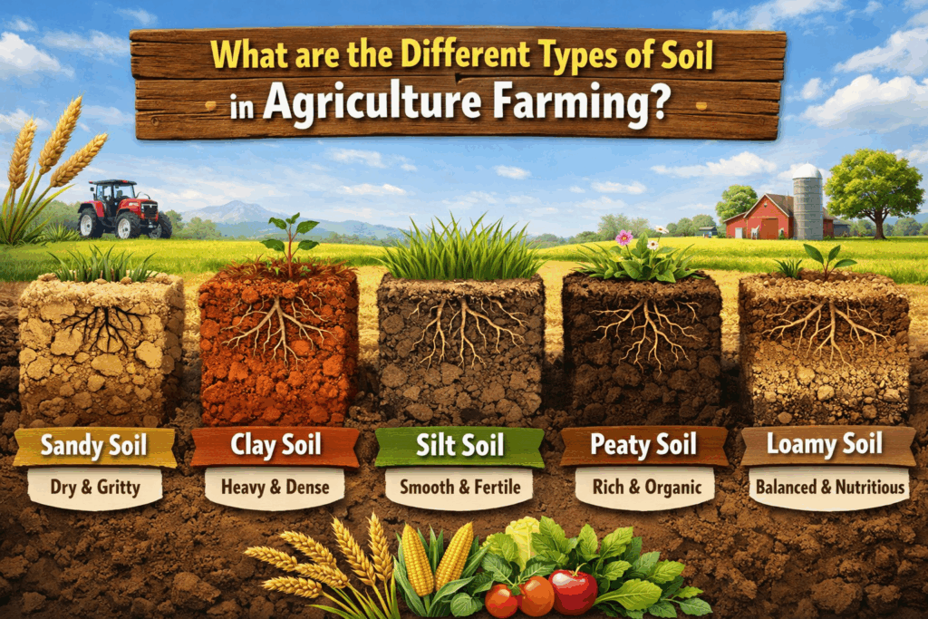
Sandy soil is characterized by large, coarse particles that can easily be felt when rubbed between the fingers. It is loose, well aerated, and drains water very quickly because the spaces between the particles are large. Sandy soils do not usually hold nutrients well, and they often have low organic matter content. One of the main benefits of sandy soil is that it is easy to work with. It can be ploughed, planted, and cultivated with less effort than heavier soils, and it warms up quickly after cold weather, which can encourage early crop growth. Sandy soil is also less likely to become waterlogged, making it useful in areas where drainage is important. In livestock farming, sandy soils can support grazing if there is enough plant cover, but they need careful management because they are prone to wind erosion and moisture loss.
Clay soil has very fine particles and feels sticky when wet and hard when dry. It has a high capacity to hold both water and nutrients because the particles are tightly packed and have a large surface area. Clay soils are often naturally fertile, and they can support strong crop growth when managed properly. One of the greatest benefits of clay soil is its moisture-holding ability, which can help crops survive dry periods better than in sandy soils. Clay soils can also store plant nutrients for longer, reducing rapid leaching losses. However, these benefits are linked to careful management because clay soils may become compacted, poorly drained, and difficult to cultivate if handled at the wrong moisture level. In mixed farming, clay soils can be very productive for crops and pasture, but livestock must not be allowed to trample them excessively when wet.
Silty soil is characterized by medium-sized particles that are smaller than sand but larger than clay. It feels smooth and soft, almost like flour when dry. Silty soils generally have better water retention than sandy soils and better drainage than clay soils. They are often fertile and can support good crop growth because they hold nutrients relatively well. One of the key benefits of silty soil is that it provides a favourable medium for root development and plant growth. It is usually easier to cultivate than clay and more productive than poor sandy soils when properly managed. However, silty soils are easily eroded by water and wind if left bare, so their benefits are best protected by maintaining ground cover, reducing over-cultivation, and using conservation farming methods.
Loamy soil is widely regarded as the most balanced and agriculturally useful soil type because it contains a mixture of sand, silt, and clay in relatively even proportions. Its characteristics include good structure, moderate drainage, good moisture retention, and good nutrient-holding capacity. Loam is usually easy to cultivate and supports a wide variety of crops and pasture plants. The main benefit of loamy soil is that it combines the positive qualities of the other soil types without showing their extreme weaknesses. It does not drain too quickly like sandy soil, nor does it become as sticky and heavy as clay soil. For a South African mixed farmer, loamy soil is highly beneficial because it supports both crop production and fodder or pasture growth, making it ideal for integrated farming systems. Even so, it still needs good management to prevent fertility decline, erosion, or compaction.
Humus-rich or organic soil is characterized by a high content of decomposed plant and animal material. It is usually dark in colour, soft in texture, and rich in biological activity. This type of soil has excellent water-holding capacity, improved nutrient supply, and strong microbial life. The benefit of humus-rich soil lies in its fertility and its ability to improve the condition of other soils. Organic matter helps bind soil particles into stable aggregates, improves aeration, increases moisture retention, and supports soil organisms that help release nutrients for crops. In mixed farming, this is especially important because livestock manure, crop residues, and compost can all be used to raise the humus content of the soil. As a result, organic matter becomes a valuable link between crop and livestock enterprises, improving the productivity of the entire farm.
Shallow soils are soils with limited depth before reaching rock, gravel, or a hard layer. Their main characteristic is restricted rooting depth and limited water storage capacity. These soils are not always suitable for deep-rooted crops, and they may dry out quickly. However, they can still have benefits when used correctly. Shallow soils may be suitable for grazing, pasture, or certain hardy crops that do not require deep rooting. The important lesson for the farmer is that even a soil with limitations can still be beneficial if matched with the correct enterprise and proper management. Using shallow soils for the wrong purpose often leads to failure and land degradation.
Deep soils, on the other hand, have a greater rooting depth and can store more water and nutrients. Their major characteristic is that they allow crops to develop extensive root systems, making plants more resilient during dry periods. The main benefit of deep soils is their high production potential. They are often better suited to intensive cropping because they support stronger plant growth and better moisture use. In mixed farming, deep soils are valuable for producing cash crops, fodder crops, and improved pastures. Their greater capacity makes them one of the most productive soil resources on the farm.
Soil structure is another important characteristic that affects the benefits of soil. Good soil structure means the soil particles are arranged in stable crumbs or aggregates. This allows air, water, and roots to move easily through the soil. Poor structure results in crusting, compaction, poor drainage, and reduced root penetration. The benefit of good structure is that it improves plant growth, reduces runoff, and increases resistance to erosion. Soils with good structure are easier to manage and usually produce better results. Mixed farmers benefit greatly when they maintain good soil structure through organic matter addition, reduced tillage, controlled grazing, and careful machinery use.
Soil fertility is a further characteristic that determines the usefulness of soil. Fertile soils contain adequate nutrients for plant growth, while infertile soils lack important nutrients such as nitrogen, phosphorus, potassium, calcium, or trace elements. The benefit of fertile soil is obvious: it supports vigorous crop and pasture growth, leading to better yields and better feed for livestock. However, fertility is not fixed forever. Even a naturally fertile soil can become depleted if nutrients are removed through harvesting, grazing, or erosion and not replaced. This means the farmer must manage fertility actively through soil testing, fertilizer use, manure application, crop rotation, and conservation practices.
Drainage is another major characteristic of soil types. Well-drained soils allow excess water to move away while still holding enough moisture for plant use. Poorly drained soils stay wet for too long and can cause root diseases, oxygen shortage, and reduced plant growth. The benefit of well-drained soil is that it creates a healthier environment for roots and makes field operations easier. In a mixed farming system, well-drained soils are also better for livestock movement because they reduce mud, hoof damage, and trampling losses. Poorly drained soils may still have value, but they often require drainage improvement or more careful land use planning.
In South African agriculture, the benefits of different soil types must always be considered in relation to local climate, rainfall, slope, and farming purpose. A sandy soil in a high rainfall area may perform better than the same soil in an arid area. A clay soil may be highly beneficial in a dry region because of its water-holding ability, but difficult in a wet region because of drainage problems. This means the farmer should not judge soil types in isolation. The best soil is not simply the one with the most nutrients or the finest texture, but the one that is most suitable for the intended agricultural use and is managed according to its characteristics.
For a mixed crop and livestock farmer, the benefits of understanding soil types go beyond crop yields alone. Good soil knowledge supports better pasture production, more efficient water use, improved fertilizer planning, stronger drought resilience, reduced erosion, and better land-use decisions. It also helps the farmer decide where to plant crops, where to place grazing camps, where to establish fodder plots, and where conservation measures are needed. Soil is not only a growing medium; it is a long-term agricultural asset that must be protected and improved.
The characteristics and benefits of soil types are essential knowledge in farming. Sandy soils are loose and well-drained, clay soils hold water and nutrients, silty soils are smooth and fertile, loamy soils are balanced and productive, and humus-rich soils improve fertility and structure. Shallow and deep soils also differ in production potential, while structure, fertility, and drainage strongly influence soil performance. Each soil type has strengths and limitations, but each also offers benefits when used wisely. For a mixed crop and livestock farmer in South Africa, understanding these characteristics makes it possible to manage land sustainably, match enterprises to the right soil, and improve both crop and livestock productivity over the long term.

KT0102 Types of soil suitable for planting crops
Types of soil suitable for planting crops are those soils that can provide good support for root growth, hold enough moisture for plant use, supply or retain nutrients, allow air movement, and permit proper drainage without becoming waterlogged. For a mixed crop and livestock farmer in South Africa, the suitability of soil for planting crops is extremely important because it determines whether crops will establish well, grow strongly, resist drought, and produce good yields. Not all soils are equally suitable for cropping. Some soils are naturally productive and easy to manage, while others have serious limitations such as shallow depth, low fertility, poor drainage, salinity, acidity, or high erosion risk. A farmer must therefore identify which soils are suitable for crop production and which are better reserved for grazing, pasture, or conservation.
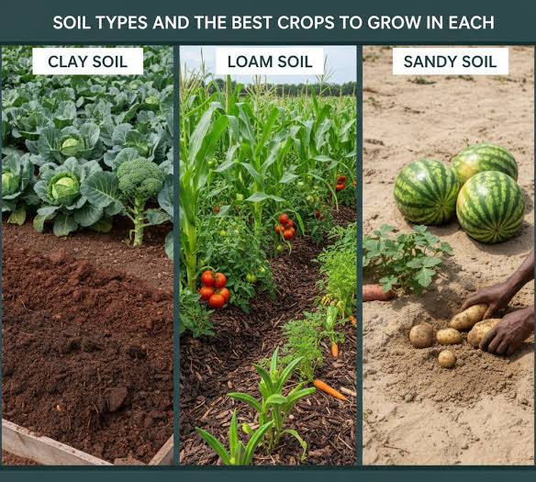
Loamy soil is generally regarded as the most suitable soil for planting crops because it contains a balanced mixture of sand, silt, and clay. This balance gives the soil several advantages at the same time. It can hold enough water for plants, but it also drains excess water so that roots do not suffocate. It retains nutrients reasonably well, while still allowing roots to penetrate easily. Loam is usually easy to work during land preparation, planting, and weeding, and it supports a wide range of crops. For this reason, many of the most productive crop fields are found on loamy soils. In South African farming systems, loam is especially valuable because it can support both cash crops and fodder crops, which benefits mixed farmers who need land for grain, forage, and crop residues for livestock feed.
Deep, well-structured clay loam and sandy loam soils are also highly suitable for planting crops. Clay loam contains more clay than ordinary loam, so it can hold more moisture and nutrients, which is useful in areas with limited rainfall. Sandy loam contains more sand, so it drains more easily and is often easier to cultivate, especially after rain. Both of these soils can be excellent for cropping if they have good structure and sufficient organic matter. Their suitability depends not only on texture but also on how well the particles are arranged in the soil. Good structure allows the movement of water, air, and roots, while poor structure causes compaction and weak plant growth. A well-structured clay loam or sandy loam soil can therefore support strong crop performance under proper management.
Sandy loam soils are often suitable for planting crops in areas where good drainage is needed and where farmers can manage moisture carefully. These soils are lighter than heavier loams and warm up quickly, which can support seed germination and early growth. They are especially useful for crops that do not tolerate waterlogging. However, because sandy loam does not hold water and nutrients as strongly as heavier soils, it requires more careful fertilizer management, mulching, and moisture conservation. In South Africa, where dry spells are common, sandy loam soils can still be productive if rainfall is adequate or where irrigation is available. Their suitability increases when the farmer builds organic matter through compost, manure, cover crops, and crop residue retention.
Clay loam and certain well-drained clay soils are suitable for planting crops because they can store large amounts of water and nutrients. This makes them especially useful in regions where rainfall is unreliable, since the soil can hold moisture for longer periods and make it available to crops over time. These soils are often naturally fertile, which supports good yields. However, they are only suitable if drainage is adequate and the soil is not cultivated when too wet. Poorly managed clay soils can become compacted, sticky, and difficult for roots to penetrate. Therefore, while clay-based soils can be very productive, they require proper timing of tillage, drainage management, and controlled traffic to protect their structure. In mixed farming, farmers must also prevent heavy livestock trampling on these soils when wet.
Silty loam soils can also be suitable for crop planting because they are often fertile and provide a favourable environment for root growth. They hold more water than sandy soils and are generally easier to work than heavy clays. Their smooth texture and moderate fertility make them useful for a variety of crops. However, silty soils are vulnerable to erosion if the land is left bare, particularly on sloping fields or in areas with heavy rain. For this reason, their suitability for cropping depends on the use of soil conservation measures such as contour farming, mulching, cover crops, strip cropping, and reduced tillage. A farmer who protects silty soil from erosion can obtain good crop yields from it.
Deep soils are more suitable for planting crops than shallow soils because they offer more rooting space and better storage of water and nutrients. A deep soil allows plant roots to spread widely and reach moisture even during dry periods. This improves crop growth and drought tolerance. Shallow soils, by contrast, often restrict roots because rock, gravel, or a hardpan layer lies close to the surface. Such soils dry out quickly and are less reliable for crop production, especially for maize, sunflower, sorghum, and other field crops commonly grown in South Africa. While some shallow soils may still support hardy or short-season crops, they are generally less suitable than deep soils for sustained cropping. Deep, fertile soils are therefore preferred for intensive crop production.
Well-drained soils are especially suitable for crop planting because plant roots need both water and oxygen. If a soil becomes waterlogged, roots cannot breathe properly, diseases may develop, and plant growth becomes weak. Suitable crop soils must therefore remove excess water while retaining enough moisture for normal growth. This is why medium-textured soils such as loams are often preferred. Poorly drained soils may still be used for crops, but they usually need drainage improvement, raised beds, or special crop selection. In general, the best cropping soils are those that strike the right balance between water retention and drainage.
Fertile soils are naturally more suitable for planting crops because they supply the nutrients needed for plant development. Essential nutrients such as nitrogen, phosphorus, potassium, calcium, magnesium, and trace elements are all needed for healthy crop growth. A suitable cropping soil should either contain these nutrients naturally or be able to hold applied nutrients effectively. Soils with good cation exchange capacity, adequate organic matter, and balanced pH are especially favourable for crop production. In South Africa, some soils are naturally acidic and require lime before crops can perform well, while others may lack phosphorus or nitrogen. Therefore, suitability is not determined by texture alone, but also by fertility status and soil chemistry.
Soils with a good amount of organic matter are more suitable for crop planting because organic matter improves almost every aspect of soil quality. It increases water-holding capacity, improves structure, supports microbial activity, and enhances nutrient availability. In mixed farming systems, organic matter can be increased through livestock manure, compost, crop residues, and green manures. This means that even soils with some limitations can become more suitable for crop production over time if their organic content is improved. A soil that is physically suitable but low in organic matter may not perform as well as a similar soil that has been enriched and maintained carefully.
The pH of the soil also determines whether it is suitable for planting crops. Most crops grow best in soils that are slightly acidic to neutral, because nutrients are most available in that range. Very acidic soils can limit root growth and make certain nutrients unavailable, while toxic elements such as aluminium may become more active. Very alkaline soils can also reduce nutrient availability. For this reason, suitable crop soils are those with a pH range that supports nutrient uptake and healthy plant development, or soils that can be corrected through liming or other amendments. In South African agriculture, soil testing is important for determining whether a soil is chemically suitable for planting crops.
In practical farming, the most suitable soils for planting crops are therefore deep loams, sandy loams, clay loams, silty loams, and well-structured, fertile soils with good drainage and sufficient organic matter. These soils provide the right environment for germination, root development, nutrient uptake, and water supply. By contrast, soils that are extremely sandy, very shallow, badly eroded, highly saline, poorly drained, compacted, or infertile are generally less suitable unless they are improved through careful management. The farmer must always match the crop to the soil. Some crops can tolerate lighter soils, while others require deeper and more fertile land. Crop choice and soil suitability must therefore go together.
For a mixed crop and livestock farmer in South Africa, identifying suitable crop soils is also important for whole-farm planning. The best soils should be reserved for crop fields, fodder production, and high-value enterprises, while poorer soils may be used for grazing or conservation. This prevents wasteful use of land and protects fragile soils from unnecessary cultivation. It also strengthens the integration between crops and livestock, because suitable crop soils can produce grain, forage, and residues that support the livestock enterprise, while animals provide manure that improves soil condition.
The soils most suitable for planting crops are those that are deep, fertile, well-drained, and well-structured, with a balanced texture and sufficient organic matter. Loamy soils are generally the best, while sandy loam, clay loam, silty loam, and certain well-managed clay soils are also highly suitable. These soils support root growth, water supply, nutrient retention, and healthy crop development. A mixed crop and livestock farmer in South Africa must understand which soils are suitable for cropping so that land can be used productively, resources can be managed wisely, and sustainable crop yields can be achieved over time.

KT0103 Ways of conserving soil
Ways of conserving soil are extremely important in agriculture because soil is one of the farmer’s most valuable natural resources. For a mixed crop and livestock farmer in South Africa, soil conservation means protecting the soil from erosion, nutrient loss, compaction, moisture loss, and general degradation. Healthy soil is essential for crop production, pasture growth, water infiltration, and long-term farm productivity. If soil is not conserved, the fertile topsoil can be lost through wind or water erosion, the land can become less productive, and the farmer may face declining yields, poor grazing conditions, and increased production costs. Soil conservation is therefore not only an environmental responsibility but also a practical and economic necessity.
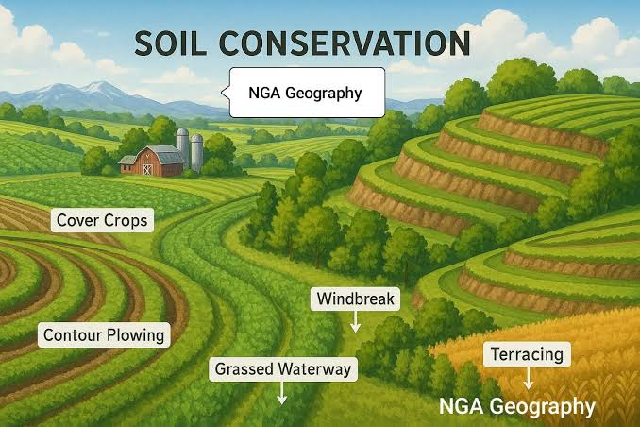
One of the main ways of conserving soil is to maintain ground cover on the land. Bare soil is highly vulnerable to erosion by wind and rain. When the soil surface is covered by crops, grass, mulch, cover crops, or crop residues, the soil is protected from the direct impact of raindrops and strong winds. Ground cover slows down runoff, improves water infiltration, and reduces the movement of soil particles. In a mixed farming system, crop residues left after harvesting can be used to protect the soil surface, while pasture and grazing lands should always retain enough plant cover to prevent exposure of the soil. Maintaining ground cover is one of the simplest and most effective methods of soil conservation.
Contour ploughing is another important method of conserving soil, especially on sloping land. Instead of ploughing up and down the slope, the farmer ploughs across the slope along the natural contour lines. This practice slows down the movement of water, reduces runoff speed, and limits the washing away of topsoil. In South Africa, where sudden heavy rains can cause severe erosion, contour farming is especially useful on cultivated slopes. By reducing the force of water flow, it helps keep soil and nutrients in place and allows more water to soak into the ground. Contour banks and grass strips may also be added to strengthen this conservation system.
Terracing is a more advanced soil conservation method used on steeper slopes. Terraces divide a slope into shorter, level sections, reducing the speed of water runoff and preventing soil from being washed downhill. Although terracing may require more labour and investment, it can be very effective where the risk of erosion is high. On farms with sloping fields, terraces can make cultivation safer and more sustainable. They also improve water retention by giving runoff more time to infiltrate. In areas where land is limited and slopes are used for cultivation, terracing can protect soil and improve crop production over the long term.
Crop rotation is another important way of conserving soil. This means planting different crops on the same land in a planned sequence over different seasons or years. Crop rotation helps maintain soil fertility, reduce pest and disease build-up, and improve soil structure. For example, planting legumes in rotation with cereals can add nitrogen to the soil and reduce the need for chemical fertilizer. Different crops also use nutrients and moisture differently, which helps prevent the soil from being exhausted by one repeated crop. In mixed farming, crop rotation can also include fodder crops, which support livestock while helping to improve the soil. A well-planned rotation system keeps the soil healthier and more productive.
Minimum tillage or conservation tillage is another effective method of soil conservation. Excessive ploughing disturbs the soil structure, exposes organic matter to rapid breakdown, and leaves the surface vulnerable to erosion. Minimum tillage reduces the number of times the soil is turned or disturbed, helping to preserve soil structure and moisture. It also leaves more crop residue on the surface, which protects the soil. Conservation tillage is particularly useful in dry parts of South Africa where moisture conservation is essential. By reducing tillage, the farmer can lower erosion risk, improve water use, and maintain soil biological activity.
Mulching is the practice of covering the soil surface with plant material such as straw, leaves, grass, or crop residues. Mulch protects the soil from direct sun, wind, and raindrop impact. It reduces evaporation, helps retain moisture, moderates soil temperature, and adds organic matter as it breaks down. Mulching is especially beneficial in South Africa where dry conditions and high temperatures can cause rapid moisture loss. In vegetable gardens, field crops, orchards, and fodder production, mulch can play an important role in conserving soil and supporting plant growth. In a mixed farming system, residues and manure can often be used to improve mulching practices.
Planting cover crops is another valuable method of soil conservation. Cover crops are planted mainly to protect and improve the soil rather than for immediate sale or harvest. They help reduce erosion, suppress weeds, improve soil structure, and increase organic matter. Some cover crops, especially legumes, also fix nitrogen from the air and add it to the soil. During periods when land would otherwise be bare, cover crops keep roots in the ground and protect the soil surface. In mixed farming, some cover crops can also be grazed or cut for fodder, making them beneficial to both the crop and livestock enterprise.
Good grazing management is essential for conserving soil on farms with livestock. Overgrazing removes too much plant cover, leaving the soil exposed to erosion and reducing the ability of grass roots to hold the soil together. When livestock graze land too heavily or too often, the veld weakens, bare patches develop, and runoff increases. Proper grazing management includes rotational grazing, resting camps, maintaining correct stocking rates, and preventing livestock from concentrating too heavily around water points, gates, and shade areas. By controlling grazing pressure, the farmer protects the soil, improves pasture recovery, and maintains long-term grazing productivity.
Windbreaks and shelterbelts are also useful in conserving soil, especially in open or dry areas where wind erosion is a problem. Trees, shrubs, or planted barriers reduce wind speed across the land and help prevent the blowing away of fine soil particles. Windbreaks also protect crops, reduce evaporation, and create a more stable farm environment. In parts of South Africa where sandy soils are common, wind erosion can cause serious soil loss if land is left unprotected. Shelterbelts therefore serve both environmental and production purposes.
The addition of organic matter is another important way to conserve soil. Organic matter improves soil structure, increases water-holding capacity, supports microorganisms, and reduces erosion risk. Manure, compost, crop residues, and green manures all contribute to better soil condition. In mixed crop and livestock farming, manure is one of the most valuable resources for soil improvement. Instead of being wasted, livestock manure can be collected and returned to the fields to improve fertility and strengthen the soil. Soils rich in organic matter are usually more stable, more productive, and more resistant to degradation.
Proper drainage control also helps conserve soil. Where runoff is uncontrolled, gullies can develop and large amounts of soil can be lost. Farmers must direct excess water safely through grassed waterways, drainage channels, or contour structures so that it does not cut into fields or grazing land. At the same time, drainage systems must be designed carefully so that they do not increase erosion elsewhere. Good drainage control protects the land from water damage and supports sustainable land use.
Avoiding soil compaction is another important conservation measure. Soil compaction happens when heavy machinery or livestock press the soil particles tightly together, reducing pore spaces for air and water movement. Compacted soil restricts root growth, increases runoff, and reduces productivity. To conserve soil, farmers should avoid working wet land with heavy machinery, use controlled traffic where possible, and manage livestock movement carefully, especially on wet soils. Good soil structure is essential for healthy crops and pasture, so preventing compaction is part of sound soil conservation.
Soil testing and proper nutrient management also support soil conservation. When soil nutrients are removed through cropping or grazing and not replaced, the soil becomes less fertile and less productive. Regular soil testing helps the farmer understand what the soil needs and apply fertilizers, lime, manure, or compost correctly. Balanced nutrient management prevents soil exhaustion and supports healthy plant growth, which in turn protects the soil surface. Conservation is not only about preventing physical erosion; it is also about maintaining chemical fertility and biological health.
Another important way of conserving soil is to match land use to land capability. Land that is too steep, shallow, stony, or erosion-prone should not be cultivated intensively. Such land may be better suited to grazing, forestry, or conservation purposes. When land is used according to its natural ability, the risk of degradation is much lower. A wise farmer does not force all land into crop production, but instead uses each area according to its strengths and limitations.
Soil can be conserved through many practical methods, including maintaining ground cover, contour ploughing, terracing, crop rotation, minimum tillage, mulching, cover cropping, good grazing management, windbreaks, adding organic matter, proper drainage, preventing compaction, and using land according to its capability. For a mixed crop and livestock farmer in South Africa, these methods are essential for protecting the fertile topsoil, improving water use, supporting crop and pasture growth, and ensuring the long-term sustainability of the farm. Soil conservation is not a single action but a continuous management approach that protects one of agriculture’s most valuable

Internal Assessment Criteria (IAC) and Weight
- IAC0101 Describe characteristics and benefits of soil types

Soil types are an important agricultural resource because they determine how well crops grow, how water moves, how roots develop, and how nutrients are stored. In South Africa, as in many farming regions, soils differ in texture, depth, structure, colour, drainage, fertility, and organic matter content. The main soil types commonly discussed in agriculture are sandy soil, clay soil, silty soil, loamy soil, and soils with high organic content. Each soil type has its own physical and chemical characteristics, and each offers certain benefits and limitations for crop production. A farmer must understand these differences in order to choose suitable crops, apply the correct cultivation methods, and manage soil for long-term productivity.
Sandy soil is made up of large soil particles and has a coarse, gritty feel. Because the particles are large and loosely packed, sandy soil has large pore spaces that allow water to drain quickly and air to move freely. This makes it easy to cultivate and promotes good root penetration. Sandy soils warm up quickly in spring or early season conditions, which can support earlier planting in some areas. The main benefit of sandy soil is its excellent drainage and aeration, which reduces the risk of waterlogging and root rot. It is also easier to work with machinery because it is light and less sticky than clay soil. However, sandy soils generally have low fertility because nutrients are easily leached out by rain or irrigation. They also have a low water-holding capacity, which means crops may suffer moisture stress unless irrigation, mulching, or organic matter additions are used.
Clay soil is made up of very fine particles that are tightly packed together. It feels sticky when wet and hard when dry. Because the particles are so small, clay soil has very small pore spaces, which means it holds water for longer periods and stores nutrients well. One major benefit of clay soil is its high fertility potential, since it can retain important plant nutrients such as calcium, potassium, and magnesium. Clay soils are often productive when they are well managed because they can support strong crop growth over time. They are also less prone to nutrient leaching than sandy soils. However, clay soils may drain slowly, become waterlogged, and compact easily if worked when wet. They can also be difficult to cultivate. Good management, including drainage improvement, careful timing of tillage, and the addition of organic matter, is needed to make clay soils more suitable for farming.

- IAC0102 Explain types of soil suitable for planting crops

The suitability of soil for planting crops depends on several factors, including texture, fertility, drainage, depth, pH, organic matter content, and water-holding capacity. A soil may be good for one crop but unsuitable for another, depending on the crop’s root system, water requirements, and nutrient needs. In general, soils that support healthy crop growth are those that provide enough moisture, nutrients, oxygen, and root space without becoming waterlogged or excessively dry. For South African farmers, choosing the correct soil for crop production is especially important because climatic conditions vary greatly across regions, and efficient use of available soil resources contributes directly to good yields and long-term sustainability.
Loamy soil is the most suitable soil for planting a wide variety of crops. This is because loam contains a balanced proportion of sand, silt, and clay, giving it good water retention, proper drainage, adequate aeration, and strong nutrient-holding capacity. Crops need a soil that allows roots to spread easily while also supplying moisture and nutrients over time, and loamy soil provides these conditions very well. It is also easier to work with during land preparation, planting, and weeding. Many field crops, vegetables, and fruit trees perform well in loamy soils because the soil supports healthy root development and balanced plant growth. For most farmers, loam is considered the ideal agricultural soil because it is versatile and productive.
Sandy loam is also very suitable for planting crops, particularly where good drainage is needed. Sandy loam has more sand than true loam, but still contains enough silt, clay, and organic matter to support crop growth. This soil is often suitable for crops such as groundnuts, potatoes, carrots, onions, and watermelons because these crops prefer loose soil that allows easy root expansion and prevents waterlogging. Sandy loam is also easier to cultivate and warms quickly, which may encourage early crop establishment. However, because it holds less water and fewer nutrients than heavier soils, farmers must often improve it with compost, manure, mulching, and more frequent but controlled irrigation. With proper management, sandy loam can be highly productive.

- IAC0103 Discuss several ways of conserving soil.

Soil conservation refers to the methods and practices used to protect soil from erosion, degradation, nutrient loss, compaction, and loss of fertility. It is one of the most important responsibilities of a farmer because soil is the foundation of crop production and also supports grazing for livestock. In South Africa, soil conservation is especially important because many farming areas are vulnerable to wind erosion, water erosion, overgrazing, drought, and declining organic matter. If soil is not conserved, it loses its ability to support healthy crops and pasture, resulting in low yields, poor grazing, and long-term damage to the farm. Soil conservation therefore aims to maintain soil structure, fertility, moisture, and biological life so that agricultural production remains sustainable.
One of the main ways of conserving soil is through contour ploughing or contour farming. This method involves ploughing and planting across the slope of the land rather than up and down the slope. By following the natural contour lines, the movement of rainwater is slowed down, allowing more water to soak into the soil and reducing the speed at which water can wash soil away. This is especially useful on sloping land where runoff can quickly cause sheet erosion or gulley formation. Contour farming helps keep topsoil in place and makes better use of rainfall. In areas with moderate to steep slopes, contour banks may also be constructed to strengthen this conservation effect.
Terracing is another important soil conservation method used mainly on steeper slopes. Terraces are level or nearly level steps built into the slope to reduce runoff and soil loss. They break the slope into smaller sections, which slows water movement and allows cultivation to take place more safely. Terracing is labour-intensive and may require high initial investment, but it is highly effective where erosion risk is severe. In suitable areas, terraces can transform sloping land into productive farmland while protecting the soil from being washed away during heavy rains.
Cover cropping is a very effective method of conserving soil because it ensures that the soil surface is not left bare. Cover crops are planted mainly to protect and improve the soil rather than for direct sale. They reduce the impact of raindrops on the soil, slow runoff, suppress weeds, add organic matter, and improve soil structure. Some cover crops, especially legumes, also fix nitrogen and increase fertility. In mixed farming systems, cover crops can serve a double purpose by protecting the soil and also providing grazing or fodder for livestock. Keeping the land covered is one of the best ways of reducing erosion and maintaining soil health.

KM-01-KT02 Sustainable land practices 20%
Topic element
- KT0201 Sustainable land management practices
- KT0202 Causes of land degradation
- KT0203 Importance of soil health
- KT0204 Importance of water in sustainable land management
- KT0205 Importance of biodiversity conservation in sustainable land management
- KT0206 Climate change mitigation (agroforestry, reforestation and carbon farming)
- KT0207 Principles of sustainable agriculture, such as organic farming, agroecology, and regenerative agriculture

KM-01-KT02 Sustainable land practices
Sustainable land practices are farming methods and land management approaches that protect the productivity of the land while allowing the farmer to continue producing crops and livestock over the long term. For a mixed crop and livestock farmer in South Africa, sustainable land practices are essential because the land must support many functions at the same time. It must provide space for crop production, grazing, water movement, biodiversity, farm infrastructure, and future generations of farming activity. If land is used carelessly, it can quickly lose its fertility, vegetation cover, and productive value through erosion, compaction, nutrient depletion, overgrazing, and water loss. Sustainable land practices are therefore about using land in a way that balances present production needs with long-term environmental protection and economic survival.
One of the most important sustainable land practices is using land according to its capability. This means that the farmer must first understand the physical characteristics of the land, such as slope, soil depth, soil type, rainfall, drainage, erosion risk, and vegetation cover, before deciding how it should be used. Not all land is suitable for the same purpose. Deep, fertile, well-drained land may be appropriate for crop production, while steep, shallow, rocky, or highly erodible land may be better suited to grazing, tree planting, or conservation. Sustainable farming begins when the farmer respects the natural limitations of each part of the farm and avoids overusing fragile areas. Land capability planning reduces degradation and helps ensure that the most productive areas are used wisely.
Soil conservation is a central part of sustainable land practice because the soil is the foundation of all agricultural production. Productive land cannot remain productive if its topsoil is lost. Sustainable farmers protect the soil by maintaining ground cover, reducing unnecessary tillage, practicing contour ploughing on slopes, rotating crops, adding organic matter, and preventing erosion by wind and water. In South Africa, intense rainfall in some areas and dry windy conditions in others can quickly damage bare land. Sustainable land practice therefore requires keeping the soil protected throughout the year. Even grazing land needs soil protection because overgrazing removes plant cover and exposes the soil to erosion. A sustainable farmer treats soil as a living resource that must be conserved, nourished, and improved over time.
Maintaining vegetation cover is another important sustainable land practice. Vegetation protects the soil surface from the direct force of rain, slows down runoff, reduces evaporation, binds the soil with roots, and supports biological activity in the soil. In crop farming, vegetation cover may come from standing crops, cover crops, mulch, or crop residues left on the field after harvest. In livestock farming, vegetation cover comes from healthy grassland, forage crops, or pasture. When land is left bare for too long, it becomes vulnerable to erosion, moisture loss, and weed invasion. Sustainable land management therefore aims to keep living plants or protective plant material on the land as much as possible.
Crop rotation is an important sustainable land practice because it helps maintain soil fertility, reduce pest and disease pressure, and improve overall land health. Repeatedly planting the same crop on the same land can lead to nutrient imbalances, build-up of crop-specific pests and diseases, and declining yields. Rotating cereals with legumes, fodder crops, or cover crops allows the soil to recover and promotes more balanced use of nutrients and moisture. For a mixed farmer, crop rotation is especially useful because some crops can be grown for livestock feed, while others improve the soil and support cash income. Sustainable land use depends on variety and balance rather than continuous strain on the same field.
Rotational grazing is one of the most important sustainable land practices where livestock are involved. In this system, animals are moved between camps so that grazed areas have time to recover before being used again. This prevents overgrazing, supports root regrowth, maintains grass cover, and improves the long-term condition of the veld. In South Africa, where natural grazing is a major resource for livestock farming, poor grazing management can lead to veld degradation, bush encroachment, soil erosion, and declining carrying capacity. Sustainable land use requires the farmer to match stocking rates with the carrying capacity of the land, rest camps when necessary, and adjust animal numbers during drought or feed shortages. Rotational grazing ensures that land remains productive and resilient over time.
Water conservation is also part of sustainable land practice because land and water are closely connected. Healthy land absorbs and stores more water, while degraded land loses water rapidly through runoff and evaporation. Sustainable farmers use contour farming, terraces, mulching, grass strips, rip lines, and cover crops to improve infiltration and reduce runoff. They also protect rivers, streams, wetlands, and dams from contamination and erosion. In South Africa, where water is scarce in many regions, land practices that conserve moisture are critical. Sustainable land management improves the ability of the land to capture rainfall and make it available to crops, pasture, and soil organisms. It also reduces pressure on irrigation and water storage systems.
The addition of organic matter is another sustainable land practice that greatly improves land productivity and resilience. Organic matter from manure, compost, crop residues, green manures, and decomposed plant material improves soil structure, increases water-holding capacity, promotes microbial life, and enhances nutrient availability. In mixed farming systems, livestock manure is a valuable resource that can be returned to crop fields to improve the soil naturally. Sustainable land use takes advantage of these internal farm cycles, where crop residues feed livestock and livestock manure feeds the soil. This reduces waste, lowers dependence on external inputs, and strengthens the long-term fertility of the land.
Minimum tillage or conservation tillage is an effective sustainable practice because it reduces disturbance to the soil. Excessive ploughing destroys soil structure, increases erosion risk, reduces organic matter, and exposes the soil to drying. By reducing the number and intensity of tillage operations, the farmer preserves the natural structure of the soil and keeps residues on the surface. This helps protect the land from erosion and moisture loss. In dry South African conditions, conservation tillage is especially useful because it supports better water retention and lowers production costs related to fuel and machinery wear. Sustainable land management does not mean never cultivating, but rather cultivating only as much as necessary and in a way that causes the least damage.
Integrated crop and livestock farming itself is a sustainable land practice when managed correctly. This is because it allows one part of the farm to support another. Crops can provide grain, fodder, and residues for animals, while animals provide manure, weed control, and income diversification. This integration helps spread risk and improve the use of land throughout the year. Instead of relying on one enterprise alone, the farmer uses land more flexibly and efficiently. Sustainable land use in mixed farming depends on managing these linkages well so that grazing, cropping, manure use, and feed production all work together rather than competing destructively for the same land.
Protecting natural resources and sensitive areas is also part of sustainable land practice. Wetlands, riverbanks, steep slopes, indigenous vegetation, and highly erodible areas should be protected from overuse, cultivation, or uncontrolled grazing. These areas often play an important role in water regulation, biodiversity conservation, and erosion control. Sustainable farmers understand that not every part of the land should be used intensively for production. Some areas must be conserved to support the health of the wider farming environment. Buffer zones, fencing off wetlands, controlling invasive plants, and maintaining natural grass strips are all examples of land practices that support sustainability.
The control of invasive alien plants and bush encroachment is another important sustainable land practice in South Africa. Invasive species often compete with useful grasses and crops for water, light, and nutrients, while bush encroachment reduces grazing value and changes the ecological balance of the land. If these problems are ignored, land productivity declines and water resources may also be affected. Sustainable land management includes monitoring vegetation changes, removing invasive species, and restoring productive veld or pasture where degradation has occurred. This keeps the land functional and suitable for long-term use.
Farm planning is a key element of sustainable land practice because sustainability does not happen by accident. The farmer must plan where crops will be planted, where animals will graze, where water points will be located, where roads should run, and which areas need protection or rehabilitation. Good planning reduces unnecessary pressure on land, prevents conflict between enterprises, and supports efficient use of labour, machinery, and natural resources. In mixed farming, land planning helps coordinate crop fields, grazing camps, fodder production areas, manure handling, and infrastructure in a way that strengthens the whole farm system.
Rehabilitation of degraded land is also part of sustainable land practice. Land that has already been damaged by erosion, overgrazing, nutrient loss, or poor cultivation must be restored through practical measures such as re-seeding, resting, contour repair, gully control, manure application, liming, and improved grazing management. Sustainable farming includes not only protecting healthy land but also repairing damaged land so that its productivity can return over time. A farmer who ignores degraded areas allows the problem to spread, while a farmer who rehabilitates them strengthens the future of the farm.
Sustainable land practices also involve balancing economic production with environmental care. A farmer cannot simply focus on maximizing short-term output without considering the condition of the land. Overuse of the land may increase production for a season or two, but it often leads to long-term losses. Sustainable practices may sometimes require patience, investment, and discipline, but they protect the productive base of the farm. In South Africa, where farming conditions are often challenging, land that is well managed sustainably becomes more resilient to drought, floods, grazing pressure, and market shocks.
Sustainable land practices are methods of managing land in a way that protects its productivity, fertility, vegetation cover, water-holding ability, and environmental value over the long term. For a mixed crop and livestock farmer in South Africa, these practices include using land according to its capability, conserving soil, maintaining vegetation cover, rotating crops, practicing rotational grazing, conserving water, building organic matter, reducing tillage, protecting sensitive areas, controlling invasive plants, planning land use carefully, and rehabilitating degraded land. These practices help ensure that the land remains productive for crops and livestock while also preserving the natural resource base on which farming depends. Sustainable land management is therefore essential for profitable, responsible, and long-lasting agriculture.

KT0201 Sustainable land management practices
Sustainable land management practices are the practical methods used to protect, improve, and use agricultural land in a way that allows continuous production without damaging the natural resource base. For a mixed crop and livestock farmer in South Africa, sustainable land management means managing soil, water, vegetation, grazing, and farm infrastructure so that the land remains productive today and in the future. This is especially important because South African farmers often face pressure from drought, erratic rainfall, erosion, overgrazing, declining soil fertility, and rising production costs. Sustainable land management is therefore not only about environmental care, but also about maintaining farm income, food production, and long-term resilience.
One of the main sustainable land management practices is land capability planning. This means using each part of the farm according to what it is naturally suited for. Deep, fertile, and well-drained land is best used for crop production, while shallow, steep, rocky, or erosion-prone land is better suited for grazing, pasture, or conservation. Wetlands and riverbanks should be protected rather than cultivated. By matching land use with land capability, the farmer reduces the risk of degradation and improves long-term productivity. This practice is important because land that is forced into unsuitable use often loses fertility, structure, and vegetation cover very quickly.
Soil conservation is a core land management practice because healthy soil is the foundation of all crop and pasture production. Soil must be protected from erosion, compaction, nutrient loss, and loss of organic matter. Farmers conserve soil by keeping the land covered with crops, grass, mulch, or crop residues; by using contour ploughing on slopes; by reducing unnecessary tillage; and by rotating crops. These measures help prevent topsoil from being washed or blown away and improve the ability of the soil to absorb and store water. In South Africa, where both heavy rains and dry winds can damage exposed land, soil conservation is one of the most important parts of sustainable land management.
Maintaining soil fertility is another essential land management practice. Crops and grazing remove nutrients from the soil, and if those nutrients are not replaced, the land becomes less productive over time. Sustainable farmers use soil testing to determine nutrient needs and then apply fertilizers, lime, compost, or manure appropriately. In mixed farming systems, livestock manure is a valuable resource that can be returned to fields to improve soil fertility and organic matter levels. Crop rotation with legumes also helps restore nitrogen naturally. Maintaining soil fertility ensures that land remains productive without becoming exhausted.
Water conservation and water management are also important sustainable land management practices. A productive farm depends on the ability of the land to capture, store, and use water efficiently. Practices such as contour farming, mulching, cover cropping, reduced tillage, grass strips, and terracing help water infiltrate into the soil instead of running off the surface. This reduces erosion and improves moisture availability for crops and pasture. Farmers must also protect dams, streams, wetlands, and boreholes from pollution and physical damage. In South Africa, where water scarcity is a major challenge, land management must always support efficient water use and the protection of water resources.
Maintaining permanent or seasonal ground cover is another valuable practice. Bare soil is highly vulnerable to erosion, crusting, and moisture loss. Ground cover protects the soil from raindrop impact, reduces runoff, slows evaporation, and supports soil life. In crop production, ground cover may come from cover crops, mulch, or retained crop residues. In grazing systems, it comes from healthy grassland and proper veld management. Keeping the soil covered is one of the simplest and most effective ways of improving sustainability and protecting the productive capacity of the land.
Rotational grazing is a major sustainable land management practice for livestock farmers. Instead of allowing animals to graze the same area continuously, the land is divided into camps and grazed in a planned sequence. This gives grass plants time to recover after grazing, maintains root strength, protects soil cover, and reduces overgrazing. Sustainable grazing management also requires the farmer to keep animal numbers within the carrying capacity of the land. Overstocking leads to veld degradation, bare patches, compaction, and reduced long-term productivity. Properly managed rotational grazing helps maintain healthy pasture and supports both livestock production and land conservation.
Crop rotation is also an important sustainable land management practice. Planting the same crop year after year on the same field can weaken the soil and encourage pests and diseases. Rotating crops helps break these cycles and improves nutrient use, soil structure, and organic matter content. For example, cereals can be rotated with legumes, fodder crops, or cover crops. In mixed farming, crop rotation has the added benefit of supporting livestock feed production while also improving the soil. This creates a stronger link between the crop and livestock enterprises and improves the use of land throughout the year.
Minimum tillage or conservation tillage is another practice that supports sustainable land management. Excessive ploughing damages soil structure, increases erosion, and speeds up the loss of organic matter. By reducing tillage, the farmer protects the soil, conserves moisture, and saves fuel and labour. Crop residues are left on the soil surface, where they shield the land from sun, rain, and wind. This practice is especially valuable in dry regions of South Africa, where moisture conservation is critical for successful crop production.
Organic matter management is a further important practice. Soils that contain more organic matter usually have better structure, better water-holding capacity, better microbial activity, and better nutrient availability. Sustainable land management therefore includes adding compost, manure, crop residues, and green manures to the soil whenever possible. In a mixed farming system, this practice is particularly beneficial because animal manure can be used to enrich crop land, while crop residues can be fed to livestock or returned to the soil. Organic matter is one of the most important indicators of land health and sustainability.
Controlling erosion through structures and field layout is also part of sustainable land management. On sloping land, contour banks, terraces, grassed waterways, diversion drains, and stone lines may be needed to slow down runoff and prevent gullies from forming. These structures help keep soil and water where they are needed. Roads, tracks, and water points must also be planned carefully so that they do not create channels for erosion. The farmer must regularly inspect these areas and repair damage before it becomes severe. Land management is sustainable only when erosion risks are anticipated and controlled.
Protection of natural vegetation and sensitive areas is another important practice. Riverbanks, wetlands, steep slopes, indigenous vegetation, and fragile soils should be protected from overgrazing, cultivation, and pollution. These areas often perform important ecological functions such as filtering water, reducing erosion, supporting biodiversity, and stabilizing the landscape. Sustainable land management means recognizing that some parts of the farm should be used lightly or set aside for protection. This helps maintain environmental balance and supports the long-term health of the whole farm.
The control of invasive alien plants and bush encroachment is also necessary for sustainable land management in South Africa. Invasive species often reduce grazing capacity, use excessive water, and outcompete useful plants. Bush encroachment can reduce the quality of veld and make grazing less productive. Sustainable farmers monitor vegetation conditions and take action to control unwanted plant growth so that the land can continue to support useful grasses, crops, and biodiversity. Restoring degraded veld is an important part of this process.
Good infrastructure management also contributes to sustainable land use. Fences, roads, water points, drains, and storage structures must be maintained so that they support rather than damage the land. Poorly placed or damaged infrastructure can concentrate runoff, cause erosion, or lead to uneven grazing pressure. For example, if water points are poorly managed, livestock may overuse the surrounding area, leading to bare soil and compaction. Sustainable land management therefore includes careful maintenance and placement of infrastructure to reduce environmental damage.
Monitoring and record keeping are practical land management practices that support sustainability. Farmers need to observe changes in veld condition, soil fertility, crop yields, erosion, water availability, and grazing pressure over time. Keeping records allows the farmer to identify trends, evaluate management decisions, and respond early to problems. A farmer who monitors the land carefully is better able to protect it than one who relies on guesswork. Sustainable management requires continuous observation, learning, and adjustment.
Rehabilitation of degraded land is another essential practice. If land has already been damaged by erosion, overgrazing, compaction, or nutrient loss, the farmer must restore it through reseeding, resting, reshaping erosion channels, adding organic matter, improving drainage, or changing grazing patterns. Sustainable land management includes correcting past damage and not allowing degraded areas to spread further. Rehabilitation is often slow, but it is necessary for restoring the productive value of the land.
In conclusion, sustainable land management practices are the methods used to ensure that land remains productive, fertile, and environmentally healthy over the long term. For a mixed crop and livestock farmer in South Africa, these practices include land capability planning, soil conservation, fertility management, water conservation, maintaining ground cover, rotational grazing, crop rotation, minimum tillage, organic matter improvement, erosion control, protection of sensitive areas, invasive plant control, infrastructure management, monitoring, and land rehabilitation. These practices help the farmer protect the land from degradation while supporting reliable crop and livestock production. Sustainable land management is therefore a key part of responsible and successful farming.

KT0202 Causes of land degradation
Causes of land degradation are the factors and activities that reduce the productive capacity, health, and long-term value of agricultural land. For a mixed crop and livestock farmer in South Africa, land degradation is a serious problem because it affects soil fertility, water infiltration, pasture growth, crop yields, and the general sustainability of the farm. When land becomes degraded, it loses its ability to support healthy crops, productive grazing, and stable ecological functions. This can lead to lower profits, increased input costs, food insecurity, and environmental damage. Understanding the causes of land degradation is therefore essential if farmers are to prevent it and manage land more responsibly.
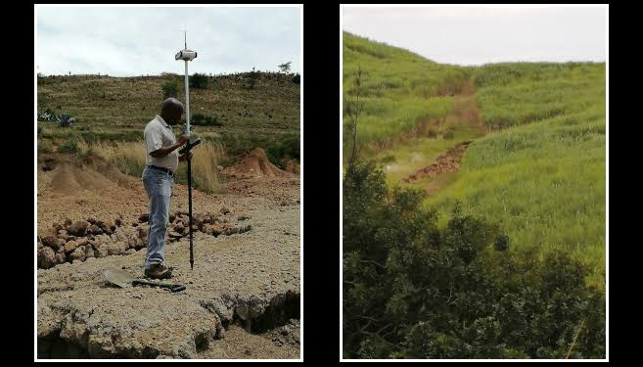
One of the major causes of land degradation is soil erosion. Soil erosion occurs when the topsoil is removed by water or wind. The topsoil is the most fertile part of the soil because it contains most of the organic matter, nutrients, and biological activity needed for plant growth. In South Africa, water erosion often happens when heavy rains fall on bare land, sloping fields, or overgrazed veld. The force of the water loosens soil particles and washes them away, sometimes forming rills and gullies. Wind erosion is common in dry areas where the soil is loose and uncovered. When topsoil is lost, the land becomes less fertile and less able to support crops or grass. Erosion is therefore one of the most damaging forms of land degradation.
Overgrazing is another important cause of land degradation, especially in mixed farming systems where livestock depend on natural veld or planted pasture. Overgrazing happens when too many animals graze on the same land for too long without giving the vegetation enough time to recover. This weakens grass plants, reduces root growth, and leaves bare patches of soil exposed to erosion. Overgrazed land often becomes compacted by trampling, and undesirable plants may replace useful grasses. In South Africa, overgrazing is a common cause of veld deterioration and declining carrying capacity. When the land can no longer support healthy vegetation, both livestock productivity and soil stability are affected.
Poor cultivation practices also contribute greatly to land degradation. Continuous ploughing, over-cultivation, and farming on unsuitable land weaken the soil structure and make the land more vulnerable to erosion and nutrient loss. Cultivating steep slopes, shallow soils, or highly erodible areas can quickly damage the land. Repeated tillage without conservation measures exposes the soil surface, destroys soil aggregates, and accelerates the breakdown of organic matter. In the long term, this reduces the ability of the soil to hold water and nutrients. Land that is cultivated without proper planning or conservation methods often loses its productivity much faster than land that is managed sustainably.
Deforestation and the removal of natural vegetation are also major causes of land degradation. Trees, shrubs, and grasses protect the soil by holding it together with roots, reducing the force of rainfall, slowing wind speed, and supporting water infiltration. When natural vegetation is cleared without proper control, the soil becomes exposed and vulnerable. In some farming areas, vegetation may be removed to expand crop fields, create settlements, or obtain firewood. If this is done unsustainably, the protective cover of the land is lost. The result is often erosion, reduced soil moisture, declining biodiversity, and poorer land quality.
Soil compaction is another significant cause of land degradation. Compaction happens when soil particles are pressed tightly together by heavy machinery, livestock trampling, or repeated movement over the same area. This reduces the pore spaces in the soil, making it harder for water, air, and roots to move through it. Compacted soils absorb less rainfall, which increases runoff and erosion. Crop roots struggle to grow in compacted soil, and pasture recovery becomes weaker. In mixed farming, compaction often develops around water points, gates, feeding areas, roads, and fields worked when the soil is too wet. Although compaction may not always be as visible as erosion, it is a serious form of land degradation because it reduces productivity and soil health.
Loss of soil fertility is another important cause of land degradation. Land becomes degraded when essential nutrients are removed through harvesting, grazing, leaching, or erosion and are not replaced. Continuous cropping without proper fertilization or rotation can leave soils exhausted and unproductive. Similarly, grazing animals remove nutrients through the plants they consume, and if the land is not managed properly, fertility gradually declines. In South Africa, many soils are naturally low in some nutrients, so careful fertility management is necessary. When soils lose nutrients and organic matter, crops become weaker, grass growth declines, and the overall productive potential of the land decreases.
Poor water management can also cause land degradation. Too much water, too little water, or badly controlled water movement can all damage the land. Poor drainage can lead to waterlogging, which deprives plant roots of oxygen and weakens soil structure. In irrigated farming, excessive watering or poor-quality water can lead to salinization, where salts build up in the soil and reduce its productivity. Uncontrolled runoff from roads, fields, or irrigation systems can also cause severe erosion. In dry areas, lack of moisture conservation can leave soils bare and vulnerable. Sustainable land use depends on controlling water in a way that supports the land rather than damaging it.
Burning veld or crop residues without proper management is another cause of land degradation. While controlled burning may sometimes be used for specific management reasons, frequent or uncontrolled burning removes protective ground cover, destroys organic matter, and reduces biological activity in the soil. Without plant cover, the soil is exposed to erosion and moisture loss. Repeated burning can also reduce the vigour of desirable pasture species and encourage poorer vegetation. If land is burned too often, its long-term productive capacity declines.
Invasive alien plants and bush encroachment can also contribute to land degradation. Invasive species often compete with useful grasses, crops, and indigenous vegetation for water, nutrients, and space. Some invasive plants spread rapidly and reduce biodiversity, grazing value, and water availability. Bush encroachment can change the balance of the veld and reduce the amount of grass available for livestock. Both problems make the land less productive and harder to manage. In South Africa, these vegetation changes are a major concern in many farming regions and often indicate declining land health.
Poor land-use planning is another major cause of land degradation. When land is used without considering its slope, soil type, rainfall, drainage, and carrying capacity, damage is likely to occur. For example, planting crops on fragile or steep land, allowing too many animals on poor veld, or locating roads and water points in unsuitable places can all accelerate degradation. Good land management requires planning, but when planning is absent, resources are overused or misused. Poor planning often leads to a combination of erosion, compaction, fertility decline, and vegetation loss.
Mining activities, construction, and uncontrolled infrastructure development can also cause land degradation in rural areas. When soil is removed, disturbed, or covered by waste materials, the natural productivity of the land is lost. Poorly managed roads, borrow pits, and building sites can create erosion channels and disturb natural drainage patterns. Even on farms, badly placed infrastructure can lead to localized land degradation if runoff is not controlled and the surrounding soil is not protected.
Climate factors also play a role in land degradation, especially under South African conditions. Drought reduces vegetation cover and weakens plant roots, making soil more vulnerable to wind and water erosion. Intense rainfall events can wash away topsoil, especially if the land is bare or degraded already. High temperatures increase evaporation and can worsen the drying of exposed soils. Although climate itself is a natural factor, land degradation becomes much worse when poor farming practices combine with droughts, floods, and heat stress. Climate pressure therefore increases the need for good land management.
Population pressure and the overuse of land can also contribute to degradation, especially where land is limited and many users depend on the same area for grazing, cultivation, fuel, and settlement. When land is used beyond its carrying capacity and not given time to recover, degradation follows. This is often seen in communal or densely used farming areas, but it can also happen on commercial farms where production pressure becomes too intense. Sustainable land use requires balance, but overuse disturbs that balance and weakens the land.
Lack of knowledge, poor management, and neglect are often underlying causes of land degradation. Farmers or land users may not recognize the early signs of erosion, overgrazing, nutrient depletion, or compaction, or they may fail to act in time. In some cases, the problem is not a single action but the gradual result of poor decisions made over several years. Land degradation often develops slowly, but once it becomes severe, it is expensive and difficult to reverse. Knowledge, monitoring, and timely action are therefore essential in preventing degradation.
The causes of land degradation include soil erosion, overgrazing, poor cultivation practices, deforestation, soil compaction, loss of fertility, poor water management, repeated burning, invasive plants, bush encroachment, poor land-use planning, infrastructure disturbance, climate stress, population pressure, and weak management. For a mixed crop and livestock farmer in South Africa, these causes are especially important because degraded land affects both crop production and livestock grazing. Understanding these causes helps the farmer take steps to protect the soil, vegetation, and water resources of the farm. Preventing land degradation is essential for maintaining productivity, profitability, and sustainability over the long term.

KT0203 Importance of soil health
Soil health is one of the most important foundations of sustainable agriculture and land management, as it directly affects crop productivity, pasture quality, water retention, and the overall resilience of a farm ecosystem. For a mixed crop and livestock farmer in South Africa, maintaining healthy soil is critical because it ensures that the land can support both crops and livestock over the long term while reducing the need for costly external inputs such as chemical fertilizers and irrigation. Soil health refers not just to the fertility or nutrient content of the soil, but also to its structure, organic matter content, biological activity, water-holding capacity, and its ability to sustain plant and microbial life. Healthy soils are living ecosystems that provide essential functions for agriculture and environmental sustainability.
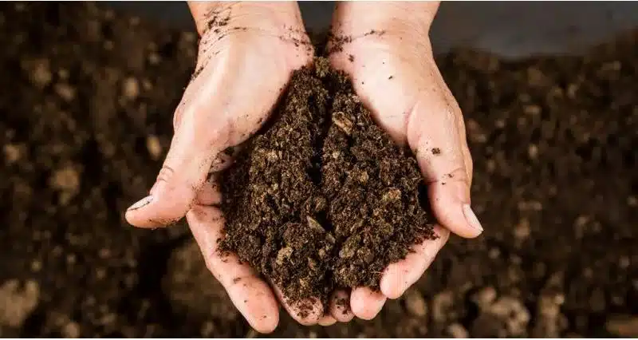
One of the primary reasons soil health is important is that it directly influences plant growth and productivity. Healthy soils contain sufficient nutrients, have good structure, and support a diverse range of microorganisms that help plants access nutrients and water. For crops, this means stronger root development, higher yields, and better resistance to pests and diseases. For pastures and grazing land, healthy soil supports dense, nutrient-rich grasses, which improves livestock nutrition and productivity. In South African conditions, where soils can often be shallow, acidic, or low in nutrients, maintaining soil health is essential to maximize the productivity of both crops and livestock.
Soil health is also important for water management. Healthy soils have good structure and adequate organic matter, which improves water infiltration, reduces runoff, and enhances moisture retention. This is particularly important in South Africa, where drought and irregular rainfall are common. Soils that are degraded, compacted, or low in organic matter are less able to absorb and hold water, which increases erosion and reduces the ability of crops and pastures to survive dry periods. By maintaining healthy soils, farmers improve the land’s resilience to climate variability and ensure that water resources are used efficiently.
Another critical aspect of soil health is its role in preventing land degradation. Soils with strong structure, high organic matter, and healthy biological activity resist erosion, compaction, and nutrient loss. When soil health is neglected, topsoil can be easily washed or blown away, fertility declines, and the land becomes vulnerable to desertification or loss of productivity. For a mixed crop and livestock farmer, maintaining soil health is therefore a preventive measure, protecting the long-term viability of the farm and reducing costs associated with soil rehabilitation or excessive fertilizer use.
Soil health also enhances biodiversity at multiple levels. A healthy soil supports a diverse range of microorganisms, insects, and earthworms that contribute to nutrient cycling, organic matter decomposition, and the natural suppression of pests and diseases. This underground biodiversity improves the resilience of crops and pastures while reducing the reliance on chemical inputs. Aboveground biodiversity, such as diverse grass species and cover crops, is also supported by healthy soils, creating more resilient and productive agroecosystems.
Healthy soils play an essential role in carbon sequestration and climate change mitigation. Soils with high organic matter and strong biological activity can capture and store carbon dioxide from the atmosphere, reducing greenhouse gases and contributing to climate change solutions. For South African farmers, this is especially relevant as climate variability affects crop and pasture growth. Practices that maintain soil health, such as composting, crop rotation, cover cropping, and reduced tillage, help build soil organic matter, enhance productivity, and contribute to environmental sustainability.
Soil health is fundamental to sustainable agriculture because it underpins crop growth, pasture productivity, water retention, biodiversity, and climate resilience. For a mixed crop and livestock farmer in South Africa, maintaining healthy soils ensures long-term farm productivity, reduces costs, protects the environment, and increases resilience to drought, erosion, and climate change. Healthy soils are living ecosystems that sustain agriculture, making soil health a cornerstone of sustainable land management.

KT0204 Importance of water in sustainable land management
Water plays a critical role in sustainable land management because it is essential for plant growth, soil health, livestock production, and overall farm productivity. For a mixed crop and livestock farmer in South Africa, water is a scarce and valuable resource, and its careful management is central to the sustainability of the farm. Water affects nearly every aspect of land use: it supports crop development, maintains pasture for grazing, facilitates nutrient uptake, and helps maintain soil structure and fertility. Without adequate water, land becomes vulnerable to degradation through erosion, compaction, and nutrient loss, which ultimately reduces its long-term productivity. Sustainable land management therefore requires that water is conserved, managed efficiently, and used in ways that protect both the soil and the natural environment.
One of the primary reasons water is important in sustainable land management is that it supports soil moisture, which is essential for healthy plant growth. Soil moisture determines how well seeds germinate, how deep roots can grow, and how effectively crops and pastures can resist drought. In areas of South Africa with erratic rainfall or semi-arid conditions, proper water management becomes critical. Practices such as mulching, cover cropping, and conservation tillage help retain soil moisture by reducing evaporation and improving water infiltration. By maintaining adequate soil moisture, farmers can reduce crop stress, enhance pasture growth, and prevent the land from becoming dry, hard, and prone to erosion.
Water is also crucial for preventing soil erosion and land degradation. When water infiltrates the soil properly, it reduces surface runoff, which can wash away fertile topsoil and create gullies. Contour ploughing, terracing, grassed waterways, and retention structures help control the flow of water over the land, slowing it down and allowing it to soak into the soil rather than eroding it. In South African conditions, where heavy rainfall events can occur after prolonged dry periods, the risk of erosion is high if water is not managed effectively. Sustainable water management reduces soil loss, maintains fertility, and protects the productive capacity of the land.
Another important aspect is the relationship between water and nutrient management. Water carries nutrients through the soil to plant roots, and adequate water ensures that plants can access nitrogen, phosphorus, potassium, and other essential elements. Poor water management—either too much, too little, or uneven distribution—can lead to nutrient leaching or concentration, resulting in soil fertility decline or localized salinity. Sustainable land management practices, such as irrigation scheduling, drip irrigation, or the use of mulch to conserve moisture, help maintain the balance of nutrients in the soil and support healthy crop and pasture growth.
Water is also critical for livestock production in mixed farming systems. Livestock require clean and reliable water sources for drinking, and adequate water is essential for maintaining healthy pastures. Sustainable land management involves protecting water sources such as dams, streams, and boreholes from overuse, pollution, and erosion. Practices such as rotational grazing, fencing off riparian zones, and providing controlled access points for animals ensure that water bodies are not damaged while maintaining water availability for both livestock and the surrounding environment.
Water supports the biological processes in soil that are vital for sustainability. Microorganisms, earthworms, and other soil organisms require moisture to function. They break down organic matter, recycle nutrients, and improve soil structure. Soils that are too dry or too waterlogged can lose biological activity, leading to compaction, poor nutrient cycling, and reduced fertility. By managing water carefully through irrigation, drainage, and moisture conservation techniques, farmers support the living systems in the soil that are essential for long-term land health.
Water management contributes to climate resilience. In South Africa, climate variability can result in droughts, floods, or unpredictable rainfall. Proper water management practices, such as rainwater harvesting, building contour dams, constructing terraces, or planting cover crops, allow farmers to capture and store water during wet periods and use it efficiently during dry spells. This reduces the vulnerability of crops and pastures to climate stress, maintains soil stability, and ensures that land remains productive even under challenging conditions.
Water is a cornerstone of sustainable land management because it maintains soil moisture, supports plant growth, prevents erosion, ensures nutrient availability, sustains livestock, supports soil biological activity, and enhances climate resilience. For a mixed crop and livestock farmer in South Africa, managing water wisely is essential for protecting the long-term productivity and health of the land. Sustainable land management integrates water conservation, efficient use, and protection of water resources to ensure that both crops and livestock can thrive without degrading the natural resource base.

KT0205 Importance of biodiversity conservation in sustainable land management
Biodiversity conservation is a vital component of sustainable land management because it helps maintain the ecological balance, productivity, and resilience of farming systems. For a mixed crop and livestock farmer in South Africa, conserving biodiversity means protecting the variety of plants, animals, microorganisms, and insects that interact within the farm ecosystem. Biodiversity supports soil fertility, pest control, pollination, water retention, and overall ecosystem stability. When biodiversity is reduced, the land becomes more vulnerable to pests, diseases, erosion, and climate stresses, which can lead to lower crop yields, weaker pastures, and degraded soil. Sustainable land management therefore requires that farmers actively conserve biodiversity as part of their long-term strategy to maintain productive and resilient land.
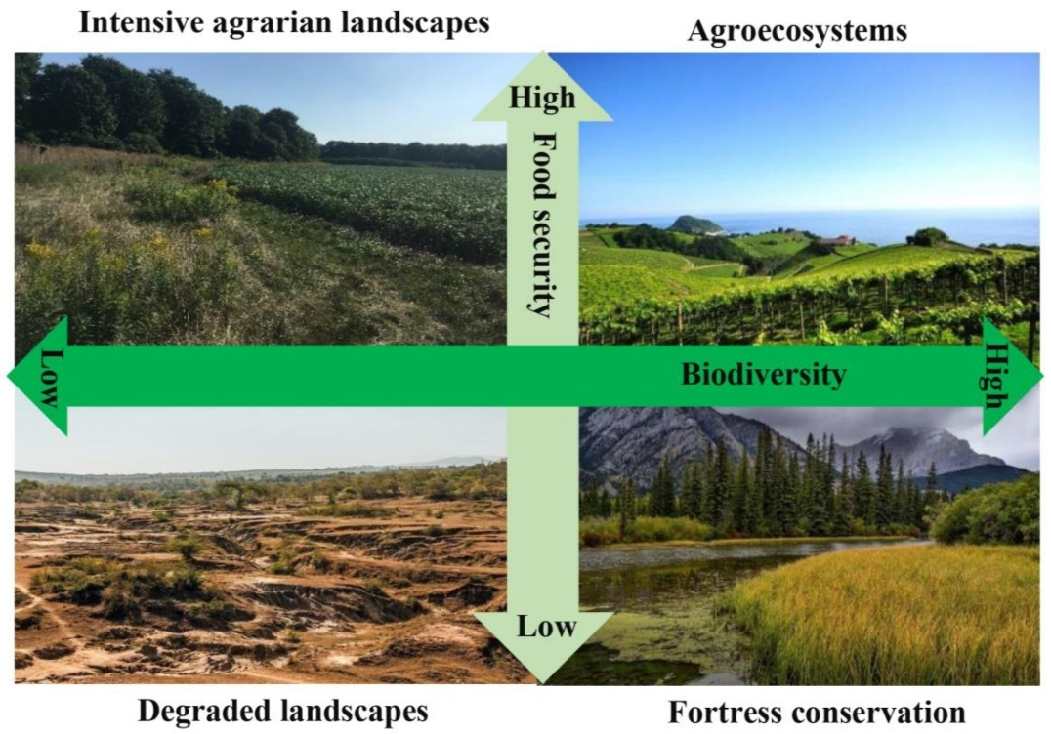
One of the primary reasons biodiversity is important in sustainable land management is that it supports soil health. Soil biodiversity, which includes earthworms, insects, bacteria, fungi, and other microorganisms, is essential for breaking down organic matter, recycling nutrients, and improving soil structure. Healthy soil with a diverse biological population retains water better, resists erosion, and provides nutrients efficiently to crops and pastures. On a South African farm, where soils may already be low in nutrients or prone to degradation, preserving soil biodiversity is crucial for maintaining long-term fertility and supporting sustainable crop and livestock production.
Plant biodiversity is also critical for sustainable land use. A mixture of native grasses, legumes, cover crops, and trees can improve soil fertility, provide forage for livestock, reduce pest and disease outbreaks, and protect against soil erosion. For example, legumes fix nitrogen in the soil, enriching it for subsequent crops, while deep-rooted plants can bring nutrients up from lower soil layers. In pasture areas, maintaining a variety of grass species ensures that livestock have a balanced diet throughout the year and reduces the risk of overgrazing specific species. This variety also increases the resilience of the land during droughts or extreme weather conditions, which are common in parts of South Africa.
Biodiversity conservation also plays a major role in natural pest and disease control. Diverse ecosystems attract predators and beneficial insects that keep harmful pests in check. Monoculture or low-diversity systems, on the other hand, are more prone to pest outbreaks and disease infestations, which can reduce crop and pasture productivity. By maintaining natural habitats, hedgerows, and mixed planting areas, a farmer encourages a balance of species that naturally control pests and diseases without relying heavily on chemical inputs. This reduces costs, protects soil and water quality, and supports long-term farm sustainability.
Pollination is another key ecosystem service supported by biodiversity. Many crops rely on insects, birds, or other animals for pollination, which is essential for fruit, seed, and fodder production. Preserving wildflowers, flowering cover crops, and natural vegetation on and around the farm ensures that pollinators such as bees, butterflies, and other insects thrive. This directly improves crop yields, pasture quality, and the overall productivity of the farm. Without biodiversity, pollination services would decline, requiring artificial or chemical interventions, which may be costly and less effective.
Biodiversity also contributes to water and soil conservation. Trees, shrubs, and groundcover plants reduce runoff, improve water infiltration, and protect the soil from erosion. Forested areas, riparian zones, and grasslands act as natural buffers, filtering water, storing nutrients, and stabilizing the land. On South African farms, where erosion and drought are significant risks, biodiversity acts as a natural protective system, reducing the negative impacts of extreme weather and ensuring sustainable land use.
In addition, conserving biodiversity improves resilience to climate change. Diverse ecosystems are better able to withstand and recover from droughts, floods, and temperature fluctuations. For a mixed crop and livestock farmer, biodiversity provides multiple sources of food, fodder, and income, reducing the risk of total failure in case of crop loss or livestock stress. Trees, shrubs, and diverse pastures also provide shade, windbreaks, and microclimates that protect soil and livestock, helping the farm adapt to changing climatic conditions.
Biodiversity conservation also supports sustainable land management through cultural and economic benefits. Indigenous plants and animals may have medicinal, nutritional, or commercial value. Conserving these species ensures that the farmer can continue to benefit from them while maintaining ecosystem health. Ecotourism opportunities, wildlife conservation programs, and government incentives for biodiversity-friendly farming can also provide additional income streams, making biodiversity conservation economically beneficial as well as environmentally necessary.
Biodiversity conservation is essential for sustainable land management because it maintains soil fertility, supports pollination, controls pests naturally, protects water and soil, increases resilience to climate variability, and provides economic and ecological benefits. For a mixed crop and livestock farmer in South Africa, actively conserving biodiversity ensures that the land remains productive, healthy, and capable of supporting crops and livestock over the long term. Protecting the variety of species on the farm is not only an environmental responsibility but also a practical strategy for maintaining sustainable, resilient, and profitable agriculture.

KT0206 Climate change mitigation (agroforestry, reforestation and carbon farming)
Climate change mitigation in agriculture is an essential aspect of sustainable land management because it helps farmers reduce greenhouse gas emissions, store carbon, and adapt to changing climatic conditions. For a mixed crop and livestock farmer in South Africa, climate change poses serious challenges, including erratic rainfall, higher temperatures, droughts, and more frequent extreme weather events. These impacts can reduce crop yields, degrade pasture, increase soil erosion, and threaten livestock production. Climate change mitigation practices, such as agroforestry, reforestation, and carbon farming, help farmers manage these risks, protect the land, and contribute to global efforts to reduce greenhouse gases. These strategies also enhance biodiversity, improve soil and water conservation, and create additional economic opportunities for the farm.
Agroforestry is the practice of integrating trees and shrubs into crop and livestock systems. It provides multiple benefits for climate change mitigation and sustainable land management. Trees absorb carbon dioxide from the atmosphere through photosynthesis, storing carbon in their trunks, roots, and leaves. In a mixed farming system, trees can provide shade for livestock, reduce heat stress, prevent soil erosion, and improve soil fertility through leaf litter and nitrogen-fixing species. For crops, trees act as windbreaks, protecting plants from wind damage and reducing water loss through evaporation. In South Africa, agroforestry can help farmers stabilize degraded land, increase resilience to drought, and diversify farm products by providing fruit, timber, fodder, or fuelwood. Integrating trees with crops and pasture is therefore both an environmental and economic strategy for mitigating climate change.
Reforestation is the process of planting trees on land that was previously deforested or degraded. Reforestation helps restore ecosystems, sequester carbon, improve water infiltration, and stabilize soils. For a mixed crop and livestock farmer, planting trees on degraded or marginal land can prevent further erosion, improve soil fertility, and provide habitat for wildlife, which enhances biodiversity. In South Africa, where deforestation and overgrazing have reduced forest cover in many areas, reforestation projects contribute to regional climate resilience by moderating temperatures, conserving water, and reducing the risk of floods and desertification. Reforestation can also create economic opportunities, as farmers may sell timber, fruit, or participate in carbon credit schemes, linking sustainability with income generation.
Carbon farming involves agricultural practices that capture and store carbon in soils and vegetation. Techniques include planting cover crops, incorporating organic matter such as compost and manure, practicing no-till or minimum-till farming, and maintaining permanent pastures. These practices increase the soil’s ability to sequester carbon while simultaneously improving soil fertility, water retention, and structure. For livestock farmers, rotational grazing and improved pasture management also enhance carbon storage in grassland soils. Carbon farming provides measurable climate benefits while improving farm productivity and resilience. In South Africa, farmers who adopt carbon farming may also participate in carbon credit markets, generating additional revenue from the carbon stored on their land.
The combination of agroforestry, reforestation, and carbon farming creates a synergistic approach to climate change mitigation. Trees and plants act as carbon sinks, while soil management practices increase carbon storage underground. These approaches reduce greenhouse gas emissions from agriculture, prevent land degradation, enhance biodiversity, and stabilize farm ecosystems. They also improve water retention, reduce erosion, and support livestock and crop production under changing climatic conditions. By integrating these practices, farmers contribute to both local and global climate goals while building a more resilient and productive farm system.
Climate change mitigation through agroforestry, reforestation, and carbon farming is essential for sustainable land management in South Africa. For a mixed crop and livestock farmer, these practices reduce greenhouse gas emissions, sequester carbon, enhance biodiversity, improve soil and water conservation, and increase farm resilience to extreme weather. They also create economic opportunities through timber, fodder, fruit production, and carbon credits. By adopting these mitigation strategies, farmers protect the land, maintain productive farming systems, and contribute to a sustainable future for agriculture and the environment.

KT0207 Principles of sustainable agriculture, such as organic farming, agroecology, and regenerative agriculture
The principles of sustainable agriculture are designed to ensure that farming systems remain productive, environmentally responsible, and socially beneficial over the long term. For a mixed crop and livestock farmer in South Africa, applying these principles helps maintain soil fertility, conserve water, protect biodiversity, and reduce dependence on chemical inputs, while still producing food, fodder, and income. Sustainable agriculture focuses on the integration of ecological, economic, and social goals, emphasizing practices that enhance the natural health of the farm ecosystem rather than relying solely on external inputs. Key approaches include organic farming, agroecology, and regenerative agriculture, each with distinct principles and methods that contribute to the overall sustainability of agricultural operations.
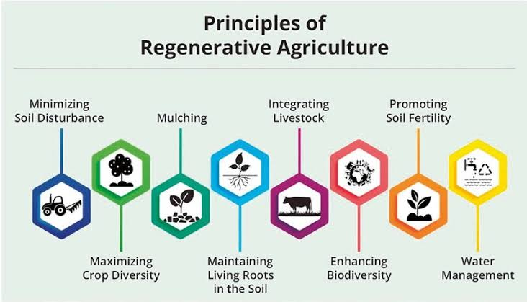

Organic farming is a sustainable agriculture practice that avoids synthetic chemicals, such as fertilizers, pesticides, and herbicides, in favor of natural inputs and ecological methods. Organic farming relies on crop rotation, composting, biological pest control, and green manure to maintain soil fertility and control pests. For a mixed crop and livestock farmer, organic farming can improve soil structure, enhance biodiversity, and reduce pollution of water systems caused by chemical runoff. Livestock are also managed organically, with an emphasis on natural feed, free-range grazing, and humane treatment. By producing crops and animal products without synthetic chemicals, farmers can access premium markets while promoting environmental and human health.
Agroecology is an approach that applies ecological principles to the design and management of agricultural systems. It emphasizes the interactions between crops, livestock, soil, water, and biodiversity, aiming to create resilient and self-sustaining ecosystems. In practice, agroecology involves intercropping, agroforestry, mixed crop-livestock systems, and the use of locally adapted plant and animal varieties. For a South African farmer, agroecology supports climate resilience by improving soil fertility, conserving water, and reducing vulnerability to pests and diseases. It also strengthens social and economic sustainability by promoting local knowledge, community involvement, and diversified income streams. Agroecology is therefore both an ecological and socio-economic strategy for sustainable farming.
Regenerative agriculture is a farming approach that goes beyond sustainability by actively restoring and improving the health of the land. Its principles include maintaining permanent soil cover, minimizing soil disturbance, enhancing biodiversity, integrating livestock, and returning organic matter to the soil. In regenerative agriculture, soils are managed to sequester carbon, increase water retention, and restore fertility, while crop and livestock systems are integrated to mimic natural ecosystems. For mixed crop and livestock farmers in South Africa, regenerative practices help rehabilitate degraded land, improve pasture productivity, reduce erosion, and increase resilience to drought. The emphasis is on regenerating natural resources rather than simply maintaining them, creating long-term productivity gains while addressing climate change.
Across all these approaches, the common principles of sustainable agriculture include maintaining healthy soils, conserving water, reducing chemical inputs, enhancing biodiversity, and integrating crops and livestock in a way that supports natural ecological processes. These principles emphasize working with nature rather than against it, reducing negative environmental impacts while maintaining or increasing farm productivity. Sustainable agriculture also considers the social and economic aspects of farming, ensuring that practices support farmer livelihoods, food security, and community well-being.
The principles of sustainable agriculture—through organic farming, agroecology, and regenerative agriculture—guide farmers in producing food and livestock products while protecting the environment and natural resources. For a mixed crop and livestock farmer in South Africa, these principles enhance soil fertility, water conservation, biodiversity, climate resilience, and long-term productivity. By integrating these practices into farm management, farmers ensure that their land remains healthy and productive for future generations, while also creating opportunities for economic growth and ecological stewardship.

Internal Assessment Criteria (IAC) and Weight
- IAC0201 Explain principles of sustainable land management including environmental, social and economic aspects.

Sustainable land management is the responsible use of land resources in a way that meets present needs without reducing the ability of future generations to use the same land productively. It is based on the understanding that land is not only a production asset, but also a natural resource that supports ecosystems, livelihoods, and social well-being. The environmental principle of sustainable land management focuses on protecting soil, water, vegetation, and biodiversity. This means farmers must prevent erosion, avoid overgrazing, conserve water, reduce pollution, and maintain soil fertility. The aim is to ensure that farming activities do not damage the land’s natural capacity to support life. In South Africa, this is especially important because many areas face drought, soil erosion, and pressure on grazing land.
The social principle of sustainable land management relates to the way land use affects people, communities, labour conditions, food security, and future generations. Land must be managed in a way that supports decent livelihoods, fair access to resources, and healthy rural communities. Sustainable land management encourages safe working conditions, responsible use of common resources, and farming systems that help provide reliable food and income. It also recognises the value of indigenous knowledge, local participation, and community cooperation in managing land successfully. In areas where people depend directly on land for survival, poor land management can lead to hunger, poverty, migration, and social conflict. Sustainable practices therefore help strengthen social stability and resilience.
The economic principle of sustainable land management focuses on making land use productive, efficient, and financially viable over the long term. A farmer must earn enough income from the land to continue farming, support workers, maintain infrastructure, and invest in improvements. However, short-term profit should not come at the cost of long-term damage. For example, overstocking grazing land may increase immediate income but reduce future carrying capacity. Sustainable land management seeks a balance between profitability and conservation by encouraging efficient input use, enterprise diversification, improved planning, and reduced waste. Economically sound land management helps farmers remain competitive while protecting their resource base.

- IAC0202 Discuss the impact of land degradation on ecosystems and human communities.

Land degradation refers to the decline in the productive and ecological quality of land caused by factors such as erosion, overgrazing, deforestation, salinisation, nutrient depletion, compaction, and poor farming practices. It affects both natural ecosystems and human communities in serious and often long-lasting ways. When land degrades, it loses its ability to support healthy plant growth, store water, cycle nutrients, and sustain biodiversity. In agricultural areas, this results in lower crop yields, poorer grazing, reduced livestock performance, and increased production costs. In severe cases, land may become unproductive and difficult to restore.
The impact on ecosystems is significant because degraded land can no longer perform its natural functions properly. Soil erosion removes fertile topsoil, which reduces plant cover and weakens the habitat of soil organisms, insects, birds, and other wildlife. Loss of vegetation leads to increased runoff, less water infiltration, and greater vulnerability to drought and flooding. Wetlands, rivers, and dams may become silted as eroded soil is washed into water systems. Biodiversity declines because plants and animals lose the habitats they depend on. In this way, land degradation disrupts ecological balance and reduces the ability of ecosystems to recover from environmental stress.
Human communities are also deeply affected by land degradation, especially in rural areas where people depend directly on land for food, grazing, fuel, and income. When soil fertility declines and yields drop, households may struggle to produce enough food or earn sufficient income. Livestock farmers may face feed shortages, poor animal condition, and reduced herd productivity. Water sources may become unreliable or polluted due to erosion and poor land cover. As a result, communities may experience poverty, food insecurity, unemployment, and increased dependence on external support. In some cases, land degradation forces people to migrate in search of better living conditions, which places further pressure on other areas.

- IAC0203 Discuss practices for improving soil health.

Soil health refers to the ability of soil to function as a living system that supports plants, animals, and human needs. Healthy soil has good structure, adequate nutrients, active microorganisms, organic matter, proper moisture balance, and the capacity to resist erosion and compaction. Improving soil health is essential for sustainable agriculture because healthy soil produces better crops, supports grazing, stores more water, and recovers more easily from drought or disturbance. One of the most important practices for improving soil health is adding organic matter. This can be done through compost, kraal manure, crop residues, green manure, and cover crops. Organic matter improves soil structure, increases water-holding capacity, feeds soil organisms, and helps retain nutrients.
Crop rotation is another important practice for improving soil health. Different crops use nutrients differently and have different rooting patterns, so rotating crops prevents one-sided nutrient depletion and helps break pest and disease cycles. Including legumes in the rotation is especially beneficial because legumes fix nitrogen from the atmosphere into the soil, improving fertility naturally. Cover cropping also supports soil health by keeping the land covered, reducing erosion, suppressing weeds, and adding biomass to the soil. In mixed farming systems, cover crops may also provide fodder while improving the soil.
Minimum tillage or conservation tillage helps improve soil health by reducing disturbance to the soil. Excessive ploughing breaks down soil structure, speeds up organic matter loss, and can increase erosion. By disturbing the soil less and leaving crop residues on the surface, the farmer protects soil life, improves moisture retention, and supports the formation of stable soil aggregates. Mulching also contributes to better soil health because it reduces temperature extremes, lowers evaporation, and adds organic matter as it decomposes.

- IAC0204 Discuss practices of water conservation in land management.

Water conservation in land management means using available water carefully, efficiently, and responsibly so that enough remains for crops, livestock, ecosystems, and future use. In South Africa, water conservation is a major priority because rainfall is often low and uneven, and drought is a recurring challenge. One important practice is rainwater harvesting, where runoff from roofs, farm buildings, and land surfaces is collected and stored in tanks, ponds, or dams for later use. This reduces dependence on external supplies and makes better use of seasonal rainfall.
Efficient irrigation is another key practice. Water should be applied according to crop needs, soil type, and weather conditions, rather than on a fixed schedule. Drip irrigation, for example, delivers water directly to the plant root zone and reduces losses from evaporation and runoff. Irrigation systems should be maintained properly to prevent leaks, blockages, and waste. Scheduling irrigation during cooler times of day can also reduce evaporation. Soil moisture monitoring helps farmers apply only the amount of water that is needed.
Mulching and cover cropping are effective water conservation practices because they reduce evaporation and improve water infiltration. When the soil is covered, it loses moisture more slowly and absorbs rainfall more effectively. Conservation tillage also helps by improving soil structure and leaving residues on the surface, which slows runoff and increases infiltration. Contour farming, terraces, and grassed waterways are further methods that reduce runoff and help keep water in the land instead of losing it through rapid flow. In grazing systems, proper veld management and controlled stocking rates protect ground cover, which helps rainfall soak into the soil instead of running off. Protecting wetlands, riparian zones, and natural vegetation is also important because these areas regulate water flow, filter pollutants, and support the recharge of water systems. Water conservation is therefore closely linked to both soil conservation and broader environmental management.

- IAC0205 Discuss practices for conserving biodiversity in agricultural production

Biodiversity refers to the variety of living organisms in an area, including plants, animals, insects, birds, soil organisms, and microorganisms. In agricultural production, biodiversity is important because it supports pollination, pest control, soil fertility, water regulation, and ecological balance. Conserving biodiversity on farms means managing agricultural activities in ways that protect and encourage life rather than destroying it. One key practice is preserving natural vegetation such as grassland patches, wetlands, riverbanks, and tree belts. These areas provide habitat for birds, pollinators, beneficial insects, and other wildlife that contribute to a healthy farming ecosystem.
Crop diversification is another important biodiversity practice. Planting different crops rather than relying on a single monoculture helps create varied habitats and reduces the spread of pests and diseases. Intercropping, crop rotation, and the inclusion of legumes, fodder crops, and cover crops all support greater biological diversity. In livestock systems, maintaining a diversity of pasture species can improve grazing value while also supporting insects and soil organisms. Agroforestry, which combines trees with crops or livestock, is another useful practice because it increases habitat diversity, provides shade, reduces erosion, and contributes to ecological stability.
Responsible chemical use is essential for biodiversity conservation. Excessive or careless use of pesticides, herbicides, and fertilisers can kill beneficial organisms, contaminate water, and harm non-target species. Integrated pest management is a better approach because it combines monitoring, biological control, resistant varieties, and selective chemical use only when necessary. This reduces harm to pollinators and natural enemies of pests. Conserving soil biodiversity is also important, which can be achieved through organic matter addition, reduced tillage, and avoiding unnecessary chemical disturbance. In South African farming systems, biodiversity conservation helps build resilience, especially under changing climate conditions, and supports long-term agricultural productivity.

- IAC0206 Explain climate change mitigation practices

Climate change mitigation practices are actions that reduce the release of greenhouse gases or increase the ability of land and vegetation to absorb carbon from the atmosphere. In agriculture, mitigation is important because farming can both contribute to climate change and help reduce its effects. One major mitigation practice is improving soil carbon storage. This is done through conservation tillage, cover crops, crop rotation, compost application, and maintaining permanent soil cover. Healthy soils with higher organic matter store more carbon and also become more productive and drought-resistant.
Tree planting and agroforestry are also valuable mitigation practices because trees absorb carbon dioxide as they grow. On farms, trees can be planted as windbreaks, along waterways, in grazing lands, or in integrated crop systems. Better livestock management can also reduce emissions. This includes improving feed quality, managing herd size appropriately, reducing overgrazing, and improving breeding efficiency so that fewer resources are wasted on unproductive animals. Manure can be managed carefully to reduce methane and nitrous oxide emissions, while still being used as a valuable fertiliser resource.
Efficient energy use is another important mitigation measure. Farmers can reduce emissions by maintaining machinery properly, reducing unnecessary fuel use, using renewable energy where possible, and applying fertilisers accurately to avoid waste. Preventing veld degradation and protecting natural vegetation are also climate mitigation practices because healthy ecosystems store carbon and remain more resilient. Climate change mitigation in agriculture does not only protect the global environment; it often improves farm efficiency, lowers costs, and strengthens the productive base of the farm.

- IAC0207 Explain principles of sustainable agriculture

Sustainable agriculture is based on principles that integrate environmental stewardship, economic viability, and social responsibility. Environmentally, it aims to conserve natural resources such as soil, water, and biodiversity, while reducing pollution and energy use. Economically, sustainable agriculture focuses on long-term profitability, efficient resource use, risk management, and diversification of crops and livestock. Socially, it supports community wellbeing, equitable labour practices, and food security. Sustainable agriculture also emphasizes system integration, such as using livestock to recycle crop residues and manure for soil fertility. Crop rotation, agroforestry, organic amendments, integrated pest management, water conservation, and climate-smart practices are all consistent with these principles. For South African mixed farmers, adopting sustainable agriculture ensures that production remains productive, resilient, and environmentally responsible despite climate variability and resource pressures.

KM-02-KT03 Water conservation strategies 20%
Topic element
- KT0301 Water conservation in agriculture
- KT0302 Impact of water scarcity in agricultural production
- KT0303 Rainwater harvesting and construction of water dams
- KT0304 Optimal use of water and irrigation in agriculture
- KT0305 Protection of ground water and prevention of water leakages
- KT0306 Importance of water quality and availability
- KT0307 Protection of wetlands
- KT0308 Importance of water regulations (licenses, water boards, quotas and tariffs)

KT0301 Water conservation in agriculture
Water conservation in agriculture is a crucial practice for ensuring sustainable food and livestock production, particularly in South Africa, where water is a limited and increasingly scarce resource. For a mixed crop and livestock farmer, conserving water means using available water efficiently, reducing waste, and protecting natural water sources to maintain farm productivity while safeguarding the environment. Water conservation in agriculture is not only about irrigation management but also involves soil management, crop and pasture planning, and ecosystem protection. It ensures that crops and pastures receive adequate moisture, livestock have reliable water sources, and the land remains productive over the long term.
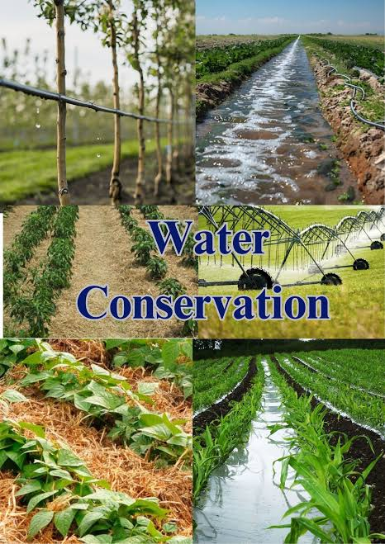
One of the main aspects of water conservation in agriculture is efficient irrigation management. Farmers need to ensure that water is applied directly to where it is most needed—such as crop roots—while minimizing losses due to evaporation or runoff. Techniques like drip irrigation, micro-sprinklers, and furrow irrigation allow precise water application, improving water-use efficiency and reducing wastage. Scheduling irrigation based on soil moisture levels, rainfall patterns, and crop growth stages ensures that water is applied only when necessary. For livestock, controlled watering points and troughs reduce water wastage and prevent contamination of water sources.
Soil management is another critical factor in water conservation. Healthy soils with good structure and high organic matter content retain water more effectively and allow it to infiltrate deeper rather than running off the surface. Practices such as mulching, cover cropping, minimum tillage, and maintaining permanent vegetation cover help conserve soil moisture. Mulch protects the soil from evaporation, reduces runoff, and adds nutrients as it decomposes, while cover crops prevent bare soil exposure and increase water infiltration. Proper soil management ensures that rainwater is used efficiently and that crops and pastures have access to moisture during dry periods.
Rainwater harvesting and storage are also important strategies. Collecting rainwater from roofs, roads, or open areas into tanks, dams, or reservoirs provides supplementary water for irrigation, livestock, or domestic use. Capturing runoff during heavy rains prevents soil erosion and stores water for use during dry spells. Contour dams, ponds, and farm reservoirs can also improve water availability while supporting soil and ecosystem conservation.
Waterway and wetland protection contributes to agricultural water conservation by maintaining natural systems that regulate water flow, filter sediment, and store water in the landscape. Protecting streams, rivers, wetlands, and riparian zones from overgrazing, pollution, and soil erosion ensures that natural water cycles continue to function properly. Planting buffer strips, fencing sensitive areas, and preserving natural vegetation along waterways reduce water loss, prevent soil degradation, and support biodiversity, which in turn enhances farm resilience.
Crop and pasture selection is another strategy that supports water conservation. Using drought-tolerant crops, deep-rooted plants, or indigenous grass species reduces water demand and improves resilience during dry periods. Crop rotation, intercropping, and the integration of cover crops help maintain soil moisture, reduce evaporation, and minimize irrigation needs. Selecting pasture species suitable for the local climate ensures that livestock have adequate fodder without placing excessive demand on limited water resources.
Water recycling and reuse is also a component of water conservation in agriculture. Treated farm wastewater or runoff can be used for irrigation, reducing the overall demand for fresh water. Organic inputs such as manure or compost improve soil structure and increase water-holding capacity, indirectly reducing irrigation requirements.
Water conservation in agriculture is essential for sustaining crop production, pasture growth, and livestock health while protecting the natural environment. For a mixed crop and livestock farmer in South Africa, this involves efficient irrigation, soil management, rainwater harvesting, protection of waterways and wetlands, appropriate crop and pasture selection, and water recycling. By implementing these practices, farmers can ensure that water is used wisely, land productivity is maintained, and farms remain resilient to drought and climate variability. Water conservation is therefore both an economic and ecological necessity for sustainable agriculture.

KT0302 Impact of water scarcity in agricultural production
Water scarcity has a significant impact on agricultural production, affecting both crop yields and livestock performance. For a mixed crop and livestock farmer in South Africa, where droughts, irregular rainfall, and water shortages are increasingly common, water scarcity poses serious challenges to the sustainability and profitability of the farm. Water is essential for photosynthesis, nutrient uptake, soil moisture maintenance, pasture growth, and livestock hydration. Without sufficient water, plants and animals cannot thrive, leading to reduced productivity, land degradation, and financial losses. Understanding the impacts of water scarcity is critical for farmers to implement effective water management and conservation strategies.
One of the primary impacts of water scarcity is reduced crop yields. Crops require consistent moisture throughout their growth stages, from germination to maturity. Water stress reduces photosynthesis, weakens plants, and limits nutrient uptake, resulting in smaller plants, fewer flowers, and lower fruit or seed production. In extreme cases, crops may fail completely, leading to food shortages and income loss. In South Africa, water scarcity is especially critical in dryland farming areas, where rainfall is low or highly variable. Even irrigated crops are affected when water supplies are insufficient, highlighting the need for careful water planning and conservation measures.
Pasture and forage production are also severely impacted by water scarcity. Grass growth depends on sufficient soil moisture, and prolonged dry periods cause pastures to become sparse, dry, or unpalatable. For livestock farmers, reduced pasture availability limits grazing, forcing reliance on supplementary feed, which increases production costs. Overgrazing of remaining pasture during water-scarce periods can further degrade the land, creating a cycle of declining soil fertility, erosion, and reduced water retention. This makes sustainable grazing management essential to protect the land during droughts.
Livestock health and productivity are directly affected by water scarcity. Animals require adequate water for hydration, digestion, thermoregulation, and milk production. Limited water availability can lead to dehydration, reduced weight gain, lower milk yields, and increased susceptibility to disease. In South Africa, where summers are often hot and dry, water scarcity can place additional stress on livestock, reducing reproductive performance and overall herd productivity. Farmers may need to limit herd size, relocate animals, or invest in water storage and supply infrastructure, all of which increase operational costs.
Water scarcity also impacts soil health and land productivity. Dry soils become hard, compacted, and prone to wind erosion, reducing their ability to absorb and store water when rainfall does occur. This reduces soil fertility, weakens plant root systems, and accelerates land degradation. In addition, water scarcity can increase salinization in irrigated fields, as less water is available to flush salts from the soil. Over time, this reduces the land’s capacity to support crops and pasture, threatening long-term sustainability.
Another important impact is economic and social stress. Reduced crop and livestock productivity due to water scarcity can lead to lower farm income, increased production costs, and financial instability. Farmers may face higher input costs for feed, irrigation, or water storage infrastructure, while output declines. This can affect rural livelihoods, food security, and the broader agricultural economy. In South Africa, where agriculture supports millions of people directly or indirectly, prolonged water scarcity has far-reaching consequences beyond individual farms.
Water scarcity also affects biodiversity and ecosystem services on the farm. Reduced water availability can cause the loss of native vegetation, reduce forage diversity, and limit the survival of beneficial soil organisms and pollinators. The decline in biodiversity further weakens farm resilience, making crops and livestock more vulnerable to pests, diseases, and climate shocks. Maintaining natural water sources and conserving biodiversity are therefore critical strategies for mitigating the negative impacts of water scarcity.
Water scarcity has profound effects on agricultural production, reducing crop yields, limiting pasture growth, stressing livestock, degrading soils, and increasing farm costs. For a mixed crop and livestock farmer in South Africa, water scarcity threatens both productivity and long-term sustainability. Effective water management, conservation strategies, and planning are essential to mitigate these impacts, maintain farm productivity, and ensure that land, water, and livestock resources remain viable under changing climatic conditions.

KT0303 Rainwater harvesting and construction of water dams
Rainwater harvesting and the construction of water dams are vital strategies for sustainable water management in agriculture, particularly for mixed crop and livestock farmers in South Africa, where rainfall is often variable and water scarcity is a major challenge. These practices allow farmers to capture, store, and manage water efficiently, ensuring that crops, pastures, and livestock have access to reliable water supplies even during dry periods. Beyond supplying water, these methods help prevent soil erosion, support biodiversity, and enhance the resilience of farms against climate variability. Implementing rainwater harvesting and water dams requires careful planning, proper design, and ongoing maintenance to maximize benefits.

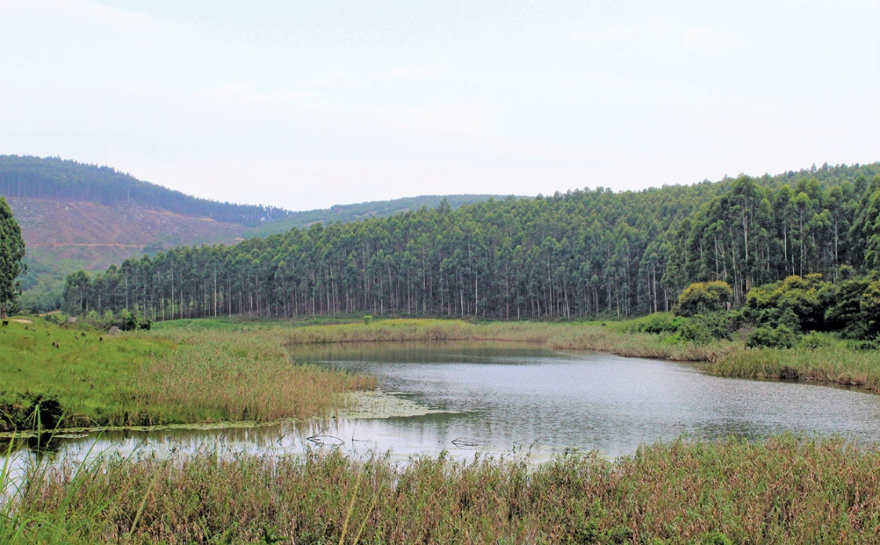
Rainwater harvesting involves collecting and storing rainwater from surfaces such as rooftops, roads, or catchment areas for future use. For a farm, this means capturing runoff from farm buildings, silos, or paved areas and channelling it into storage tanks, barrels, or small reservoirs. The collected water can be used for irrigating crops, watering livestock, or even domestic farm needs. Rainwater harvesting reduces dependence on groundwater or municipal water supplies, lowers irrigation costs, and helps protect natural water sources from overuse. It also reduces surface runoff, which can carry soil, nutrients, and contaminants away from the fields, thereby helping to prevent soil erosion.
The construction of water dams is another essential strategy for water management. Farm dams or reservoirs are designed to store large volumes of water, particularly during periods of heavy rainfall, for use during dry spells. Dams can be constructed by creating embankments across natural valleys or depressions, or by excavating storage ponds. The location of the dam must be carefully selected to ensure maximum water capture, minimal seepage, and safe overflow management. Dams not only provide water for irrigation and livestock but also help recharge groundwater, support aquatic biodiversity, and provide a source of water during extreme droughts. In South African farming regions, where rainfall patterns are unpredictable, farm dams are critical infrastructure for maintaining agricultural productivity and resilience.
Benefits of rainwater harvesting and dams include improved soil moisture management, enhanced crop yields, reliable livestock watering, and reduced pressure on other water sources. By capturing rainwater and storing it in dams, farmers can irrigate crops during dry periods without depleting rivers or groundwater, which protects the broader environment. Additionally, well-designed water storage systems can trap silt and sediment, preventing it from entering natural waterways and contributing to land degradation downstream.
Design and maintenance considerations are critical for the effectiveness of both rainwater harvesting and dams. Proper catchment design ensures that rainwater flows efficiently into storage systems, while filtration and first-flush systems prevent debris and contaminants from entering tanks. Dams require regular inspection for seepage, cracks, and sediment buildup. Maintaining vegetation around the dam helps prevent erosion of embankments, while overflow systems must be carefully managed to avoid uncontrolled flooding. Farmers must also monitor water quality to prevent contamination that could harm crops, livestock, or human health.
Integration with other water conservation practices enhances the benefits of rainwater harvesting and dams. For example, combining these systems with drip irrigation, mulching, or cover cropping ensures that stored water is used efficiently and retained in the soil for longer periods. Additionally, protecting surrounding wetlands, planting trees, and maintaining vegetation in catchment areas improve water infiltration, reduce runoff, and enhance overall farm water security.
Rainwater harvesting and the construction of water dams are essential tools for sustainable water management in agriculture. For mixed crop and livestock farmers in South Africa, these practices provide reliable water supply, protect soil and ecosystems, support livestock and crop production, and enhance resilience to drought and climate variability. By carefully planning, constructing, and maintaining rainwater harvesting systems and dams, farmers can secure water resources, improve farm productivity, and ensure the long-term sustainability of their land and livelihoods.

KT0304 Optimal use of water and irrigation in agriculture
The optimal use of water and irrigation in agriculture is essential for sustaining farm productivity, conserving resources, and ensuring the long-term viability of agricultural operations. For a mixed crop and livestock farmer in South Africa, where water is often scarce and rainfall unpredictable, using water efficiently is critical to maintaining healthy crops, productive pastures, and livestock health. Optimal water use involves applying the right amount of water at the right time, using appropriate irrigation methods, and integrating water-saving practices that reduce waste while maximizing productivity. By managing water intelligently, farmers can increase yields, lower costs, protect the environment, and build resilience against drought and climate variability.
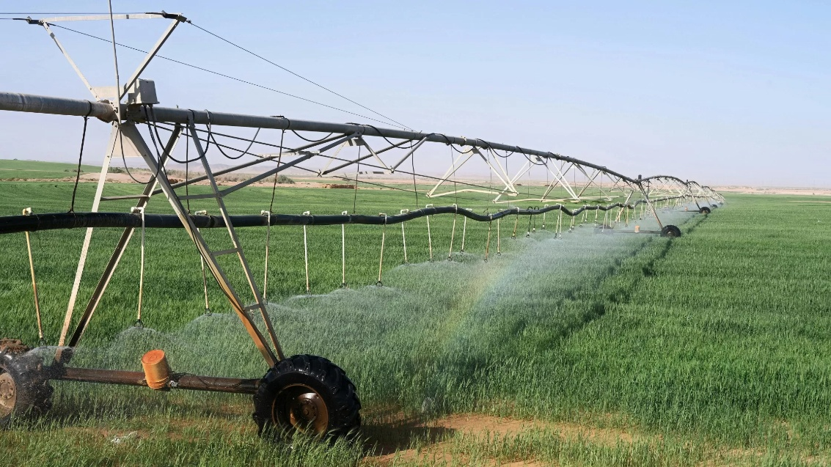
One key principle of optimal water use is efficient irrigation scheduling. This means supplying crops and pastures with water when they need it most, rather than applying water on a fixed schedule or in excess. Factors such as crop type, growth stage, soil moisture, rainfall, and temperature must all be considered. For example, young seedlings require frequent, shallow watering to establish roots, while mature crops may need deeper but less frequent watering. By monitoring soil moisture through simple tools like tensiometers, moisture probes, or even visual inspection, farmers can avoid over-irrigation, which wastes water and may lead to nutrient leaching or root diseases, while also preventing under-irrigation that stresses plants and reduces yields.
Choosing the appropriate irrigation method is another crucial component. Efficient irrigation techniques include drip irrigation, micro-sprinklers, and furrow irrigation, which deliver water directly to plant roots with minimal losses. Drip irrigation, for instance, reduces evaporation and runoff, making it highly suitable for row crops, orchards, and vegetable gardens. Micro-sprinklers can cover larger areas evenly, while furrow irrigation can be effective on sloped fields if carefully managed. In livestock systems, providing controlled access to troughs reduces spillage and ensures that water is used for hydration rather than being wasted. Selecting the right irrigation method based on soil type, crop needs, and water availability is essential for optimal water use.
Soil and water conservation practices complement efficient irrigation by improving water retention in the soil. Techniques such as mulching, cover cropping, minimum tillage, and maintaining permanent vegetation reduce evaporation, increase infiltration, and enhance the soil’s capacity to hold water. Mulch, for example, acts as a protective layer, keeping the soil moist and reducing temperature fluctuations. Cover crops reduce runoff and erosion while improving soil structure, allowing water to penetrate deeper into the soil. These practices ensure that water applied through irrigation or rainfall is retained longer and used more effectively by crops and pastures.
Integrating water management with farm planning is another strategy for optimizing water use. Crop and pasture selection based on local rainfall patterns, drought tolerance, and water requirements can reduce irrigation demand. Rotating crops or using drought-resistant varieties ensures that water is applied where it is most needed. In mixed crop-livestock systems, allocating water efficiently between crop fields, pastures, and livestock watering points helps balance competing demands and prevents overuse of limited water resources.
Monitoring and reducing water losses is also critical for optimal use. Leaks in irrigation pipes, inefficient delivery systems, or open water troughs can lead to significant water wastage. Regular inspection, maintenance, and repair of irrigation infrastructure ensure that water reaches its intended target. Farmers can also implement water-saving technologies such as pressure regulators, timers, and moisture sensors to improve efficiency.
The optimal use of water and irrigation in agriculture is essential for maximizing productivity, conserving resources, and maintaining sustainable farming systems. For a mixed crop and livestock farmer in South Africa, efficient water management ensures that crops and pastures receive adequate moisture, livestock remain healthy, and soils are protected from erosion and nutrient loss. By combining efficient irrigation methods, soil moisture management, proper farm planning, and careful monitoring, farmers can use water wisely, reduce costs, protect the environment, and build resilience against drought and climate variability. Effective water management is therefore a cornerstone of sustainable agricultural production.

KT0305 Protection of ground water and prevention of water leakages
The protection of groundwater and the prevention of water leakages are crucial aspects of sustainable water management in agriculture. For a mixed crop and livestock farmer in South Africa, safeguarding groundwater ensures a reliable supply of clean water for crops, pastures, livestock, and domestic farm use. Groundwater is a vital resource, especially in areas with low or irregular rainfall, and overexploitation or contamination can have long-term negative impacts on farm productivity and environmental health. Preventing water leakages from storage systems, pipelines, and irrigation networks is equally important to conserve water, reduce costs, and improve the efficiency of farm operations. Together, these practices contribute to sustainable land use, environmental protection, and the resilience of farming systems.
Groundwater protection begins with careful management of water extraction. Farmers must ensure that boreholes, wells, and pumps are constructed according to engineering standards to prevent contamination from surface runoff, chemicals, or pathogens. Over-extraction can lower the water table, reduce flow to nearby wetlands or streams, and cause land subsidence, which can permanently damage soil structure. Protecting surrounding vegetation and maintaining buffer zones around water sources helps prevent sedimentation and pollution from fertilizers, pesticides, and livestock waste. Additionally, farmers should monitor groundwater quality regularly, testing for salinity, chemical residues, and biological contaminants to maintain safe and sustainable usage.
Preventing contamination is another key aspect of groundwater protection. Agricultural activities can introduce harmful substances into aquifers if not managed properly. Fertilizers, herbicides, pesticides, and animal waste can seep through the soil into groundwater. Implementing controlled application of chemicals, proper storage of agrochemicals, and safe disposal of livestock waste reduces the risk of groundwater pollution. For livestock operations, fencing off sensitive water sources and providing designated watering points can prevent direct contamination from animals while maintaining access to clean water.
Prevention of water leakages is critical to conserving water and ensuring operational efficiency on the farm. Leaks from irrigation pipes, storage tanks, dams, and water troughs can result in significant water losses over time. Regular inspection, maintenance, and prompt repair of pipelines, taps, and fittings help minimize water wastage. Using high-quality materials, proper installation techniques, and pressure regulators can prevent leaks and reduce the risk of infrastructure damage. In addition, implementing automated irrigation systems with sensors or timers ensures that water is applied only when needed and reduces losses due to overwatering or overflow.
Efficient water storage is also essential for preventing leakage and protecting groundwater. Farm dams, tanks, and reservoirs should be constructed to minimize seepage through lining with clay, concrete, or synthetic materials if necessary. Overflow channels should be carefully designed to avoid uncontrolled water loss or erosion. Properly maintaining storage structures not only conserves water but also protects downstream ecosystems and prevents sedimentation that could compromise groundwater recharge.
Integration with overall farm water management ensures that groundwater protection and leak prevention contribute to sustainable agricultural production. By combining water-saving irrigation practices, soil moisture conservation, rainwater harvesting, and groundwater monitoring, farmers can maximize water efficiency, reduce stress on natural resources, and maintain productivity even during droughts or dry seasons. These practices also help maintain healthy soils, protect biodiversity, and enhance resilience to climate variability.
The protection of groundwater and the prevention of water leakages are vital for sustainable agriculture. For mixed crop and livestock farmers in South Africa, these practices ensure the availability of clean water for crops, pastures, and livestock while preventing environmental degradation. By carefully managing groundwater extraction, preventing contamination, maintaining water infrastructure, and integrating efficient water use strategies, farmers can conserve water resources, reduce costs, and build resilient and sustainable farming systems. Protecting groundwater and minimizing leaks is therefore both an economic and ecological necessity for long-term agricultural success.

KT0306 Importance of water quality and availability
Water quality and availability are critical components of sustainable agriculture, especially for mixed crop and livestock farmers in South Africa, where water scarcity and pollution can significantly impact farm productivity and ecosystem health. Clean, sufficient water is essential for crop growth, livestock hydration, soil health, and the overall functionality of farm systems. The quality and quantity of water directly influence plant development, livestock performance, and the farm’s economic viability. Understanding the importance of water quality and availability helps farmers make informed decisions about irrigation, livestock management, and land use, ensuring long-term sustainability.
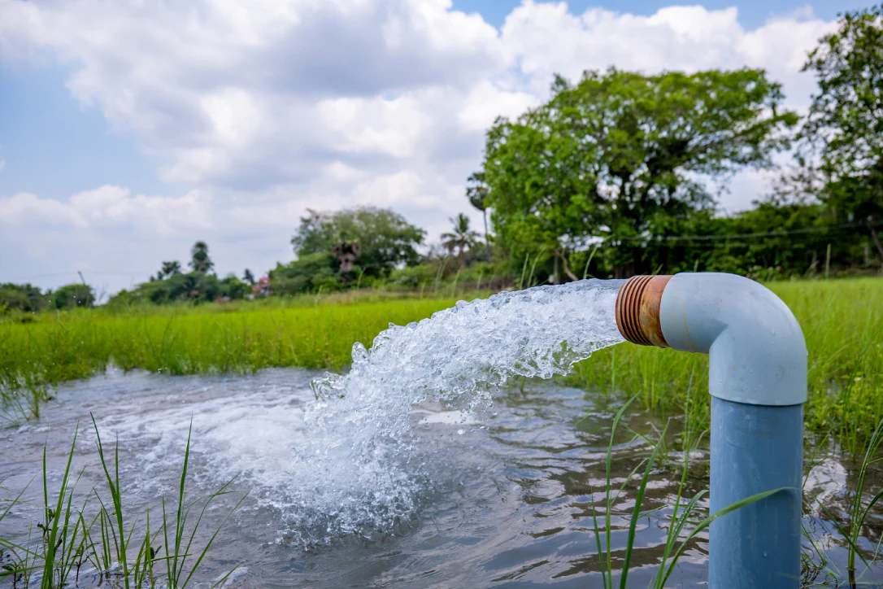
Water quality refers to the chemical, physical, and biological characteristics of water that determine its suitability for use. High-quality water is free from pollutants, pathogens, excessive salts, and harmful chemicals that can negatively affect crops, soil, and livestock. Poor water quality can reduce crop yields, cause soil degradation, and lead to livestock diseases. For example, water contaminated with nitrates, heavy metals, or pathogens can damage plant tissues, decrease germination rates, and reduce forage quality. For livestock, poor-quality water can lead to dehydration, reduced milk production, lower weight gain, and increased susceptibility to diseases. Ensuring that water is clean and safe is therefore vital for maintaining productivity and protecting both human and animal health.
Water availability refers to the sufficient and reliable supply of water for irrigation, livestock, and farm operations. In South Africa, where rainfall is uneven and droughts are frequent, ensuring water availability is crucial. Limited water supply can result in reduced crop yields, poor pasture growth, and stress on livestock. Insufficient water availability may also force farmers to rely on expensive alternatives, such as purchasing feed or pumping groundwater, increasing production costs. Adequate water supply supports consistent farm operations, allowing crops to grow optimally, pastures to remain productive, and livestock to maintain health and performance.
Maintaining both water quality and availability is essential for soil health. High-quality water promotes healthy soil microbial activity, nutrient cycling, and organic matter decomposition, which are critical for plant growth. Conversely, poor-quality water with high salinity or chemical residues can lead to soil contamination, reduce fertility, and impair the soil’s water-holding capacity. Availability of sufficient water ensures that soil moisture is maintained, reducing the risk of drought stress, soil erosion, and land degradation.
Water quality and availability also support biodiversity and ecosystem services on the farm. Clean water sources sustain aquatic organisms, soil microorganisms, and plant species that contribute to pollination, natural pest control, and nutrient cycling. Adequate water ensures that native vegetation, wetlands, and riparian zones thrive, enhancing resilience to climate variability and extreme weather events. Protecting water sources, such as rivers, dams, and boreholes, while preventing pollution from fertilizers, pesticides, and livestock waste, preserves these ecological services, which in turn benefit farm productivity.
Water quality and availability have economic and social importance. Reliable access to clean water reduces costs associated with crop losses, livestock health issues, and irrigation inefficiencies. It also ensures food security, both on the farm and for local communities, while supporting sustainable livelihoods. In regions where water scarcity is common, farms that manage water effectively gain a competitive advantage and can adapt more readily to climate change impacts.
The importance of water quality and availability in agriculture cannot be overstated. For mixed crop and livestock farmers in South Africa, clean and sufficient water is essential for healthy crops, productive pastures, livestock well-being, soil health, biodiversity, and farm profitability. By protecting water sources, monitoring quality, and ensuring adequate supply, farmers can optimize agricultural productivity, reduce environmental risks, and build resilient, sustainable farming systems. Water is both a critical input and a cornerstone of long-term agricultural success.

KT0307 Protection of wetlands
The protection of wetlands is a critical aspect of sustainable agriculture and environmental management, especially for mixed crop and livestock farmers in South Africa. Wetlands are unique ecosystems where water, soil, and vegetation interact to provide essential ecological services, including water filtration, flood control, groundwater recharge, carbon sequestration, and habitat for biodiversity. On farms, wetlands help maintain water quality, regulate water flow, and support healthy soils, all of which are vital for crop growth, pasture productivity, and livestock health. Protecting wetlands ensures that these benefits continue, contributing to both environmental sustainability and long-term agricultural productivity.
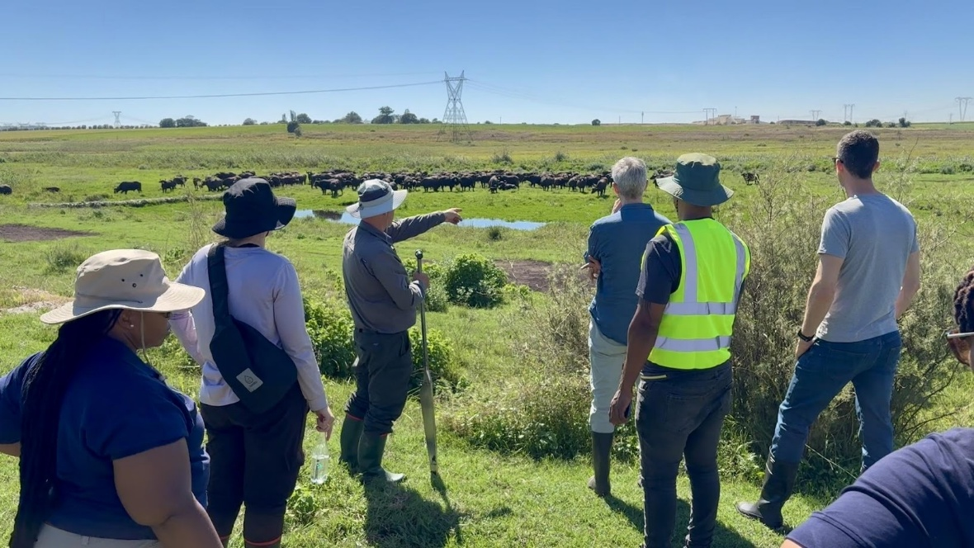
One of the primary reasons wetlands need protection is their role in water filtration and purification. Wetlands act as natural filters, trapping sediments, nutrients, and pollutants before they reach rivers, streams, or groundwater. Fertilizers, pesticides, and livestock waste from agricultural lands can contaminate water systems, but wetlands reduce this risk by absorbing and breaking down harmful substances. By maintaining healthy wetlands, farmers ensure that water used for irrigation, livestock, or domestic purposes remains clean and safe, reducing crop stress, improving soil health, and safeguarding livestock from waterborne diseases.
Wetlands also provide flood control and water regulation. During periods of heavy rainfall, wetlands act as natural sponges, absorbing excess water and slowly releasing it into rivers and streams. This prevents flooding downstream, reduces soil erosion, and protects farm infrastructure such as irrigation channels, roads, and storage facilities. In dry periods, wetlands help maintain soil moisture and support groundwater recharge, ensuring a more consistent water supply for crops and livestock. For South African farmers, where rainfall can be highly variable, wetlands act as a buffer against the extremes of drought and flooding, improving farm resilience.
Another important function of wetlands is supporting biodiversity. Wetlands provide habitats for a wide range of plants, animals, and microorganisms that are vital for ecological balance. Aquatic plants, fish, amphibians, insects, and birds all rely on wetlands for survival. Biodiversity in wetlands enhances ecosystem services such as pollination, pest control, and nutrient cycling, which indirectly support crop and pasture productivity. Conserving wetlands also protects endangered species and maintains the ecological integrity of the farm landscape.
Wetlands contribute significantly to soil health and nutrient management. By reducing runoff and erosion, wetlands prevent the loss of topsoil and essential nutrients. They also promote the accumulation of organic matter, improving soil structure and fertility. For a mixed crop and livestock farm, this means healthier pastures and more productive crop fields, reducing the need for artificial fertilizers and costly soil amendments.
Sustainable farming practices are essential for protecting wetlands. Farmers should avoid overgrazing, limit chemical runoff, maintain buffer zones around wetland areas, and prevent drainage or land conversion that can destroy wetland habitats. Planting vegetation along wetland margins, fencing off sensitive areas, and controlling livestock access to water points helps protect these ecosystems while still allowing farms to use water sustainably.
The protection of wetlands is essential for sustainable agriculture in South Africa. Wetlands provide water filtration, flood control, groundwater recharge, biodiversity support, and soil conservation, all of which enhance farm productivity and resilience. For mixed crop and livestock farmers, conserving wetlands ensures a reliable water supply, maintains healthy soils, supports pasture and crop growth, and protects livestock. By implementing protective measures and integrating wetlands into farm management plans, farmers can safeguard these valuable ecosystems, contributing to both environmental sustainability and long-term agricultural success.

KT0308 Importance of water regulations (licenses, water boards, quotas and tariffs)
The importance of water regulations in agriculture cannot be overstated, especially for mixed crop and livestock farmers in South Africa, where water is a scarce and highly regulated resource. Water regulations ensure that water use is equitable, sustainable, and legally compliant, protecting both the environment and the rights of all water users. These regulations cover water licenses, water boards, quotas, and tariffs, and they provide a framework for managing water efficiently, preventing over-extraction, and safeguarding water quality for agricultural, domestic, and industrial purposes. Understanding and complying with these regulations is essential for maintaining farm productivity, avoiding legal penalties, and contributing to sustainable water management.
Water licenses are legal authorizations required for the use of certain amounts of water from rivers, dams, or groundwater. In South Africa, farmers must obtain a water use license when drawing significant quantities of water for irrigation, livestock, or other farm operations. This ensures that water use is monitored, controlled, and allocated according to availability and environmental requirements. For farmers, having a water license guarantees legal access to water while helping avoid conflicts with other water users and regulatory authorities. Licenses also encourage farmers to use water efficiently, as usage is closely monitored and any excess extraction can result in penalties or fines.
Water boards are institutions responsible for managing water supply, distribution, and infrastructure within a specific region. They regulate water use, maintain dams, pipelines, and treatment facilities, and ensure that water is supplied reliably to agricultural and domestic users. For mixed crop and livestock farmers, water boards are important because they provide technical guidance, monitor water quality, and enforce regulations regarding water allocation and usage. By working with water boards, farmers can plan irrigation schedules, access water-saving programs, and ensure compliance with national and regional water policies.
Water quotas set limits on the amount of water that a farmer can extract or use over a specific period. Quotas are designed to prevent overuse of water resources, especially during droughts or in water-stressed regions. For a mixed crop and livestock farm, adhering to quotas requires careful planning of irrigation, livestock watering, and crop selection. By respecting quotas, farmers contribute to the equitable distribution of water, avoid depletion of rivers and aquifers, and ensure that water remains available for other farmers, communities, and ecosystems. Quotas also encourage efficient water use and the adoption of conservation practices such as rainwater harvesting, mulching, and drip irrigation.
Water tariffs refer to the fees charged for the use of water supplied by municipalities or water boards. Tariffs are often based on the quantity of water used and the type of user. For farmers, understanding water tariffs is important for budgeting and managing operational costs. Higher tariffs may incentivize the adoption of water-saving technologies and efficient irrigation methods, reducing wastage and lowering costs. Water tariffs also contribute to maintaining infrastructure, supporting sustainable water delivery, and funding programs that improve water availability and quality.
Compliance with water regulations is not only a legal requirement but also a critical element of sustainable farm management. By obtaining licenses, respecting quotas, paying tariffs, and working with water boards, farmers ensure that water resources are used responsibly and equitably. This helps prevent environmental degradation, protects water quality, maintains farm productivity, and contributes to long-term agricultural sustainability. Water regulations also play a key role in planning for climate change, as they help farmers manage water scarcity during droughts and periods of irregular rainfall.
Water regulations—including licenses, water boards, quotas, and tariffs—are essential for sustainable water management in South African agriculture. For mixed crop and livestock farmers, these regulations ensure legal access to water, promote efficient and responsible use, protect the environment, and safeguard long-term farm productivity. Understanding and adhering to water regulations allows farmers to manage water effectively, reduce operational risks, conserve resources, and contribute to the equitable and sustainable distribution of water for all users. Compliance is therefore both a legal obligation and a strategic component of sustainable farm management.

Internal Assessment Criteria (IAC) and Weight
- IAC0301 Discuss water conservation in agriculture.

Water conservation in agriculture involves using water resources efficiently to maintain crop and livestock production while reducing wastage and protecting natural ecosystems. Conservation strategies include reducing evaporation through mulching, planting cover crops, and maintaining vegetative ground cover. Efficient irrigation systems, such as drip or sprinkler irrigation, target water directly to plant roots, minimizing loss. In livestock operations, water points should be managed to prevent trampling, erosion, and contamination. Conservation also involves storing water through rainwater harvesting and small farm dams, recycling water where possible, and monitoring usage to detect leaks or inefficiencies. In South Africa, where water scarcity is common, conserving water ensures long-term farm productivity, lowers input costs, and helps preserve water for surrounding communities and ecosystems.

- IAC0302 Discuss impact of water scarcity in agriculture.

Water scarcity has significant negative effects on both crop and livestock production. Insufficient water can limit plant growth, reduce yields, and compromise the quality of produce. In livestock systems, water shortages affect animal hydration, feed intake, reproduction, and overall productivity. Water scarcity can also increase competition for resources, raising costs for irrigation and feed supplementation. Beyond the farm, it affects rural communities, exacerbating food insecurity and economic vulnerability. In South Africa, where droughts are frequent and rainfall is unevenly distributed, water scarcity can lead to crop failure, loss of pasture, and increased risk of livestock mortality. This demonstrates the importance of proactive water management, conservation, and planning to reduce vulnerability and maintain sustainable agricultural systems.

- IAC0303 Discuss rainwater harvesting and construction of water dams

Rainwater harvesting involves capturing and storing rainfall for future agricultural use, reducing dependence on external water sources. Techniques include collecting runoff from rooftops, paved surfaces, or fields and channeling it into tanks, reservoirs, or farm dams. Constructed water dams store water during rainy periods for use during dry spells, supporting irrigation, livestock, and household needs. Proper dam design includes soil compaction, lining, spillways, and erosion control to prevent seepage and water loss. In South African mixed farming systems, rainwater harvesting and small farm dams are vital for mitigating drought impacts, ensuring water availability, and supporting both crop growth and livestock needs. These systems also help recharge groundwater, reduce soil erosion, and improve water security at the farm level.

- IAC0304 Explain optimal use of water and irrigation in agricultural production

Optimal water use requires applying the right amount of water at the right time to meet the needs of crops or livestock without waste. Efficient irrigation practices include drip irrigation, which delivers water directly to the plant root zone, and sprinkler systems, which evenly distribute water across fields. Scheduling irrigation based on crop growth stages, soil moisture, and weather conditions prevents overwatering and improves water-use efficiency. Monitoring soil moisture with probes or sensors helps avoid under- or over-irrigation. In livestock systems, water should be provided in clean, easily accessible points to reduce contamination and wastage. Optimal water use increases crop yields, reduces energy and water costs, and protects the farm’s water resources from depletion or pollution.

- IAC0305 Discuss the protection of ground water and prevention of water leakages

Groundwater is a critical source of water for irrigation, livestock, and domestic use, and it must be protected from contamination and overuse. Practices include preventing the infiltration of chemicals, fertilizers, pesticides, and animal waste into aquifers, properly maintaining wells, and avoiding over-extraction. Sealing abandoned boreholes, monitoring water levels, and protecting recharge zones are also important. On the farm, preventing water leakages in pipes, tanks, and irrigation systems conserves water and reduces unnecessary stress on groundwater resources. In South Africa, where groundwater is an important supplementary resource, protecting it ensures a reliable and sustainable supply for both agriculture and human communities.

- IAC0306 Explain the importance of water quality and its availability for environmental sustainability.

Water quality and availability are critical for maintaining crop growth, livestock health, and ecosystem balance. Clean, uncontaminated water supports plant nutrient uptake and reduces the risk of disease in animals. Poor water quality, contaminated with chemicals, sediments, or pathogens, can harm crops, reduce yields, and compromise livestock productivity. Water availability ensures that ecosystems such as wetlands, rivers, and grasslands remain functional, supporting biodiversity and natural processes. For mixed farming in South Africa, ensuring both the quality and reliable availability of water is essential for sustainable production, environmental protection, and human health, particularly in regions prone to drought or pollution.
- IAC0307 Describe the role and significance of wetland protection in maintaining biodiversity and water resources.
Wetlands are natural reservoirs that play a critical role in agriculture and ecosystem sustainability. They act as water filters, removing sediments and pollutants, and help recharge groundwater supplies. Wetlands provide habitats for a wide range of species, supporting biodiversity and ecological balance. They also act as buffers against floods and droughts by storing excess water and releasing it gradually. For farmers, protecting wetlands ensures long-term water availability for crops and livestock and maintains essential ecosystem services such as soil fertility, pollination, and pest control. In South Africa, wetland protection is especially important in agricultural regions where water scarcity and ecosystem degradation threaten both production and biodiversity.

- IAC0308 Analyze the importance of water regulations, including licenses, water boards, quotas, and tariffs, in managing water resources.

Water regulations in South Africa provide a framework for fair and sustainable use of water resources. Licenses and permits ensure that water use is legally monitored and prevents over-extraction from rivers, dams, and groundwater sources. Water boards manage supply, quality, and distribution, ensuring that agricultural, industrial, and domestic users have equitable access. Quotas regulate the volume of water that can be used by individual farmers or sectors, promoting conservation and reducing conflict over scarce resources. Tariffs incentivize efficient water use by attaching a cost to consumption, encouraging farmers to adopt water-saving technologies and practices. Understanding and complying with these regulations is essential for farmers to avoid legal penalties, ensure water security, and contribute to sustainable water management at both farm and regional levels.

KM-02-KT05 Carbon footprint, biodiversity 10%
Topic element
- KT0501 Carbon footprint
- KT0502 Carbon footprint in agriculture and its mitigation measures
- KT0503 Importance of biodiversity in maintaining healthy ecosystem
- KT0504 Threats to biodiversity
- KT0505 Importance of conserving biodiversity

KM-02-KT05 Carbon footprint, biodiversity
Understanding the concepts of carbon footprint and biodiversity is crucial for sustainable agriculture, particularly for mixed crop and livestock farmers in South Africa. Both factors directly influence environmental health, farm productivity, and resilience to climate change. Managing a farm with consideration for carbon emissions and biodiversity ensures long-term sustainability, regulatory compliance, and market competitiveness, especially as global and local policies increasingly reward environmentally responsible farming practices.
Carbon footprint refers to the total amount of greenhouse gases (GHGs) emitted directly or indirectly by farm activities, expressed in units of carbon dioxide equivalent (CO₂e). In agriculture, carbon emissions arise from several sources: fuel and energy use for machinery and irrigation, livestock methane emissions, synthetic fertilizer production, deforestation, and soil management practices. For mixed crop and livestock farmers, a large carbon footprint can indicate inefficient resource use, contribute to climate change, and potentially attract regulatory penalties or limit access to environmentally conscious markets. Reducing the farm’s carbon footprint involves adopting practices such as no-till or minimum-till farming, using organic fertilizers, optimizing livestock feeding to reduce methane emissions, planting trees (agroforestry), and capturing rainwater for irrigation. These strategies not only lower emissions but also improve soil health, increase biodiversity, and enhance resilience to climate variability.
Biodiversity is the variety of life on a farm, including plants, animals, insects, soil microorganisms, and aquatic organisms. Healthy biodiversity is essential for ecosystem stability and productivity. It supports nutrient cycling, natural pest and disease control, pollination, soil structure, and water regulation. On a mixed crop and livestock farm, maintaining biodiversity ensures that crops and pastures are more resilient to pests, diseases, and extreme weather events. Diverse pasture species provide better nutrition for livestock, while native plants and cover crops protect soil and water resources. Biodiversity also provides habitats for beneficial organisms, including pollinators like bees and predatory insects that naturally reduce pest populations, reducing the need for chemical inputs.
The relationship between carbon footprint and biodiversity is closely linked. Practices that reduce carbon emissions—such as planting trees, maintaining permanent pasture cover, and improving soil organic matter—also enhance biodiversity. Conversely, intensive farming methods that increase carbon emissions, such as overgrazing, deforestation, and monocropping, can reduce biodiversity, degrade soil, and harm local ecosystems. For South African farmers, integrating carbon reduction strategies with biodiversity conservation creates a synergistic effect: farms become more sustainable, resilient, and productive while contributing to global climate mitigation efforts.
Farmers can actively manage both carbon footprint and biodiversity by implementing strategies such as agroforestry, cover cropping, rotational grazing, reforestation, and organic farming. Agroforestry and reforestation increase carbon sequestration and provide habitats for wildlife. Cover crops and rotational grazing improve soil health, reduce greenhouse gas emissions, and maintain diverse plant and microbial communities. Organic farming reduces synthetic chemical use, which preserves soil biodiversity and protects water quality. By adopting these practices, farmers not only contribute to environmental conservation but can also access carbon credit schemes or eco-certifications, creating additional economic benefits.
Carbon footprint and biodiversity are fundamental components of sustainable agriculture. For mixed crop and livestock farmers in South Africa, managing these factors helps reduce greenhouse gas emissions, improve soil and pasture health, enhance resilience to climate change, and protect ecosystems. Sustainable practices that lower carbon emissions and promote biodiversity contribute to long-term farm productivity, regulatory compliance, environmental stewardship, and potential economic incentives. By prioritizing carbon and biodiversity management, farmers ensure that their operations are both ecologically responsible and economically viable for the future.

KT0501 Carbon footprint
The concept of carbon footprint is increasingly important in agriculture, particularly for mixed crop and livestock farmers in South Africa. A carbon footprint measures the total amount of greenhouse gases (GHGs) released directly or indirectly by farm activities, expressed in units of carbon dioxide equivalent (CO₂e). These emissions contribute to climate change, which poses serious risks to agricultural productivity, water availability, and ecosystem health. Understanding and managing a farm’s carbon footprint is therefore essential for environmental sustainability, regulatory compliance, and economic competitiveness in global and local markets that are increasingly sensitive to climate-friendly practices.
In a mixed crop and livestock farm, carbon emissions arise from multiple sources. Livestock, especially ruminants like cattle and sheep, produce methane (CH₄) during digestion through a process called enteric fermentation. Methane is a potent greenhouse gas, much stronger than CO₂ in trapping heat in the atmosphere. Fertilizer use also contributes to carbon emissions. Synthetic nitrogen fertilizers release nitrous oxide (N₂O), another highly potent greenhouse gas, while energy-intensive fertilizer production consumes fossil fuels. Fuel and energy use for machinery, irrigation, transport, and on-farm operations contribute additional CO₂ emissions. Even land management practices, such as deforestation or intensive tillage, release carbon stored in soils and vegetation, further increasing the farm’s carbon footprint.
Measuring the farm’s carbon footprint involves calculating emissions from all these activities. This allows farmers to identify major sources of greenhouse gases and implement strategies to reduce them. For example, reducing fuel consumption through efficient machinery use, using renewable energy sources, or adopting precision agriculture techniques can lower CO₂ emissions. Improving livestock management—such as optimizing feed quality, rotational grazing, or reducing herd size—can minimize methane emissions while maintaining productivity. Soil management practices like conservation tillage, cover cropping, and adding organic matter help sequester carbon in the soil, effectively offsetting some emissions.
The importance of managing a carbon footprint goes beyond environmental protection. Reducing greenhouse gas emissions can also enhance farm efficiency and profitability. Practices that lower emissions often coincide with better resource management, such as reduced fertilizer and water use, improved soil fertility, and higher livestock productivity. Additionally, South African farmers may benefit from carbon credit schemes or eco-certifications, which provide financial incentives for adopting low-carbon farming practices.
The carbon footprint represents the total greenhouse gas emissions generated by agricultural activities. For mixed crop and livestock farmers in South Africa, monitoring and managing the carbon footprint is essential for reducing environmental impact, improving farm sustainability, and accessing climate-conscious markets. By implementing strategies such as improved livestock feeding, efficient fuel use, sustainable soil management, and renewable energy integration, farmers can minimize emissions, increase productivity, and contribute to climate change mitigation while ensuring long-term agricultural viability.

KT0502 Carbon footprint in agriculture and its mitigation measures
The carbon footprint in agriculture refers to the total greenhouse gas (GHG) emissions produced by farm activities, expressed in carbon dioxide equivalent (CO₂e). For mixed crop and livestock farmers in South Africa, agriculture is both a contributor to GHG emissions and a sector highly vulnerable to climate change. Sources of emissions on a farm include methane (CH₄) from ruminant livestock, nitrous oxide (N₂O) from fertilizers, and carbon dioxide (CO₂) from machinery, irrigation, energy use, and land-use changes. Understanding the carbon footprint and implementing mitigation measures is critical to reducing environmental impact, improving sustainability, and maintaining farm profitability.
Sources of Carbon Emissions in Agriculture:
- Livestock: Ruminants such as cattle, sheep, and goats produce methane through enteric fermentation. Methane is a potent greenhouse gas, contributing significantly to the farm’s carbon footprint.
- Soil and Fertilizers: Nitrous oxide is emitted from the application of synthetic fertilizers, manure, and nitrogen-rich amendments. Intensive tillage and soil disturbance can also release stored carbon from the soil.
- Energy Use: Diesel-powered machinery, irrigation pumps, and transportation contribute carbon dioxide emissions through the burning of fossil fuels.
- Land Use Changes: Deforestation, overgrazing, and poor land management reduce carbon sequestration potential and release carbon stored in vegetation and soil.
Mitigation Measures:
- Improved Livestock Management: Optimizing livestock feeding, adopting rotational grazing, and using feed additives that reduce methane production can lower emissions. Proper herd sizing ensures that livestock production is efficient and environmentally sustainable.
- Sustainable Soil Management: Practices such as minimum or no-till farming, cover cropping, crop rotation, and adding organic matter to soil enhance carbon sequestration while maintaining soil fertility and structure. These methods help store more carbon in the soil and reduce CO₂ emissions.
- Efficient Fertilizer Use: Applying fertilizers at the correct time, rate, and method reduces nitrous oxide emissions. Incorporating organic fertilizers like compost or manure can also provide nutrients while lowering GHG emissions compared to synthetic fertilizers.
- Renewable Energy and Efficient Machinery: Using solar or wind energy for irrigation and farm operations reduces CO₂ emissions. Maintaining machinery, reducing unnecessary fuel use, and adopting precision agriculture techniques improve energy efficiency.
- Agroforestry and Reforestation: Planting trees within farmland or restoring degraded areas captures carbon from the atmosphere and enhances biodiversity. Agroforestry also provides shade, improves soil fertility, and supports long-term ecosystem health.
- Water Management: Efficient irrigation and water conservation practices reduce energy use and prevent unnecessary emissions related to pumping and water treatment. Techniques such as drip irrigation, mulching, and rainwater harvesting are particularly effective.
Benefits of Mitigation:
Implementing carbon footprint mitigation measures not only reduces greenhouse gas emissions but also improves farm resilience, increases productivity, and can provide economic advantages. Farms with lower emissions may access carbon credit programs or receive incentives from environmentally conscious markets. Moreover, mitigation practices improve soil health, water use efficiency, and biodiversity, contributing to long-term sustainability.
In conclusion, agriculture significantly contributes to greenhouse gas emissions, but farmers in South Africa can implement targeted mitigation measures to reduce their carbon footprint. Strategies such as improved livestock management, sustainable soil practices, efficient fertilizer use, renewable energy adoption, agroforestry, and water conservation help lower emissions while enhancing productivity and resilience. By actively managing the farm’s carbon footprint, mixed crop and livestock farmers can contribute to climate change mitigation, protect the environment, and secure sustainable and profitable agricultural operations for the future.

KT0503 Importance of biodiversity in maintaining healthy ecosystem
Biodiversity, the variety of life within an ecosystem—including plants, animals, microorganisms, and their interactions—is fundamental to maintaining healthy and resilient ecosystems, particularly in agricultural landscapes. For mixed crop and livestock farmers in South Africa, preserving biodiversity on and around the farm is critical for sustaining soil fertility, water quality, crop and pasture productivity, and overall ecosystem stability. Biodiversity supports ecological processes that are essential for both natural environments and productive farming systems, creating a balance between agricultural production and environmental health.
One of the primary benefits of biodiversity is enhanced ecosystem resilience. Diverse ecosystems are better able to withstand environmental stresses such as drought, pests, diseases, and climate change. On a farm, a variety of crops, pasture species, and native vegetation provides natural buffers against these stresses. For example, diverse pasture species can maintain fodder availability during dry periods, while crop diversity reduces the risk of total yield loss if a pest or disease targets a particular crop. Biodiversity ensures that the ecosystem can recover quickly from disturbances, maintaining long-term agricultural productivity.
Soil health and nutrient cycling are also directly supported by biodiversity. Soil microorganisms, earthworms, and other organisms break down organic matter, fix nitrogen, and recycle nutrients, making them available for crops and pastures. This natural fertility reduces the need for synthetic fertilizers, lowers costs, and minimizes environmental pollution. Additionally, diverse root structures from multiple plant species improve soil structure, increase water infiltration, and prevent erosion, which is especially important in South African farms prone to drought and heavy rains.
Biodiversity contributes to natural pest and disease control. Predatory insects, birds, and other organisms feed on pests that could otherwise damage crops or pastures. Similarly, a variety of plant species can disrupt pest life cycles, reducing outbreaks and minimizing reliance on chemical pesticides. This ecological balance not only protects crops and livestock but also preserves water and soil quality by reducing chemical inputs.
Pollination and seed dispersal are further benefits of biodiversity. Many crops and fruiting plants rely on pollinators such as bees, butterflies, and birds. Maintaining habitats that support these pollinators ensures better yields, higher-quality produce, and more resilient food systems. Likewise, animals and insects help disperse seeds, contributing to natural regeneration and the sustainability of both crops and native vegetation.
Biodiversity also enhances water regulation and purification. Wetlands, riparian zones, and diverse vegetation buffer water flow, prevent erosion, and filter pollutants, ensuring clean water for irrigation, livestock, and human use. Maintaining plant and animal diversity along waterways helps stabilize riverbanks, improve infiltration, and sustain groundwater recharge. This is particularly important in South Africa, where water scarcity is a persistent challenge.
Biodiversity provides economic and social benefits. A healthy, diverse ecosystem reduces production costs by minimizing the need for chemical fertilizers and pesticides, stabilizes yields, and supports ecosystem services that benefit the farm. Biodiversity also creates opportunities for eco-tourism, carbon credits, and sustainable farming certifications, which can provide additional income streams for farmers.
Biodiversity is essential for maintaining healthy ecosystems on farms. For mixed crop and livestock farmers in South Africa, biodiversity supports ecosystem resilience, soil fertility, pest and disease control, pollination, water regulation, and economic sustainability. Protecting and enhancing biodiversity on agricultural land ensures that natural processes continue to function effectively, supporting both productive farming and long-term environmental sustainability. By integrating biodiversity conservation into farm management, farmers can achieve a balance between agricultural productivity and ecosystem health.

KT0504 Threats to biodiversity
Biodiversity—the variety of plants, animals, microorganisms, and ecosystems—is essential for sustaining healthy and resilient agricultural landscapes. For mixed crop and livestock farmers in South Africa, maintaining biodiversity on farms is critical for soil fertility, pest control, water management, and ecosystem stability. However, biodiversity is increasingly under threat due to a combination of human activities, environmental pressures, and climate change. Understanding these threats helps farmers implement strategies to protect ecosystems, maintain productivity, and ensure long-term sustainability.
One of the primary threats to biodiversity is habitat loss and fragmentation. Agricultural expansion, deforestation, urbanization, and infrastructure development reduce the natural habitats available for wildlife and native plants. On farms, converting wetlands, forests, or natural grasslands into monoculture fields or heavily grazed pastures limits habitats for pollinators, soil organisms, and wildlife. Fragmented habitats prevent species from moving freely, reducing genetic diversity and resilience, which can compromise ecosystem services that support crops and livestock.
Overgrazing and poor land management also threaten biodiversity. When livestock graze intensively without proper rotational planning, pastures are depleted, native plants are lost, and soil structure deteriorates. This leads to erosion, loss of fertile topsoil, and reduced availability of forage species. Over time, overgrazing causes desertification in some areas, reducing plant and animal diversity and weakening the ecosystem’s ability to recover from drought or other environmental stresses.
Pollution and chemical use are significant contributors to biodiversity loss. Excessive use of fertilizers, pesticides, and herbicides contaminates soil, water, and non-target species. Pollutants can kill beneficial insects, reduce soil microorganism populations, and contaminate nearby wetlands or rivers, affecting aquatic biodiversity. Chemical runoff can also disrupt natural nutrient cycles, reduce pollination, and weaken pest control mechanisms provided by predatory species.
Invasive alien species pose another threat. Non-native plants, animals, or microorganisms can outcompete indigenous species for resources, leading to the decline or extinction of native species. For example, invasive plant species can dominate pastures, reducing forage availability and altering soil composition. Invasive insects or pathogens can attack crops or livestock, further stressing farm ecosystems. Preventing the introduction and spread of invasive species is essential to preserve biodiversity and maintain agricultural productivity.
Climate change is increasingly impacting biodiversity on farms. Rising temperatures, irregular rainfall, prolonged droughts, and extreme weather events alter habitats and disrupt species life cycles. Sensitive species may decline or migrate, reducing ecosystem resilience. Changes in climate also increase pest and disease pressure, forcing farmers to rely on chemical interventions that may further threaten biodiversity.
Unsustainable water management and wetland degradation are additional threats. Draining wetlands for crop production, over-extraction of groundwater, or contamination of rivers and streams reduces aquatic biodiversity and disrupts natural water regulation systems. Wetlands provide habitats for birds, amphibians, fish, and beneficial insects, and their loss diminishes ecosystem services such as water purification, flood control, and soil protection.
Biodiversity faces multiple threats in agricultural landscapes, including habitat loss, overgrazing, chemical pollution, invasive species, climate change, and unsustainable water management. For mixed crop and livestock farmers in South Africa, these threats can reduce soil fertility, compromise crop and livestock productivity, weaken natural pest control, and diminish resilience to environmental stresses. Protecting biodiversity through sustainable land management, conservation practices, integrated pest management, and habitat restoration is therefore critical for maintaining healthy ecosystems, ensuring long-term farm productivity, and promoting environmental sustainability.

KT0505 Importance of conserving biodiversity
Conserving biodiversity is essential for maintaining healthy, productive, and resilient agricultural systems. For mixed crop and livestock farmers in South Africa, biodiversity—the variety of plants, animals, microorganisms, and ecosystems on and around the farm—supports ecological processes that directly and indirectly enhance farm productivity, sustainability, and resilience to environmental stressors. Conserving biodiversity is not only an ecological imperative but also an economic and social necessity, as it ensures long-term food security, soil fertility, water quality, and ecosystem stability.
One of the primary reasons for conserving biodiversity is its role in ecosystem services. Healthy ecosystems provide essential services such as nutrient cycling, soil formation, pollination, pest and disease control, and water regulation. For example, a diverse soil microbiome decomposes organic matter and releases nutrients, improving soil fertility for crops and pastures. Pollinators like bees and butterflies enhance fruit and seed production, while predatory insects and birds help control pests naturally. By conserving biodiversity, farmers maintain these critical ecosystem services, reducing the need for costly chemical inputs and supporting sustainable agricultural production.
Soil and water conservation are also strongly linked to biodiversity. Native plants, cover crops, and diverse pastures reduce soil erosion, improve water infiltration, and enhance water retention. Wetlands, riparian vegetation, and natural habitats filter water, prevent sedimentation, and maintain water quality. Conserving these biological resources ensures that both crops and livestock have access to fertile soil and clean water, which are fundamental to farm productivity and resilience, particularly in drought-prone areas of South Africa.
Biodiversity also contributes to climate change resilience. Diverse ecosystems can better withstand environmental stresses such as droughts, floods, heatwaves, and pest outbreaks. Different plant and animal species respond in varied ways to changing conditions, ensuring that some components of the farm system continue to function even under adverse conditions. For livestock, diversified pastures provide nutrition throughout dry and wet seasons, reducing vulnerability to climate variability. Conserving biodiversity strengthens the adaptive capacity of farms, making them more sustainable in the long term.
Economic and social benefits are additional reasons to conserve biodiversity. Biodiverse farms often have lower input costs because natural processes reduce the need for synthetic fertilizers, pesticides, and irrigation. Biodiversity can also provide additional income streams, such as ecotourism, carbon credits, or sales of indigenous crops and seeds. Socially, conserving biodiversity supports local communities by maintaining resources such as medicinal plants, forage, and clean water, which are critical for livelihoods and food security.
Conserving biodiversity supports ethical and legal responsibilities. South African environmental legislation, such as the National Environmental Management: Biodiversity Act, encourages farmers to protect natural ecosystems, wetlands, and endangered species. Compliance with these regulations is essential to avoid legal penalties and demonstrate responsible stewardship of natural resources.
Conserving biodiversity is vital for sustaining healthy ecosystems, maintaining soil fertility, ensuring water quality, supporting pollination and pest control, enhancing climate resilience, and providing economic and social benefits. For mixed crop and livestock farmers in South Africa, protecting and promoting biodiversity on farms ensures long-term productivity, reduces dependency on external inputs, and contributes to environmental sustainability. By implementing conservation practices such as habitat protection, cover cropping, rotational grazing, and wetland preservation, farmers can safeguard biodiversity and secure the future of both their farms and the wider ecosystem.

Internal Assessment Criteria (IAC) and Weight
- IAC0501 Discuss the importance of reducing carbon emissions and the role of individuals and organizations in reducing carbon emissions to address climate change.

Reducing carbon emissions is crucial for addressing climate change because greenhouse gases, such as carbon dioxide (CO₂), methane (CH₄), and nitrous oxide (N₂O), trap heat in the atmosphere and drive global warming. Rising temperatures lead to droughts, irregular rainfall, heat stress on crops and livestock, and increased vulnerability to pests and diseases. Individuals and organizations play a vital role in reducing carbon emissions. Farmers can adopt climate-smart practices such as improving livestock feeding to reduce methane, planting trees to sequester carbon, using renewable energy for irrigation, and minimizing fossil fuel use in machinery. Organizations, including agricultural cooperatives, extension services, and government agencies, can support education, implement policies, and provide incentives for low-emission technologies. By reducing carbon emissions, both individuals and organizations help stabilize climate patterns, ensuring agricultural productivity and protecting ecosystems for future generations.

- IAC0502 Explain how sustainable farming practices contribute to reducing the carbon footprint.

Sustainable farming practices reduce the carbon footprint by lowering greenhouse gas emissions and increasing carbon sequestration. Crop rotation, cover cropping, conservation tillage, and agroforestry enhance soil organic carbon, which traps CO₂ from the atmosphere. Efficient irrigation, precision fertilization, and the use of organic fertilizers reduce nitrous oxide emissions associated with excessive chemical fertilizers. In livestock farming, rotational grazing, improved feed efficiency, and proper manure management minimize methane emissions. Renewable energy sources, such as solar-powered water pumps, further reduce dependence on fossil fuels. By integrating these practices, farmers in South Africa can produce food and livestock products with lower environmental impact, reduce operational costs, and enhance the resilience of their farms to climate variability.

- IAC0503 Describe the benefits of biodiversity in maintaining ecological balance

Biodiversity, the variety of living organisms in an ecosystem, is essential for ecological balance and farm productivity. Diverse plant species, insects, animals, and microorganisms support ecosystem services such as pollination, natural pest control, nutrient cycling, and soil fertility. On a mixed farm, biodiversity helps maintain healthy crops and livestock by reducing pest and disease outbreaks and improving soil structure through natural biological activity. Native vegetation, wetlands, and agroforestry systems preserve habitats for beneficial species. Biodiversity also contributes to climate resilience, as ecosystems with multiple species are better able to adapt to environmental stress, such as drought or heat. Maintaining biodiversity ensures that the farm ecosystem remains productive, resilient, and sustainable over time.

- IAC0504 Describe the threats that impact ecosystems explaining their consequences.

Ecosystems face multiple threats from human activity and environmental change. Deforestation, overgrazing, and land degradation reduce vegetation cover, causing soil erosion and loss of fertility. Pollution from agrochemicals and livestock waste contaminates soil and water, harming plants, animals, and humans. Climate change, including rising temperatures and erratic rainfall, disrupts natural cycles, leading to droughts, floods, and loss of species. Invasive species can outcompete native flora and fauna, reducing biodiversity. Over-extraction of water for irrigation or livestock can deplete rivers and groundwater, impacting both wildlife and agriculture. The consequences of these threats include reduced agricultural productivity, increased vulnerability to climate events, loss of ecosystem services, and food insecurity for communities dependent on natural resources.

- IAC0505 Explain various ways to conserve biodiversity and promote environmental sustainability.

Biodiversity can be conserved and environmental sustainability promoted through several integrated practices. Protecting natural habitats, such as wetlands, forests, and grasslands, ensures species survival and ecosystem function. Agroforestry, which integrates trees into crop and livestock systems, provides shelter, food, and soil stabilization while enhancing biodiversity. Crop rotation, intercropping, and cover cropping promote soil health and provide habitats for beneficial organisms. Reducing chemical inputs through integrated pest management protects non-target species and prevents pollution. Maintaining water resources, including dams, rivers, and groundwater, ensures both biodiversity and agricultural needs are met. Community education, policy support, and participation in conservation programs further strengthen environmental stewardship. On South African mixed farms, implementing these strategies ensures long-term ecological balance, resilient production systems, and sustainability for future generations.

KM-02-KT06 Livestock housing 20%
Topic element
- KT0601 Livestock housing and its importance to livestock farming
- KT0602 Different types of livestock housing
- KT0603 Livestock housing design requirements
- KT0604 Facilities for feed and water in livestock housing
- KT0605 Importance of waste management in livestock housing
- KT0606 Importance of health and welfare in livestock housing
- KT0607 Importance of biosecurity in livestock housing
- KT0608 Regulations and standards that govern livestock housing

KM-02-KT06 Livestock housing
Livestock housing is a critical component of mixed crop and livestock farming in South Africa, as it directly affects animal health, productivity, welfare, and farm efficiency. Proper housing provides shelter from adverse weather conditions, protection from predators, control over hygiene and disease, and an environment that supports growth, reproduction, and overall livestock performance. Designing and managing appropriate housing systems is essential for optimizing production, ensuring compliance with animal welfare standards, and maintaining a sustainable farming operation.
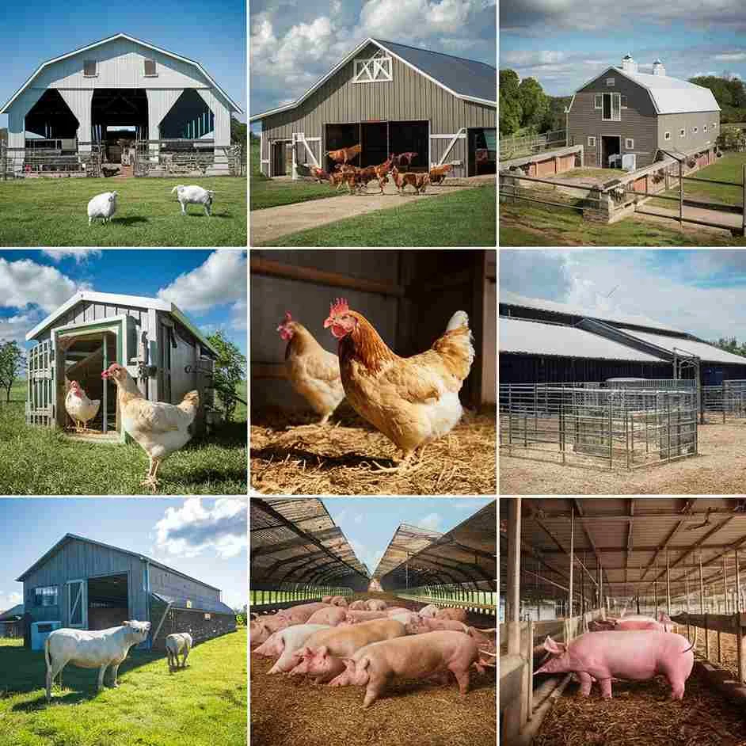
Purpose and Benefits of Livestock Housing:
Livestock housing provides protection from environmental stressors such as extreme heat, cold, rain, and wind. In South Africa, temperature fluctuations and seasonal storms can stress animals, reducing feed intake, growth rates, milk production, and reproductive performance. Housing structures like barns, sheds, or shade structures help regulate temperature and humidity, creating a more stable microclimate that promotes animal comfort and productivity.
Disease prevention and hygiene are other critical reasons for effective livestock housing. Properly designed housing separates animals from waste, provides clean feeding and watering areas, and allows for efficient manure management. This reduces the risk of infections caused by bacteria, parasites, and viruses, which can spread rapidly in overcrowded or poorly ventilated environments. Ventilation is particularly important, as it prevents respiratory problems by removing moisture, ammonia, and dust from animal housing.
Livestock management efficiency is enhanced through appropriate housing. Housing systems allow farmers to monitor animal health, control feeding, facilitate breeding programs, and manage labour effectively. For example, barns or pens enable easy handling for vaccinations, milking, weighing, or sorting livestock. Controlled housing also helps in implementing biosecurity measures, reducing the risk of introducing diseases from outside sources.
Different types of livestock require specific housing designs. Cattle may need open-sided barns or kraals with ample space for lying, feeding, and movement. Sheep and goats benefit from small shelters or pens that protect against wind and predators. Poultry require ventilated coops with nesting boxes, perches, and controlled temperature. Pigs need pens that allow movement, rooting, and proper waste disposal. Housing designs must consider the size, number, and behaviour of animals to ensure welfare and productivity.
Environmental management within housing is another important factor. Proper drainage, manure collection, and bedding materials prevent waterlogging, odour, and contamination of soil and water sources. Manure can be collected and composted for use as organic fertilizer, supporting crop production and reducing chemical input requirements. Sustainable housing practices, such as using recycled materials or incorporating solar panels for lighting and ventilation, also reduce the farm’s environmental footprint.
Livestock housing is a fundamental aspect of sustainable mixed crop and livestock farming in South Africa. It ensures animal welfare, protects against environmental stressors, prevents disease, improves management efficiency, and supports productivity. Proper design, maintenance, and management of housing systems contribute to healthier animals, higher yields, and sustainable farm operations. By investing in appropriate livestock housing, farmers can enhance animal performance, safeguard farm resources, and strengthen the overall resilience and sustainability of their agricultural enterprise.

KT0601 Livestock housing and its importance to livestock farming
Livestock housing is a fundamental aspect of livestock farming, providing a controlled environment where animals can live, grow, and reproduce safely and efficiently. For mixed crop and livestock farmers in South Africa, proper housing is essential to ensure animal welfare, maintain health, optimize productivity, and support sustainable farm operations. The design, location, and management of livestock housing directly affect the performance of animals, the efficiency of farm labour, and the overall profitability of the farm.
The primary purpose of livestock housing is to provide shelter from adverse environmental conditions. In South Africa, livestock are exposed to varying climates, including high temperatures, heavy rains, strong winds, and cold winters. Proper housing protects animals from these extremes, reducing stress and preventing temperature-related illnesses. For example, barns, shade structures, or well-ventilated pens help regulate the internal microclimate, ensuring that animals maintain normal body temperature, feed intake, and growth rates. By providing shelter, farmers can enhance reproductive performance, increase milk or meat production, and improve overall animal health.
Disease prevention and hygiene are also key benefits of livestock housing. Housing allows farmers to manage cleanliness by separating animals from waste, controlling moisture levels, and providing proper feeding and watering systems. Well-ventilated housing reduces the buildup of ammonia, dust, and pathogens, which can cause respiratory or gastrointestinal diseases. By implementing proper housing, farmers can reduce the incidence of disease outbreaks, minimize veterinary costs, and ensure safer food products for consumption.
Efficient livestock management is another advantage of proper housing. Pens, barns, or coops allow farmers to easily monitor animal health, manage feeding schedules, implement breeding programs, and handle livestock during vaccinations, weighing, or sorting. Controlled housing makes it easier to implement biosecurity measures, reducing the risk of introducing diseases from outside animals, wildlife, or contaminated equipment. This is particularly important in mixed farming systems where crops and livestock coexist, as it prevents cross-contamination and protects farm resources.
Different types of livestock require specific housing designs to meet their unique needs. Cattle require spacious barns or kraals with adequate ventilation and access to feed and water. Sheep and goats need smaller shelters that protect against predators and harsh weather while allowing freedom of movement. Poultry require coops with proper perches, nesting areas, and temperature control, while pigs need pens that allow rooting behaviour and easy waste removal. Correctly designed housing accommodates the behaviour, size, and number of animals, ensuring welfare and productivity.
Finally, livestock housing contributes to environmental sustainability and resource management. Proper drainage, waste collection, and bedding management prevent soil erosion, water contamination, and foul odours. Manure collected from housing can be composted and used as an organic fertilizer for crop production, integrating crop and livestock systems sustainably. Additionally, energy-efficient housing designs, such as using natural ventilation or solar-powered lighting, reduce farm operational costs and environmental impact.
Livestock housing is a vital component of livestock farming. It provides protection from environmental stressors, supports animal health and welfare, enables efficient farm management, and promotes sustainable resource use. For mixed crop and livestock farmers in South Africa, investing in proper housing ensures higher productivity, lower disease risks, and long-term farm sustainability. Effective housing is therefore both a practical necessity and a strategic tool for successful livestock farming.

KT0602 Different types of livestock housing
Livestock housing is a key component of animal farming, and the type of housing used directly affects the welfare, productivity, and health of the animals. On mixed crop and livestock farms in South Africa, choosing the appropriate type of housing depends on the species, number of animals, climate, available resources, and management objectives. Properly designed housing provides shelter, safety, and controlled environmental conditions, while allowing for efficient feeding, watering, and waste management.
1. Open Shelters or Sheds:
Open shelters are simple structures with a roof and partial walls, designed to protect animals from sun, rain, and wind while allowing free movement and ventilation. They are commonly used for cattle, goats, and sheep in areas with moderate climates. Open shelters provide natural light and air circulation, reducing respiratory issues. They are cost-effective and easy to construct, making them suitable for small- to medium-scale farms. However, they may require additional measures for predator protection and extreme weather conditions.
2. Closed or Enclosed Housing:
Closed housing consists of fully enclosed structures with controlled ventilation, temperature, and lighting. These are commonly used for poultry, pigs, and dairy cattle, especially in intensive farming systems. Enclosed housing allows farmers to maintain optimal temperature, humidity, and hygiene, which is essential for disease prevention and high productivity. In dairy farming, enclosed barns with milking areas ensure clean milk production, while in poultry, temperature-controlled coops improve egg production and bird health.
3. Intensive or Confined Housing (Pens and Stalls):
Intensive housing restricts animal movement to pens, stalls, or cages. This system is often used for pigs, dairy cows, or poultry in commercial operations. Pens allow for close monitoring of feeding, health, and reproductive management, and waste can be easily collected and used for manure. However, confined housing requires careful attention to space allocation, ventilation, and animal welfare to prevent stress, injuries, or disease outbreaks.
4. Pasture-Based or Free-Range Housing:
Pasture-based housing combines minimal shelter with open grazing areas. Animals spend most of their time on pastures but have access to shelters for shade, rain protection, and night-time security. This type is commonly used for cattle, sheep, and goats in extensive farming systems. It promotes natural behaviour, improves animal welfare, and reduces feed costs, but requires adequate fencing and predator management.
5. Poultry Housing Types:
- Battery Cages: Birds are kept in cages for egg production. While space-efficient, this system requires careful management to ensure welfare and prevent stress-related issues.
- Deep-Litter Systems: Birds are housed on a floor covered with bedding such as sawdust or straw. The bedding absorbs manure and can be composted for fertilizer. This system allows more movement and natural behaviours than cages.
- Free-Range Systems: Poultry have access to outdoor areas for foraging while having shelters for protection and nesting. This supports welfare and egg quality but requires predator management.
6. Pig Housing Types:
- Pens: Pigs are kept in pens with slatted or solid floors. Slatted floors allow waste to fall through, reducing manual cleaning.
- Farrowing Crates: Used for sows giving birth to piglets, these crates protect piglets from being crushed while allowing controlled feeding and monitoring.
- Deep-Litter Housing: Bedding absorbs manure, and pigs can root and move naturally, improving welfare and manure management.
7. Specialized Housing for Dairy Cattle:
- Loose Housing: Cows have free access to lying areas, feed, and water.
- Stanchion or Tie-Stall Barns: Cows are tied to specific stalls for feeding and milking.
- Free-Stall Barns: Cows can move freely between resting, feeding, and milking areas. This type balances welfare and management efficiency.
The types of livestock housing vary according to species, farm size, management objectives, and environmental conditions. Open shelters, closed barns, intensive pens, pasture-based systems, and specialized poultry or pig housing each have unique advantages and limitations. Mixed crop and livestock farmers in South Africa must choose housing systems that provide protection, welfare, and efficient management while supporting productivity and sustainability. Proper housing not only ensures animal health but also enhances farm profitability and environmental stewardship.

KT0603 Livestock housing design requirements
Proper design of livestock housing is essential for ensuring animal welfare, productivity, and farm sustainability. For mixed crop and livestock farmers in South Africa, well-designed housing protects animals from environmental stress, disease, and injury while supporting efficient management and resource use. Housing design must consider the type of livestock, climate, farm size, available resources, and operational objectives. Meeting design requirements ensures animals grow and reproduce efficiently, reduces mortality, and contributes to a profitable and sustainable farming system.
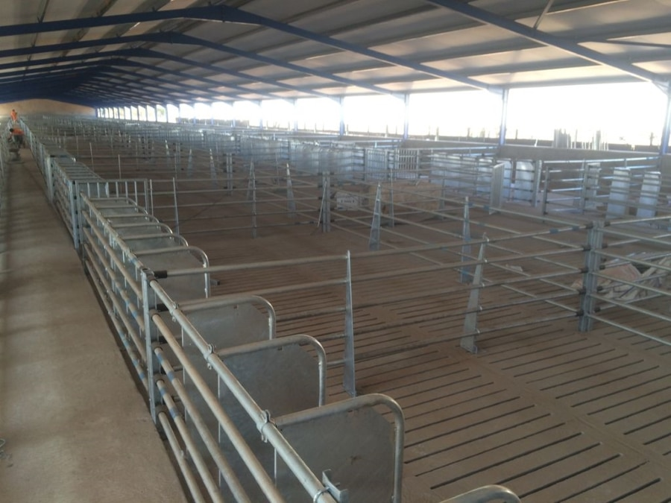
1. Space Requirements:
Adequate space is critical to prevent overcrowding, stress, and injury. Each species has specific space needs depending on age, size, and purpose (e.g., meat, milk, or breeding). For example, dairy cows need enough space to lie down, stand, and move freely, while poultry requires proper floor area and perching space. Overcrowding can lead to competition for food and water, aggression, disease spread, and reduced productivity. Proper spacing also facilitates cleaning and inspection.
2. Ventilation and Airflow:
Good ventilation is essential to maintain air quality, control temperature, and reduce humidity and ammonia buildup. Poor ventilation can cause respiratory diseases, heat stress, and reduced feed intake. Housing design should include windows, vents, or fans to allow fresh air circulation while preventing drafts. The orientation of the housing can also maximize natural airflow and minimize exposure to extreme weather conditions.
3. Lighting Requirements:
Adequate lighting is important for animal health, behaviour, and productivity. Natural light helps regulate biological rhythms and improves reproductive performance, while artificial lighting can extend daylight hours in poultry or dairy systems to increase egg production or milk yield. Housing design should provide sufficient light while preventing glare and excessive heat.
4. Flooring and Bedding:
Flooring must be durable, non-slippery, easy to clean, and comfortable for the animals. Bedding materials such as straw, sawdust, or sand improve comfort, absorb moisture, and reduce the risk of injury and disease. Proper flooring and bedding prevent lameness in livestock, reduce infections, and make manure collection and cleaning easier. Slatted floors or deep-litter systems may be used depending on species and farm management practices.
5. Feeding and Watering Systems:
Housing should include easy access to feed and water to ensure all animals can eat and drink without competition. Feed troughs, silos, and waterers must be designed for hygiene, durability, and efficiency. Proper placement reduces feed wastage, prevents contamination, and ensures uniform growth and health. Automated systems can further improve efficiency and reduce labour requirements.
6. Waste Management:
Livestock housing must allow for effective collection, removal, and disposal of manure and wastewater. Proper drainage, sloped floors, and designated manure areas prevent waterlogging, reduce odour, and minimize contamination of soil and water sources. Efficient waste management also supports environmental sustainability and provides an opportunity to reuse manure as fertilizer for crops.
7. Protection from Predators and Environmental Hazards:
Housing must safeguard livestock from predators, theft, and extreme weather conditions. Fencing, gates, and secure shelters are necessary to protect animals, especially smaller livestock such as goats, sheep, and poultry. Roofs, walls, or windbreaks provide protection from sun, rain, and wind, reducing stress and improving productivity.
8. Durability and Maintenance:
Materials used for construction should be durable, affordable, and easy to maintain. Housing should withstand local weather conditions, require minimal repairs, and last for several years. Maintenance considerations include easy access for cleaning, feeding, and health inspections without disrupting animals.
9. Biosecurity Considerations:
Housing design should facilitate biosecurity by limiting the introduction and spread of disease. Separate areas for sick animals, quarantine pens for new livestock, and controlled access points reduce disease risks. Designs that minimize contact with wildlife or contaminated water further protect livestock health.
Livestock housing design requirements focus on providing adequate space, ventilation, lighting, bedding, feeding and watering systems, waste management, protection, durability, and biosecurity. For mixed crop and livestock farmers in South Africa, meeting these requirements ensures animal welfare, improves productivity, reduces disease and mortality, and supports sustainable farm management. Well-designed housing is therefore a cornerstone of successful livestock farming, balancing animal needs, operational efficiency, and environmental stewardship.

KT0604 Facilities for feed and water in livestock housing
Providing appropriate facilities for feed and water within livestock housing is essential for ensuring animal health, welfare, and productivity. For mixed crop and livestock farmers in South Africa, well-designed feeding and watering systems reduce competition among animals, prevent contamination, support growth and reproduction, and improve farm efficiency. Proper facilities also allow farmers to monitor intake, manage nutrition effectively, and maintain hygienic conditions that reduce disease risk.
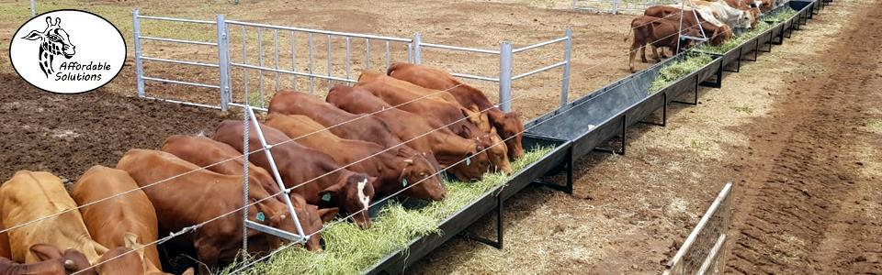
1. Feed Facilities:
Feed facilities include troughs, bunkers, feeders, and silos designed to provide easy access to clean and adequate feed. The design and placement of feed facilities must consider the number and size of animals, species-specific feeding behaviours, and type of feed (e.g., concentrate, silage, hay, or pasture). For example:
- Troughs: Long, narrow structures allow multiple animals to feed simultaneously. They should be at the correct height to prevent spillage, reduce competition, and ensure all animals can access feed comfortably.
- Feed Bunkers and Silos: These store bulk feed such as grains, silage, or hay. Silos protect feed from moisture, pests, and spoilage, ensuring a continuous supply of high-quality nutrition.
- Automated Feeders: In larger or intensive operations, automated feeding systems distribute feed at scheduled times, reducing labour and ensuring uniform nutrition.
Proper feed facilities also support hygiene and disease control. Feeders should be cleaned regularly to prevent mould, bacterial growth, or contamination with manure or water. Contaminated feed can lead to gastrointestinal diseases, reduced growth rates, and lower productivity.
2. Water Facilities:
Access to clean, fresh water is vital for all livestock. Water facilities within housing include troughs, automatic waterers, nipple drinkers, and tanks. Proper design ensures that animals can drink easily, reduces water wastage, and prevents contamination. Key considerations include:
- Troughs: Should be positioned to allow multiple animals to drink simultaneously, preventing competition and stress. They must be cleaned regularly to remove algae, dirt, or manure.
- Automatic Waterers: These provide continuous access to water, maintaining hygiene and reducing labour. They are especially useful in dairy, pig, and poultry housing systems.
- Nipple Drinkers: Common in pig and poultry housing, these devices provide small amounts of water on demand, reducing spillage and maintaining cleaner floors.
3. Placement and Accessibility:
Feed and water facilities must be easily accessible to all animals within the housing system. Adequate spacing prevents overcrowding and competition, which can cause stress, injuries, and unequal growth or production. Facilities should also be positioned away from bedding areas or waste accumulation to prevent contamination.
4. Monitoring and Management:
Facilities should allow farmers to monitor feed and water intake for nutritional management. Observing changes in consumption can indicate health issues, stress, or poor feed quality. Proper monitoring supports early intervention, ensuring the well-being and productivity of livestock.
5. Integration with Farm Sustainability:
Well-designed feed and water facilities support sustainable farm practices. Efficient feeding reduces waste, lowers input costs, and maximizes nutrient utilization. Water management systems, such as recirculation or rainwater harvesting, conserve resources while ensuring a reliable supply for livestock.
Feed and water facilities in livestock housing are essential for animal health, welfare, and productivity. Proper design, placement, and maintenance of feeders and waterers ensure clean, adequate, and easily accessible nutrition and hydration. For mixed crop and livestock farmers in South Africa, investing in efficient feeding and watering facilities improves growth, reproduction, disease prevention, and overall farm efficiency while supporting sustainable and profitable farming operations.

KT0605 Importance of waste management in livestock housing
Waste management is a critical aspect of livestock housing that directly affects animal health, farm productivity, environmental sustainability, and regulatory compliance. For mixed crop and livestock farmers in South Africa, proper management of manure, wastewater, and other livestock by-products ensures hygienic living conditions, reduces disease risks, improves nutrient recycling, and supports sustainable farming practices. Efficient waste management contributes to both the welfare of livestock and the economic viability of the farm.
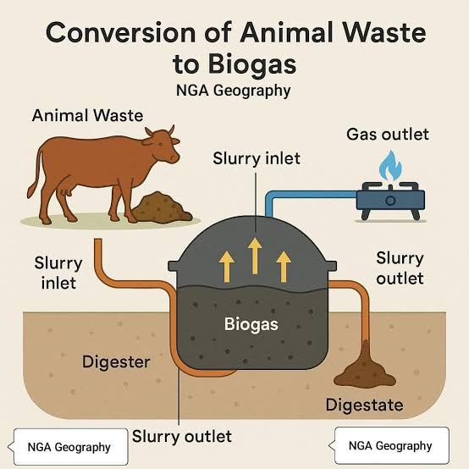
One of the main reasons for managing waste in livestock housing is disease prevention and animal health. Accumulation of manure, urine, and other organic waste creates breeding grounds for pathogens, bacteria, parasites, and flies, which can cause respiratory, digestive, and skin diseases. Poor hygiene can lead to high mortality rates, reduced growth, lower milk production, and compromised reproductive performance. Regular removal, proper storage, and treatment of waste minimize these risks and create a clean, safe, and comfortable environment for livestock.
Environmental protection is another key aspect of waste management. Untreated or improperly disposed waste can contaminate soil, rivers, groundwater, and wetlands with nutrients, pathogens, and chemicals. This pollution affects biodiversity, water quality, and human health. Effective waste management, including composting, biogas production, or controlled storage, reduces the environmental footprint of livestock operations and helps farmers comply with South African environmental regulations, such as the National Environmental Management Act and the Fertilizers, Farm Feeds, Agricultural Remedies, and Stock Remedies Act.
Nutrient recycling and soil fertility are significant benefits of proper waste management. Manure and organic waste are rich in nitrogen, phosphorus, potassium, and other essential nutrients that can be recycled as organic fertilizer for crops and pastures. Composting or treating livestock waste converts it into stable, nutrient-rich material that enhances soil structure, increases water retention, and improves crop productivity. For mixed crop and livestock farms, this creates a closed-loop system, reducing the need for synthetic fertilizers and lowering input costs.
Operational efficiency and labour management are also improved through proper waste systems. Housing designs that facilitate waste collection, such as slatted floors, manure pits, and drainage channels, make it easier for farmers to clean and manage livestock housing regularly. Automated or semi-automated systems reduce labour requirements, minimize animal stress during cleaning, and allow farmers to focus on other management tasks such as feeding, breeding, and healthcare.
Economic and sustainability considerations are closely linked to waste management. Properly managed waste can be a valuable resource through compost sales, biogas generation, or use as organic fertilizer. Biogas plants convert livestock waste into renewable energy for heating or electricity, reducing reliance on fossil fuels and lowering operational costs. This not only supports farm profitability but also contributes to sustainable and climate-smart agriculture.
Waste management in livestock housing is essential for maintaining animal health, preventing disease, protecting the environment, recycling nutrients, improving operational efficiency, and enhancing farm sustainability. For mixed crop and livestock farmers in South Africa, implementing effective waste management practices ensures hygienic and comfortable living conditions, reduces environmental impact, and creates additional economic opportunities. Proper design, maintenance, and utilization of waste management systems are therefore vital for productive, sustainable, and profitable livestock farming.

KT0606 Importance of health and welfare in livestock housing
Health and welfare are fundamental considerations in livestock housing, directly impacting animal productivity, farm sustainability, and profitability. For mixed crop and livestock farmers in South Africa, providing an environment that supports good health and welfare ensures that livestock grow efficiently, reproduce successfully, and remain resilient to disease and environmental stress. Proper attention to health and welfare within housing not only meets ethical and legal obligations but also improves farm efficiency and long-term sustainability.
Animal Health: Proper livestock housing plays a critical role in preventing diseases and maintaining good health. Clean, well-ventilated, and dry housing reduces the prevalence of respiratory infections, gastrointestinal illnesses, and parasitic infestations. Providing adequate space prevents overcrowding, which lowers the spread of contagious diseases. Health monitoring becomes easier in well-organized housing, allowing farmers to detect early signs of illness, administer treatments, and prevent outbreaks. Maintaining animal health reduces mortality rates, veterinary costs, and production losses, ensuring a more productive and profitable farm operation.
Animal Welfare: Welfare encompasses the physical and psychological well-being of livestock. Housing that meets welfare standards provides shelter from extreme temperatures, wind, rain, and predators. Comfortable bedding, sufficient space, access to food and clean water, and areas for natural behaviours such as grazing, rooting, or perching promote welfare. Animals that experience good welfare are less stressed, have higher feed conversion efficiency, better growth rates, improved reproductive performance, and higher quality meat, milk, or eggs. Stress reduction is particularly important in South Africa’s variable climates, where livestock may be exposed to heatwaves, droughts, or cold spells.
Disease Control and Biosecurity: Housing that supports health and welfare also enhances biosecurity. Segregated areas for sick or new animals, proper waste management, and clean feeding and watering systems help prevent the introduction and spread of pathogens. By minimizing disease risks, farmers maintain consistent production levels and reduce losses associated with morbidity and mortality. Biosecure housing ensures compliance with animal health regulations, which is important for market access and export opportunities.
Productivity and Economic Benefits: Healthy and well-cared-for livestock are more productive. In dairy cattle, proper welfare reduces mastitis, improves milk yield, and enhances reproductive efficiency. In poultry, comfortable housing and welfare practices improve egg production and growth rates. For mixed crop and livestock farms, this translates into higher returns on investment, reduced feed wastage, and lower veterinary costs. Investments in housing that prioritizes health and welfare often result in long-term economic gains.
Ethical and Legal Considerations: In South Africa, animal welfare is protected under legislation such as the Animal Protection Act and the Codes of Practice for Animal Housing. Farmers are ethically obligated to provide housing that meets the physical and behavioural needs of their livestock. Compliance with these regulations avoids penalties, enhances the farm’s reputation, and meets the expectations of consumers increasingly concerned with ethical farming practices.
Prioritizing health and welfare in livestock housing is essential for sustainable and productive farming. Proper housing reduces disease risk, prevents stress, promotes natural behaviours, and supports ethical obligations. For mixed crop and livestock farmers in South Africa, maintaining health and welfare improves productivity, lowers operational costs, enhances animal performance, and ensures compliance with regulatory standards. Investing in housing that safeguards animal health and welfare is therefore a strategic approach to achieving both ethical and economic success in livestock farming.

KT0607 Importance of biosecurity in livestock housing
Biosecurity in livestock housing is a set of practices and measures aimed at preventing the introduction, spread, and transmission of diseases within a farm. For mixed crop and livestock farmers in South Africa, implementing effective biosecurity measures is essential for maintaining animal health, ensuring productivity, protecting farm income, and complying with national regulations. Livestock diseases can spread rapidly, causing high mortality, reduced production, and financial losses, making biosecurity a critical component of sustainable livestock management.
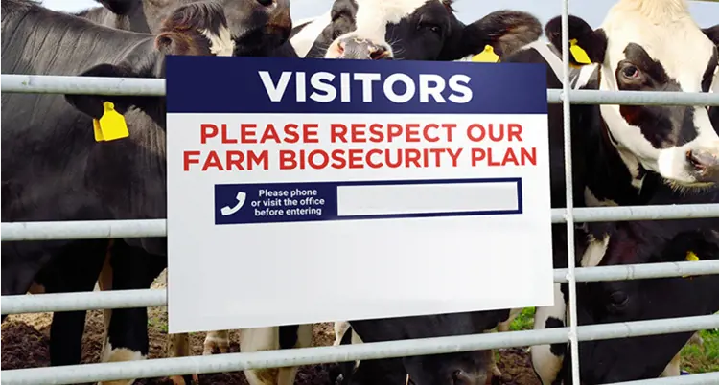
Disease Prevention and Control:
The primary purpose of biosecurity is to reduce the risk of infectious diseases entering or spreading within livestock populations. Housing that incorporates biosecurity measures, such as designated quarantine areas for new or sick animals, controlled entry points, and restricted access to visitors, minimizes exposure to pathogens. Diseases like foot-and-mouth disease, avian influenza, or Newcastle disease can devastate livestock populations if biosecurity is neglected. Proper housing design, combined with hygiene protocols, helps contain diseases, reducing the need for costly treatments and preventing outbreaks that can affect neighbouring farms.
Protection of Farm Productivity:
Healthy animals are more productive, while disease outbreaks can lead to reduced growth rates, lower milk or egg production, reproductive failures, and even livestock deaths. Implementing biosecurity in housing ensures that animals are protected from harmful agents, allowing farmers to maintain consistent production levels. For example, separating sick animals and maintaining clean feeding and watering systems prevent contamination, ensuring that the rest of the herd or flock remains healthy. This consistency directly impacts profitability and farm sustainability.
Hygiene and Sanitation:
Biosecurity emphasizes hygiene practices, including regular cleaning and disinfecting of housing, feeding, and watering equipment. Manure management, removal of soiled bedding, and proper drainage reduce pathogen survival and limit disease vectors such as flies, rodents, or wild birds. Clean and sanitized housing not only prevents infections but also improves animal comfort, welfare, and growth efficiency.
Regulatory Compliance and Market Access:
South African legislation, such as the Animal Diseases Act and Codes of Practice for animal farming, requires farmers to implement biosecurity measures. Complying with these regulations ensures legal protection, reduces the risk of penalties, and enhances access to local and international markets. Consumers and commercial buyers increasingly favor farms that demonstrate biosecurity practices, recognizing the link between biosecurity, food safety, and animal welfare.
Economic and Risk Management Benefits:
Effective biosecurity reduces financial losses by preventing disease-related mortality, treatment costs, and production declines. It also protects farm assets and investments, including breeding stock, feed, and infrastructure. By mitigating disease risks, farmers can avoid large-scale culling or quarantine, ensuring business continuity. In addition, biosecurity measures contribute to environmental sustainability by preventing the need for chemical treatments or excessive veterinary interventions.
Integration with Housing Design:
Livestock housing that supports biosecurity includes features such as controlled entry and exit points, quarantine pens, easy-to-clean floors and walls, proper ventilation to prevent disease accumulation, and separation of different animal groups by age or species. Housing layout should minimize contact between animals, restrict access of wildlife, and prevent cross-contamination from feed, water, or equipment.
Biosecurity in livestock housing is essential for disease prevention, animal health, productivity, and farm profitability. For mixed crop and livestock farmers in South Africa, implementing biosecurity measures reduces the risk of disease outbreaks, maintains consistent production, protects investments, ensures regulatory compliance, and enhances market opportunities. Integrating biosecurity into housing design, hygiene protocols, and farm management practices is therefore critical for sustainable and resilient livestock farming.

KT0608 Regulations and standards that govern livestock housing
Livestock housing in South Africa is governed by a combination of national legislation, industry codes, and international best practices designed to ensure animal welfare, environmental protection, and farm productivity. For mixed crop and livestock farmers, understanding and complying with these regulations and standards is essential to maintain healthy and productive livestock, meet legal obligations, and operate sustainably. Regulations cover aspects such as housing design, space requirements, ventilation, hygiene, waste management, and biosecurity, ensuring that animals are kept in safe and humane conditions.
1. Animal Welfare Legislation:
The Animal Protection Act (1962) and other related statutes provide the legal framework for animal welfare in South Africa. These laws require farmers to provide livestock with adequate shelter, food, water, and space to exhibit natural behaviours. Housing must protect animals from extreme weather, predators, and injury. Non-compliance can result in fines, prosecution, or closure of the farm. Farmers are legally obligated to ensure that housing meets the welfare needs of all livestock species, including cattle, sheep, goats, pigs, and poultry.
2. Codes of Practice for Livestock Housing:
Industry-specific codes, such as the Codes of Practice for the Housing and Care of Animals issued by the South African National Standards (SANS) and the South African Bureau of Standards (SABS), provide detailed guidelines for designing and managing livestock housing. These standards cover:
- Minimum space allocation per animal
- Ventilation and lighting requirements
- Flooring and bedding materials
- Feeding and watering facilities
- Waste management systems
- Biosecurity measures
Following these codes ensures that livestock housing promotes welfare, reduces disease risks, and supports optimal production. For commercial farms, compliance with codes of practice is often required for certification and market access.
3. Environmental and Waste Management Regulations:
The National Environmental Management Act (NEMA) and related regulations govern the impact of livestock housing on the environment. Farmers must manage manure, wastewater, and runoff to prevent soil and water contamination. Proper drainage, composting, and storage of waste are required to minimize environmental risks. Adhering to these regulations ensures sustainable farming practices and reduces legal liabilities related to pollution.
4. Biosecurity and Health Regulations:
The Animal Diseases Act (1984) and associated regulations outline biosecurity requirements to prevent disease outbreaks. Housing must be designed to allow isolation of sick or new animals, control access to visitors, and minimize contact with wildlife or contaminated equipment. These measures protect livestock health, prevent economic losses, and ensure compliance with national disease control programs.
5. Occupational Health and Safety Standards:
Livestock housing regulations also intersect with farmworker safety under the Occupational Health and Safety Act (1993). Housing structures must be safe for both animals and workers, with secure fencing, non-slip floors, proper ventilation, and adequate lighting. Safe handling areas, walkways, and equipment reduce the risk of injuries to both animals and personnel.
6. International Guidelines:
Many South African farms also follow international standards for livestock housing, such as those from the World Organisation for Animal Health (WOAH, formerly OIE) and the FAO’s Livestock Environmental Guidelines. These guidelines provide best practices for sustainable housing, welfare, and biosecurity, supporting global trade and access to international markets.
Livestock housing in South Africa is governed by a combination of legal, environmental, health, and welfare standards. Farmers must comply with national legislation, industry codes of practice, biosecurity requirements, and environmental regulations to ensure animal welfare, protect the environment, and maintain productivity. Understanding and implementing these regulations not only avoids legal penalties but also enhances farm efficiency, sustainability, and market credibility. Properly regulated livestock housing is therefore a cornerstone of responsible and profitable farming.

Internal Assessment Criteria (IAC) and Weight
- IAC0601 Explain the principles of livestock housing

The principles of livestock housing are designed to provide animals with a safe, comfortable, and productive environment while minimizing stress, disease, and environmental impact. Good livestock housing should protect animals from extreme weather conditions such as heat, cold, wind, rain, and snow. It should ensure adequate space, proper ventilation, suitable lighting, and easy access to food and water. Hygiene, biosecurity, and ease of management are also critical. Proper housing supports optimal growth, reproduction, and productivity by reducing energy expenditure for thermoregulation and stress responses. For a South African mixed crop and livestock farmer, well-designed housing enhances animal welfare, improves farm efficiency, and reduces losses due to disease or environmental stress.

- IAC0602 Describe how the design and construction of livestock housing affect animal welfare, productivity, and environmental impact.
The design and construction of livestock housing have a direct impact on animal welfare, productivity, and environmental sustainability. Well-constructed housing with durable materials, proper insulation, and adequate drainage prevents injury, disease, and stress. Proper flooring, bedding, and shelter from harsh weather conditions enhance animal comfort and welfare, leading to better growth rates, milk production, or reproductive performance. Poorly designed housing, however, can result in overcrowding, injuries, heat or cold stress, and increased susceptibility to disease, lowering productivity. Environmentally, housing that incorporates manure management systems, proper waste drainage, and runoff control reduces pollution, protects soil and water resources, and promotes sustainable farming practices.

- IAC0603 Explain the role of ventilation in regulating temperature, humidity, and air quality.

Ventilation is critical in livestock housing as it regulates temperature, humidity, and air quality, which directly influence animal health and productivity. Proper airflow removes excess heat, moisture, dust, and harmful gases such as ammonia and carbon dioxide, preventing respiratory problems and heat stress. In hot climates, like many regions of South Africa, effective ventilation prevents overheating and ensures animals remain comfortable. In cooler climates, controlled ventilation maintains air circulation without causing drafts that could chill animals. Well-ventilated housing supports disease prevention, improves feed efficiency, and enhances growth and reproductive performance by maintaining a stable and healthy microclimate.

- IAC0604 Discuss how temperature affects animal health, productivity, and welfare.

Temperature plays a significant role in livestock welfare and productivity. High temperatures can cause heat stress, leading to reduced feed intake, slower growth, lower milk or egg production, and decreased reproductive performance. Extreme cold can result in hypothermia, increased energy requirements, and reduced immunity. Both heat and cold stress can weaken animals and make them more susceptible to disease. Maintaining an optimal temperature range through housing design, ventilation, and bedding ensures that animals remain healthy and productive. Farmers in South Africa, particularly in regions with high summer temperatures or cold winters, must monitor temperature and implement cooling or heating strategies to support animal welfare.

- IAC0605 Explain how lighting influences animal behaviour, health, and productivity.

Lighting in livestock housing influences animal behavior, health, and productivity. Adequate light regulates daily activity patterns, feeding behavior, and sleep cycles, contributing to welfare and performance. For example, poultry require specific light durations and intensities to stimulate egg production, while dairy cattle show improved milk yield under proper light exposure. Natural lighting is preferable where possible, but artificial lighting can supplement or extend day length for production benefits. Poor or inconsistent lighting can stress animals, reduce feeding, and negatively impact growth, reproduction, or lactation. Properly designed lighting enhances productivity, promotes normal behavior, and supports overall animal health.

- IAC0606 Describe how space requirements vary depending on the size, age, and breed of animals.

Adequate space is essential for animal welfare, comfort, and productivity. Space requirements vary with the size, age, and breed of livestock. Young or small animals need less space than adults, but overcrowding can still cause stress, aggression, and disease spread. Larger breeds require more space for lying, standing, and movement to maintain health and comfort. Space also affects feeding access, ventilation, and hygiene. Providing sufficient space reduces injuries, supports natural behavior, improves feed efficiency, and enhances productivity. Farmers must consider these factors when designing pens, stalls, or grazing areas to accommodate animal growth and breed-specific needs.

- IAC0607 Explain how to ensure animals have continuous access to clean and fresh feed and water.

Continuous access to clean and fresh feed and water is vital for livestock health, growth, and productivity. Water sources must be uncontaminated and replenished regularly, and feeding systems should provide balanced diets appropriate for age, breed, and production stage. Automated or gravity-fed systems can help maintain consistent supply, while manual checking ensures that feed and water remain clean. In South African mixed farms, where water scarcity and feed availability vary seasonally, farmers must carefully monitor feed and water access, especially during droughts, to prevent dehydration, nutrient deficiencies, and stress.

- IAC0608 Describe methods for disposing manure, urine, and other waste products to minimize environmental impact and prevent disease spread.

Proper waste disposal is essential to prevent environmental pollution and disease. Manure and urine should be collected and stored in designated areas or pits before being composted or applied to fields as fertilizer. Composting stabilizes nutrients, reduces pathogens, and minimizes odour, while spreading manure improves soil fertility. Wastewater should be filtered or directed into ponds or bio-digesters where appropriate. Avoiding runoff into rivers and streams prevents contamination of water sources. Effective waste management reduces the risk of zoonotic diseases, protects the environment, and contributes to sustainable nutrient recycling in mixed crop-livestock systems.

- IAC0609 Explain how to monitor and maintain animal health and welfare, and identify signs of illness, injury, or distress.

Monitoring animal health and welfare involves regular observation, record-keeping, and proactive care. Farmers should watch for changes in behaviour, appetite, appearance, or mobility, as these may indicate illness or injury. Routine health checks, vaccination, parasite control, and prompt treatment of sick animals are critical. Maintaining hygiene, appropriate housing conditions, and proper nutrition also supports welfare. Recognizing early signs of distress, such as lethargy, coughing, limping, or abnormal feeding behaviour, allows farmers to intervene quickly, preventing disease spread and reducing production losses.

- IAC0610 Describe strategies for preventing the introduction and spread of diseases, parasites, and pests.

Disease, parasite, and pest control are critical for maintaining animal welfare and productivity. Strategies include biosecurity measures such as quarantining new or sick animals, disinfecting housing and equipment, controlling visitor access, and ensuring clean feed and water. Regular vaccination and deworming programs reduce susceptibility to disease, while integrated pest management (IPM) prevents infestations. Maintaining clean housing, proper ventilation, and hygienic feeding practices reduces pathogen proliferation. In South Africa, where livestock diseases such as foot-and-mouth and tick-borne infections are prevalent, these preventive measures protect animal health, safeguard farm income, and support public health.

- IAC0611 Explain how to comply with regulations and standards for livestock housing.
Compliance with livestock housing regulations ensures that animal welfare, environmental protection, and human health standards are met. South African legislation and codes of practice define minimum space, ventilation, hygiene, waste management, and biosecurity standards. Compliance involves proper housing design, record-keeping, vaccination programs, and manure management systems. Inspections by regulatory authorities ensure adherence to legal requirements and may include water use, feed quality, and disease control measures. Following these standards not only avoids legal penalties but also promotes sustainable and ethical farming practices, improves animal welfare, and enhances the farm’s reputation.

REFERENCE

- Soil Classification Working Group. Taxonomic Soil Classification System for South Africa. (Print: Department of Agricultural Development)↩
- Fey, Martin. Soils of South Africa. (Print: Cambridge University Press)↩
- Brady, Nyle C., and Ray R. Weil. The Nature and Properties of Soils. (Print: Pearson Education)↩
- Greenhouse, J.P. Handbook of Agricultural Science. (Print: Academic Press)↩
- Smith, H.J. Conservation Agriculture in South Africa: Lessons from the Field. (Print: ARC-GCI)↩
- Savory, Allan. Holistic Management: A New Framework for Decision Making. (Print: Island Press)↩
- Hensley, M., et al. In-field Rainwater Harvesting for Crop Production. (Print: Water Research Commission)↩
- Howell, Terry A. Principles of Irrigation. (Print: American Society of Agricultural Engineers)↩
- Hillel, Daniel. Introduction to Environmental Soil Physics. (Print: Elsevier Academic Press)↩
- Bruulsema, T.W. The 4R Plant Nutrition Manual. (Print: International Plant Nutrition Institute)↩
- Havlin, John L., et al. Soil Fertility and Fertilizers: An Introduction to Nutrient Management. (Print: Pearson)↩

