613101-000-00-KM-04
Harvesting and Value Addition of Crops and Livestock market readiness, NQF Level 5, Credits 5

LEARNER GUIDE

Module # | 613101-000-00-KM-04
NQF Level | 5
Credits | 5
Occupational Code | 613101-000-00-00
SAQA QUAL ID | 125077
Qualification Title | Higher Occupational Certificate: Mixed Crop and Livestock Farmer

Name
Contact Address
Telephone (H)
Telephone (W)
Facsimile
Cellular
E-mail

Note to the learner
This Learner Guide provides a comprehensive overview of the module. It is designed to improve the skills and knowledge of learners, and thus enabling them to effectively and efficiently complete specific tasks.

Purpose
The main focus of learning in this knowledge module is to ensure the quality, safety, and marketability of agricultural products, while also maximizing their economic value. The learning contact time, which is the time that reflects the required duration of enrolment for this module, is at least 6 days
List of Knowledge Topics:
- KM-04-KT01 Concepts and importance of timely harvesting 25
- KM-04-KT02 Concepts and importance of crops post-harvest handling 25
- KM-04-KT03 Concepts and importance of value adding 25
- KM-04-KT04 Livestock market readiness 25

Exemptions
None

Entry Requirements
NQF Level 4 Qualification with Agriculture Science/Applied Agriculture/Agricultural Technology or related.

Provider Accreditation Requirements for the Knowledge Module

Physical Requirements
- Classroom with chairs, tables, sufficient lighting and ventilation
- Whiteboards, data projector and screen Computer, internet access, applicable software. Ablutions facilities.
- Curriculum Aligned Learning Material
- Quality Management System
- Learner Management Information System

Human Resource Requirements:
- Facilitator must hold a minimum of NQF Level 6 qualification in Agriculture with 3 years working experience in Crop and Livestock production environment.

FACILITATOR/LEARNER RATIO 1:30

Legal Requirements
- CIPC registered entity
- Valid Tax Compliance pin
- Infrastructure compliant with OHS Act
- Display of Labour Laws within the premises
- Compliant to POPI Act
- Valid Lease Agreement / Title deed

Venue, Date and Time:
Consult your facilitator should there be any changes to the venue, date and/or time.
Refer to your timetable

Assessments

The only way to establish whether you are competent and have accomplished the learning outcomes is through continuous assessments. This assessment process involves interpreting evidence about your ability to perform certain tasks. You will be required to perform certain procedures and tasks during the training programmer and will be assessed on them to certify your competence.
This module includes assessments in the form of self-evaluations/activities and exercises. The exercises, activities and self-assessments will be done in pairs, groups or on your own. These exercises/activities or self-assessments (Learner workbook) must be handed to the facilitator. It will be added to your portfolio of evidence, which will be proof signed by your facilitator that you have successfully performed these tasks.

Listen carefully to the instructions of the facilitator and do the given activities in the time given to you.

KM-04-KT01 Concepts and importance of harvesting. 25%
Topic elements to be covered include:
- KT0101 Factors influencing the timing of harvest
- KT0102 Techniques for determining crop maturity
- KT0103 Tools and equipment for harvesting
- KT0104 Practices for safe post-harvesting handling

KM-04-KT01: Concepts and Importance of Harvesting
Harvesting is the process of removing mature crops or agricultural products from the field, orchard, garden, or production area at the correct stage of development so that they can be used, stored, processed, or sold. It is one of the most important stages in crop production because it is the point at which the farmer finally collects the results of all the work done during land preparation, planting, irrigation, fertilisation, weed control, pest management, and crop care. In simple terms, harvesting is the transition from production to utilisation or marketing. If harvesting is done properly, the farmer protects the quality and quantity of the produce. If it is done poorly, even a well-grown crop can lose value very quickly.
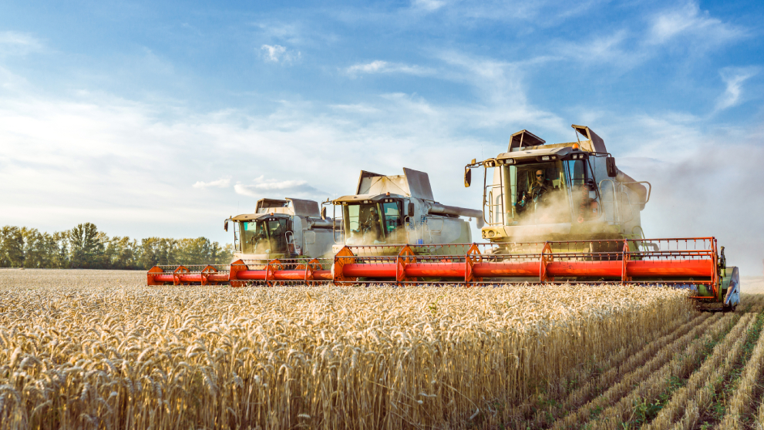
The concept of harvesting is not limited to merely picking or cutting crops. It includes deciding the right time to harvest, using the correct harvesting methods, handling the produce carefully, and preparing it for storage, consumption, or sale. Different crops require different harvesting approaches. Grain crops such as maize, wheat, and sorghum are usually harvested when the grain has reached full maturity and the moisture content is suitable for safe storage. Vegetables may be harvested when they are tender, fresh, and market-ready, while fruits may be picked according to ripeness, colour, taste, or the distance to the target market. Root and tuber crops such as potatoes, carrots, onions, and sweet potatoes are harvested when they have reached the correct size and maturity underground. The concept of harvesting therefore includes understanding crop physiology, maturity signs, weather conditions, labour availability, and market requirements.
An important part of harvesting is recognising maturity. A crop must be harvested at the right stage to achieve the best balance between quality, yield, and shelf life. If it is harvested too early, the product may be underdeveloped, low in weight, poor in flavour, and unattractive to buyers. If it is harvested too late, it may become overripe, dry out, shatter, rot, lose nutritional value, or become more vulnerable to pests, birds, and bad weather. In crops such as maize and beans, late harvesting can cause field losses when cobs or pods dry excessively or when birds and insects attack them. In fruits and vegetables, late harvesting often reduces freshness and market value. The concept of correct maturity is therefore central to successful harvesting.
Harvesting also involves choosing the appropriate method. Some crops are harvested manually using hands, knives, sickles, forks, spades, or pruning tools. Others are harvested mechanically with harvesters, combines, diggers, or other specialised equipment. Manual harvesting is common on many small-scale and mixed farms in South Africa because it allows careful selection and reduces damage in delicate crops such as tomatoes, green beans, cabbages, spinach, and fruit. Mechanical harvesting may be more efficient for larger-scale grain and fodder crops because it saves time and labour, but it must be properly managed to avoid wastage and crop damage. The method selected depends on the type of crop, size of the farm, cost of labour, available machinery, terrain, and intended use of the produce.
The importance of harvesting lies first in its effect on crop yield. A crop may have grown well in the field, but if it is harvested badly, a large portion of the produce can be lost. Shattering, bruising, breakage, spillage, trampling, and leaving produce in the field all reduce the amount that reaches the market or storage. Proper harvesting ensures that the maximum possible yield is recovered from the field. This is especially important for farmers who work with limited land, limited rainfall, and high production costs. Every kilogram lost during harvest is a direct loss of income and effort.
Harvesting is also important because it directly influences product quality. Quality includes size, colour, cleanliness, shape, taste, nutritional value, shelf life, and freedom from defects. Buyers in both formal and informal markets prefer produce that is fresh, clean, undamaged, and uniform. Rough handling during harvesting can bruise fruits, tear leaves, crack grain, or damage tubers, making them less attractive and lowering their price. In some cases, physical damage also allows diseases and decay to develop more quickly. Proper harvesting protects the appearance and internal quality of the product, helping the farmer to maintain standards and satisfy market requirements.
Another important reason harvesting matters is that it affects storage life. Crops intended for storage must be harvested under suitable conditions and handled correctly to prevent spoilage. Grain that is harvested too wet may develop mould, heating, or fungal contamination in storage. Potatoes and onions that are harvested carelessly may be cut or bruised and later rot in storage. Leafy vegetables harvested during the heat of the day may wilt quickly and lose freshness before they reach consumers. Proper harvesting therefore supports good post-harvest management and reduces losses after the crop leaves the field. This is vital for food security, especially in farming systems where crops are stored for home use, seed, feed, or delayed sale.
Harvesting is important for profitability because it determines how much of the crop can be sold and at what price. A farmer who harvests at the right time and presents produce in good condition is more likely to receive a better market price. For example, vegetables harvested while fresh and crisp are more attractive to traders and consumers. Grain harvested at the correct moisture content can be stored safely and sold later when prices improve. Crops harvested poorly may be downgraded, rejected, or sold cheaply. The farmer therefore earns more when harvesting is planned and executed properly. In this way, harvesting is not just a field activity but an economic decision that influences farm income.
The importance of harvesting also extends to labour and time management. Harvesting often takes place within a limited window, meaning that the farmer must act quickly once the crop reaches maturity. Delays can expose the crop to storms, wind, hail, pests, birds, theft, and over-maturity. Good harvesting requires planning for labour, equipment, containers, transport, and storage space in advance. On mixed farms, this planning is even more important because crops and livestock activities may compete for labour and resources. Efficient harvesting ensures that farm operations continue smoothly and that produce moves quickly from the field to the next stage.
In South African agriculture, harvesting is especially important because farmers operate under varied climatic conditions, including drought, heat, irregular rainfall, and sometimes extreme weather. These conditions can shorten the harvesting window and increase the risk of field losses. For smallholder and mixed farmers, limited access to machinery, transport, and cold storage makes timely and careful harvesting even more important. A farmer must therefore adapt harvesting practices to local conditions, crop type, and available resources. This practical understanding helps improve resilience and productivity.
Harvesting is also linked to food safety and hygiene. Produce intended for human consumption must be harvested with clean hands, clean tools, and clean containers to avoid contamination. Dirty harvesting practices can expose food to soil, chemicals, animal waste, and harmful microorganisms. This is especially important for fresh vegetables, fruits, milk-producing fodder crops, and products entering formal value chains. Good harvesting practice helps protect consumer health and supports compliance with market standards.
Another concept related to harvesting is selective harvesting versus once-off harvesting. Some crops, such as spinach, tomatoes, green beans, and fruit, may be harvested several times as produce matures gradually. This is called selective or multiple harvesting. Other crops, such as maize for grain, wheat, onions, or dry beans, are often harvested once when most of the crop is mature. The farmer must understand which system applies to each crop because this affects labour, scheduling, and expected yield. Selective harvesting often improves quality because only mature produce is picked, while once-off harvesting is efficient for uniform crops.
Harvesting is the careful removal of mature crops from the production area at the right time, using the right methods, and with proper handling so that yield, quality, and value are protected. It is important because it determines how much of the crop is recovered, how good the product looks and tastes, how long it can be stored, how safely it can be consumed, and how much income the farmer can earn. Harvesting connects crop production to storage, processing, and marketing, making it one of the most important activities in agriculture. A farmer who understands the concepts and importance of harvesting is better able to reduce losses, protect quality, and improve farm profitability.

KT0101: Factors Influencing the Timing of Harvest
The timing of harvest is one of the most important decisions a farmer makes because it affects the quantity, quality, safety, storage life, and market value of the crop. Harvesting too early or too late can lead to major losses even when the crop has grown well. The correct harvest time is not chosen by looking at the calendar alone. It is influenced by a combination of biological, environmental, technical, and market factors. A mixed crop and livestock farmer in South Africa must therefore observe the crop carefully, understand its growth pattern, and take into account weather conditions, labour, intended use, and market requirements before deciding when to harvest.
One of the main factors influencing harvest timing is the stage of crop maturity. Each crop has a point at which it reaches the best balance between yield and quality. This is known as physiological or harvest maturity. At this stage, the crop has developed sufficiently for its intended purpose. For grain crops such as maize, wheat, and sorghum, this usually means that the grain has filled properly and moisture content is reducing to a level suitable for harvesting and storage. For vegetables, maturity may be judged by size, colour, tenderness, and freshness. For fruit, maturity depends on sweetness, firmness, flavour, and ripeness. If the crop is harvested before it reaches the correct maturity, it may have poor quality, low weight, weak flavour, or reduced nutritional value. If it is harvested too late, it may become overripe, dry out, split, drop from the plant, or lose market appeal. Maturity is therefore the most basic and most important guide to harvest timing.
The intended use of the crop also strongly influences when it should be harvested. The same crop may be harvested at different stages depending on whether it is meant for fresh consumption, storage, processing, animal feed, or seed. Maize harvested for roasting or boiling as green mealies is picked much earlier than maize intended for dry grain. Tomatoes for local fresh markets may be harvested when they are more ripe, while tomatoes for distant transport may be picked when still firm and partially coloured. Lucerne or other fodder crops must be harvested at a stage that balances quantity and nutritional quality for livestock feed. Crops harvested for seed must be fully mature to ensure good germination. This means that harvest timing is not only about plant development, but also about the purpose for which the crop will be used.
Weather conditions are another major factor affecting harvest timing. In South Africa, farmers often face varying rainfall patterns, high temperatures, wind, hail, and drought conditions, all of which can influence when a crop should be taken from the field. Rain during harvest can damage grain quality, increase moisture content, cause mould development, and delay field access. Very hot weather can increase wilting in vegetables and reduce freshness after harvest. Wind can cause grain shattering, fruit drop, or physical damage to mature crops if harvesting is delayed. Where bad weather is expected, a farmer may choose to harvest slightly earlier to protect the crop from losses. On the other hand, if the crop is still too wet, harvesting too soon may create storage problems. Weather therefore requires the farmer to balance ideal maturity with practical risk management.
Moisture content is especially important in determining harvest timing for grain, pulses, and other storable crops. Crops such as maize, beans, sunflower, and wheat must be harvested when moisture levels are suitable enough to avoid damage and spoilage. If harvested too wet, the grain may develop mould, rot, or fungal toxins in storage. Wet produce is also heavier, more difficult to thresh or shell, and more expensive to dry artificially. If harvested too dry, however, grain may crack, shatter, or fall from pods and heads, causing field losses. The farmer must therefore monitor crop dryness carefully and harvest when moisture is within a safe and practical range. This is one of the key technical factors in harvest timing.
Market demand and market requirements also influence when a farmer should harvest. Buyers often want produce of a certain size, colour, ripeness, or freshness, and these expectations determine when the crop is market-ready. For example, spinach must be harvested while leaves are tender, green, and attractive, while cabbages are harvested when heads are firm and of marketable size. A farmer supplying supermarkets may have to follow stricter specifications than one selling locally at a community market. Market prices may also change seasonally. In some cases, farmers may harvest as soon as produce is ready in order to capture high prices early in the season. In other cases, grain may be harvested and stored for sale later when prices improve. This shows that harvest timing is not based only on agronomy, but also on business considerations.
Labour availability is another practical factor that influences the timing of harvest, especially on mixed farms where labour is also needed for livestock care, feeding, cleaning, and other daily activities. Some crops have a narrow harvest window and require many workers in a short time. If labour is not available when the crop is ready, the harvest may be delayed, leading to losses. This is common in fruit and vegetable farming, where crops may become overripe or unmarketable if not picked on time. Farmers must therefore plan ahead for labour needs, train workers, and arrange tools and containers before harvest begins. The availability of family labour, seasonal workers, or hired teams can make a major difference in harvest efficiency.
The availability and condition of equipment also affect harvest timing. If a farmer uses machinery such as a combine harvester, maize picker, mower, or baler, that equipment must be available and in good working condition when the crop is ready. Mechanical breakdowns can delay harvesting and expose crops to losses. Even on smaller farms using manual harvesting, there must be enough knives, bags, crates, wheelbarrows, drying sheets, or transport vehicles to move produce quickly and safely. If equipment is limited, the farmer may have to stagger the harvesting process or begin earlier in order to finish on time. Equipment readiness is therefore an important management factor.
Pest and disease pressure can also force farmers to adjust harvest timing. Crops nearing maturity are sometimes attacked by birds, insects, rodents, moulds, or fungal diseases. For example, mature grain may be damaged by birds or storage pests even before it leaves the field. Fruit may rot if left too long during wet conditions. Vegetables may become diseased or physically damaged if harvest is delayed. In such cases, the farmer may decide to harvest earlier than originally planned to reduce further losses. This is especially important where pest pressure rises rapidly at maturity or where access to control measures is limited.
The condition of the field and access to the crop can also influence when harvesting takes place. Wet or muddy fields may delay machinery movement or make it difficult for workers to enter without damaging the crop. In some areas, poor roads and difficult transport conditions also affect the timing of harvesting because produce must be moved quickly after it is picked. This is particularly important for perishable produce such as tomatoes, leafy vegetables, milk-related fodder crops, and fruit. A farmer may need to align harvest timing with transport availability, road conditions, and delivery schedules to avoid spoilage and maintain quality.
Storage capacity is another important consideration. A crop may be ready for harvest, but if the farmer has no dry storage, cool room, shed space, or proper containers, harvesting too early may expose the product to spoilage. Grain needs dry, pest-free storage, while vegetables and fruits may need cool, shaded conditions. If storage is limited, the farmer may harvest in batches or time the harvest to match immediate sales or deliveries. This factor is often very important for smallholder and mixed farmers who have limited infrastructure and must manage harvests carefully to reduce waste.
The type of crop and harvesting pattern also influence timing. Some crops are harvested once, while others are harvested repeatedly over a period of time. Crops such as maize, wheat, onions, and dry beans are often harvested in one main operation when most of the crop has matured. Crops such as tomatoes, chillies, spinach, and green beans are harvested selectively over several days or weeks as produce reaches the right stage. This means the farmer must monitor such crops continuously and schedule regular picking. Understanding whether the crop matures uniformly or gradually is essential for deciding when and how often harvesting should take place.
Food safety and quality requirements also play a role in harvest timing. Crops treated with pesticides must not be harvested before the recommended pre-harvest interval has passed. This waiting period ensures that chemical residues decline to safe levels before the produce is consumed or sold. Harvesting before this period ends can create serious health risks and may lead to product rejection by buyers. Farmers must therefore keep accurate spray records and factor these legal and safety requirements into harvest decisions.
In a mixed farming system, the interaction between crop and livestock enterprises may also influence harvest timing. Crop residues may be needed as livestock feed, bedding, or mulch, and this can affect how and when crops are harvested. For example, maize may be harvested in a way that allows stover to be collected for cattle feed. Fodder crops must be harvested at the right stage to provide both sufficient volume and good nutritional quality. If harvesting is delayed too long, feed may become fibrous and less digestible. The mixed farmer must therefore consider both crop marketing needs and livestock feeding needs when deciding on timing.
The timing of harvest is influenced by many interconnected factors, including crop maturity, intended use, weather conditions, moisture content, market requirements, labour, equipment availability, pest and disease pressure, field access, storage capacity, food safety rules, and the relationship between crop and livestock enterprises. A successful farmer does not rely on one factor only, but considers all of them together in order to harvest at the most suitable time. Proper timing protects yield, maintains quality, reduces losses, supports food safety, and improves profitability. For a mixed crop and livestock farmer in South Africa, understanding these factors is essential for efficient and market-oriented production.

KT0102: Techniques for Determining Crop Maturity
Determining crop maturity is a very important skill in farming because it helps the farmer decide the correct time to harvest. Crop maturity refers to the stage at which a plant or its produce has developed enough to be harvested for its intended use, whether for fresh consumption, storage, processing, animal feed, or seed. If a crop is harvested before it reaches maturity, it may have low weight, poor taste, reduced quality, weak shelf life, and poor market value. If it is harvested too late, it may become overripe, dry, fibrous, cracked, spoiled, or lost in the field. A farmer must therefore use reliable techniques to assess maturity so that harvesting takes place at the right time and under the best possible conditions.
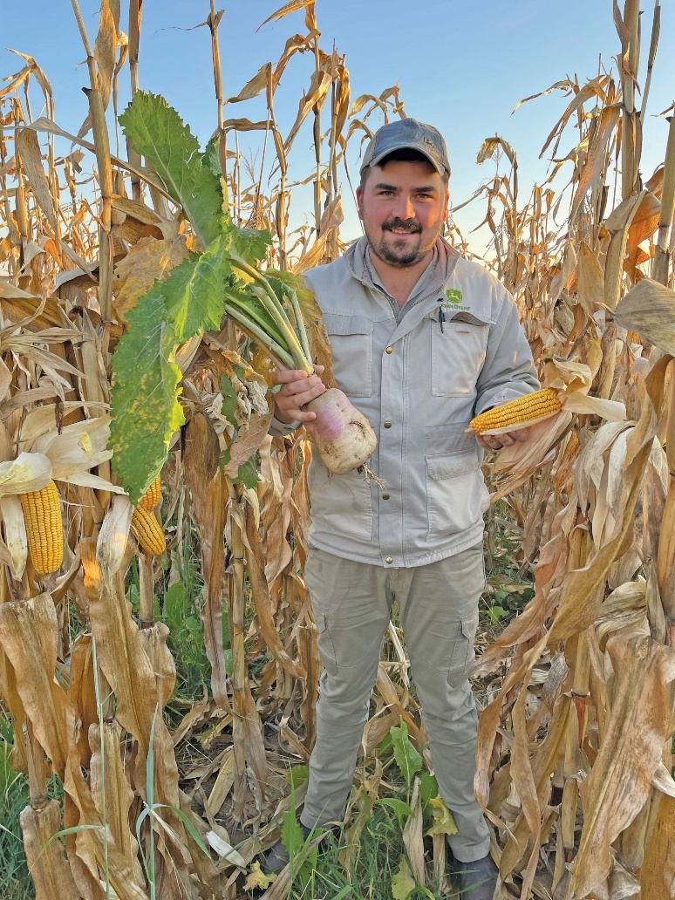
One of the most common techniques for determining crop maturity is visual observation. This involves carefully looking at the external appearance of the crop and identifying visible signs that show it is ready for harvest. In many crops, maturity is associated with changes in colour, size, shape, or the drying of certain plant parts. For example, mature maize often shows dry husks and hard, well-filled kernels, while mature onions have tops that fall over and begin to dry. Tomatoes change from green to breaker stage, pink, or red depending on the desired market stage. Cabbages become firm and solid when mature, while butternuts develop a hard rind and dull surface colour. Visual observation is one of the simplest and most practical methods, especially for small-scale and mixed farmers, but it must be supported by experience and knowledge of the specific crop.
Another useful technique is checking the size and shape of the produce. Many vegetables and fruits are harvested when they reach a marketable size rather than waiting for full biological maturity. For example, cucumbers, green beans, baby marrows, and cabbages are often judged by their size, uniformity, and shape. Produce that is too small may not meet market standards, while produce that is too large may become coarse, fibrous, or unattractive to consumers. Farmers therefore compare the crop to the expected size and form for that variety. This technique is particularly important where crops are grown for fresh markets, supermarkets, or processing businesses that require uniformity.
Colour change is another important maturity indicator and is often used as a practical field technique. As crops mature, their colour often changes in a predictable way. For instance, bananas change from dark green to lighter green before ripening, peppers may change from green to red or yellow, and many fruits develop their characteristic ripe colour at maturity. Grain crops may also show colour changes as the plant dries. In maize, leaves and husks become yellow or brown as the cob matures. In dry beans, pods turn yellow or brown and begin to dry out. Colour observation must be done carefully because colour may also be influenced by weather, nutrient deficiencies, disease, or varietal characteristics. For this reason, it is often best used together with other maturity techniques.
Texture and firmness testing is another technique used to determine crop maturity. This is especially important in fruits, vegetables, and root crops. A mature cabbage head should feel firm when pressed. A mature tomato for transport should be firm enough to avoid bruising, while a tomato for immediate sale may be softer and more coloured. Fruit such as avocados, mangoes, or peaches may be assessed partly by firmness, depending on the crop and its destination. Root crops such as sweet potatoes and potatoes may be checked for skin set, meaning the skin does not rub off easily when handled. Firmness helps the farmer assess whether the produce is developed enough for harvesting, handling, transport, and storage.
Taste and eating quality can also be used as maturity techniques in certain crops. This is common for crops grown for direct human consumption, such as melons, sweetcorn, peas, and some fruits. Farmers may sample a few units from the field and evaluate sweetness, tenderness, juiciness, flavour, or dryness. Sweetcorn, for example, is often tested by checking the kernels and tasting whether they are sweet, milky, and tender. Watermelons and melons may be tested for flavour and internal development. While taste is a useful maturity guide, it is not always practical on a large scale and may need to be combined with visual and physical methods for greater accuracy.
The use of days to maturity is another important technique. Seed packets, extension guides, and crop production manuals often indicate the average number of days from planting to harvest for a specific crop variety. This gives the farmer a rough estimate of when the crop should be ready. For example, one maize variety may mature in a shorter period than another, and some vegetable varieties are specifically bred for early or late maturity. Farmers use planting dates and records to predict the likely harvest period and then confirm maturity by field inspection. Days to maturity is useful for planning labour, storage, transport, and marketing, but it should never be used alone because actual maturity may be affected by rainfall, temperature, soil fertility, pest damage, and management practices.
Moisture content testing is a very important technique for determining maturity in grain, pulses, and other dry crops. Crops such as maize, wheat, sunflower, sorghum, and beans must be harvested when the moisture content has dropped to a level that allows safe harvesting, threshing, shelling, and storage. If grain is harvested too wet, it can spoil, mould, heat up, or develop fungal contamination in storage. Farmers may use simple traditional methods, such as biting kernels, shaking pods, or listening to the sound of grain in the head or cob, but more accurate methods involve moisture meters. A moisture meter helps determine whether the crop has reached a safe moisture level for harvesting. This technique is especially useful for commercial and market-oriented farming, where storage and quality standards are important.
Kernel or seed hardness is another maturity technique used in grain crops. In maize, a mature kernel becomes hard and difficult to puncture with the fingernail. In beans and peas, mature seeds become firm and dry within the pod. For some grains, farmers examine a sample from different parts of the field and check whether the kernels are full, hard, and well formed. In crops such as maize for green mealies, the farmer may use the milk stage as a guide, squeezing a kernel to see whether a milky fluid comes out. For dry grain, the kernel must be much harder and fully developed. This technique is practical and often used where sophisticated instruments are not available.
Observation of plant parts is another important field technique. Sometimes the maturity of the crop is shown not only by the produce itself but also by the condition of the leaves, stems, husks, vines, or tops. In onions, maturity is shown when the neck softens and the tops fall over. In potatoes, maturity is often linked to the yellowing and dying back of the haulms. In maize, the drying of leaves and husks can indicate advanced maturity. In groundnuts, maturity may be checked by examining the inside colour of the shell and the condition of the plant. These plant-based signs are useful because they give a broader indication of the crop’s stage of development in the field.
Sampling is another valuable technique for determining crop maturity. Instead of relying on one plant or one corner of the field, the farmer takes samples from different parts of the field and examines them carefully. This provides a more accurate picture because not all plants mature at exactly the same time. Some parts of the field may be more fertile, wetter, or healthier than others. By sampling across the field, the farmer can judge whether enough of the crop has reached maturity to justify harvesting. This is especially important for large fields, uneven soils, and crops harvested in one operation.
In some crops, laboratory or technical testing may be used to determine maturity more scientifically. For example, sugar content may be measured in fruit or sugarcane, oil content may be assessed in oil crops, and dry matter tests may be used in processing crops. These methods are more common in commercial farming, research, and processing industries where exact quality standards must be met. Although not always available to small farmers, these tests show that crop maturity can also be measured in chemical and physiological terms, not only by outward appearance.
Market requirements also influence how maturity is determined. A crop may be biologically mature, but not yet at the ideal stage for the intended buyer. For example, tomatoes for a local open-air market may be harvested when red and ripe, while tomatoes for distant transport may be picked at the breaker stage. Green beans must be harvested while tender and free from large developed seeds inside. Spinach is harvested when leaves are broad, green, and tender, not when they are old and fibrous. This means that maturity must always be judged in relation to end use, customer preference, and storage or transport needs.
Experience and farmer judgment are also important techniques. Over time, farmers develop the ability to recognise the maturity signs of different crops through repeated observation and practice. They learn how a mature cabbage feels, how a mature maize cob looks, or how a ready onion plant behaves in the field. This practical knowledge is very valuable, especially in mixed farming systems where different crops are grown at the same time. However, experience should still be supported by proper records, technical guidelines, and careful observation to avoid costly mistakes.
Techniques for determining crop maturity include visual observation, checking size and shape, monitoring colour change, testing texture and firmness, tasting produce where appropriate, using days-to-maturity records, measuring moisture content, checking seed or kernel hardness, observing plant parts, taking field samples, and applying technical tests where available. These techniques help the farmer decide the most suitable time to harvest so that quality, yield, shelf life, safety, and market value are protected. For a mixed crop and livestock farmer in South Africa, correct maturity determination is essential because it supports efficient harvesting, reduces losses, improves marketing opportunities, and contributes to overall farm profitability.

KT0103 Tools and equipment for harvesting
Tools and equipment for harvesting are essential because they help the mixed crop and livestock farmer remove crops and collect livestock products efficiently, safely, and with minimal loss of quality. In South Africa, the choice of harvesting tools depends on the type of crop or livestock product, the size of the farm, labour availability, terrain, climate, cost of equipment, and the market requirements for the final product. A farmer must select tools and equipment that suit the commodity being harvested and that reduce damage, wastage, contamination, and delays. Good harvesting equipment also improves productivity, lowers labour strain, and helps ensure that the harvested product reaches the market in the best possible condition.
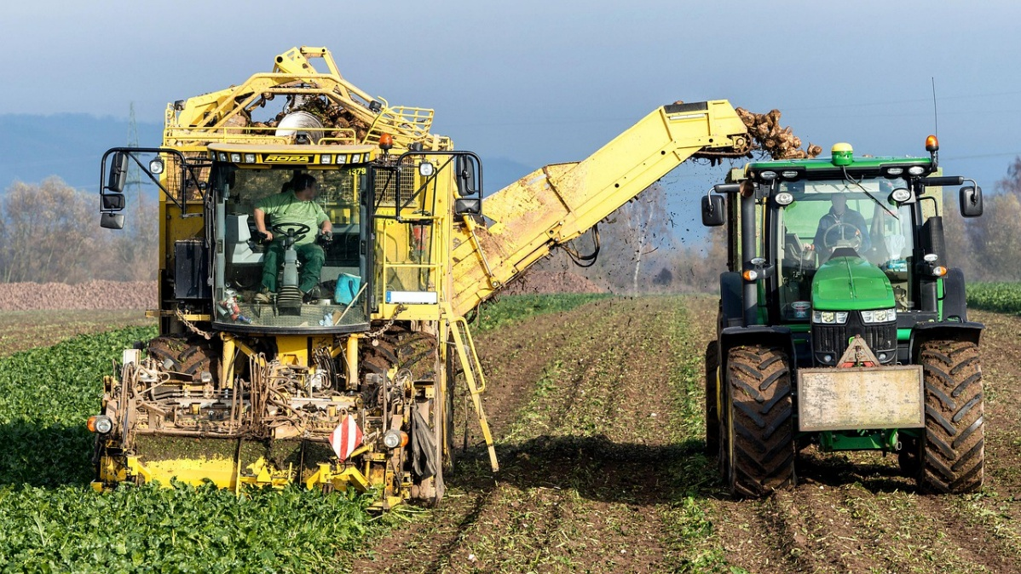
For crop harvesting, simple hand tools are still widely used, especially on small-scale and mixed farms. These include knives, sickles, slashers, pruning shears, secateurs, spades, forks, hoes, and hand trowels. Knives are useful for harvesting vegetables such as cabbage, lettuce, spinach, and other leafy crops where clean cutting is needed. Sickles are commonly used for cutting grain crops, grasses, and fodder. Secateurs and pruning shears are important for harvesting fruit, vegetables, and horticultural crops because they allow careful cutting without damaging stems, branches, or fruit. Spades and forks are useful when lifting root crops such as potatoes, carrots, onions, and beetroot from the soil. These hand tools are affordable and suitable where crops are harvested carefully by hand, but they must be kept sharp, clean, and in good repair to work effectively.
Harvesting containers are also an important part of harvesting equipment. These include baskets, buckets, crates, bins, sacks, wheelbarrows, and field trailers. Their role is to hold and move produce from the field to the collection point, storage area, or transport vehicle. Clean crates and baskets are particularly important for fresh produce because they reduce bruising and allow good airflow. Buckets may be used for fruits, vegetables, eggs, or milk collection, but they must be food-safe and easy to clean. Sacks are often used for grain, potatoes, onions, and other bulk produce, although they must not be overfilled because this can damage the product. Wheelbarrows and small trailers reduce the physical burden on workers and improve efficiency, especially on larger fields. The farmer must choose containers that protect the product rather than damage it during handling.
On larger farms or where labour is limited, mechanical harvesting equipment becomes more important. Mechanical equipment includes reapers, mowers, diggers, threshers, shellers, balers, forage choppers, and combine harvesters. Reapers and mowers are used for cutting grain crops, pasture, or fodder. Potato diggers and similar machines help lift root crops from the soil more quickly than hand tools. Threshers separate grain from stalks and husks, while shellers remove maize kernels from cobs. Balers are used to compress hay or straw into manageable bales for storage or sale. Forage choppers are used to cut green fodder for feeding or silage making. Combine harvesters perform several operations at once, such as cutting, threshing, and cleaning grain crops like wheat, maize, and sorghum. These machines save time and labour, but they are expensive and require maintenance, fuel, skilled operation, and suitable field conditions.
Specialised equipment is often needed for delicate or high-value crops. Fruit harvesting may require ladders, picking bags, clippers, orchard bins, and padded containers. Ladders must be stable and safe to use when harvesting fruit from trees such as mangoes, citrus, avocados, and peaches. Picking bags allow workers to collect fruit carefully while keeping both hands free. Clippers help remove fruit without tearing the stem or bruising the product. Padded containers and orchard bins reduce impact damage during transport from the tree to the packing area. For vegetables such as tomatoes, peppers, and beans, shallow crates are often better than deep sacks because they prevent crushing. This kind of specialised equipment helps preserve appearance and quality, which is important for formal markets and export channels.
Equipment used after harvesting is also part of the harvesting system because it supports immediate handling and quality preservation. This includes tarpaulins, sorting tables, grading screens, washing tanks, drying racks, moisture meters, weighing scales, and packing tools. Tarpaulins provide a clean surface for placing grain, pods, or produce during collection and drying. Sorting tables help workers remove damaged or poor-quality produce before packing. Grading screens assist in separating produce by size. Washing tanks are used for crops that need cleaning before sale, such as root vegetables. Drying racks are useful for grains, herbs, and some fruits that need moisture reduction. Moisture meters are especially important for grains because they help determine whether the crop is dry enough for safe storage. Weighing scales help with packaging, sales, and recordkeeping. These tools improve market readiness and reduce post-harvest losses.
For livestock farming, harvesting tools and equipment are linked to the collection of products such as milk, eggs, wool, meat animals, hides, and manure. In dairy production, equipment includes milking machines, milk cans, buckets, filters, storage tanks, and cleaning materials. On small farms, milk may be collected by hand milking into clean buckets or cans, while larger farms may use mechanical milking machines. Milking equipment must be sanitised properly to prevent contamination and spoilage. Filters are used to remove visible dirt from milk before cooling and storage. Milk cans and tanks must be made of suitable food-grade material and kept cool to preserve quality. The quality of milking equipment directly affects milk hygiene and marketability.
In poultry production, egg trays, collection baskets, nesting boxes, and cleaning equipment are necessary for efficient egg harvesting. Eggs must be collected carefully and regularly to reduce breakage and contamination. Egg trays help keep eggs secure during storage and transport, while clean nesting boxes reduce dirt and cracks. For broiler or meat bird harvesting, catching crates and transport cages are used to move birds safely and with minimal stress. Proper equipment helps prevent injury to the birds and preserves meat quality. The same principle applies in livestock transport for cattle, sheep, and goats, where loading ramps, handling pens, crushes, and transport vehicles are essential equipment for moving animals safely and humanely.
For sheep farming, wool harvesting requires shearing equipment such as hand shears, electric clippers, shearing combs, cutters, wool tables, and wool packs. Hand shears may still be used on small flocks, but electric clippers are faster and more efficient on larger operations. Shearing equipment must be sharp and well maintained to avoid injuring the animal or damaging the fleece. After shearing, wool tables help sort and class the fleece, while wool packs are used for baling and transport. In livestock enterprises generally, weighing scales, branding equipment, identification tags, and treatment tools also support market readiness because they help farmers prepare animals for sale according to buyer specifications.
Safety equipment is a very important part of harvesting tools and equipment. Farmers and workers need gloves, boots, overalls, hats, masks, and sometimes eye protection when harvesting crops or handling livestock products. Gloves protect hands from cuts, chemicals, thorns, and contamination. Boots reduce the risk of slipping, puncture wounds, or snake bites in the field. Overalls and aprons help maintain hygiene, especially in milk or meat handling. Hats protect workers from the sun, which is important under South African conditions. Where dust is generated during grain harvesting or feed handling, masks help protect workers’ breathing. Safe use of harvesting equipment reduces accidents and protects both the worker and the product.
Maintenance of harvesting tools and equipment is essential for efficiency and long-term cost savings. Hand tools must be sharpened, cleaned, dried, and stored properly after use. Rusted, blunt, or broken tools can damage produce and injure workers. Mechanical harvesters and other machines need regular servicing, lubrication, replacement of worn parts, and correct adjustment before use. Milking machines and egg handling equipment must be cleaned and sanitised thoroughly. Poorly maintained equipment leads to breakdowns, delays, losses, and poor-quality produce. Therefore, maintenance should be planned as part of farm management and not only done when something goes wrong.
The farmer must also match harvesting equipment to the scale and purpose of production. A small mixed farmer producing vegetables, eggs, milk, and some grain for local sale may rely mainly on hand tools, simple containers, basic weighing scales, and small processing or storage equipment. A larger commercial farmer supplying supermarkets or processors may require tractors, trailers, combine harvesters, balers, milk cooling tanks, shearing machines, and other advanced equipment. The correct choice depends on cost, expected returns, labour savings, and product quality needs. The farmer should avoid buying expensive machinery that cannot be maintained or fully used, but should also avoid using poor equipment that increases losses and limits production.
Tools and equipment for harvesting include all the hand tools, containers, machines, handling devices, and protective items used to remove, collect, transport, clean, and prepare crops and livestock products for storage or sale. On a mixed crop and livestock farm in South Africa, these tools range from simple knives, sickles, buckets, and crates to advanced machinery such as threshers, balers, milking machines, and shearing clippers. Their importance lies in improving efficiency, reducing losses, protecting quality, ensuring hygiene, and supporting market readiness. A successful farmer must know not only which tools to use, but also how to use, clean, maintain, and store them properly so that harvesting becomes productive, safe, and profitable.

KT0104 Practices for safe post-harvesting handling
Safe post-harvesting handling refers to all the actions taken after crops have been harvested or livestock products have been collected in order to preserve quality, prevent contamination, reduce losses, and protect the health of workers and consumers. For a mixed crop and livestock farmer in South Africa, safe post-harvesting handling is extremely important because farm products are often vulnerable to bruising, spoilage, pests, dirt, bacteria, and poor storage conditions once they leave the field or the animal. Good post-harvest handling ensures that produce remains fresh, clean, marketable, and suitable for human consumption or further processing. It also strengthens the farmer’s ability to meet market standards, reduce waste, and maintain a good reputation with buyers.
One of the first safe practices in post-harvest handling is harvesting products at the correct maturity stage and handling them gently from the very beginning. Produce that is harvested too early or too late is more likely to deteriorate quickly or become damaged during storage and transport. Once harvested, crops such as fruits, vegetables, roots, grains, and legumes must be handled carefully to avoid cuts, bruises, cracking, crushing, or unnecessary exposure to heat. Bruised or damaged produce deteriorates faster and becomes more susceptible to fungal or bacterial infection. Livestock products such as milk and eggs are also highly sensitive and must be collected carefully to prevent contamination and spoilage. Gentle handling is therefore the foundation of safe post-harvest practice.
Cleanliness is one of the most important requirements in safe post-harvesting handling. All tools, harvesting containers, storage rooms, transport vehicles, working surfaces, and equipment must be kept clean before and after use. Dirty crates, buckets, knives, milk cans, egg trays, or sorting tables can spread soil, germs, mould, and chemical residues onto fresh products. Farmers and workers should wash their hands regularly, especially before handling food products such as vegetables, milk, eggs, and meat-related items. Protective clothing such as clean overalls, gloves, gumboots, aprons, and head coverings may also be necessary depending on the type of product being handled. In livestock product handling, hygiene is particularly critical because milk, eggs, and meat products can carry harmful bacteria if handled carelessly. Good sanitation protects both product quality and consumer health.
Another important practice is sorting and grading products immediately after harvest or collection. Sorting means removing damaged, diseased, undersized, rotten, or contaminated products from the good-quality produce. Grading means separating the good products according to size, colour, weight, ripeness, or quality class. This process is important because poor-quality items can affect the rest of the batch during storage or transport. For example, one rotten tomato or damaged fruit in a crate can spread decay to surrounding produce. In eggs, cracked eggs should be removed from the sound eggs, and in milk, any milk from sick animals should be kept separate and not mixed with healthy milk. Sorting and grading improve safety, shelf life, uniformity, and buyer confidence.
Temperature control is a key part of safe post-harvest handling, especially for perishable products. Many fresh vegetables, fruits, milk, meat, and eggs deteriorate quickly if exposed to high temperatures for long periods. In South Africa’s warm climate, farmers should remove harvested produce from direct sunlight as soon as possible and place it in a cool, shaded, and well-ventilated area. Produce should not be left in the field longer than necessary. Milk must be cooled promptly after milking because warm milk supports rapid bacterial growth. Meat products and dressed poultry require cold storage to remain safe. Even eggs last better when kept in clean, cool conditions. Temperature management slows spoilage, preserves freshness, and supports food safety.
Safe washing and cleaning of produce is another important post-harvest practice. Some vegetables, roots, and fruits need washing to remove soil, dust, and plant debris before sale. However, the water used must be clean and safe, because dirty water can spread contamination instead of removing it. Washing areas and tanks should be cleaned regularly, and produce should not be soaked in stagnant or contaminated water. In some cases, washing is followed by drying so that excess moisture does not encourage fungal growth during storage. Crops that are not meant to be washed immediately, such as onions or some grains, should instead be brushed or dried according to best handling practice. The method chosen must suit the product and the intended market.
Proper packaging is another essential safety practice. Packaging should protect the product from injury, contamination, moisture loss, and excessive pressure during storage and transport. Strong, clean, and appropriate containers must be used. Fruits and vegetables are often packed in crates, cartons, punnets, or baskets that allow ventilation and reduce crushing. Grain may be packed in clean bags or bulk containers that protect it from moisture and pests. Eggs need special trays or cartons that prevent breakage. Milk should be stored in food-grade containers with secure lids. Packaging should never introduce contamination, and reused packaging must be cleaned thoroughly before use. Good packaging also improves presentation and supports market standards.
Storage practices play a major role in post-harvest safety. Different products require different storage conditions. Grains and legumes should be dried to safe moisture levels before storage to prevent mould growth, insect attack, and the development of toxins. Fruits and vegetables should be stored in clean, cool, and ventilated spaces to slow deterioration. Root crops such as potatoes and onions require dry and suitable storage to prevent sprouting and rot. Milk and meat products require cold storage and must not be kept at unsafe temperatures. Storage rooms should be protected against rodents, insects, birds, water leaks, and dirt. Storing products off the ground and away from walls can also reduce pest infestation and improve airflow. Safe storage helps maintain quality and extends shelf life.
Pest and disease control in storage and handling areas is also critical. Once products have been harvested, they remain vulnerable to infestation by insects, rodents, birds, and microorganisms. Storage structures must therefore be inspected regularly and kept clean and sealed as far as possible. Grain stores should be monitored for weevils and other pests. Fresh produce rooms must be kept tidy so that waste or rotten produce does not attract flies or rodents. In livestock product areas, hygiene and cleaning routines are essential to prevent bacterial contamination. Any chemicals used for pest control must be handled carefully and kept away from harvested produce and food-contact surfaces. Safe pest management protects both the product and the people who consume it.
Safe handling also includes careful transport from the farm to storage points, packhouses, markets, processors, or collection centres. Products should be loaded and transported in a way that prevents bruising, crushing, contamination, and overheating. Overloading bags, crates, or vehicles can damage produce. Perishable products should be moved quickly and, where necessary, under cool or refrigerated conditions. Vehicles used for transport should be clean and should not carry chemicals, animals, manure, fuel, or dirty materials together with food products. Eggs, milk, fresh vegetables, and fruit all require extra care during transport. In livestock marketing, animals must also be handled humanely during loading and transport to reduce stress, injury, and poor meat quality.
Worker safety is part of safe post-harvest handling as well. Workers involved in sorting, packing, storing, lifting, and transporting products must be trained in safe handling methods. They should know how to use knives, crates, machinery, and cleaning agents correctly. They must be protected from injuries caused by heavy lifting, slips, cuts, dust, sharp tools, or exposure to chemicals. In dairy or meat-related handling, workers also need to understand hygiene standards and disease prevention. Safe working conditions improve productivity and reduce mistakes that may damage products. A responsible farmer therefore protects both the product and the people handling it.
Recordkeeping and traceability also contribute to safe post-harvest handling. Farmers should keep records of harvest dates, batch quantities, storage conditions, treatments used, cleaning schedules, transport details, and any quality problems observed. In livestock products, records of animal health treatments, milking hygiene, egg production, and storage times are especially useful. These records help the farmer monitor quality, identify problems, and show buyers that the products were handled responsibly. Traceability is increasingly important in formal markets because it improves food safety and accountability.
Another good practice is separating different categories of products to avoid contamination. Chemicals, fertilisers, pesticides, animal feeds, fuel, and veterinary medicines must never be stored or transported together with harvested crops or livestock products intended for consumption. Fresh produce should also be kept separate from rotten or rejected products. In a mixed farming system, manure, live animals, and feed should not contaminate harvested crops, milk, or eggs. This separation is especially important on small farms where different activities happen close together. Clear organisation of storage and work areas helps prevent accidental contamination.
For livestock products, safe post-harvest handling must focus strongly on hygiene and spoilage prevention. Milk should be collected from healthy animals using clean equipment, filtered if necessary, and cooled immediately. Eggs should be collected frequently, handled with clean hands, and stored in clean trays away from strong smells, dirt, and direct sunlight. Meat products should only be processed under hygienic and regulated conditions. Wool should be kept clean and dry after shearing, while hides and skins should be salted or preserved properly if they are to be marketed. Manure intended for compost or fertiliser should be handled separately from food products to avoid contamination risks. Each livestock product therefore has its own safety requirements.
Practices for safe post-harvesting handling include cleanliness, gentle handling, sorting, grading, temperature control, proper washing, suitable packaging, safe storage, pest control, clean transport, worker protection, traceability, and prevention of contamination. For a mixed crop and livestock farmer in South Africa, these practices are necessary to preserve quality, reduce losses, protect consumer health, and improve market readiness. Safe post-harvest handling is not just about keeping products looking good; it is about ensuring that the food and other farm products remain safe, hygienic, and valuable from the time of harvest until they reach the buyer or processor. When these practices are followed carefully, the farmer strengthens both the profitability and sustainability of the farming business.

Internal Assessment Criteria (IAC) and Weight
- IAC0101 Explain the factors influencing the timing of harvest and their impact on crop quality and yield.

The timing of harvest is one of the most important decisions a farmer makes because it directly affects both the quality and the quantity of the product. In crop production, harvesting too early usually results in produce that is immature, underdeveloped, low in weight, poor in taste, and less attractive to buyers. For example, maize harvested before full maturity may have a high moisture content, making it difficult to store safely and increasing the risk of mould. Fruit harvested too early may fail to develop proper sweetness, colour, and flavour, while vegetables may be too small or tender for the intended market. On the other hand, harvesting too late can also cause serious losses. Grains may shatter or lodge, fruits may become overripe and bruise easily, and vegetables may become fibrous, oversized, or unmarketable. Correct timing therefore helps the farmer obtain the best marketable yield while preserving product quality.
One major factor influencing harvest timing is the physiological maturity of the crop. This is the stage at which the plant has completed its growth and the harvested part has reached its full development. Different crops have different maturity indicators. In grain crops, maturity may be shown by hard kernels and dry plant material. In fruit crops, maturity may be indicated by colour change, firmness, sugar content, or aroma. In root crops, maturity may be observed through root size and skin development. Harvesting at physiological maturity usually provides the highest yield potential and ensures the product can withstand handling, storage, and transport. For livestock feed crops such as lucerne, sorghum, or maize silage, the correct harvesting stage also determines nutritional quality, digestibility, and storage performance.
Weather and climate conditions also strongly influence the timing of harvest. In South Africa, rainfall patterns, temperature, humidity, and wind conditions can either support or disrupt harvesting plans. If rain is expected, farmers often harvest mature crops quickly to avoid spoilage, fungal infection, sprouting, or field losses. Dry weather is especially important for harvesting grain, hay, and other products that must be stored with low moisture levels. Very hot weather can reduce the quality of fruits and vegetables by causing wilting, sunburn, or rapid moisture loss after harvest. Wind can cause grain shattering or fruit drop, while frost may damage crops if harvesting is delayed. Farmers must therefore monitor weather conditions carefully and plan harvest activities to reduce quality loss and protect yield.

- IAC0102 Describe techniques for determining crop maturity.

Determining crop maturity is a practical skill that helps the farmer decide the correct time to harvest. Crop maturity means that the harvested part of the plant has reached the stage where it provides the best balance between quality, yield, and market suitability. Farmers use a combination of visual observation, physical testing, moisture assessment, time records, and simple measurements to judge maturity. Because different crops mature in different ways, no single method is suitable for all products. A mixed crop farmer in South Africa must therefore understand the maturity indicators for grain crops, vegetables, fruits, fodder crops, and root crops grown on the farm.
One common technique is visual assessment of colour change. Many crops show clear colour changes as they mature. For example, maize cobs may be ready when husks turn brown and dry, tomatoes change from green to red or yellow depending on the variety, bananas lose their angular shape and become fuller, and many fruits develop their final skin colour. Dry beans and peas also show maturity when pods dry and change colour. Colour is a simple and useful guide, but it must be interpreted carefully because some crops may change colour before they are fully mature, and environmental conditions can affect how colour develops.
Another technique is checking the size and shape of the harvested part. Mature vegetables, fruits, tubers, and grains often reach a standard size, fullness, or form. For example, cabbages become firm and compact, pumpkins reach their expected size and develop hard skins, and onions are often ready when bulbs are well formed and tops begin to fall over. In root crops such as carrots, beetroot, and potatoes, the size of the root or tuber is an important maturity sign, especially when linked to market requirements. However, size alone is not always enough because some oversized produce may already be past its best market stage.

- IAC0103 Describe the tools and equipment used for harvesting.

Harvesting requires the right combination of manual tools and mechanized equipment depending on the type of crop, scale of production, and farm resources.
a) Manual Tools:
- Sickles and knives: Used for cutting cereals, grasses, and small-scale vegetable crops. They are inexpensive and suitable for small plots or uneven terrain.
- Pruning shears: Ideal for fruits like grapes, apples, and citrus, allowing careful cutting to avoid damaging the plant and improve future yields.
- Harvest baskets and crates: Facilitate the collection of harvested crops like vegetables and fruits, reducing bruising or damage during transport to storage areas.
b) Mechanized Equipment:
- Combine harvesters: Efficiently harvest cereals such as maize, wheat, and barley by cutting, threshing, and cleaning grain in a single operation.
- Forage harvesters and mowers: Used for hay and silage production, cutting and chopping grasses at the optimal stage to maintain nutritional value for livestock.
- Balers: Compact forage into bales for easy handling and storage.
- Tractors and trailers: Transport harvested crops from the field to storage or processing areas, reducing labour and time.
c) Post-Harvest Equipment:
- Moisture meters: Ensure crops are dried to safe levels before storage, preventing mould or spoilage.
- Dryers and ventilated storage bins: Particularly important for grains and seeds to maintain quality during storage.
- Cold storage or refrigeration units: Essential for perishable crops like fruits, vegetables, and livestock products such as milk and eggs.

- IAC0104 Explain safety measures for harvesting.

Safety during harvesting is critical to protect workers, livestock, and equipment. Key measures include:
a) Personal Safety:
- Personal Protective Equipment (PPE): Workers should wear gloves, boots, hats, eye protection, and clothing appropriate for sun exposure and chemical residues.
- Training: Staff must be trained to handle sharp tools, machinery, and livestock safely.
b) Machinery Safety:
- Regular maintenance: Harvesting machines should be inspected and serviced to prevent malfunctions or accidents.
- Operation protocols: Only trained personnel should operate tractors, balers, or combine harvesters.
- Emergency procedures: Clear instructions on stopping machines and responding to injuries or entanglements should be in place.
c) Crop and Livestock Safety:
- Animal handling: Ensure safe distances when harvesting near livestock to prevent injuries from startled animals.
- Chemical safety: If pesticides or fertilizers were applied before harvest, ensure re-entry periods are observed, and workers are aware of residue risks.
d) Environmental Considerations:
- Ergonomics: Rotate workers during manual harvesting to reduce fatigue and musculoskeletal injuries.
- Weather precautions: Avoid harvesting during extreme heat or storms to prevent heat stress, accidents, or crop damage.

KM-04-KT02 Concepts and importance of post-harvest handling 25%
Topic element
- KT0201 Principles of post-harvest handling
- KT0202 Techniques for cleaning and sanitizing harvesting equipment and facilities
- KT0203 Methods for sorting and grading crops, such as appearance, shape, size, colour, and weight.
- KT0204 Storage conditions for different crops, such as temperature, humidity, and ventilation
- KT0205 Transportation methods for different crops, such as refrigerated trucks, containers, and air freight
- KT0206 Quality control measures for post-harvest handling

KM-04-KT02 Concepts and importance of post-harvest handling
Post-harvest handling refers to all the activities that take place after crops are harvested or livestock products are collected, up to the point where they are stored, processed, transported, marketed, or consumed. For a mixed crop and livestock farmer in South Africa, post-harvest handling includes cleaning, sorting, grading, packing, cooling, drying, storing, transporting, and sometimes processing products such as grain, vegetables, fruit, milk, eggs, wool, and meat animals. These activities are important because the quality of farm produce can decline very quickly after harvest if it is not handled correctly. Good post-harvest handling protects the value of what has been produced and helps ensure that the product remains safe, attractive, and suitable for the intended market.
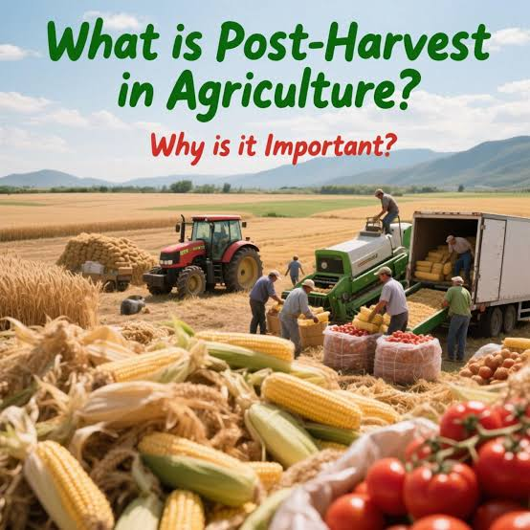
The concept of post-harvest handling is based on the understanding that harvesting is not the end of production. Once produce is removed from the field or collected from animals, it remains alive or highly sensitive for some time and continues to undergo physical, chemical, and biological changes. Fruits and vegetables continue to respire, lose moisture, ripen, and age. Grain can absorb moisture and become vulnerable to mould or insect infestation. Milk can spoil quickly if not cooled. Eggs can crack or become contaminated. Livestock transported to market can lose weight or suffer stress. This means that farmers must manage products carefully after harvest in order to slow deterioration and maintain quality. Post-harvest handling is therefore a continuation of production management, not a separate or optional activity.
One of the main concepts in post-harvest handling is quality preservation. Quality includes factors such as freshness, cleanliness, size, colour, taste, texture, nutritional value, shelf life, and freedom from damage or contamination. Buyers and consumers judge products according to these characteristics, and poor handling can destroy quality even when production in the field was excellent. For example, tomatoes that are bruised during harvesting or transport may rot quickly. Grain that is stored while still too wet may develop mould. Milk collected in dirty containers may be rejected due to hygiene concerns. Eggs that are stacked carelessly may crack before reaching the market. Post-harvest handling is therefore essential because it protects the physical and market quality of farm products.
Another important concept is loss prevention. Post-harvest losses occur when products are damaged, spoiled, spilled, eaten by pests, contaminated, or downgraded before they are sold or used. These losses reduce the amount of product available for sale and lower farm income. In South Africa, post-harvest losses can be significant, especially where farmers face challenges such as poor storage facilities, limited cold chain access, rough transport, high temperatures, pest infestation, and limited market infrastructure. On a mixed farm, losses may occur in both crop and livestock products. Vegetables may wilt or rot, grain may be attacked by insects, milk may sour, and eggs may break. Effective post-harvest handling reduces these losses and helps the farmer keep more of what has already been produced.
Food safety is also a central concept in post-harvest handling. Farm products intended for human consumption must remain safe and hygienic from the point of harvest to the point of sale or processing. Contamination can occur through dirty hands, unclean tools, unsafe water, animal waste, chemical residues, pests, or poor storage conditions. For a mixed crop and livestock farmer, this is especially important because crop and livestock enterprises operate close together, increasing the risk of cross-contamination if care is not taken. Safe post-harvest handling includes cleaning equipment, using hygienic containers, separating food products from chemicals and manure, controlling pests, and keeping perishable products cool. These actions protect consumer health and help the farmer comply with market requirements.
The concept of value retention is closely linked to the importance of post-harvest handling. Farmers invest time, labour, water, feed, land, and money into production. If the harvested product is mishandled, much of that investment can be lost. Post-harvest handling protects the economic value of produce by keeping it in a condition that attracts buyers and earns good prices. A well-graded crate of clean vegetables, a bag of dry grain free from pests, a can of clean cooled milk, or a tray of unbroken eggs has much greater market value than poorly handled products. This means that good post-harvest handling is not only a technical activity but also a business strategy for increasing profitability.
Post-harvest handling is important because it supports market readiness. Different buyers have different requirements regarding size, weight, cleanliness, packaging, grading, and delivery condition. Formal markets such as supermarkets, fresh produce markets, processors, hotels, and export channels often require strict standards. Informal markets may be less strict, but quality still matters because customers prefer fresh, attractive, and clean products. Through sorting, grading, packaging, cooling, and safe transport, the farmer prepares products to meet these standards. Without proper post-harvest handling, even good products may be rejected or sold at lower prices. Thus, post-harvest handling is essential for accessing better and more reliable markets.
Another major importance of post-harvest handling is shelf-life extension. Shelf life is the period during which a product remains suitable for sale or consumption. Crops such as leafy vegetables, tomatoes, berries, and fresh fruit can deteriorate quickly if not cooled and handled carefully. Milk spoils rapidly in warm conditions. Meat products require strict temperature control. Grain and legumes can last much longer, but only if properly dried and stored. Good post-harvest handling slows spoilage and allows farmers more time to store, transport, and market their products. This is particularly valuable in South Africa, where farmers may be located far from markets or may need to wait for better selling opportunities.
Proper post-harvest handling also improves food security. Food that is lost after harvest cannot be consumed, sold, or used productively. Reducing post-harvest losses means that more food remains available for households, local communities, and markets. For mixed farmers who produce both crops and livestock products, this can make an important contribution to farm family nutrition and income. Grain stored safely can feed both people and animals. Milk handled correctly remains safe for home use or sale. Surplus vegetables can be stored, dried, or sold before they spoil. By managing products properly after harvest, farmers help ensure that the food they produce continues to provide value and nourishment.
The importance of post-harvest handling is also seen in its relationship with value addition. Before products are processed or transformed, they must first be handled safely and correctly. Cleaning, drying, sorting, cooling, and proper storage are often the first steps before value addition such as milling, juicing, preserving, yoghurt making, cheese production, meat processing, or packaging. Poor post-harvest handling reduces the quality of raw materials and limits the farmer’s ability to add value successfully. Good post-harvest handling therefore forms the foundation for profitable processing and improved product presentation.
Labour efficiency and management are also linked to post-harvest handling. Well-organised handling systems save time, reduce unnecessary movement, and improve coordination between harvesting, storage, transport, and marketing. For example, having clean crates ready, shaded collection points prepared, and sorting areas organised helps workers perform tasks faster and more effectively. On livestock enterprises, regular milk collection, clean egg handling, and orderly loading of animals improve workflow and reduce stress. When post-harvest handling is poorly organised, farmers often face confusion, delays, product damage, and higher labour costs. Therefore, good handling systems improve both quality and operational efficiency.
Another important concept is traceability and accountability. Modern agricultural markets increasingly require farmers to show where products came from, when they were harvested, how they were handled, and whether they meet hygiene and safety standards. Post-harvest records help farmers track batches, storage conditions, grading results, transport details, and product movement. This is particularly important for formal and high-value markets. Traceability helps identify problems quickly, builds trust with buyers, and supports compliance with regulations. It also helps the farmer assess which products, methods, or markets are most profitable.
In mixed farming systems, post-harvest handling is important because it links crop and livestock enterprises in practical ways. Some harvested crops may be stored for human consumption, while by-products and residues may be used as animal feed. Livestock manure may later support crop production, but it must be managed separately from food products to avoid contamination. This means the farmer must organise handling areas carefully and maintain hygiene between different enterprises. Effective post-harvest handling helps the whole farm function more efficiently and safely.
Post-harvest handling is also important from a sustainability perspective. Reducing spoilage, contamination, and waste means that fewer resources are lost. Every kilogram of produce or litre of milk that is spoiled represents wasted land, water, feed, labour, and energy. Safe storage, proper packaging, careful transport, and value-preserving practices make farming more efficient and environmentally responsible. On a mixed farm, this contributes to long-term sustainability and resilience.
The concepts of post-harvest handling include quality preservation, loss prevention, food safety, value retention, shelf-life extension, market readiness, labour efficiency, traceability, and sustainability. Its importance lies in protecting farm produce after harvest so that it remains safe, marketable, and profitable. For a mixed crop and livestock farmer in South Africa, post-harvest handling is essential because it ensures that the value created during production is not lost between harvest and sale. Good post-harvest handling reduces waste, improves product quality, supports compliance with market standards, and strengthens the overall success of the farming business.

KT0201 Principles of post-harvest handling
The principles of post-harvest handling are the basic rules and practices that guide how crops and livestock products should be managed after harvesting or collection so that their quality, safety, and market value are preserved. For a mixed crop and livestock farmer in South Africa, these principles are very important because once products are removed from the field or collected from animals, they immediately become vulnerable to deterioration, contamination, weight loss, physical damage, spoilage, and pest attack. Post-harvest handling must therefore be done with care, speed, cleanliness, and proper organisation. These principles apply to a wide range of farm products, including grain, vegetables, fruit, milk, eggs, meat animals, wool, and fodder.
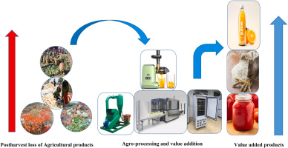
One of the main principles of post-harvest handling is harvesting or collecting the product at the correct stage of maturity or readiness. Products that are harvested too early may be underdeveloped, have poor flavour, low weight, and low market value. Products harvested too late may be overripe, fibrous, too dry, or more likely to suffer damage and spoilage. In livestock, products such as milk and eggs must be collected at the right time and under proper hygienic conditions, while animals intended for sale must be marketed at the right weight and condition. This principle is important because correct timing is the starting point for maintaining product quality after harvest.
Another key principle is gentle handling. Harvested crops and livestock products should be handled in a manner that prevents bruising, cracking, puncturing, crushing, contamination, or stress. Fruits and vegetables are especially sensitive to rough handling, and even small injuries can shorten shelf life and reduce market value. Eggs can crack easily, milk can become contaminated, and live animals can lose weight or suffer injury if handled roughly. Workers should therefore use suitable tools, clean containers, and careful lifting and loading techniques. Gentle handling preserves the physical condition of products and helps reduce losses.
Cleanliness and hygiene are also central principles of post-harvest handling. All tools, equipment, containers, hands, clothing, storage facilities, and transport vehicles must be kept clean. This is because dirt, bacteria, fungi, pests, and chemical residues can easily contaminate harvested products. For a mixed crop and livestock farmer, hygiene is especially important because crops, livestock, manure, chemicals, and machinery may all be present in the same farm environment. Milk must be handled in sanitised containers, eggs must be collected from clean nesting areas, and fresh produce must not be packed in dirty crates or washed with unsafe water. Clean handling protects food safety and improves market acceptance.
The principle of rapid removal from harmful conditions is very important after harvest. Once products are harvested, they should be removed quickly from conditions that increase deterioration, such as direct sunlight, heat, excess moisture, rain, or dirty surroundings. Fresh vegetables and fruits can wilt, lose water, and heat up if left in the field too long. Milk spoils quickly in warm temperatures, and grain can be damaged if harvested material is left exposed to rain or dampness. This means that products should be moved promptly to shade, cooling areas, drying surfaces, storage structures, or packing stations. Quick action after harvest slows quality loss and protects value.
Sorting and grading are another important principle of post-harvest handling. Sorting involves removing damaged, diseased, rotten, immature, or contaminated products from good-quality products. Grading involves grouping products according to size, colour, weight, quality, or market class. These steps are necessary because poor-quality products can lower the value of the entire batch and may cause further spoilage during storage or transport. For example, one spoiled fruit can spread rot to others, and cracked eggs can contaminate surrounding eggs. Sorting and grading improve uniformity, buyer confidence, and market readiness. They also make it easier to direct products to the most appropriate markets.
The principle of moisture control is particularly important in post-harvest handling. Different products require different moisture conditions to remain safe and marketable. Grain, pulses, and some seeds must be dried to safe moisture levels before storage to prevent mould growth, heating, and insect infestation. Fresh fruits and vegetables, on the other hand, need to retain enough moisture to avoid shrivelling and wilting, but they should not be stored under excessively wet conditions that encourage rot. In livestock products, moisture control is also relevant because milk containers must be dry and clean externally, and wool should be kept dry after shearing. Good moisture management protects product quality and prevents losses.
Temperature management is another major principle. High temperatures increase respiration, ripening, wilting, and spoilage in crops, and they encourage bacterial growth in livestock products such as milk and meat. Farmers should therefore keep perishable products cool and out of direct sun as soon as possible after harvest or collection. Cooling milk immediately after milking is one of the most important dairy handling principles. Fresh produce should be stored in shaded, ventilated, or cooled areas depending on the commodity. Meat products require strict cold chain control. Proper temperature management extends shelf life, preserves freshness, and supports food safety.
Safe and suitable packaging is also a principle of post-harvest handling. Packaging materials and containers should protect products from damage, contamination, and excessive pressure during handling, storage, and transport. Packaging should also suit the type of product being packed. For example, eggs need trays or cartons, vegetables often need ventilated crates, grain requires clean dry bags, and milk must be stored in food-grade containers with lids. Packaging should not introduce contamination, and reused containers must be cleaned properly before use. Good packaging helps maintain quality and makes products easier to transport and market.
Proper storage is another key principle. Storage conditions must match the needs of the product. Grain and dry produce require clean, dry, pest-free storage areas. Fresh fruits and vegetables often require cool, well-ventilated spaces. Milk and meat products need chilled storage. Wool should be stored dry and clean, and eggs should be stored in cool, safe conditions. Storage structures should protect products from rain, rodents, insects, birds, mould, and theft. Products should also be stored in an orderly way, often off the ground and away from walls, to improve airflow and inspection. Good storage reduces spoilage and allows the farmer more flexibility in marketing.
The principle of pest and contamination control is also very important. Post-harvest products are attractive to insects, rodents, birds, and microorganisms. At the same time, products may be contaminated by chemicals, fuel, dust, manure, dirty water, or animal waste if handling areas are not organised properly. A mixed farmer must therefore separate food products from chemicals, veterinary medicines, manure, and machinery oils. Storage and packing areas should be monitored regularly for pest problems, and waste should be removed promptly. This principle is essential for both food safety and quality preservation.
Efficient transport and movement of products form another principle of post-harvest handling. Products should be transported in clean vehicles and moved carefully to avoid damage, spillage, overheating, and delay. Overloading bags, sacks, or crates can cause crushing and bruising. Perishable goods should be delivered quickly, and where necessary, transported under cool or refrigerated conditions. Livestock should be loaded and transported humanely to reduce stress and injury. Good transport practice ensures that the quality preserved during harvesting and storage is not lost before the product reaches the market.
Recordkeeping and traceability are also important principles in modern post-harvest handling. Farmers should keep records of harvest dates, quantities, quality grades, storage conditions, cleaning schedules, treatments used, and marketing details. For livestock products, records of animal health, milk handling, egg collection, and transport can also be very important. These records help the farmer identify sources of loss, improve management, comply with buyer requirements, and provide proof of responsible handling. Traceability is increasingly necessary for access to formal and high-value markets.
Worker safety and training are also part of post-harvest handling principles. Workers need to understand how to handle products hygienically, use tools correctly, lift and pack safely, and follow farm procedures. They should wear suitable protective clothing where necessary and know how to avoid contamination. Training reduces errors, improves efficiency, and protects both workers and products. On a mixed farm, this is particularly important because different products require different handling methods and hygiene standards.
Another principle is value preservation through timely decision-making. Farmers should know when to store, when to process, when to transport, and when to sell. Delays or poor decisions after harvest can cause products to lose quality and value. Some products need immediate sale, while others can be stored or value-added first. For example, surplus tomatoes may be processed into sauce, milk may be turned into cultured products, and grain may be dried and stored for later sale. Good post-harvest handling includes making practical decisions that protect quality and maximise returns.
The principles of post-harvest handling include correct timing, gentle handling, cleanliness, rapid removal from harmful conditions, sorting, grading, moisture control, temperature management, suitable packaging, proper storage, pest control, safe transport, recordkeeping, worker training, and value preservation. For a mixed crop and livestock farmer in South Africa, these principles are essential because they protect the quality, safety, and profitability of farm products after harvest. When followed properly, they reduce losses, maintain product standards, improve market readiness, and ensure that the effort invested in production results in maximum benefit for the farming business.

KT0203 Methods for sorting and grading crops, such as appearance, shape, size, colour, and weight.
Methods for sorting and grading crops are important post-harvest practices that help a mixed crop and livestock farmer in South Africa prepare produce for storage, sale, processing, or transport. Sorting means separating produce according to condition or type, while grading means classifying produce into categories based on specific quality standards such as appearance, shape, size, colour, and weight. These methods are used to improve uniformity, increase market value, reduce post-harvest losses, and meet the requirements of different buyers. When crops are properly sorted and graded, the farmer is better able to market products successfully because buyers prefer produce that is consistent, attractive, and easy to evaluate.
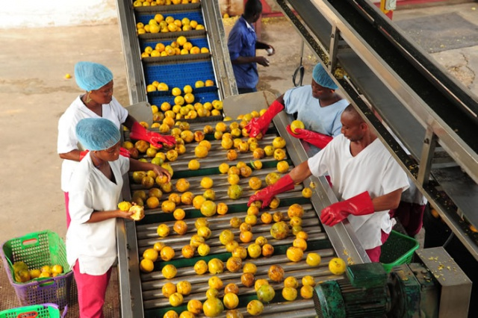
The first method used in sorting crops is visual inspection. This is the most common and basic method, especially on small and medium mixed farms. Workers inspect harvested produce by looking at it carefully and separating healthy, marketable items from damaged, diseased, rotten, overripe, underripe, insect-damaged, cracked, or bruised items. Visual inspection is particularly useful for fruits, vegetables, and fresh produce such as tomatoes, potatoes, onions, cabbage, spinach, citrus, and beans. This method relies on trained workers who can identify defects quickly and accurately. It is an important first step because poor-quality produce should not be mixed with good produce, as it can lower the value of the batch and increase spoilage.
Sorting by appearance is one of the main grading methods used after visual inspection. Appearance includes the overall external quality of the crop, such as cleanliness, freshness, smoothness, freedom from blemishes, and absence of disease or injury. Produce with a fresh and clean appearance is usually more attractive to buyers and consumers. For example, vegetables covered in soil, fruits with cuts or fungal spots, and grain mixed with foreign matter will usually receive lower prices. Farmers therefore sort produce into acceptable and unacceptable groups based on visible appearance. In formal markets, appearance often strongly influences whether produce is accepted, downgraded, or rejected.
Sorting and grading by shape is also important because many buyers want produce that has a regular and uniform form. Crops that are misshapen, twisted, too thin, too curved, or deformed may still be usable, but they are often less desirable in fresh markets. For example, carrots that are forked, cucumbers that are bent, tomatoes that are badly misshapen, or potatoes with unusual growth patterns may be graded into a lower class. Shape grading helps create uniformity in packed produce, which improves market presentation. On a mixed farm, lower-grade produce can still be used for home consumption, livestock feed, informal sale, or processing, so sorting by shape also helps the farmer direct products to the most suitable use.
Size grading is one of the most widely used methods in crop handling. Crops are grouped according to their dimensions, such as length, diameter, or general bulk. This can be done by hand, by using measuring tools, or by using grading screens and sizing equipment. For example, potatoes may be graded into small, medium, and large sizes; onions may be sorted by bulb diameter; and fruits such as oranges or apples may be graded according to size categories required by the buyer. Uniform size is important because it improves packing efficiency, creates a better visual display, and helps buyers estimate value more easily. In some markets, larger produce may receive higher prices, while in others medium-sized and uniform produce may be preferred.
Colour grading is another common method, especially for fruits and vegetables. Colour often indicates freshness, ripeness, maturity, and market appeal. Crops are sorted according to the stage and uniformity of their colour. For example, tomatoes may be separated into green, breaker, pink, and red stages depending on the intended market and transport distance. Citrus fruits may be graded according to skin colour development, while leafy vegetables may be checked for healthy green colour without yellowing. Colour is important because consumers often judge produce quality by what they see first. A bright, uniform colour suggests freshness and good handling, whereas uneven or discoloured produce may be considered poor quality or overripe.
Weight grading is another useful method for sorting and grading crops. Produce can be weighed individually or in groups using scales, and then separated into different classes. This method is common in fruits, root crops, and some vegetables where buyers require certain weight ranges. Weight grading is useful because it gives a more precise measure than visual size alone. For example, two fruits may appear similar in size but differ in density and marketable mass. In grain handling, total bag weight is important for trade, while in some fresh produce markets, individual item weight helps determine grading standards. Accurate weighing improves fairness in selling and helps ensure consistency in packing and pricing.
Manual sorting and grading is widely used on many South African farms, especially where labour is available and production volumes are manageable. Workers sort produce by hand on the ground, on tables, or along simple packing lines. This method is flexible and suitable for many types of crops, especially delicate produce that could be damaged by machines. However, manual grading requires trained workers, good supervision, and clear standards. If workers are not trained properly, grading may be inconsistent and cause disagreements with buyers. For this reason, farmers often provide examples or grading guides so that workers know what qualifies as first grade, second grade, or reject quality.
Mechanical or equipment-based grading methods are used more often on larger farms or in packhouses. These may include sizing screens, rollers, conveyor systems, weight graders, and optical sorters. Sizing screens separate produce according to diameter or width, while roller graders allow smaller produce to fall through earlier gaps and larger produce to continue further along the line. Weight graders automatically classify produce based on mass. In advanced systems, optical sorters use cameras and sensors to detect colour, shape, and defects. These systems improve speed, accuracy, and consistency, but they are more expensive and generally suited to higher-volume operations. Even where machines are used, manual inspection is often still needed to remove damaged or diseased produce.
Sorting and grading should always begin with the removal of defective produce. This includes rotten, mouldy, insect-damaged, bruised, cracked, immature, overripe, contaminated, or diseased items. Removing these first is important because they can reduce the quality of the rest of the produce and may spread decay during storage and transport. Once defective items have been removed, the remaining produce can then be graded according to market standards. This two-step approach improves efficiency and ensures that grading categories are made up only of marketable produce.
Different markets may require different sorting and grading methods. Fresh produce sold to supermarkets usually needs strict grading based on appearance, size, colour, and packaging uniformity. Produce for processing may not need perfect shape or appearance, but it still needs to be sound, mature, and safe. Informal markets may accept wider variation, but cleanliness and basic quality still matter. Therefore, the farmer must understand the target market before final grading is done. A mixed farmer can increase profitability by grading produce carefully and sending each grade to the market where it has the best value.
Sorting and grading also reduce post-harvest losses by helping the farmer manage produce properly. High-quality produce can be sold fresh at better prices, lower grades can be sold quickly in informal markets, and rejects may be used for livestock feed, compost, or processing where appropriate. This prevents waste and allows the farmer to recover value from products that might otherwise be lost. For a mixed crop and livestock farmer, this is especially useful because lower-grade crop products may still support the livestock side of the business.
Clean working conditions are essential during sorting and grading. Tables, crates, scales, knives, and grading equipment must be clean to prevent contamination. Workers should wash their hands and handle produce carefully to avoid causing bruising while grading. Products should be kept in shaded or cool areas during the process, especially in hot weather, so that they do not lose freshness. Good hygiene and careful handling during grading support product quality and food safety.
Recordkeeping can also form part of effective grading practice. Farmers can record how much produce falls into each grade, which crops perform best, which defects are most common, and which markets give the best returns for different grades. This information helps improve production and marketing decisions in future seasons. For example, if a large proportion of produce is downgraded because of uneven size or poor colour, the farmer can look at production practices, irrigation, fertilisation, variety choice, or harvesting timing to improve future results.
Methods for sorting and grading crops include visual inspection and classification according to appearance, shape, size, colour, and weight. These methods may be done manually or with the help of grading equipment, depending on the scale of the farm and the type of crop. For a mixed crop and livestock farmer in South Africa, sorting and grading are essential because they improve market readiness, maintain quality, increase value, reduce waste, and help match products to the right buyers. When carried out correctly, these methods strengthen both the profitability and efficiency of the farming enterprise.

KT0204 Storage conditions for different crops, such as temperature, humidity, and ventilation
Storage conditions are a critical part of post-harvest handling because the way crops are stored directly affects their quality, shelf life, safety, and market value. For a mixed crop and livestock farmer in South Africa, understanding and managing storage conditions such as temperature, humidity, and ventilation is essential to prevent spoilage, reduce losses, and maintain product readiness for sale or processing. Different crops have unique requirements, so farmers must adapt storage methods to the type of produce, the intended market, and the expected storage duration. Proper storage not only preserves quality but also protects the farmer’s investment and ensures food safety.
Temperature is one of the most important factors affecting crop storage. Most fruits, vegetables, and perishable crops deteriorate faster at higher temperatures due to increased respiration, moisture loss, and microbial activity. For example, leafy vegetables such as spinach and lettuce must be kept in cool conditions to slow wilting, while fruits like mangoes, avocados, and citrus require moderate temperatures to prevent over-ripening. Root crops such as carrots, potatoes, and onions are more tolerant of slightly warmer temperatures but can still suffer from sprouting, rotting, or shrivelling if too hot. Grain and legumes, on the other hand, should be stored at ambient temperatures but kept dry; excessive heat can increase insect activity and spoilage. Dairy products, eggs, and meat require strict cold storage to prevent bacterial growth, with milk being particularly sensitive to temperature changes. Farmers must therefore adjust storage temperature according to the specific crop to maintain freshness and safety.
Humidity is another key consideration for proper storage. Excessive moisture can lead to mould growth, rotting, sprouting, and reduced shelf life, while too little moisture can cause shrivelling, weight loss, and deterioration in quality. For example, onions and garlic need dry conditions to prevent fungal diseases and sprouting. Root crops such as carrots, beets, and potatoes require moderate humidity to prevent drying out while avoiding mould. Leafy vegetables and herbs, however, need higher humidity levels to reduce wilting and maintain turgidity. Grains and legumes must be stored at low humidity to avoid mould and insect infestation. A farmer must balance humidity levels for each crop type and may use simple solutions such as ventilated storage rooms, moisture-proof bags, or humidity-controlling techniques to achieve the ideal environment.
Ventilation is closely linked to both temperature and humidity management. Proper airflow helps remove excess heat and moisture, prevents the build-up of gases like carbon dioxide in stored crops, and reduces the risk of fungal or bacterial growth. Ventilation is particularly important in bulk storage of grains, legumes, fruits, and root crops. Poor ventilation can create pockets of heat and moisture, which accelerate spoilage and pest infestation. For vegetables like cabbages, leafy greens, and tomatoes, ventilated crates and shelves help maintain airflow, reduce decay, and preserve quality. In large storage facilities, fans, vents, and spacing between products are often used to ensure uniform air circulation. On small farms, simple measures such as storing produce off the ground and away from walls can improve ventilation naturally.
Different types of crops have different storage requirements, and farmers must match the conditions to each type. Grains such as maize, wheat, and sorghum should be dried to safe moisture content before storage, kept in cool, dry, well-ventilated areas, and protected from pests. Legumes like beans and lentils require similar conditions to prevent insect attack and mould. Root crops such as potatoes, onions, and carrots require moderate temperatures, moderate humidity, and good ventilation to prevent sprouting and decay. Fruits require careful temperature and humidity control depending on the species; some fruits such as apples and pears can be stored longer in cool, humid environments, while tropical fruits require slightly warmer temperatures. Leafy vegetables and herbs need high humidity, cool temperatures, and good airflow to maintain freshness. For nuts and seeds, storage should be dry and cool to prevent rancidity and insect infestation.
Storage conditions must also be adapted to the scale of the farm and available facilities. Small-scale farmers may use simple structures such as ventilated sheds, tarpaulins, crates, and bags to protect crops from sun, rain, and pests. Larger or commercial farms may use specialised cold rooms, grain silos, temperature-controlled storage, or refrigerated units for perishable produce. Even simple improvements such as raised pallets, separation of different crop types, shading, and monitoring of temperature and moisture can significantly improve storage outcomes.
Good storage practices also include monitoring and maintenance. Farmers should regularly inspect stored crops for signs of spoilage, insect infestation, sprouting, or moisture build-up. Removing defective or damaged products promptly prevents them from affecting the rest of the batch. Grain stores may require fumigation or aeration to prevent pests. Cold storage units should be checked for temperature consistency, while ventilated rooms should be cleared of debris to maintain airflow. Recordkeeping of storage conditions and batch details helps track quality and improves decision-making for marketing or processing.
Proper storage conditions—including careful management of temperature, humidity, and ventilation—are fundamental to post-harvest handling for a mixed crop and livestock farmer in South Africa. Matching the storage environment to the specific crop type ensures that products remain fresh, safe, and marketable, reduces post-harvest losses, maintains quality, and supports profitability. Whether using simple storage sheds or advanced cold rooms, the principles of proper storage remain the same: maintain the ideal environment, protect products from pests and contamination, and monitor conditions regularly to ensure maximum shelf life and market readiness.

KT0205 Transportation methods for different crops, such as refrigerated trucks, containers, and air freight
Transportation methods are a critical aspect of post-harvest handling because they determine how farm produce moves from the farm to storage, markets, processors, or export points while maintaining quality, freshness, and safety. For a mixed crop and livestock farmer in South Africa, selecting the appropriate transport method is essential to prevent spoilage, bruising, contamination, and weight loss. Different crops have unique requirements based on perishability, sensitivity to temperature and handling, and market destination, and using the wrong transport method can significantly reduce product value and profitability.
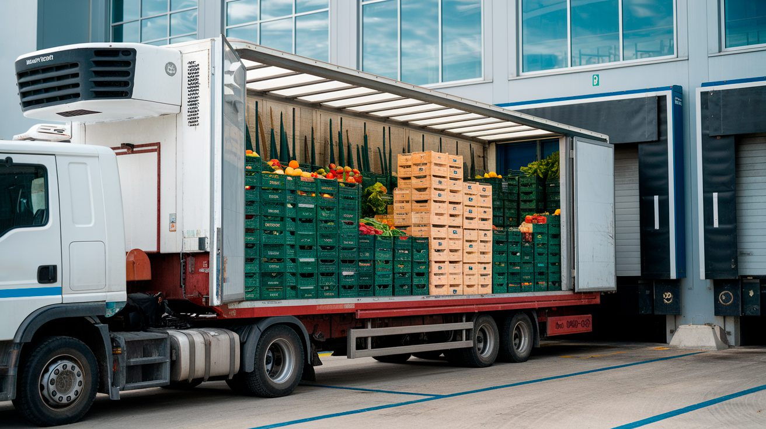
Refrigerated trucks (reefers) are widely used for transporting perishable crops and livestock products that require strict temperature control. Fruits such as mangoes, apples, pears, and berries, vegetables such as lettuce, spinach, and broccoli, as well as dairy products like milk and processed cheeses, need to be kept at low temperatures to slow respiration, prevent microbial growth, and extend shelf life. Refrigerated trucks allow farmers to transport produce over long distances to urban markets, supermarkets, and processing facilities without compromising quality. They are also used for chilled meat, eggs, and certain horticultural exports. Inside the truck, produce is often loaded in ventilated crates, pallets, or containers, with air circulation carefully controlled to maintain uniform temperatures and humidity. For a mixed farmer, access to refrigerated transport ensures that high-value perishable crops reach the market in prime condition, fetching better prices.
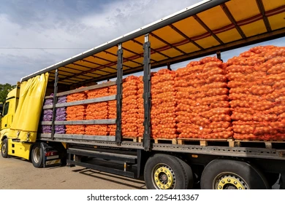
Standard open or covered trucks and containers are commonly used for crops that are less sensitive to temperature changes or for shorter distances. Root crops such as potatoes, onions, carrots, and pumpkins, as well as grains and legumes, can be transported safely in dry, ventilated trucks or containers. These methods protect produce from physical damage, sun exposure, and rain while allowing airflow to reduce spoilage. Farmers may use crates, mesh bags, or bulk containers depending on the type of crop. Covered trucks are particularly useful during the rainy season to prevent wetting and potential rot. For livestock products such as wool or bulk eggs, clean, ventilated containers or boxes on standard trucks are sufficient to preserve quality. Proper securing and stacking are important to avoid crushing and bruising during transport.
Air freight is often used for high-value or highly perishable crops destined for distant domestic or international markets. Fruits like berries, table grapes, avocados, and exotic vegetables may need to reach export destinations quickly to maintain freshness and meet strict quality standards. Air freight is the fastest transport option, which minimizes the time between harvest and delivery, reducing losses due to overripening or spoilage. For a South African mixed farmer targeting export markets, air transport allows products to meet international quality requirements and deadlines. Special packaging, including insulated boxes or pallets, and temperature-controlled conditions during transit are essential to ensure the produce arrives in top condition.
Rail transport is another method used for bulk crops, especially grains, legumes, and processed goods. Rail is often cost-effective for large quantities over medium to long distances. Proper handling during loading and unloading is important to prevent damage, contamination, and moisture exposure. Grain silos and bulk containers are commonly used for rail transport. While less suitable for highly perishable crops, rail is efficient for staples like maize, wheat, sunflower seeds, and beans.
Waterborne transport (ships and barges) is typically used for export markets, especially for bulk grains, legumes, and non-perishable horticultural products. While slower than air transport, waterborne transport is cost-effective for large volumes. Farmers or cooperatives must ensure that crops are properly dried, packed, and protected from moisture, pests, and physical damage before shipment. Temperature-sensitive products are usually transported in refrigerated shipping containers, while bulk grains and legumes are transported in dry cargo holds with aeration systems to maintain quality.
Local transport methods for short distances may include smaller trucks, pickup vehicles, tractors with trailers, or even wheelbarrows and carts for very small-scale operations. These methods are practical for moving crops from the field to nearby storage sheds, packing areas, local markets, or collection points. While simple, these methods still require careful handling to avoid bruising, crushing, and contamination. Even for small-scale transport, crates, boxes, or sacks should be clean and suitable for the crop type.
Animal transport may sometimes be used for livestock on mixed farms. For example, cattle, goats, sheep, and poultry must be loaded into trailers or vehicles that are designed for animal welfare, with proper ventilation, sufficient space, and protection from injury and stress. Humane handling during transport not only meets regulatory standards but also ensures better meat quality if animals are intended for slaughter. Stress during transport can negatively affect meat tenderness, milk yield, or egg quality.
Key considerations for transportation of crops include:
- Temperature control: Perishable crops require cold transport to slow spoilage.
- Ventilation: Proper airflow prevents heat and moisture buildup, reducing decay and mould.
- Physical protection: Crates, boxes, or bags protect crops from bruising and crushing.
- Distance and duration: Longer distances or delays require more careful handling, cooling, and insulation.
- Hygiene and cleanliness: Vehicles, containers, and equipment must be clean to prevent contamination.
- Compliance with regulations: Especially for exports, transport must meet food safety, animal welfare, and phytosanitary standards.
Transportation methods must match the perishability, fragility, and market requirements of the crop or livestock product. Refrigerated trucks, containers, air freight, rail, waterborne, and local transport all play specific roles in ensuring post-harvest quality is preserved. For a mixed crop and livestock farmer in South Africa, choosing the right method of transport is critical for reducing post-harvest losses, maintaining market readiness, and maximising profitability. Efficient transport complements proper harvesting, sorting, grading, and storage practices to ensure the full value of farm produce is captured.

KT0206 Quality control measures for post-harvest handling
Quality control measures for post-harvest handling are practices and checks that a mixed crop and livestock farmer in South Africa uses to ensure that crops and livestock products maintain their safety, freshness, and market value from the moment they are harvested or collected until they reach storage, processing facilities, or the market. Effective quality control protects farm produce from spoilage, contamination, physical damage, and pest infestation while meeting the standards required by buyers, processors, and regulatory authorities. It is an essential component of post-harvest management because it ensures consistency, builds trust with buyers, reduces losses, and maximises income.
One key quality control measure is inspection and sorting immediately after harvest. Farmers must examine produce to identify damaged, diseased, overripe, underripe, or contaminated items. Sorting allows high-quality produce to be separated from lower-grade or reject items, while grading classifies produce based on size, colour, weight, and appearance. This ensures that only products meeting market standards are packed and sold, improving market readiness and customer satisfaction. For livestock products, inspection may include checking milk for contamination, eggs for cracks, or meat for signs of spoilage.
Hygiene and cleanliness are essential quality control measures. All equipment, tools, containers, storage areas, and vehicles used in post-harvest handling must be clean and sanitised. Workers should maintain personal hygiene, including washing hands, wearing clean protective clothing, and handling produce carefully. Contamination from dirt, chemicals, pests, or human contact can significantly reduce product quality and safety. In dairy handling, milk containers and milking equipment must be sanitized, while eggs should be collected from clean nesting areas. Maintaining high hygiene standards ensures that products are safe for consumption and meet regulatory requirements.
Temperature and humidity monitoring is another critical quality control measure. Many crops and livestock products are sensitive to temperature and moisture levels. Farmers must ensure that perishable produce such as leafy vegetables, fruits, milk, eggs, and meat are stored and transported under optimal conditions. Cooling produce immediately after harvest slows respiration, delays ripening, and prevents microbial growth. Grain, legumes, and root crops require dry, well-ventilated storage to prevent mould, sprouting, and pest infestation. Regular monitoring with thermometers and hygrometers helps identify problems early and prevents quality deterioration.
Proper packaging and handling is a key control measure to prevent physical damage and contamination. Products should be packed in clean, sturdy containers that are suitable for the type of crop or livestock product. For example, fruits and vegetables are placed in ventilated crates or cartons, eggs in protective trays, grains in clean bags, and milk in food-grade containers. Packaging protects the product during storage and transport, and reduces losses due to bruising, crushing, or spillage. Handling during packing and loading should be gentle to maintain quality and reduce post-harvest losses.
Pest and disease management in storage and handling areas is also a quality control measure. Crops and livestock products are vulnerable to insects, rodents, birds, and microbial infections after harvest. Farmers should regularly inspect storage facilities, implement pest control measures, and remove spoiled or infested produce promptly. Preventing pest infestation protects both the quality and safety of products and ensures compliance with market standards. For example, grains stored in silos should be monitored for weevils, while fruits and vegetables should be stored off the ground and away from sources of contamination.
Traceability and recordkeeping are important quality control measures. Farmers should keep records of harvest dates, batch quantities, sorting and grading results, storage conditions, pest treatments, transport details, and quality inspections. This allows problems to be traced back to specific batches, helps improve post-harvest practices over time, and provides documentation for buyers or regulators. Traceability also helps the farmer identify patterns in quality deterioration and take corrective actions for future harvests.
Training and supervision of workers is another quality control measure. Workers handling crops and livestock products should be trained in safe and hygienic post-harvest practices, including proper handling techniques, use of tools, packaging methods, and monitoring procedures. Supervisors should ensure that workers follow established protocols consistently. Skilled and well-supervised labour reduces mistakes, protects product quality, and ensures that the post-harvest handling process meets both market and safety standards.
Regular audits and quality checks during storage, transport, and packing are additional measures. Farmers should periodically inspect produce in storage to ensure that temperature, humidity, and hygiene standards are maintained. Any signs of spoilage, contamination, or pest infestation should be addressed immediately. During transport, produce should be checked to ensure that it is handled carefully, kept at the correct temperature, and remains uncontaminated. For livestock products, this may involve checking milk for spoilage, eggs for cracks, or meat for temperature compliance during cold chain transport.
Preventing cross-contamination is also a key quality control measure. Crop produce should be kept separate from chemicals, fertilizers, animal feed, manure, and livestock products that could cause contamination. In mixed farming systems, careful separation of produce from livestock areas, manure storage, and machinery reduces the risk of chemical or microbial contamination, which could compromise quality and safety.
Quality control measures for post-harvest handling include inspection and sorting, hygiene and cleanliness, temperature and humidity monitoring, proper packaging and handling, pest and disease management, traceability and recordkeeping, worker training, regular audits, and prevention of cross-contamination. For a mixed crop and livestock farmer in South Africa, these measures are essential to maintain the safety, freshness, and market value of produce. Consistently applying these quality control measures ensures reduced losses, better market access, compliance with regulations, and higher profitability.

Internal Assessment Criteria (IAC) and Weight
- IAC0201 Explain the importance of post-harvest handling in maintaining crop quality and ensuring food safety.

Post-harvest handling is a critical stage in agriculture because it directly affects the quality, safety, and market value of crops. After harvesting, crops remain biologically active and are susceptible to spoilage due to pests, fungi, bacteria, and environmental conditions such as temperature and humidity. Proper post-harvest handling reduces losses, maintains nutritional content, preserves appearance, and ensures that crops meet food safety standards required by consumers, local markets, and export regulations. For example, maize must be properly dried and stored to prevent aflatoxin contamination, which poses serious health risks and reduces marketability. Similarly, fresh vegetables and fruits require careful handling to prevent bruising, wilting, and microbial contamination. For mixed crop-livestock farmers, post-harvest handling ensures that both crop and feed products retain quality, which ultimately supports livestock health and productivity.

- IAC0202 Describe techniques for cleaning and sanitizing equipment and facilities used in post-harvest handling.

Maintaining hygiene during post-harvest handling is essential to prevent contamination and ensure food safety. Techniques include:
- Cleaning: Removing visible dirt, soil, plant residues, and organic matter from tools, storage bins, containers, and machinery using brushes, water, and detergents.
- Sanitizing: Applying approved sanitizing agents or disinfectants to eliminate harmful microorganisms. For example, using a chlorine-based solution for washing crates or food contact surfaces.
- Routine checks: Inspecting storage areas, harvesting tools, and equipment for damage, rust, or residues that can harbor pathogens.
- Personnel hygiene: Workers should wash hands, wear clean clothing, and follow proper handling procedures to prevent contamination during handling.
Regular cleaning and sanitization not only improve crop safety but also extend shelf life and help comply with South African food safety regulations.

- IAC0203 Explain methods for sorting and grading crops based on their characteristics.

Sorting and grading are essential for delivering consistent quality and meeting market standards. Methods include:
- Visual assessment: Inspecting crops for size, colour, shape, and uniformity. Damaged, diseased, or immature produce is separated from high-quality stock.
- Mechanical sorting: Using sieves, graders, or conveyor belts to automatically classify crops by size, weight, or diameter.
- Quality grading: Categorizing produce into premium, standard, or lower grades based on aesthetic appearance and internal quality (e.g., sugar content, firmness).
- Livestock feed crops: Grading forage based on nutritional content such as protein and fibre levels to ensure appropriate feed quality.

- IAC0204 Describe storage conditions for different crops.

Proper storage maintains crop quality and prevents spoilage. Storage requirements vary by crop type:
- Grains (maize, wheat, soybeans): Store in dry, ventilated bins at low humidity (10–14%) to prevent mould and insect infestations.
- Fruits and vegetables: Store in cool, humid conditions (often 4–10°C) with adequate ventilation to prevent wilting, bruising, and microbial growth.
- Legumes and seeds: Keep in sealed containers at low humidity to maintain viability and prevent pest damage.
- Feed crops (hay, silage): Hay should be stored in dry, well-ventilated areas to prevent mould, while silage is stored anaerobically to preserve nutrients.

- IAC0205 Explain transportation methods for different crops.

Transport plays a crucial role in maintaining quality during delivery to markets:
- Bulk grains: Use covered trucks or trailers to protect from moisture, dust, and pests.
- Perishable crops (fruits, vegetables, dairy): Refrigerated trucks or containers maintain temperature and prevent spoilage.
- Fragile produce (berries, leafy vegetables): Use crates, trays, or cushioned packaging to reduce bruising and physical damage.
- Livestock feed: Transport bales or silage in a way that avoids moisture absorption or contamination.

- IAC0206 Describe quality control measures for post-harvest handling to ensure crop quality and safety.

Quality control ensures crop safety, consistency, and market acceptability. Measures include:
- Inspection: Regularly checking crops for pests, disease, spoilage, and foreign matter.
- Moisture content analysis: Measuring grains and seeds to ensure proper drying before storage.
- Temperature and humidity monitoring: Especially for perishable crops and livestock products to prevent spoilage.
- Record-keeping: Documenting handling, storage conditions, and movement to trace any quality issues back to their source.
- Compliance with standards: Adhering to South African food safety and export regulations such as HACCP or GlobalGAP certification.

KM-04-KT03 Concepts and importance of value adding 25%
Topic element
- KT0301 Importance of value addition
- KT0302 Principles of value addition, such as processing, packaging, and marketing
- KT0303 Techniques for adding value to agricultural products, such as drying, canning, freezing, and fermenting
- KT0304 Packaging materials and methods for adding value to agricultural products, such as labels, seals, and branding
- KT0305 Quality control measures for value-added products, such as inspection, testing, and certification
- KT0306 Regulatory requirements for value-added products, such as labelling, packaging, traceability and safety standards

KM-04-KT03 Concepts and importance of value adding
Value adding in agriculture refers to the processes, practices, or activities that a mixed crop and livestock farmer in South Africa uses to increase the economic, functional, or market value of farm produce after it has been harvested or collected. Rather than selling raw or unprocessed products, value adding transforms them into products that are more desirable, convenient, or profitable, while also extending shelf life, improving quality, or creating niche markets. For example, a farmer may convert tomatoes into tomato paste, milk into cheese or yoghurt, maize into flour, or wool into spun yarn. Value adding is not limited to processing—it can also involve cleaning, grading, packaging, branding, or marketing, all of which enhance the perceived and actual value of the product.
The concept of value adding is based on the idea that a product’s market value is not fixed at the point of harvest. While raw crops and livestock products have inherent value, additional interventions can increase profitability and competitiveness. For example, fresh tomatoes may fetch lower prices in bulk markets due to perishability, but when processed into sauce, paste, or dried products, they can be stored longer and sold at higher prices. Similarly, milk sold as raw liquid may have limited shelf life and market options, whereas processed milk products such as cheese or yoghurt have longer shelf life, higher demand, and access to niche or formal markets. Value addition therefore creates new opportunities for revenue and reduces dependence on raw commodity sales.
One of the main benefits of value adding is income enhancement. By transforming raw products into more desirable forms, farmers can charge higher prices and access higher-value markets. For example, eggs can be graded, cleaned, and packaged into uniform cartons, allowing farmers to sell them to supermarkets at premium rates compared to ungraded eggs. Similarly, fruits can be washed, sorted, and packaged into attractive trays for urban or export markets. Even simple actions like drying, fermenting, or juicing can significantly increase product value.
Value adding also supports market competitiveness. Consumers, retailers, and processors increasingly demand products that are convenient, hygienic, and uniform. Products that are processed, packaged, and branded according to market expectations are more likely to attract buyers and establish a reputation for quality. For a South African mixed farmer, value-added products can access urban markets, supermarkets, export channels, or niche markets, where raw products may have limited acceptance. Packaging, branding, and labelling are examples of non-processing value addition that increases consumer appeal and trust.
Another important aspect of value adding is loss reduction and shelf-life extension. Many crops and livestock products are highly perishable. Through processing, packaging, or preservation methods, farmers can prevent spoilage, reduce post-harvest losses, and maintain product quality over longer periods. For example, converting milk into yoghurt or cheese extends its usability; drying maize, beans, or fruits prevents mould and insect damage; and vacuum-packing or cold storage slows spoilage. By adding value, farmers can store and sell products at more favourable times rather than being forced to sell immediately after harvest, which often results in lower prices.
Value adding also contributes to food safety and quality assurance. Processing and proper packaging allow farmers to remove contaminants, improve hygiene, and meet regulatory and market standards. For example, milk must be pasteurized to comply with health regulations, while fruits may need washing, sorting, and packaging to meet supermarket quality standards. Value addition thus increases consumer confidence, supports compliance with legislation, and opens doors to formal and high-value markets.
Value adding encourages diversification and risk management. By producing multiple products from the same raw material, farmers reduce their reliance on a single commodity and spread financial risk. For example, a mixed farmer can produce maize flour, animal feed, and fermented maize products from the same harvest, while milk can be transformed into yoghurt, cheese, and butter. This diversification creates multiple revenue streams and buffers the farm against price fluctuations in any single product.
The concept of value adding also includes employment and skills development. Processing, packaging, and marketing require labour, machinery, and management skills. Farmers who engage in value addition often create job opportunities on the farm, gain experience in production planning, product development, and marketing, and enhance the overall efficiency and sustainability of the enterprise.
Value adding is important for competitive positioning in local and international markets. Processed, packaged, and branded products often meet higher standards demanded by urban consumers, supermarkets, and export markets. This creates opportunities for premium pricing, contracts with formal buyers, and long-term business growth. For example, dried fruits, packaged vegetables, or yoghurt with a recognised brand can attract higher prices than raw produce.
The concept of value adding revolves around enhancing the economic, functional, and market value of farm produce through processing, grading, packaging, or branding. Its importance lies in increasing income, reducing post-harvest losses, extending shelf life, improving food safety, diversifying revenue streams, creating employment opportunities, and enhancing market competitiveness. For a mixed crop and livestock farmer in South Africa, value addition is a strategic approach to maximise returns, meet market demands, and ensure the sustainability of the farming enterprise.

KT0301 Importance of value addition
The importance of value addition in agriculture lies in the ability of a mixed crop and livestock farmer in South Africa to increase the economic, functional, and market value of farm produce beyond its raw form. Value addition transforms crops and livestock products into forms that are more convenient, appealing, or suitable for different markets. By doing so, farmers can increase profitability, reduce post-harvest losses, access formal or high-value markets, and improve food safety and quality. Understanding the importance of value addition is crucial for small, medium, and large-scale farmers because it directly affects income, competitiveness, and sustainability.
One of the main reasons value addition is important is income enhancement. Raw farm products often fetch lower prices, especially when sold in bulk or in local markets. By processing, packaging, or branding products, farmers can obtain higher prices and access more lucrative markets. For example, maize harvested from the field can be sold as mealie meal, animal feed, or fermented products, each attracting different buyers at higher returns than raw grain. Similarly, milk can be turned into cheese, yoghurt, or butter, allowing farmers to capture additional income per litre of milk produced. Value addition therefore enables farmers to maximize profits from the same harvest or livestock production.
Another important aspect is reduction of post-harvest losses. Many crops and livestock products are highly perishable and prone to spoilage if sold raw or left unprocessed. Through value addition, produce can be preserved, stored longer, and transported safely to distant markets. For example, fruits can be dried, canned, or juiced, and meat can be processed into packaged cuts or cured products. These interventions reduce spoilage, minimize waste, and ensure that the farmer retains more value from production. For a mixed crop and livestock farm, this is particularly important because it allows products to be used efficiently, including lower-grade produce, which might otherwise be wasted.
Value addition also increases market access and competitiveness. Consumers, retailers, and export markets often demand products that are uniform, hygienic, and convenient. By adding value, farmers can meet these standards and access markets that would otherwise be unavailable for raw produce. Packaged, graded, or branded vegetables, fruits, dairy products, or eggs are more likely to be accepted by supermarkets, processors, and export buyers. This gives farmers a competitive advantage and helps establish long-term relationships with buyers.
Food safety and quality improvement is another key importance. Processing, cleaning, grading, packaging, and proper storage help prevent contamination, reduce microbial growth, and comply with food safety regulations. For example, pasteurizing milk or packaging fresh vegetables in clean containers ensures that products meet regulatory requirements, protecting consumers and the farmer’s reputation. Maintaining quality through value addition supports the credibility of the farm and builds trust in the market.
Value addition also supports diversification and risk management. By producing multiple products from the same raw material, farmers reduce reliance on a single crop or livestock product and spread financial risk. For instance, maize can be sold as raw grain, milled into mealie meal, or processed into snacks, while milk can become cheese, yoghurt, or butter. Diversification through value addition creates multiple income streams and buffers the farm against market fluctuations or seasonal variations.
Employment creation and skills development is another important factor. Value addition requires labour, machinery, management, and technical skills. Farmers who engage in processing, packaging, or marketing products often generate additional employment on the farm. Workers gain skills in handling, processing, grading, and marketing, which strengthens the overall productivity and sustainability of the enterprise.
Finally, value addition allows farmers to position themselves for higher-value markets, including exports. Processed, packaged, and branded products can meet the standards demanded by international buyers and urban consumers, allowing farmers to access premium pricing and long-term contracts. Products such as dried fruits, packaged vegetables, cheeses, or yoghurt with consistent quality and attractive presentation are more competitive than raw produce.
The importance of value addition lies in enhancing income, reducing post-harvest losses, improving food safety, increasing market access, diversifying revenue streams, creating employment, and improving market competitiveness. For a mixed crop and livestock farmer in South Africa, embracing value addition ensures that farm produce reaches its maximum economic and functional potential while supporting sustainability and growth of the farming enterprise.

KT0302 Principles of value addition, such as processing, packaging, and marketing
The principles of value addition are the fundamental guidelines that a mixed crop and livestock farmer in South Africa follows to increase the economic, functional, and market value of farm produce. These principles guide how products are transformed from their raw state into forms that are more desirable, convenient, safe, and profitable. They involve a combination of processing, packaging, and marketing, which together ensure that farm products are market-ready, comply with quality standards, and meet consumer demands. Understanding these principles helps farmers maximize income, reduce losses, and strengthen their position in both local and export markets.
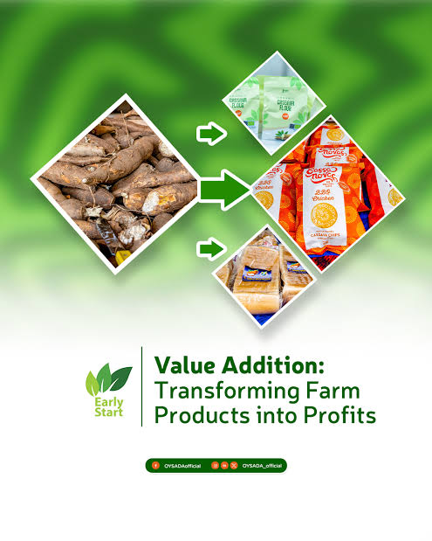
Processing is a central principle of value addition. Processing involves transforming raw farm products into forms that are easier to store, transport, or consume. For crops, this may include cleaning, peeling, chopping, drying, milling, fermenting, juicing, or canning. For example, maize can be milled into mealie meal, tomatoes can be processed into paste or sauce, and fruits can be dried or juiced. Livestock products can also be processed; milk can be turned into cheese, yoghurt, or butter, while meat can be cut, packaged, or cured. Processing adds value by extending shelf life, reducing spoilage, creating convenience, and opening up new market opportunities. It also allows farmers to capture additional income from the same quantity of raw produce.
Packaging is another key principle. Proper packaging protects products from physical damage, contamination, and moisture loss while improving their presentation and appeal to consumers. Packaging also provides information about the product, such as brand, expiry date, and handling instructions. For crops, this may involve placing vegetables in ventilated crates, fruits in trays, grains in clean bags, or processed products in sealed containers. For livestock products, milk and yoghurt are stored in food-grade bottles, eggs in cartons, and meat in vacuum-sealed packaging. Effective packaging ensures that the quality preserved during harvesting and processing is maintained until the product reaches the market, which can command higher prices and consumer trust.
Marketing is the third principle of value addition and involves promoting and selling farm products in a way that maximizes value and reaches the intended consumers. Marketing includes understanding the target market, establishing competitive pricing, creating attractive branding, and identifying appropriate sales channels. A product that is well-processed and packaged still needs effective marketing to succeed. Farmers can use local markets, supermarkets, informal retail, online platforms, and export channels to reach buyers. Marketing also involves creating awareness of the product’s benefits, such as freshness, organic production, or convenience, which can attract premium prices.
Quality maintenance is a cross-cutting principle that underpins processing, packaging, and marketing. Farmers must ensure that all steps are done under hygienic and safe conditions to preserve freshness, prevent contamination, and meet regulatory standards. Proper handling, temperature control, moisture management, and pest prevention are critical to maintaining quality. For example, fresh vegetables and fruits should be cooled after harvest, processed in clean facilities, and packaged properly before reaching markets. Milk must be pasteurized, stored at appropriate temperatures, and transported in clean containers. By maintaining high-quality standards, farmers can protect brand reputation, meet buyer requirements, and command better prices.
Innovation and adaptation are also important principles. Farmers need to select processing methods, packaging materials, and marketing strategies that are suitable for the specific product, scale of production, and market demand. For example, small-scale farmers may focus on simple drying, juicing, or packaging methods, while larger farms may invest in automated processing lines, branded packaging, and cold-chain logistics. Adapting to changing consumer preferences, such as organic, health-focused, or convenience products, helps farmers capture additional value.
Sustainability is another principle. Value addition should minimize waste and environmental impact. For instance, by-products from processing can be repurposed as animal feed, compost, or bio-energy, creating additional value streams. Efficient use of resources, such as water and energy during processing, also reduces costs and improves long-term profitability.
Traceability and recordkeeping are additional principles to ensure accountability, compliance, and continuous improvement. Farmers should document processing steps, storage conditions, packaging, and marketing activities. This allows them to track quality issues, verify safety standards, and improve operational efficiency. Traceability is especially important for export markets, where strict standards must be met.

KT0303 Techniques for adding value to agricultural products, such as drying, canning, freezing, and fermenting
Techniques for adding value to agricultural products are practical methods that a mixed crop and livestock farmer in South Africa can use to transform raw farm produce into products that are more durable, marketable, and profitable. These techniques not only extend shelf life and reduce post-harvest losses but also create new opportunities to access higher-value markets. Value addition can involve physical, chemical, or biological processes, depending on the type of crop or livestock product, the intended market, and available resources. Some of the most commonly used techniques include drying, canning, freezing, and fermenting.
Drying is one of the oldest and simplest methods of value addition. It involves removing moisture from crops to reduce the risk of microbial growth, spoilage, and decay. Drying can be done naturally, using sunlight, or artificially using ovens, dehydrators, or solar dryers. Crops like maize, beans, peppers, tomatoes, fruits, and herbs are commonly dried on South African farms. For example, tomatoes can be dried into sundried tomatoes, fruits like mangoes or apricots can be dehydrated for snacks, and maize can be dried to safe moisture content for storage or milling. Drying increases the shelf life of produce, reduces weight for easier transport, and allows farmers to sell products when market prices are more favourable.
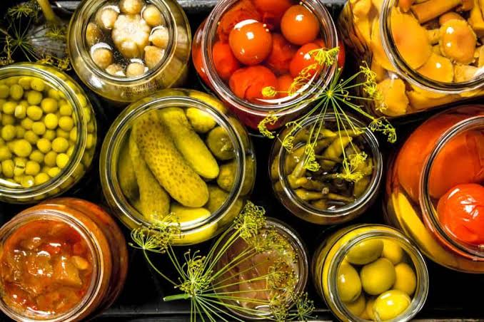
Canning is another widely used technique that preserves perishable produce by sealing it in airtight containers after heat treatment. The process destroys microbes and enzymes that cause spoilage, allowing products to be stored for long periods without refrigeration. Vegetables, fruits, sauces, and even meat can be canned. For example, tomatoes can be processed into canned tomato paste, fruit can be canned in syrup, and beans can be canned for ready-to-eat consumption. Canning increases the marketability of products, ensures year-round availability, and allows farmers to reach distant markets, including export destinations, without worrying about rapid spoilage.
Freezing is a method that preserves the freshness, taste, and nutritional quality of perishable products by lowering their temperature to slow down microbial activity and enzyme reactions. Vegetables, fruits, meat, and dairy products such as milk and cheese can be frozen. For example, green beans or spinach can be blanched and frozen, while meat and poultry can be packaged and stored in cold storage before sale. Freezing maintains product quality and safety for long periods, making it ideal for supplying urban markets, supermarkets, and processing facilities. This technique is particularly valuable for highly perishable crops that cannot be sold immediately after harvest.
Fermenting is a biological technique in which natural or added microorganisms, such as bacteria, yeast, or fungi, are used to transform raw products into new value-added products. Fermentation improves shelf life, enhances flavour, and can increase nutritional value. Examples include producing yoghurt or cheese from milk, sourdough bread from wheat, or fermented maize products like mageu. Fermentation is also used for vegetables, such as making pickled cabbage or kimchi-style products. On mixed South African farms, fermenting allows farmers to diversify their product range, reduce waste, and tap into markets for traditional or specialty foods.
Other techniques may also complement these primary methods. Juicing transforms fruits and vegetables into concentrated or packaged beverages, which increases value and convenience for consumers. Processing into flour or meal allows cereals and legumes to be converted into products like maize meal or bean flour. Smoking or curing meat extends shelf life and creates specialty products like biltong or cured sausages. Packaging and branding further enhance the appeal and marketability of all processed products, making them more attractive to formal markets, supermarkets, and export buyers.
The choice of value-adding technique depends on the crop or livestock product, the market demand, available equipment, and resources. Simple methods like sun drying or fermenting can be done on small-scale farms with limited investment, while more advanced methods such as freezing, canning, and juicing require specialized equipment and infrastructure. Farmers must also ensure that processed products comply with food safety and quality standards to maintain consumer trust and market access.
Techniques for adding value to agricultural products—including drying, canning, freezing, and fermenting—enable farmers to extend shelf life, improve quality, diversify product offerings, and increase income. For a mixed crop and livestock farmer in South Africa, understanding and applying these techniques is essential to reduce post-harvest losses, meet market demands, and maximise profitability while creating opportunities for growth in both local and export markets.

KT0304 Packaging materials and methods for adding value to agricultural products, such as labels, seals, and branding
Packaging is a crucial part of value addition for agricultural products because it protects produce, preserves quality, enhances marketability, and communicates important information to consumers. For a mixed crop and livestock farmer in South Africa, effective packaging can significantly increase the perceived and actual value of products, reduce post-harvest losses, and allow access to higher-value markets, including urban retail outlets and export channels. Packaging is not just about containment—it is an essential marketing and quality assurance tool that signals professionalism and care in handling.
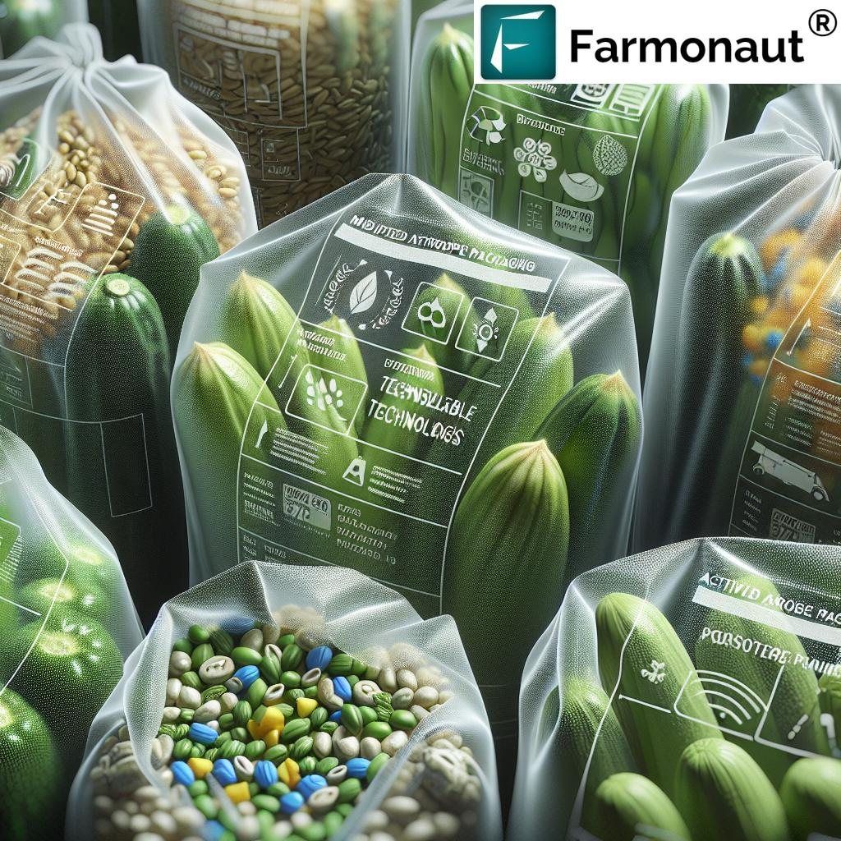
Packaging materials vary depending on the type of product, storage requirements, and intended market. Common materials include plastic crates, cardboard boxes, paper bags, glass jars, plastic containers, vacuum-sealed bags, and woven or mesh bags. For perishable crops like leafy vegetables, fruits, and tomatoes, ventilated plastic crates are preferred because they allow airflow, reduce bruising, and make handling and transport easier. For grains, legumes, and root crops, woven or polypropylene bags provide strength and protection during storage and transport. Processed products, such as jams, dried fruits, or yoghurt, often use glass jars or plastic containers with tight-fitting lids to prevent contamination and extend shelf life.
Labels are an important part of packaging for value addition. Labels provide information about the product, such as the name, weight, nutritional content, production date, expiry date, storage instructions, and farm or company details. In South Africa, labelling is often required by law for processed food products, dairy, and packaged goods to comply with health and safety regulations. Labels also build consumer confidence and allow farmers to differentiate their products from competitors. For example, a carton of eggs with a clearly printed farm name, grading information, and best-before date appears more professional and is likely to fetch higher prices than unlabelled produce.
Seals and closures enhance both safety and value. Tamper-proof seals, airtight lids, vacuum seals, and shrink wraps protect products from contamination, moisture, pests, and damage during storage and transport. Seals are especially important for processed products like canned goods, dairy, juices, or meat products, where hygiene and safety are critical. For perishable products like fruits or vegetables, sealing packaged trays or using cling film can preserve freshness during handling and transport. A sealed product signals to buyers that the farmer maintains high standards, which can justify a premium price.
Branding adds significant value beyond the physical protection of the product. Branding involves creating a recognizable name, logo, or identity for farm produce or processed goods. For a mixed crop and livestock farmer, branding can be applied through labels, packaging design, printed cartons, or even coloured crates. Branding communicates quality, consistency, and reliability to consumers and markets, allowing farmers to establish a reputation and attract repeat customers. For example, a farm that produces packaged dried fruits with a consistent logo and brand name can create consumer loyalty and access higher-value retail and export markets.
Packaging methods are equally important. Proper filling, layering, cushioning, and sealing prevent bruising, crushing, or contamination. For delicate crops like tomatoes, strawberries, or leafy vegetables, careful layering in ventilated crates with padding between layers reduces damage during transport. Vacuum packaging or modified atmosphere packaging may be used for meat, dairy, or cut fruits to extend shelf life and preserve freshness. For bulk crops like maize, beans, or potatoes, stacking in strong bags or containers with good ventilation ensures safe storage and easy handling.
Good packaging also supports traceability and compliance. By including batch numbers, farm information, and production dates on packaging, farmers can track products, identify quality issues, and demonstrate adherence to regulatory standards. This is especially important for exports, formal retailers, or cooperative marketing schemes, where quality standards are strictly enforced.
Effective packaging can enhance visual appeal and consumer choice, which is a key part of value addition. Attractive packaging, clear labelling, and professional presentation encourage buyers to choose a product over competitors, even if the product itself is similar. Packaging can communicate freshness, hygiene, convenience, and farm identity—all of which increase perceived value and market price.
Packaging materials and methods—including crates, boxes, jars, bags, labels, seals, and branding—play a vital role in adding value to agricultural products. For a mixed crop and livestock farmer in South Africa, proper packaging protects products, ensures food safety, communicates quality, extends shelf life, enhances visual appeal, and enables access to higher-value markets. When integrated into the value addition process, packaging is a powerful tool for increasing income, reducing losses, and improving farm competitiveness.

KT0305 Quality control measures for value-added products, such as inspection, testing, and certification
Quality control measures for value-added products are essential practices that ensure the safety, consistency, and marketability of processed crops and livestock products. For a mixed crop and livestock farmer in South Africa, implementing quality control ensures that value-added products meet regulatory standards, satisfy customer expectations, and maintain the farm’s reputation. These measures reduce losses, prevent recalls or disputes, and increase consumer trust, ultimately enhancing profitability and sustainability.
Inspection is the first step in quality control for value-added products. It involves examining raw materials before processing, as well as finished products, to identify defects, contamination, or deviations from established standards. For example, before making dried fruits or packaged vegetables, the farmer inspects for bruised, overripe, or spoiled items. In dairy processing, milk is checked for spoilage, bacterial contamination, or off-flavours. Inspection also extends to packaging, where labels, seals, and branding are checked for accuracy and compliance. Regular inspection ensures that only high-quality inputs enter the production process, and that finished products meet expected standards.
Testing is a more detailed quality control measure that involves using laboratory or field methods to verify product characteristics, safety, and compliance. For crops, testing may include checking moisture content, sugar levels, acidity, or nutrient composition. For livestock products, testing can include microbial analysis, fat content, pH levels, or detection of contaminants such as pesticides or antibiotics. For example, yoghurt or cheese may be tested for bacterial count and pH to ensure safety and quality, while dried maize or beans may be tested for moisture content to prevent spoilage during storage. Testing provides objective evidence that value-added products meet established quality standards.
Certification is an official recognition that value-added products comply with specific quality, safety, or regulatory standards. In South Africa, farmers may seek certification from agencies such as the Department of Agriculture, Forestry and Fisheries (DAFF), the South African Bureau of Standards (SABS), or private certification bodies for organic, HACCP (Hazard Analysis Critical Control Point), ISO, or export compliance. Certification ensures that products can access formal markets, supermarkets, or international buyers who require verified quality and safety standards. For example, dairy products need to comply with pasteurization and hygiene regulations to receive SANS certification, while processed fruit products may require HACCP certification for export.
Other quality control measures include:
- Process monitoring: Ensuring that production steps such as heating, cooling, fermenting, drying, or packaging are carried out correctly, consistently, and under hygienic conditions.
- Recordkeeping: Documenting all production, inspection, testing, and storage activities to trace products, identify issues, and demonstrate compliance.
- Worker training and hygiene: Ensuring that personnel involved in processing, packaging, and handling value-added products follow strict hygiene practices and are trained in quality standards.
- Sampling: Randomly checking batches of products during and after production to verify uniformity, safety, and compliance.
- Customer feedback and audits: Regularly reviewing customer complaints, returns, or market feedback to improve processes and maintain consistent quality.
Implementing these quality control measures ensures that value-added products are safe, consistent, and high-quality, which enhances consumer confidence and allows farmers to command premium prices. It also reduces post-processing losses, prevents contamination, and supports access to formal retail and export markets.
Quality control measures for value-added products—inspection, testing, certification, process monitoring, recordkeeping, and worker training—are critical for maintaining product safety, compliance, and marketability. For a mixed crop and livestock farmer in South Africa, these measures protect the farm’s reputation, increase income, reduce losses, and ensure that value-added products meet both local and international market standards.

KT0306 Regulatory requirements for value-added products, such as labelling, packaging, traceability and safety standards
Regulatory requirements for value-added products are essential rules and standards that a mixed crop and livestock farmer in South Africa must follow to ensure that processed or packaged agricultural products are safe, properly labelled, traceable, and compliant with both national and international laws. These requirements protect consumers, maintain product quality, and enable farmers to access formal markets, supermarkets, and export channels. Non-compliance can result in fines, rejection of products, or loss of market access, so understanding and adhering to regulations is critical for profitability and sustainability.
Labelling requirements are one of the key regulatory areas for value-added products. Labels must provide accurate and clear information about the product, including the product name, weight or volume, ingredients, production and expiry dates, storage instructions, nutritional information (if applicable), and the producer’s name and contact details. In South Africa, labelling of food products is regulated under the Foodstuffs, Cosmetics and Disinfectants Act (Act 54 of 1972), which requires that all packaged food sold to consumers carries sufficient information for safe and informed use. Accurate labelling ensures compliance, builds consumer trust, and differentiates the product in competitive markets.
Packaging standards are closely linked to labelling and quality. Regulatory requirements specify that packaging materials must be safe for contact with food, non-toxic, and strong enough to protect the product from contamination, moisture, and damage. Packaging must also preserve product quality during storage and transport. For example, dairy products must be packaged in materials that prevent microbial contamination and maintain freshness, while processed vegetables or grains should be packed in moisture-resistant containers to prevent spoilage. Regulations may also specify acceptable materials and methods to ensure environmental safety and consumer protection.
Traceability is another regulatory requirement that ensures products can be traced from production to the point of sale. Farmers and processors must maintain records of production batches, processing steps, storage, and transport. Traceability allows authorities and buyers to identify the source of any quality or safety issues and ensures accountability in the supply chain. For example, if a batch of yoghurt is found to be contaminated, traceability enables quick identification of the affected batch and prevents widespread distribution, protecting consumers and the farmer’s reputation. Traceability is particularly important for exports, where buyers and regulators demand full documentation of production and handling processes.
Safety standards govern the hygiene, processing, and handling of value-added products to protect consumers from foodborne illnesses, chemical contamination, or adulteration. Farmers must comply with standards related to microbial safety, temperature control, chemical residues, and overall production hygiene. For example, milk and dairy products must be pasteurized, processed, and stored under hygienic conditions to prevent bacterial growth. Similarly, processed fruits and vegetables should be washed, handled in clean environments, and packaged in safe containers. Compliance with safety standards is essential for consumer protection, regulatory approval, and access to formal and export markets.
Additional regulatory considerations include compliance with:
- Export and import regulations, such as those enforced by the Department of Agriculture, Forestry and Fisheries (DAFF), for products destined for international markets.
- HACCP (Hazard Analysis and Critical Control Points) certification, which is often required for formal retail and export channels.
- SANS (South African National Standards) for product quality, labelling, and processing.
- Environmental regulations, ensuring that packaging, waste management, and processing comply with sustainable and environmentally safe practices.

Internal Assessment Criteria (IAC) and Weight
- IAC0301 Explain the importance of value adding in increasing the economic value of agricultural products.

Value addition is the process of enhancing the economic worth of agricultural products through processing, packaging, branding, or improving quality. For farmers in South Africa, value addition increases profitability by transforming raw products into higher-value goods. For example, maize can be processed into meal, breakfast cereals, or animal feed, while milk can be processed into cheese, yogurt, or butter. Value addition also helps farmers access premium markets, reduce post-harvest losses, and stabilize income throughout the year. By offering higher-quality, ready-to-use, or specialty products, farmers can differentiate themselves in competitive local and export markets, making their products more appealing to consumers and increasing overall economic returns.

- IAC0302 Describe the principles of value adding in processing, packaging, and marketing.

Effective value addition is guided by three main principles:
- Processing: Transforming raw materials into more useful or marketable forms while maintaining nutritional value, safety, and quality. For instance, converting fresh fruits into dried fruit snacks or fruit juice.
- Packaging: Protecting products, extending shelf life, and making them visually appealing to attract buyers. Packaging also facilitates transport, storage, and marketing.
- Marketing: Identifying target markets, promoting product benefits, and building brand recognition. Effective marketing ensures that value-added products reach consumers willing to pay a premium for quality, convenience, or sustainability.

- IAC0303 Explain techniques for adding value to agricultural products.

Value addition can be achieved through several techniques depending on the type of product:
- Processing: Milling, drying, pasteurization, fermentation, juicing, freezing, or canning to create ready-to-use or preserved products.
- Blending or fortifying: Mixing crops or livestock products with additives to enhance nutritional content, flavour, or functionality. For example, fortifying maize meal with vitamins or producing flavoured yogurt from milk.
- Branding: Creating a recognizable name, logo, or packaging style to differentiate products in the market.
- Packaging and portioning: Offering products in convenient sizes or consumer-ready packaging, which can appeal to urban and export markets.

- IAC0304 Describe packaging materials and methods used in value adding.

Packaging is both functional and promotional. Materials and methods depend on the product type:
- Materials:
  - Plastic, glass, or metal containers for liquids (milk, juice, sauces)
  - Paper, cardboard, or laminated bags for grains, flour, or dried fruits
  - Vacuum-sealed bags or pouches for meat or dried products to prevent spoilage
  - Biodegradable or eco-friendly packaging to appeal to environmentally conscious consumers
- Methods:
  - Vacuum sealing: Removes air to extend shelf life and preserve freshness.
  - Modified atmosphere packaging: Adjusts gas composition in packaging to reduce spoilage in fruits, vegetables, and meat.
  - Labelling: Includes product information, nutritional content, expiry dates, and branding.

- IAC0305 Discuss quality control measures for value-added products.

Quality control ensures that value-added products are safe, consistent, and meet consumer expectations:
- Inspection: Regular checks of raw materials and finished products for contamination, defects, or spoilage.
- Monitoring processing conditions: Temperature, humidity, and processing times are controlled to preserve quality and safety.
- Testing: Microbiological, chemical, or physical tests to ensure compliance with health and safety standards.
- Traceability: Keeping records of production batches to track product origin and respond to any quality issues.

- IAC0306 Explain regulatory requirements for value-added products, labelling, packaging, traceability, and safety standards.

Compliance with regulatory requirements is crucial to legally market value-added products in South Africa:
- Labelling: Products must display ingredients, nutritional information, expiry dates, batch numbers, and allergen warnings.
- Safety standards: Food products must comply with regulations from the Department of Agriculture, Forestry and Fisheries (DAFF), the South African Bureau of Standards (SABS), and the Department of Health, including HACCP guidelines.
- Traceability: Maintaining records of sourcing, processing, and distribution to allow quick response to recalls or safety concerns.
- Packaging regulations: Packaging materials should be food-grade, non-toxic, and suitable for the type of product to prevent contamination or spoilage.

KM-04-KT04 Livestock market readiness 25%
Topic element
- KT0401 Categories of different livestock grades
- KT0402 Weaning livestock for market
- KT0403 Concept of backgrounding and feed lotting
- KT0404 Packaging materials and methods for adding value to agricultural products, such as labels, seals, and branding
- KT0405 Weighing of animals

KM-04-KT04 Livestock market readiness
Livestock Market Readiness refers to the preparation and management practices that a mixed crop and livestock farmer in South Africa must undertake to ensure that livestock are healthy, well-presented, and meet market requirements for sale, processing, or export. Market readiness is critical because it directly affects the price, demand, and profitability of livestock products. Buyers—whether at auctions, abattoirs, or commercial markets—look for animals that are in good health, the appropriate weight, well-groomed, and free from disease. Achieving market readiness requires careful attention to feeding, health, handling, transportation, and compliance with regulatory standards.
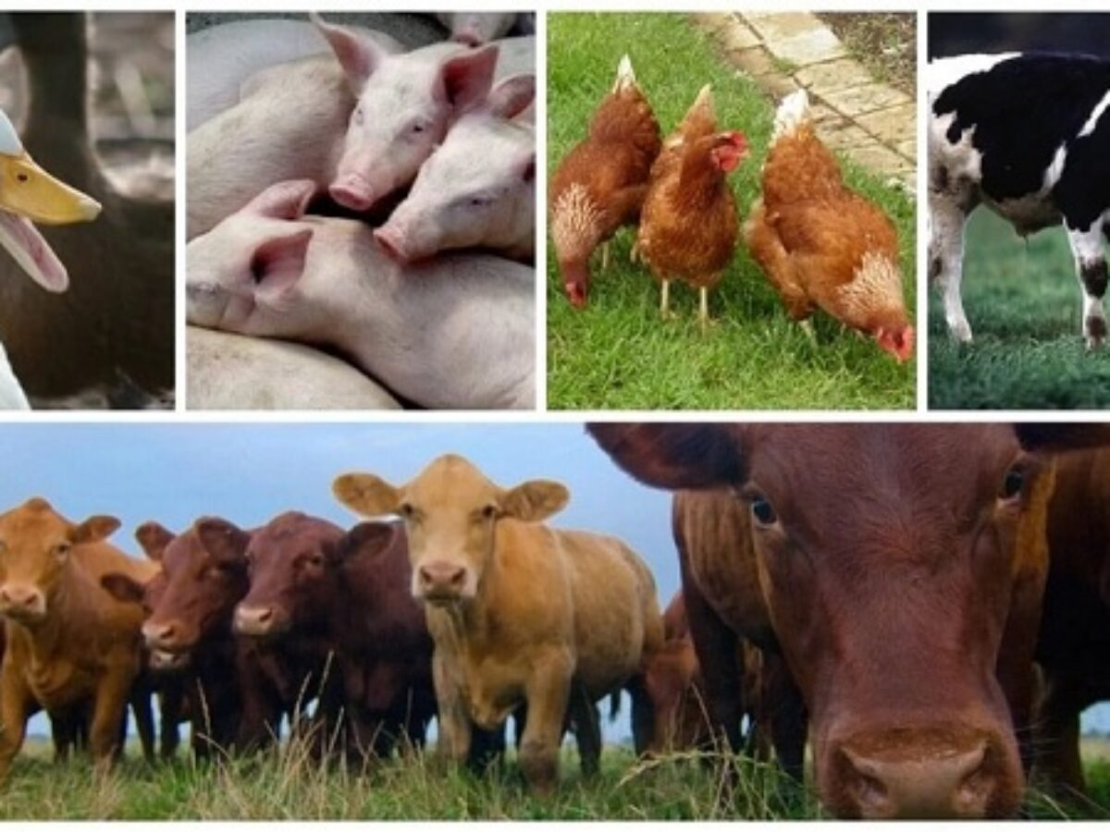
One key aspect of livestock market readiness is health and disease management. Animals must be free from signs of illness, infection, or parasitic infestation. This involves regular veterinary checks, vaccinations, and treatments for internal and external parasites. Farmers must maintain health records for each animal, as buyers often require proof of vaccinations and treatments, particularly for export or formal markets. Healthy animals are more likely to fetch higher prices and are less likely to be rejected by buyers or slaughterhouses. Disease-free livestock also protect other animals on the farm and prevent outbreaks that could damage market reputation.
Feeding and nutrition are essential for ensuring livestock reach optimal weight, condition, and quality. Proper feeding regimes, which include balanced rations of roughage, grains, and supplements, ensure that animals have the right body condition for market. For beef cattle, sheep, and goats, weight gain and muscle development affect the quality grading of meat, which influences price. Dairy cattle must be fed adequately to maintain milk yield and quality if they are sold for dairy purposes. Farmers also adjust feeding schedules in the weeks leading up to market to improve the appearance and condition of the animals.
Handling and behaviour management is another critical component. Animals that are accustomed to gentle handling are easier to load, transport, and present at market, reducing stress and potential injury. Calm, well-managed livestock are preferred by buyers and are less likely to suffer from bruising or weight loss during transport. Proper handling also ensures safety for the farmer, transport personnel, and other animals.
Grooming and presentation play an important role in market readiness. Livestock that are clean, brushed, and properly trimmed are more attractive to buyers. For example, cattle may be washed and hooves trimmed, sheep may be shorn and cleaned, and goats may be brushed to enhance appearance. Proper grooming demonstrates good husbandry practices and increases the likelihood of higher prices, particularly in auctions or shows.
Transportation and pre-market preparation are also vital. Farmers must ensure that animals are transported in safe, well-ventilated vehicles that prevent overcrowding and injury. Animals may need to be rested before transport, with access to water and feed to reduce stress. For export or formal markets, farmers must comply with transport regulations, including biosecurity measures, animal welfare standards, and documentation requirements.
Weight and grading assessment is essential for market readiness. Livestock must meet the weight, age, and quality standards demanded by buyers. Farmers often use scales, visual assessment, and body condition scoring to determine market readiness. Proper grading ensures that animals are sold in the appropriate categories, achieving maximum value for each animal.
Recordkeeping and regulatory compliance are also critical. Farmers must maintain accurate records of animal health, breeding, feeding, and treatments. Compliance with South African regulations, including the Animal Diseases Act (Act 35 of 1984) and export or abattoir requirements, ensures that livestock are marketable and meet both domestic and international standards. Traceability of animals from farm to market builds buyer confidence and reduces the risk of market rejection.
Livestock market readiness encompasses a combination of health management, nutrition, handling, grooming, transport preparation, weight assessment, and regulatory compliance. For a mixed crop and livestock farmer in South Africa, preparing animals for market ensures higher prices, buyer satisfaction, reduced losses, and improved farm reputation. Proper attention to these practices allows farmers to compete effectively in both local and formal markets, maximising profitability and sustainability.

KT0401 Categories of different livestock grades
Categories of Different Livestock Grades refer to the classification of animals based on characteristics such as age, weight, breed, sex, conformation, and overall quality. For a mixed crop and livestock farmer in South Africa, understanding livestock grades is essential for marketing, determining sale value, selecting animals for breeding, and meeting buyer requirements. Livestock grading ensures consistency in quality, allows fair pricing, and helps buyers choose animals suited for specific purposes such as meat, dairy, breeding, or export.
1. Grade by Age and Weight
Livestock are often graded by age and weight because these factors directly affect meat quality, productivity, and market value. For example:
- Cattle: Calves (under 12 months), yearlings (12–24 months), and mature cattle (over 24 months). Younger animals usually produce more tender meat and are preferred in certain markets, while mature animals may fetch higher prices for bulk meat or breeding stock. Weight categories also determine pricing; animals within optimal weight ranges are often graded higher.
- Sheep and goats: Lambs or kids are younger animals under 12 months, while adult sheep or goats are graded based on weight and age. Younger animals tend to have finer, more tender meat.
2. Grade by Conformation and Body Condition
Conformation refers to the animal’s physical structure, muscle development, and skeletal build. Body condition scoring evaluates fat cover and overall health. Animals with good conformation and ideal body condition are graded higher because they are likely to produce higher-quality meat, milk, or breeding stock. For example:
- Cattle with strong, well-balanced frames and adequate muscle cover are preferred for beef production.
- Sheep and goats with straight backs, proportional limbs, and even fat cover are considered higher grades.
3. Grade by Breed or Genetic Quality
Breed influences productivity, meat quality, milk yield, and adaptation to local conditions. Livestock may be graded based on purebred, crossbred, or indigenous breeds. For instance:
- Purebred beef cattle like Angus or Bonsmara are highly graded for meat quality and breeding potential.
- Dairy cattle like Holstein Friesians or Jerseys are graded based on milk yield and genetic traits.
- Indigenous breeds may be graded for resilience, adaptability, and suitability for extensive farming systems.
4. Grade by Sex
Sex is an important grading factor for livestock marketing. Male and female animals may have different growth rates, fat distribution, and suitability for breeding or meat production:
- Bulls or rams may be graded higher for breeding purposes due to their genetic value.
- Steers or wethers (castrated males) are often preferred for meat because they produce tender, well-marbled carcasses.
- Female animals are graded for milk production potential and reproductive health.
5. Grade by Health Status
Healthy animals free from disease, parasites, or defects are graded higher. Buyers check for visible signs of illness, injuries, or deformities. Animals with poor health or untreated diseases are graded lower and may be rejected by formal markets or abattoirs.
6. Grade by Market Purpose
Livestock can also be graded according to their intended market:
- Meat market: Animals are graded for tenderness, fat content, size, and carcass yield.
- Dairy market: Animals are graded based on milk yield, udder conformation, and reproductive history.
- Breeding stock: Animals are graded on pedigree, fertility, genetic traits, and physical conformation.
- Export markets: Livestock must meet strict grading standards, including weight, breed, health certifications, and appearance.
In South Africa, grading systems may vary depending on the species and the market (auction, abattoir, or export). Auctions often use standard visual and weight-based grading categories to classify livestock for buyers. Abattoirs may grade carcasses according to SANS meat grading standards, ensuring uniformity and quality for consumers.
Livestock grades are determined by age, weight, conformation, breed, sex, health, and market purpose. Understanding these categories allows mixed crop and livestock farmers to manage their herds effectively, select animals for breeding, maximize sale value, and meet buyer expectations. Proper grading ensures fair pricing, access to formal and export markets, and enhances overall farm profitability.

KT0402 Weaning livestock for market
Weaning Livestock for Market is a crucial practice for mixed crop and livestock farmers in South Africa that involves separating young animals from their mothers at an appropriate age to prepare them for sale, growth, or further fattening. Proper weaning ensures that young livestock develop healthy body weight, adapt to independent feeding, and meet market specifications, while reducing stress and maintaining overall herd productivity. Market-ready weaned animals are more attractive to buyers, fetch better prices, and reduce management challenges associated with overstocked or dependent young animals.

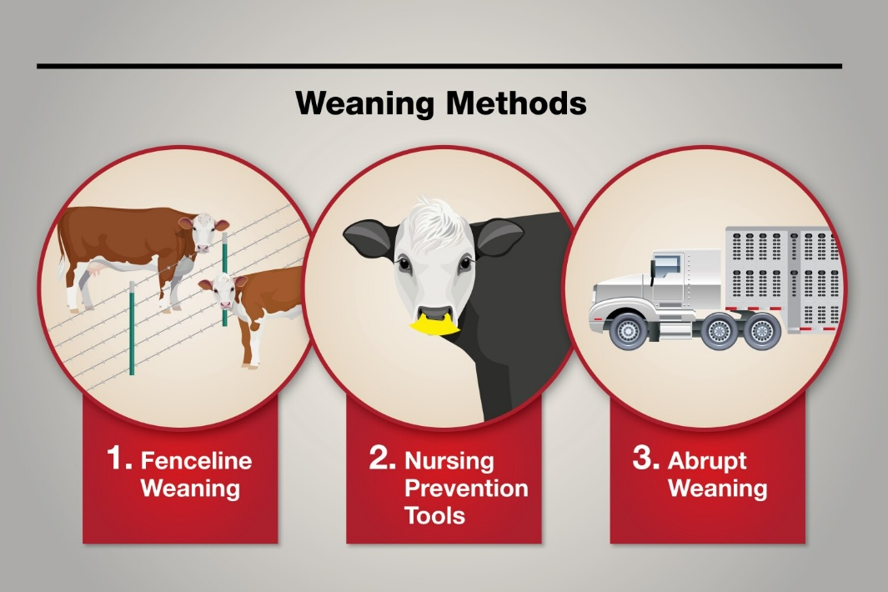
The timing of weaning is critical for both the health of the young animals and the productivity of the mothers. For example, calves, lambs, and kids are typically weaned at a stage when they are capable of digesting solid feed independently—usually around 3 to 6 months for cattle and sheep, and 2 to 4 months for goats, depending on breed, nutrition, and growth rates. Weaning too early can cause nutritional deficiencies, stress, and slower growth, while weaning too late can reduce the mother’s ability to regain condition for the next breeding cycle. Proper timing ensures that both the young animals and their dams remain healthy and productive.
Preparation for weaning involves gradually introducing young livestock to solid feed, such as pasture, hay, silage, or formulated feed, before separation. This helps the animals adjust to the change in diet and reduces stress associated with weaning. Farmers also ensure that water, minerals, and other supplements are readily available to support growth and immune function. For example, calves may be given creep feed while still suckling, allowing them to adapt to solid feed before full separation. Proper preparation minimizes weight loss and health issues, which is important for market readiness.
Stress management during weaning is another important consideration. Weaning is a stressful event for young animals, as they are separated from their mothers and must adapt to new feeding routines and social dynamics. Farmers can reduce stress by weaning in stages, keeping groups familiar with each other, and providing adequate shelter and space. Stress reduction is important because stressed animals may experience reduced weight gain, weaker immunity, and a lower market value.
Health management is critical during and after weaning. Young animals must be dewormed, vaccinated, and checked for parasites or disease before market. Maintaining health ensures that weaned livestock meet buyer expectations, comply with regulatory standards, and remain fit for transport and sale. Poor health can result in rejection at auctions or abattoirs, lower prices, and increased mortality.
Weight and growth monitoring is essential for market-ready weaned livestock. Farmers track weight gain and body condition to ensure that animals meet market specifications for age, size, and quality. Weaned livestock that achieve optimal weight and body condition are more likely to fetch higher prices and satisfy buyer requirements. Tools like weighing scales, body condition scoring, and visual assessment are used to monitor progress.
Housing and handling of weaned livestock is also important. Young animals require clean, safe, and well-ventilated pens or paddocks to prevent injury, stress, or disease transmission. Adequate space, access to feed and water, and gentle handling help maintain health and encourage steady growth, which is crucial for market readiness.
Recordkeeping is a key management practice. Farmers maintain records of birth dates, weaning dates, feed intake, vaccinations, treatments, and weight gains. Accurate records allow farmers to plan sales, determine the most profitable time to market animals, and provide buyers with essential information about the animal’s history and health status.
Weaning livestock for market involves timely separation from mothers, gradual introduction to solid feed, stress management, health care, weight monitoring, and proper handling. For a mixed crop and livestock farmer in South Africa, effective weaning practices ensure that young livestock are healthy, meet market specifications, and achieve optimal sale prices. Properly weaned animals not only improve farm profitability but also support herd productivity and long-term sustainability.

KT0403 Concept of backgrounding and feed lotting
Concept of Backgrounding and Feedlotting refers to the management practices used by mixed crop and livestock farmers in South Africa to prepare livestock for market or for breeding by improving growth, body condition, and overall market value. These practices involve controlled feeding and care after weaning or prior to sale, ensuring that animals reach the appropriate weight, fat cover, and health standards to meet buyer expectations. Backgrounding and feedlotting are essential tools for maximizing profitability, improving meat quality, and managing herd productivity.
Backgrounding is the phase of livestock management that occurs after weaning but before finishing in a feedlot or final market preparation. The purpose of backgrounding is to allow young animals—such as calves, lambs, or kids—to grow steadily and develop muscle and frame without excessive fat accumulation. This phase focuses on providing a balanced diet of forage, supplements, and minerals, while monitoring weight gain and body condition. Backgrounding typically occurs on pasture, rangeland, or in small holding areas where animals have space to graze and exercise. The main objectives of backgrounding are to:
- Promote steady, healthy growth
- Reduce stress from weaning
- Build immunity and overall health
- Prepare animals for more intensive feeding systems, such as feedlots or market finishing
Backgrounded livestock are more resilient and adaptable, which reduces disease risk and improves feed conversion efficiency. For example, a farmer may background weaned calves for 60–90 days on improved pasture or with supplementary feeding to achieve target weight and condition before moving them to a feedlot or selling them to a buyer.
Feedlotting, on the other hand, is a more intensive feeding system designed to rapidly increase the weight and fat cover of livestock before market. Animals are kept in confined pens or feedlots and provided with high-energy rations, often consisting of grains, silage, hay, and supplements, to maximize growth and improve meat quality. Feedlotting allows farmers to achieve uniformity in size, weight, and fat deposition, which is highly valued by buyers, abattoirs, and formal markets.
The main advantages of feedlotting include:
- Faster weight gain compared to pasture feeding, reducing the time to market
- Improved carcass quality, with better marbling and fat cover suitable for premium markets
- Efficient use of feed resources, particularly in areas where pasture availability is limited
- Controlled health and nutrition management, which reduces the risk of disease and ensures animals meet market specifications
Both backgrounding and feedlotting require careful monitoring of animal health, feed intake, and growth performance. Farmers must ensure that feed is balanced for energy, protein, and minerals, and that animals have access to clean water. Veterinary care, parasite control, and vaccination programs must also be maintained to keep animals healthy throughout these phases.
Integration of these concepts ensures that weaned or purchased animals grow efficiently, reach desired market weight, and are sold at optimal prices. Backgrounding provides the foundation for growth, while feedlotting accelerates finishing for the market. Together, these systems allow farmers to plan production cycles, optimize feed resources, and improve the overall profitability and competitiveness of livestock operations.
Backgrounding and feedlotting are complementary management strategies that prepare livestock for market by improving weight, health, and quality. For a mixed crop and livestock farmer in South Africa, implementing these practices ensures animals are market-ready, meet buyer requirements, and achieve maximum financial returns while supporting sustainable herd management.

KT0404 Packaging materials and methods for adding value to agricultural products, such as labels, seals, and branding
Packaging Materials and Methods for Adding Value to Agricultural Products refers to the practices used by mixed crop and livestock farmers in South Africa to protect, preserve, and enhance the market appeal of their products. Packaging is a critical part of value addition because it ensures that products remain safe and high-quality during storage and transport, communicates important information to buyers, and increases perceived value through professional presentation, branding, and labelling. Effective packaging can therefore help farmers access premium markets, reduce losses, and build consumer trust.
Packaging Materials vary depending on the type of product, its perishability, storage requirements, and target market. Common materials include:
- Plastic crates or baskets: Ideal for fresh vegetables, fruits, and eggs; allow ventilation and prevent bruising during transport.
- Cardboard boxes and cartons: Used for bulk or processed products; provide strength, stackability, and protection during handling.
- Glass jars and bottles: Suitable for dairy products, jams, sauces, and juices; prevent contamination and allow visibility of the product.
- Plastic containers and vacuum-sealed bags: Common for processed meats, dried fruits, and ready-to-eat products; extend shelf life and maintain hygiene.
- Woven or polypropylene bags: Used for grains, legumes, or root crops; strong, durable, and suitable for long-term storage or bulk transport.
Labels are a critical element of packaging that provide essential information about the product. Labels typically include the product name, weight or volume, ingredients, nutritional information, production and expiry dates, storage instructions, and the producer’s name and contact details. In South Africa, food labelling is regulated under the Foodstuffs, Cosmetics and Disinfectants Act (Act 54 of 1972). Accurate labelling ensures compliance with legal requirements, builds consumer confidence, and differentiates products in competitive markets.
Seals and closures enhance product safety, preserve freshness, and prevent contamination. Examples include tamper-proof seals, airtight lids, shrink wraps, and vacuum sealing. These are particularly important for processed products like milk, cheese, sauces, or packaged meat. A properly sealed product signals to buyers that the farmer follows high standards of hygiene and quality, which can increase market value.
Branding adds significant value beyond physical protection. Branding involves creating a recognizable logo, name, or identity for farm products, which can be applied to labels, packaging, or containers. Effective branding communicates quality, consistency, and professionalism, helping farmers attract repeat customers and access formal markets. For example, packaged dried fruits or cheeses with a farm logo and brand name are more likely to be chosen by urban consumers or supermarkets over unbranded products.
Packaging Methods are as important as the materials used. Proper methods ensure products are protected, preserved, and visually appealing:
- Layering and cushioning: Protect delicate produce like tomatoes, strawberries, or leafy vegetables during transport.
- Vacuum or modified atmosphere packaging: Used for meats, cheeses, or cut fruits to extend shelf life and maintain freshness.
- Stacking and palletizing: Ensures safe storage and efficient transport for bulk products like grains or potatoes.
- Hygienic handling and filling: Prevents contamination during packaging, particularly for processed or ready-to-eat products.
Benefits of effective packaging include:
- Protection from damage and contamination
- Extended shelf life for perishable products
- Enhanced visual appeal and marketability
- Compliance with legal and safety standards
- Support for traceability and quality assurance
Packaging materials and methods—including crates, boxes, jars, bags, labels, seals, and branding—are essential for adding value to agricultural products. For a mixed crop and livestock farmer in South Africa, proper packaging protects products, ensures safety, improves market appeal, and allows access to higher-value markets. When integrated with processing and marketing strategies, packaging is a powerful tool to increase profitability, reduce losses, and enhance farm reputation.

KT0405 Weighing of animals
Weighing of Animals is a critical management practice for mixed crop and livestock farmers in South Africa, as it provides accurate information on the weight of livestock, which directly influences market readiness, pricing, feeding regimes, health management, and overall farm productivity. Proper weighing ensures that animals meet market specifications, helps in calculating feed requirements, and supports recordkeeping for breeding, sales, and regulatory compliance.
Purpose and Importance of Weighing:
Weighing livestock allows farmers to monitor growth rates, assess body condition, and determine the appropriate time to sell or move animals to different production systems (such as feedlots). Accurate weights are essential for setting fair market prices, as livestock are often sold per kilogram or graded according to weight categories. For example, beef cattle or sheep sold at auctions or abattoirs must meet weight requirements for optimal carcass yield, while dairy calves may be weighed to track growth and feeding efficiency.
Methods of Weighing:
- Platform Scales: These are large, fixed scales suitable for cattle, sheep, or goats. Animals are led onto the platform, and the weight is recorded digitally or manually. Platform scales provide highly accurate measurements and are commonly used at farms, auctions, and abattoirs.
- Portable Livestock Scales: Lightweight, mobile scales can be moved to different locations on the farm. They are ideal for smaller herds or farms without permanent scale infrastructure.
- Suspension (Hanging) Scales: Often used for smaller animals such as goats, lambs, or pigs. Animals are placed in a harness or sling attached to the scale, and weight is recorded. These scales are convenient for small livestock and temporary weighing needs.
- Weight Estimation Techniques: In situations where scales are unavailable, farmers may estimate weight using body measurements such as girth and length in combination with standard formulae. While less accurate than scales, this method is useful for quick assessments or field situations.
Weighing Procedures:
- Animals should be calm and handled gently to reduce stress, which can affect weight readings and overall welfare.
- Ensure the weighing platform is level, clean, and properly calibrated for accurate measurements.
- Record weights immediately and maintain a log for each animal to monitor growth trends over time.
- For batch sales, weigh animals individually to determine pricing and classify them according to market categories.
Applications of Weighing:
- Market Readiness: Ensures animals have reached target weight for sale, maximizing income and meeting buyer specifications.
- Feeding Management: Accurate weights help calculate feed rations and supplements to maintain growth rates or body condition.
- Health Monitoring: Sudden weight loss or stagnation can indicate illness, parasites, or nutritional deficiencies.
- Breeding Decisions: Weight data assist in selecting breeding stock and managing herd reproduction effectively.
- Recordkeeping and Compliance: Weight records support traceability, regulatory reporting, and farm management documentation.
Weighing of animals is an essential practice for monitoring growth, determining market readiness, managing feed and health, and ensuring fair pricing. For a mixed crop and livestock farmer in South Africa, regular and accurate weighing helps optimize herd productivity, improve profitability, and maintain compliance with market and regulatory requirements.

Internal Assessment Criteria (IAC) and Weight
- IAC0401 Describe the different categories of livestock grades and their significance in production and marketing.

Livestock grading is the process of classifying animals based on characteristics such as age, weight, body condition, breed, and intended market use. In South Africa, common categories include:
- Weaners: Young animals recently weaned from their mothers, typically 6–8 months old. Their grade is important for determining readiness for backgrounding or feedlotting.
- Steers and heifers: Young cattle used for beef production; grading is based on weight, frame size, and muscling.
- Cull animals: Older or less productive animals removed from breeding herds; often sold for lower-value markets.
- Breeding stock: High-quality animals selected for reproduction; grading focuses on genetic traits, health, and fertility.
Significance:
- Production planning: Helps farmers make decisions on feeding, breeding, and culling to maximize herd performance.
- Marketing and pricing: Livestock grades affect market value; higher-grade animals fetch better prices in auctions or contracts.
- Health and welfare monitoring: Grading ensures animals are managed according to their growth stage and nutritional requirements.

- IAC0402 Explain how to identify weaners that are ready for the market based on physical and physiological indicators.

Weaners are ready for the market when they meet specific physical and physiological indicators:
- Body weight: Animals should reach the target weight for their breed and market specifications. For example, beef weaners may be sold at 200–250 kg.
- Body condition score (BCS): Assesses fat cover and muscle development; a BCS of 3–4 on a 5-point scale is usually ideal.
- Health status: Animals should be free from disease, parasites, and injuries.
- Physical maturity indicators: Firm muscling, straight back, and well-formed limbs signal readiness for sale.
- Behavioural cues: Animals that feed well, are active, and show good temperament are suitable for transport and market.

- IAC0403 Describe the concepts of backgrounding and feed lotting, and their role in livestock production.

In mixed crop and livestock farming in South Africa, backgrounding and feed lotting are two important livestock production systems used to prepare animals for sale or slaughter. These systems help farmers improve animal growth, make better use of feed resources, and target specific markets. They are especially important in beef production, but the principles can also apply to other livestock systems where animals are grown out for improved body condition and market value.
Backgrounding is the stage where young animals, usually weaners, are grown on a moderate nutrition programme before entering a feedlot or being sold. During this phase, the animals are allowed to develop frame size, muscle, and general body strength without being pushed too hard for rapid fattening. Backgrounding often takes place on natural grazing, planted pastures, crop residues, hay, silage, or supplementary feed. On a mixed farm, this system is very useful because the farmer can use maize stover, sorghum residues, planted pastures, legumes, or conserved fodder produced on the crop side of the business. The main purpose of backgrounding is to grow the animal steadily and cheaply while maintaining good health and strong skeletal development. It is a lower-cost system than full feedlotting because it relies more on grazing and roughage than on expensive concentrate feeds.
Backgrounding plays an important role in livestock production because it improves the condition of weaners before they enter the next production stage. Animals that have been backgrounded properly usually adapt better to feedlot conditions, show improved feed intake, and are less likely to suffer stress-related setbacks. This stage also allows farmers to delay the sale of weaners until market prices improve. Instead of selling animals immediately after weaning when prices may be low, the farmer can add live weight and improve the market class of the animal. In South Africa, where seasonal grazing conditions and feed availability vary between provinces, backgrounding can help farmers bridge the gap between weaning and finishing while making effective use of available veld, crop residues, and stored feed.
Feed lotting is a more intensive system in which animals are placed in confined pens and fed carefully balanced rations that are high in energy to promote rapid weight gain and finishing. The purpose of feed lotting is to produce animals that reach slaughter weight and desired fat cover in a short period. Feedlot diets usually include grains, protein supplements, roughage, minerals, and vitamins. In a mixed farming system, feed lotting can create strong links between crop and livestock enterprises because crops such as maize, barley, sorghum, and soybeans can be used directly or indirectly in livestock feed. Crop by-products can also be incorporated into rations, helping to lower feed costs and improve overall farm efficiency.

- IAC0404 Explain the importance of weighing animals and the process involved in accurate measurement for monitoring growth and market readiness.

Weighing animals is one of the most important management practices in livestock production because it provides accurate information about growth, health, feed efficiency, and market readiness. On a mixed crop and livestock farm in South Africa, regular weighing helps the farmer determine whether animals are gaining weight as expected, whether feeding programmes are working, and when animals are ready for sale, breeding, or slaughter. Without weighing, decisions are often based only on visual judgment, which can be inaccurate and may lead to financial losses.
The importance of weighing animals lies in its role in monitoring performance. Weight gain is a direct indicator of how well an animal is converting feed into body mass. If animals are not gaining weight properly, the farmer can investigate possible causes such as poor nutrition, disease, parasites, stress, or inadequate water supply. Regular weighing also helps compare the performance of different groups of animals, feeding systems, or seasons. For example, a farmer may find that weaners on a certain pasture or feed ration gain weight faster than others, allowing better management decisions in future.
Weighing is also essential for determining market readiness. Buyers, feedlots, abattoirs, and auction markets often use live weight as a key factor in pricing animals. Animals that are too light may not meet market requirements, while animals kept too long may become costly to feed and may not return enough profit. Accurate weighing helps the farmer sell at the right time, when the animal has reached the target weight and body condition for the intended market. This improves profitability and reduces unnecessary feed costs.
Another important reason for weighing animals is health and treatment management. Many veterinary medicines, vaccines, dewormers, and supplements must be given according to body weight. If the weight is guessed incorrectly, the animal may receive too little or too much treatment. Under-dosing can make the treatment ineffective, while overdosing can be wasteful or harmful. Accurate weighing therefore supports proper animal health care and welfare.

REFERENCE

- Du Plessis, J. Maize Production. (Print: Department of Agriculture, Forestry and Fisheries, Republic of South Africa)↩
- Myburg, P. A. The Handbook of South African Viticulture. (Print: AgriConnect)↩
- Smith, C. W. Crop Production: Evolution, History, and Technology. (Print: John Wiley & Sons)↩
- Brooker, D. B., Bakker-Arkema, F. W., & Hall, C. W. Drying and Storage of Grains and Oilseeds. (Print: Van Nostrand Reinhold)↩
- Wills, R., & Golding, J. Postharvest: An Introduction to the Physiology and Handling of Fruit and Vegetables. (Print: UNSW Press)↩
- Kitinoja, L., & Kader, A. A. Small-Scale Postharvest Handling Practices: A Manual for Horticultural Crops. (Print: University of California, Davis)↩
- Thompson, A. K. Postharvest Technology of Fruit and Vegetables. (Print: Blackwell Science)↩
- South African Bureau of Standards. SANS 10156: The Handling of Agricultural Products in Cold Storage. (Print: SABS)↩
- Van Schalkwyk, H. D., et al. Agricultural Marketing in South Africa. (Print: Van Schaik Publishers)↩
- Kirsten, J. F., & Sartorius, K. Linking Agribusiness and Small-scale Farmers in South Africa. (Academic Journal: Development Southern Africa)↩
- Department of Agriculture, Land Reform and Rural Development. National Red Meat Development Programme↩

